Single Sign-on Web Systems (SSWS) Special Education Indicators Application Directions

Revised March 2022

Step One: Permission
The local SSWS administrator will need to assign access to the Special Education Indicators Application.

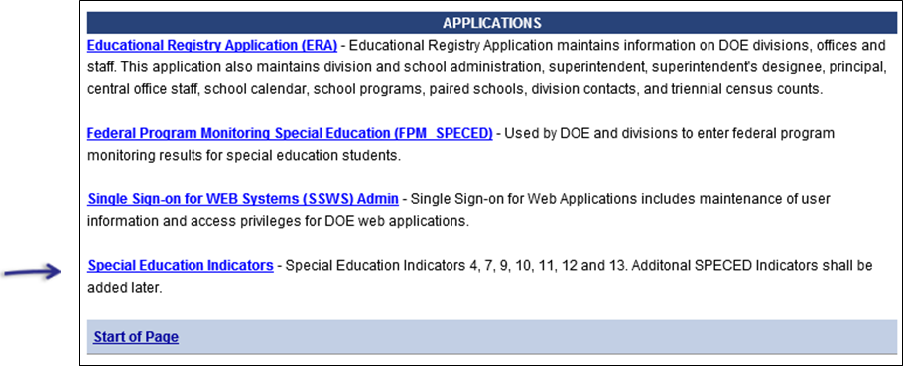

The local SSWS administrator will also need to assign the following permissions within the application:
- Data Entry Permission for Special Education Indicators 4, 7, 9, 10, 11, 12, and 13.
- Director Approval – Approves Special Education indicators and submits data to the users with Division Approval (Superintendents and Superintendent Designee).
- Generate Reports – Provides access to an application’s reporting modules.

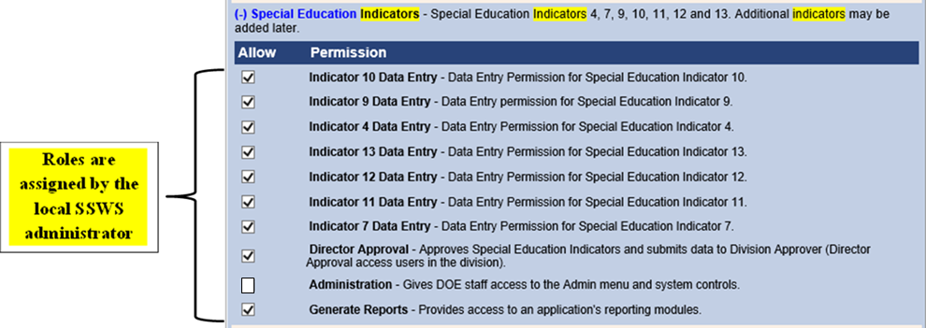

- Division Approval is completed through the Superintendent Data Collection Approval (SDCA) application which is a centralized process for School Division Superintendents and their Designees to review and approve their data prior to submission to the Virginia Department of Education (VDOE) for all required data collection events.

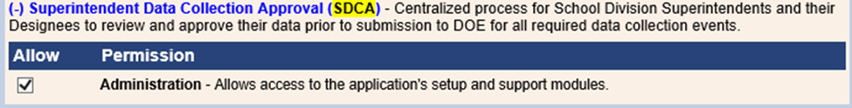

Step Two: Special Education Indicators Home Screen
- The menu to the right, under Maintain Indicators, lists the level of access assigned by your local SSWS administrator.
- An individual may be assigned one or more levels depending on the size and structure of the school division. In the example pictured below, one individual is assigned all access. This is not an ideal situation.

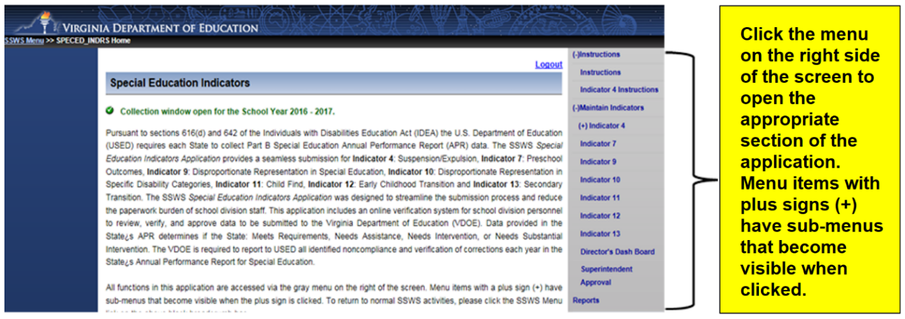

Step Three: Data Entry
- Each staff assigned to enter data can do so via the SSWS Special Education Indicators Application.
- Data is keyed directly into the application for each indicator.
- Once data is entered for an indicator, it must be finalized. This is done by clicking on the “Finalize” button on the data entry screen (see example below). After the “Finalize” button is clicked, data entry staff cannot edit the data without the director unlocking the data by logging in and “disapproving” the submission. Communication between staff is vital if multiple people are entering data for the same indicator.
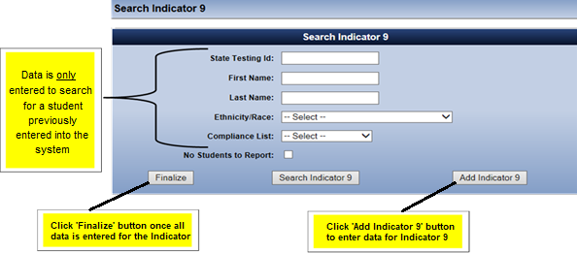

Step Four: Director Approval
- Once an indicator is finalized, the data is marked “Completed” and is available for the director to review in the Directors Dash Board. In this example, Indicator 9 has been finalized and is ready for the director to review. Click on Indicator 9 in the Directors Dash Board to review a summary report. Click “Disapprove” if data needs to be added or edited. That will unlock the data entry screen and allow data staff to revise the submission.
- All required indicators must be “Completed” (Finalized) before it can be submitted to the Division Superintendent for final approval and submission to the VDOE.

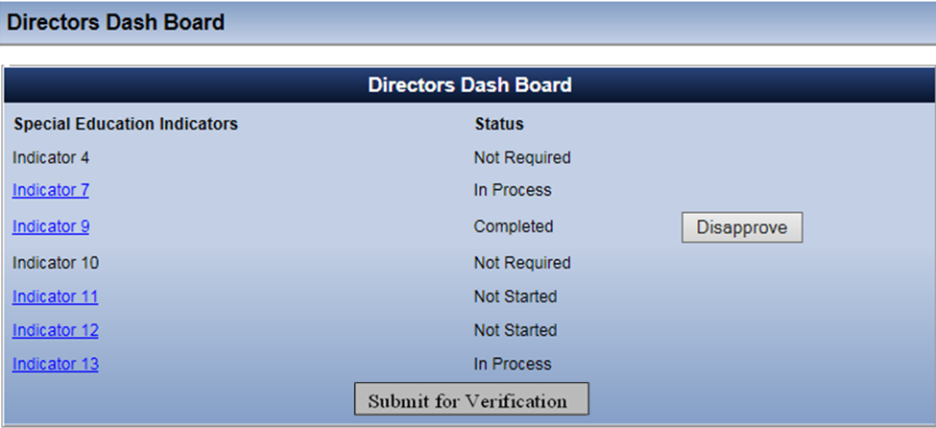

- After all required indicators are finalized, marked complete, and reviewed for accuracy, the data is ready to be submitted to the Division Superintendent (or designee). Once the “Submit for Verification” button is clicked, the data is locked and cannot be edited without the Division Superintendent (or designee) unlocking the data by logging in to SDCA and “disapproving” the submission.
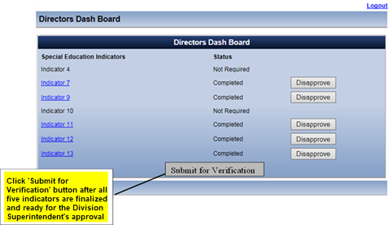

Step Five: Division Approval
- Division approval is completed through the Superintendent Data Collection Approval (SDCA) application.
- Clicking the “Approval” button will be considered the same as a signature on the paper form. The data collection is not considered complete until it is approved by the Division Superintendent (or designee). The approval must be given by the due date of the data collection. Once the data is submitted to the VDOE the submission window closes and can only be unlocked by VDOE staff. Reopening the window for resubmission may impact future local determinations for accurate and/or timely submission of data.
- If the Division Superintendent (or designee) disapproves the submission, the director will have access to the application and may also disapprove the specific indicator that needs revision. This will permit data entry staff access to the data entry screen for revision.

