**Kindergarten Mathematics**

**Vocabulary Word Wall Cards**

Mathematics vocabulary word wall cards provide a display of mathematics content words and associated visual cues to assist in vocabulary development. The cards should be used as an instructional tool for teachers and then as a reference for all students. **The cards are designed for print use only.**

**Table of Contents**

**Number and Number Sense**

Number Model of 2

Number Model of 9

Number Model of 14

Number Path

Counting by Ones

Counting by Tens

More Than

Fewer Than

Fair Share

**Computation and Estimation**

Addition

Subtraction

Estimate

Join

Separate

Part-Whole

**Measurement**

Penny

Nickel

Nickel = Five Pennies

Dime

Dime = Ten Pennies

Quarter

Quarter = Twenty-five Pennies

Calendar

Weight: Heavier/Lighter

Length: Longer/Shorter

Height: Taller/Shorter

Temperature: Hotter/Colder

Volume: Less/More

**Geometry**

Circle

Square

Triangle

Rectangle

Above/Below

Next To

Smaller/Larger

Same

**Probability and Statistics**

Picture Graph

Table

**Patterns, Functions, and Algebra**

Core

Pattern: Repeating

Pattern: Transfer a Repeating Pattern

Time: Longer/Shorter

# Number



2

two

numeral

# Number

9

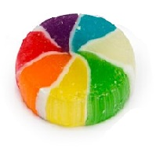



nine



numeral

# Number

|  |  |
| --- | --- |
|  |  |
|  |  |
|  |  |
|  |  |
|  |  |

14

fourteen

numeral

Number Path

|  |  |  |  |  |  |  |  |  |  |
| --- | --- | --- | --- | --- | --- | --- | --- | --- | --- |
| **1** | **2** | **3** | **4** | **5** | **6** | **7** | **8** | **9** | **10** |

# Counting by Ones



**0 1 2 3 4 5 6**

# Counting by Tens

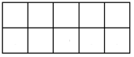

0

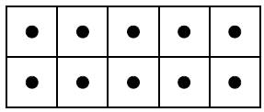

10



20





30

More Than

🞏🞏

⭘⭘⭘⭘⭘⭘

more ⭘ than 🞏

# Fewer Than

🞏🞏

⭘⭘⭘⭘⭘⭘

fewer 🞏 than⭘

# Fair Share

Joe and Tamara have a sandwich

to share equally.

one-half

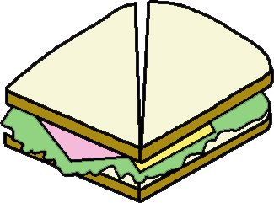



Addition

(add)

3 dogs and 1 dog is

4 dogs

|  |  |  |  |  |  |  |  |
| --- | --- | --- | --- | --- | --- | --- | --- |
| MC900440666[1] |  |  |  |  |  | MC900440666[1] | MC900440666[1] |
| MC900440666[1] | MC900440666[1] | and | MC900440666[1] | is |  | MC900440666[1] | MC900440666[1] |

Subtraction

(subtract)

6 cupcakes take away 2 is 4



Estimate

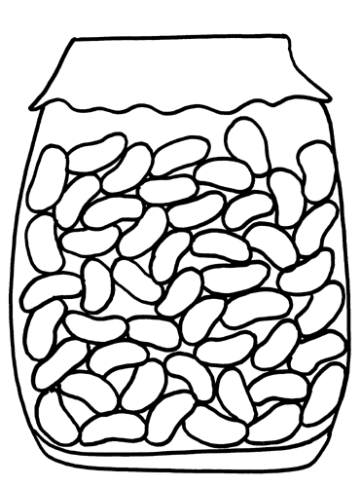

About how many beans are in the jar?

Join

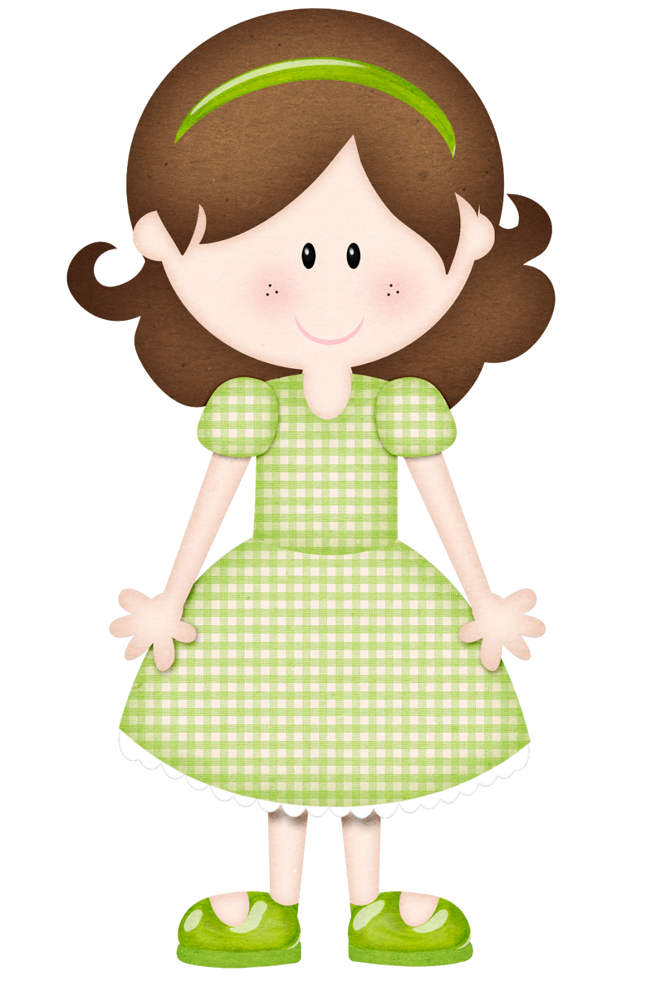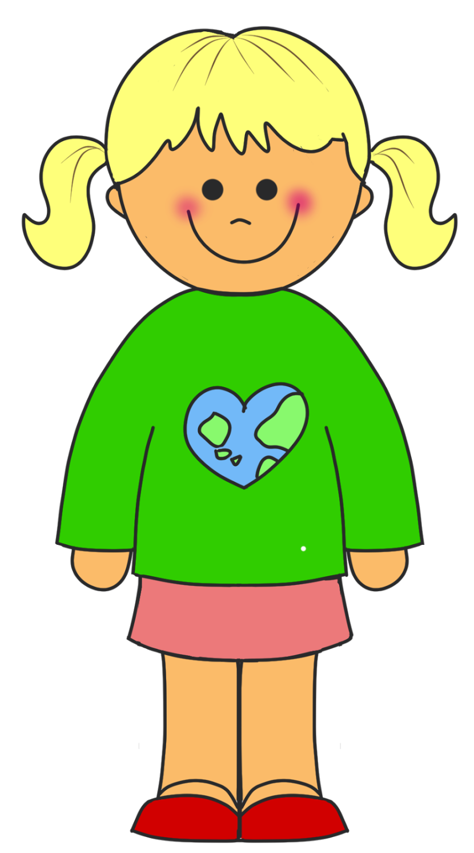



How many girls and boys are there?

Separate

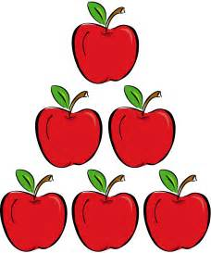

6 apples

3 were eaten

How many are there now?

Part-Whole



9 red and yellow balloons

How many could be red and how many could be yellow?

Penny

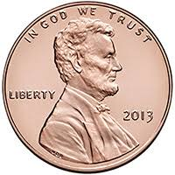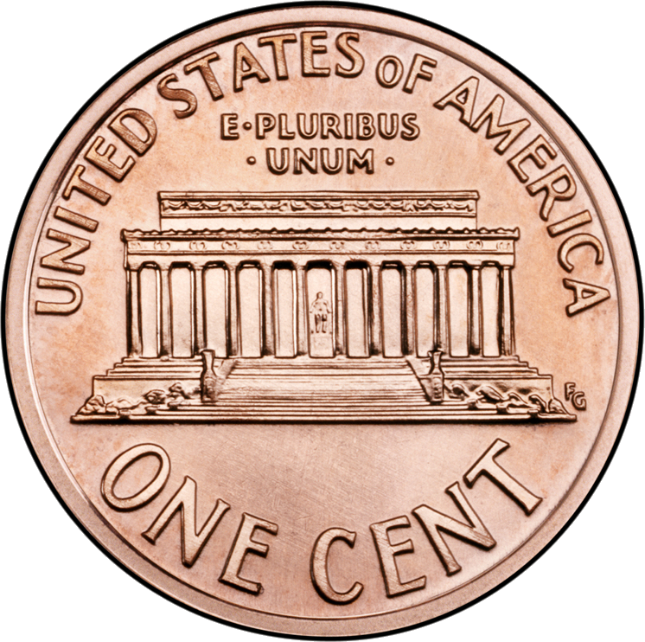

1¢

one cent

Nickel

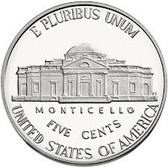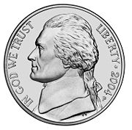

5¢

five cents

Nickel



one nickel equals five pennies

C:\Documents and Settings\uul54192\Local Settings\Temporary Internet Files\Content.IE5\VWJV0ZMV\MC900019342[1].wmfC:\Documents and Settings\uul54192\Local Settings\Temporary Internet Files\Content.IE5\VWJV0ZMV\MC900019342[1].wmfC:\Documents and Settings\uul54192\Local Settings\Temporary Internet Files\Content.IE5\VWJV0ZMV\MC900019342[1].wmfC:\Documents and Settings\uul54192\Local Settings\Temporary Internet Files\Content.IE5\VWJV0ZMV\MC900019342[1].wmfC:\Documents and Settings\uul54192\Local Settings\Temporary Internet Files\Content.IE5\VWJV0ZMV\MC900019342[1].wmf

5 cents

Dime

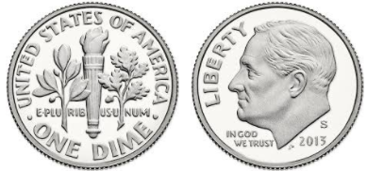

10¢

ten cents

Dime

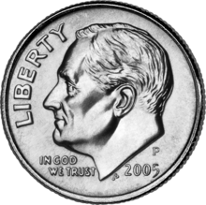

one dime equals ten pennies

C:\Documents and Settings\uul54192\Local Settings\Temporary Internet Files\Content.IE5\VWJV0ZMV\MC900019342[1].wmfC:\Documents and Settings\uul54192\Local Settings\Temporary Internet Files\Content.IE5\VWJV0ZMV\MC900019342[1].wmfC:\Documents and Settings\uul54192\Local Settings\Temporary Internet Files\Content.IE5\VWJV0ZMV\MC900019342[1].wmfC:\Documents and Settings\uul54192\Local Settings\Temporary Internet Files\Content.IE5\VWJV0ZMV\MC900019342[1].wmfC:\Documents and Settings\uul54192\Local Settings\Temporary Internet Files\Content.IE5\VWJV0ZMV\MC900019342[1].wmf

C:\Documents and Settings\uul54192\Local Settings\Temporary Internet Files\Content.IE5\VWJV0ZMV\MC900019342[1].wmfC:\Documents and Settings\uul54192\Local Settings\Temporary Internet Files\Content.IE5\VWJV0ZMV\MC900019342[1].wmfC:\Documents and Settings\uul54192\Local Settings\Temporary Internet Files\Content.IE5\VWJV0ZMV\MC900019342[1].wmfC:\Documents and Settings\uul54192\Local Settings\Temporary Internet Files\Content.IE5\VWJV0ZMV\MC900019342[1].wmfC:\Documents and Settings\uul54192\Local Settings\Temporary Internet Files\Content.IE5\VWJV0ZMV\MC900019342[1].wmf

10 cents

Quarter

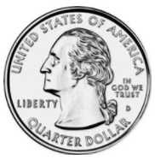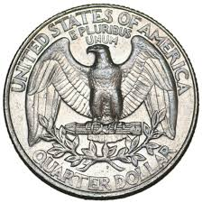

25¢

twenty-five

cents

Quarter



one quarter equals twenty-five pennies



25 cents



Time:

Longer time/

Shorter time



longer time

(to walk to school)

shorter time

(to drive to school)

Calendar

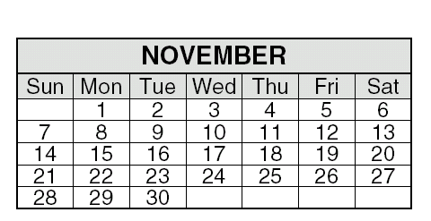

Weight: Heavier/Lighter

# 

# heavier

# lighter

Length:

Longer/Shorter

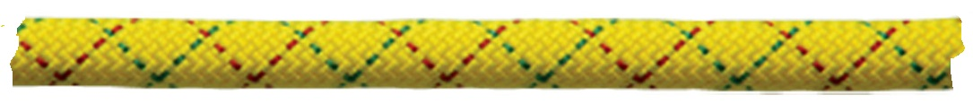

longer



shorter

longer





shorter

Height:

Taller/Shorter





taller shorter

Temperature:

Hotter/Colder



hotter

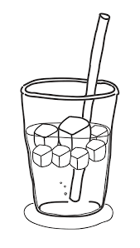

colder

Volume:

Less /More

less more

Circle

Square

Triangle

Rectangle

Above/Below



above



below

Next To





Smaller/Larger

smaller

larger

Same

same shape

same color

Picture Graph

Our Favorite Pets

|  |  |  |  |
| --- | --- | --- | --- |
| Cat | Dog | Horse | Fish |
| MCj04406680000[1]  MCj04406680000[1] | MCj04406660000[1] | MCj03438250000[1]  MCj03438250000[1]  MCj03438250000[1]  MCj03438250000[1] | MCj04125000000[1]  MCj04125000000[1]  MCj04125000000[1] |

Table

Pets

|  |  |
| --- | --- |
| Animals | Number |
| Dogs | 2 |
| Cats | 1 |
| Birds | 3 |
| Lizards | 1 |

Core

part of the pattern that repeats

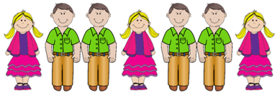

core

Pattern:

#### Repeating

🞇■🞇■🞇■🞇

Transfer a Repeating Pattern

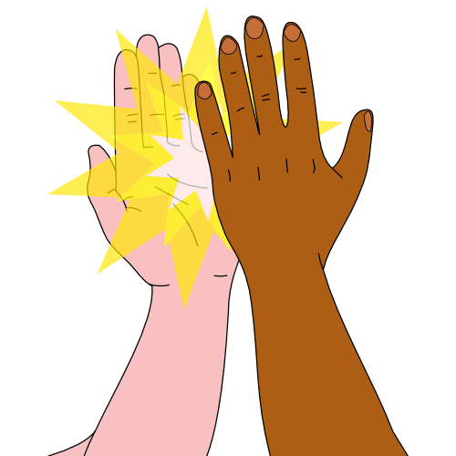

can be represented as

**A B C A B C**