Grade 8 Mathematics

Vocabulary Word Wall Cards

Mathematics vocabulary word wall cards provide a display of mathematics content words and associated visual cues to assist in vocabulary development. The cards should be used as an instructional tool for teachers and then as a reference for all students. **The cards are designed for print use only.**

**Table of Contents**

**Number and Number Sense**

Comparing Real Numbers

Natural Numbers

Whole Numbers

Integers

Rational Numbers

Irrational Numbers

Real Numbers

**Computation and Estimation**

Square Root - Definition

Square Root - Example

Proportion

Percent of Increase

Percent of Decrease

Reconcile an Account

**Measurement and Geometry**

Complementary Angles

Supplementary Angles

Vertical Angles

Adjacent Angles

Pyramid

Cone

Volume – Changing One Attribute

Surface Area – Changing One Attribute

Reflection

Translation

Dilation

Reflection and Translation

Three Dimensional Models

Composite figures

Right Triangle

Pythagorean Theorem

**Probability and Statistics**

Probability of Independent Events

Probability of Dependent Events

Boxplots

Comparing Boxplots

Scatterplot

Positive Linear Relationship

Negative Linear Relationship

No Relationship

**Patterns, Functions and Algebra**

Term

Constant

Like Terms

Order of Operations

Relations

Functions

Domain

Range

Slope – Definition

Slope

Linear Function

Identifying Slope and y-Intercept

Dependent/independent Variable

Independent Variable

Dependent Variable

Connecting Representations

Multistep Equations

Multistep Equations (model)

Verbal and Algebraic Expressions and Equations

Inequality

# Comparing Real Numbers



$$-\frac{5}{2}$$

$$\frac{1}{2}$$

$2\frac{1}{2}$

$$-2$$

Values for numbers get larger as move further to the right on the number line

Values for numbers get smaller as move further to the left on the number line

-3 -2 -1 0 1 2 3

$-\frac{5}{2}$ < $\frac{1}{2}$ or $\frac{1}{2}$ > $-\frac{5}{2}$

-2 > $-2\frac{1}{2}$ or $-2\frac{1}{2}$ < -2

$2\frac{1}{2}<\sqrt{8}$ or $\sqrt{8}>2\frac{1}{2}$

# Natural Numbers

The set of numbers

1, 2, 3, 4…

Real Numbers

Irrational Numbers

Rational Numbers

Integers

Irrational Numbers

Rational Numbers

Integers

Whole Numbers

Whole Numbers

**Natural Numbers**

|  |
| --- |
| Examples 15 , $\frac{\text{8}}{\text{1}},$ 101 , 1, $\text{5.0}$, $\sqrt{\text{16}}$, $\frac{\text{10}}{\text{2}}$ |

# Whole Numbers

The set of numbers

0, 1, 2, 3, 4…

Real Numbers

Irrational Numbers

Rational Numbers

Irrational Numbers

Rational Numbers

Integers

Integers

Whole Numbers

**Whole Numbers**

Natural Numbers

|  |
| --- |
| Examples 19 , $\frac{\text{99}}{\text{1}},$ 953 , 1, $\text{7.0}$, 0, $\sqrt{\text{81}}$, $\frac{\text{18}}{\text{3}}$ |

# Integers

The set of numbers

…-3, -2, -1, 0, 1, 2, 3…

Whole Numbers

Integers

Rational Numbers

Irrational Numbers

Natural Numbers

Whole Numbers

**Integers**

Rational Numbers

Irrational Numbers

Real Numbers

|  |
| --- |
| Examples -13 , 27 , (-3)2, , , 0, |

# Rational Numbers

Whole Numbers

Integers

Rational Numbers

Irrational Numbers

Natural Numbers

Whole Numbers

Integers

**Rational Numbers**

Irrational Numbers

Real Numbers

|  |
| --- |
| Examples 2 $\frac{\text{3}}{\text{5}}$, -5 , 0, $\text{0.3}$, $\sqrt{\text{16}}$,  , $\frac{\text{13}}{\text{7}}$ |

The set of all numbers that can be written as the ratio of two integers with a non-zero denominator

# Irrational Numbers

Whole Numbers

Integers

Rational Numbers

Irrational Numbers

Natural Numbers

Whole Numbers

Integers

Rational Numbers

**Irrational Numbers**

Real Numbers

The set of all numbers that cannot be expressed as the ratio of integers

Examples

$\sqrt{\text{7}}$, $\text{π}$, -0.23223222322223…

# Real Numbers

Whole Numbers

Integers

Rational Numbers

Irrational Numbers

Natural Numbers

Whole Numbers

Integers

**Rational Numbers**

**Irrational Numbers**

The set of all rational and irrational numbers

# 

# Square Root

any number which, when multiplied by itself,   
equals the number

radical symbol

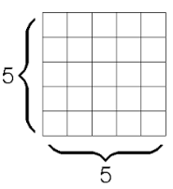

$\sqrt{25}$ = 5

$\sqrt{\text{25}}$ = $\sqrt{\text{5∙5}}$ = $\sqrt{{\text{5}}^{\text{2}}}$ = 5

Squaring a number and taking a square root are inverse operations.

- = -6

(-6)2 = -6 ∙ -6 = 36

# Square Root

$\sqrt{\text{10}}$ ≈ 3.16

**4**

**3**

**0**

$\sqrt{\text{10}}$ is between

$\sqrt{\text{9}}$ and $\sqrt{\text{16}}$

# 

# Proportion

a statement of equality   
between two ratios



*a:b = c:d*

*a is to b*

*as c is to d*

Example

2 is to 5 as

4 is to 10

2:5 = 4:10

# Percent of Increase

Percent of change =  · 100

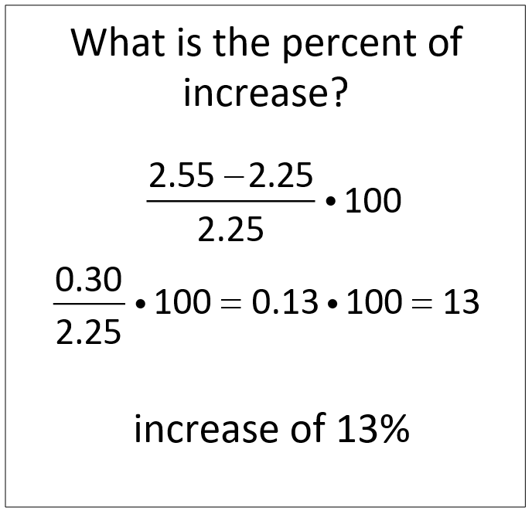

Was $2.25

per gallon

Now $2.55

per gallon

# Percent of Decrease

Percent of change =  · 100

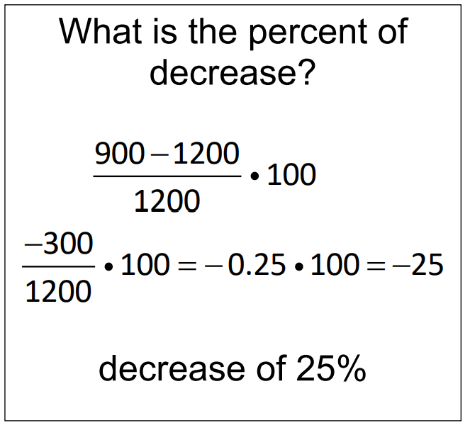

Was $1200

Now only $900

# Reconcile an Account

Joe owed a balance of $147.60 on his credit card account on June 1. Below is a list of transactions that occurred during June.

|  |  |  |
| --- | --- | --- |
| **Transactions** | | |
| **Date** | **Description** | **Amount** |
| 6/3 | Giddy-up Gas | $ 31.00 |
| 6/7 | Payment | $ 150.00 |
| 6/12 | Food-o-rama | $ 134.12 |
| 6/22 | Big Top Pizza | $ 34.32 |
| 6/28 | Bart’s Sport Shop | $ 16.04 |

Determine how much he owes on his credit card account after the purchase at Bart’s Sport Shop.

Purchases: 

Balance - Purchases: ̶ $147.60 ̶ $215.48 = ̶ $363.08

Amount Owed: ̶ $363.08 + $150.00 = ̶ $213.08

# Complementary Angles

**2**

**1**

**1**

**2**

Fig 1

Fig 2

m∠1 + m∠2 = 90°

in each figure

# Supplementary Angles

**2**

**1**

**2**

**1**

Fig 1

Fig 2

m∠1 + m∠2 = 180°

in each figure

# Vertical Angles

**1**

**4**

**3**

**2**

∠1 and ∠3 are vertical angles.

∠2 and ∠4 are vertical angles.

∠1 ≅ ∠3 and ∠2 ≅ ∠4

# Adjacent Angles

 is adjacent to 

in each figure

Fig 2

**1**

**2**

**2**

**1**

**2**

**1**

Fig 1

Fig 3

Share a common side and a common vertex

# Square-Based Pyramid

***l***

***h***

*B**=* area of square base

*p =* perimeter of base

*h* = height

*l* = slant height

*V = $\frac{\text{1}}{\text{3}}$ Bh*

*S.A. = $\frac{\text{1}}{\text{2}}$ lp+ B*

# Cone

***r***

***h***

*r =* radius of base

*h* = height

*l* = slant height

*V = π r 2h*

*S.A. = π r 2 + π r l*

***l***

# Volume of Rectangular Prism

(Changing one attribute)

*V* = *lwh*

8 · 2 · 3 = 48 cm3

3 cm

2 cm

8 cm

8

2

3

3

6

Height is multiplied by 2

Volume is multiplied by 2

# Surface Area of a Rectangular Prism (Changing one attribute)

*New Volume*

*V* = 8 · 2 · 6 = 96 cm3

*S.A.* = 2*lw* + 2*lh* + 2*wh*

*S.A. =* 2(8·2) + 2(8·3) + 2(2·3)

*S.A.*  = 32 + 48 +12 = **92 units2**

8

bottom

back

top

front

left side

right side

6

6

6

6

New *S.A.* =2(8·2) + 2(8·6) + 2(2·6)

New *S.A.* = 32 + 96 + 24 = **152 units2**

2

3

3

6

8

Height is multiplied by 2

2

3

# Reflection

a transformation in which an image is formed by reflecting the preimage over a line called the line of reflection   
(all corresponding points in the image and preimage are equidistant from the line of reflection)

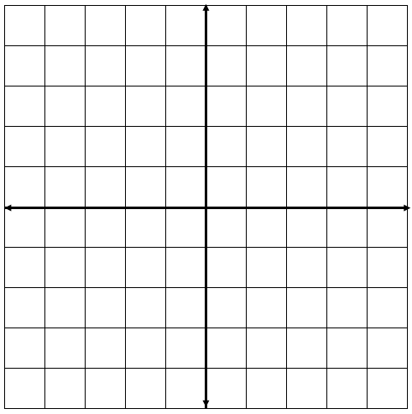

***y***

***x***

D

F

E

D′

E′

F′

|  |  |
| --- | --- |
| Preimage | Image |
| D(1,-2) | D′(-1,-2) |
| E(3,-2) | E′(-3,-2) |
| F(3,2) | F′(-3,2) |

Translation

The preimage of triangle DEF is reflected across the *y*-axis to create the image D’E’F’

a transformation in which an image is formed by moving every point on the preimage the same distance in the same direction.

***y***



The preimage of rectangle ABCD is translated 5 units to the left and 3 units down to create the image A’B’C’D’

B′

A′

D′

C′

A

C

B

D

***x***

|  |  |
| --- | --- |
| Preimage | Image |
| A(1,2) | A′(-4,-1) |
| B(4,2) | B′(-1,-1) |
| C(4,4) | C′(1, 1) |
| D(1,4) | D′(-4, 1) |

# Dilation

|  |  |
| --- | --- |
| Preimage | Image |
| A(0,4) | A′(0,2) |
| B(4,0) | B′(2,0) |
| C(0,0) | C′(0,0) |

center of dilation is (0,0)

scale factor = 



x

y

C

A

B

A′

B′

C′

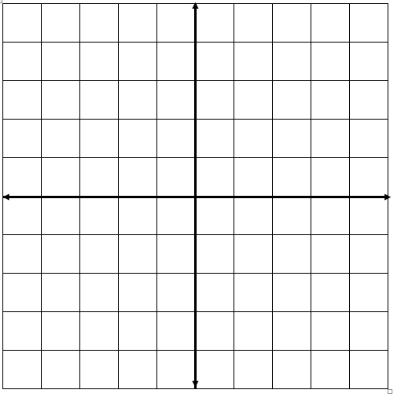

center of dilation is (0,0)

scale factor = 2

y

|  |  |
| --- | --- |
| Preimage | Image |
| G(0,-2) | G′(0,-4) |
| H(0,0) | H′(0,0) |
| J(1,0) | J′(2,0) |
| L(1, -2) | L′(2,-4) |

L

J′

J

H′

H

G

x

L′

G′

# Reflection and Translation

|  |  |
| --- | --- |
| Preimage | Image |
| D(1,-2) | D′(-1,0) |
| E(3,-2) | E′(-3,0) |
| F(3,2) | F′(-3,4) |



***y***

***x***

D

F

E

D′

E′

F′

Figure *DEF* is reflected over the *y*-axis and translated up 2 units to create the image *D’E’F’*.

# Three Dimensional Models

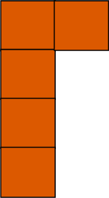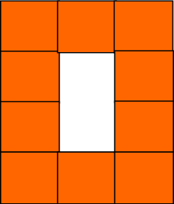

top

side

front

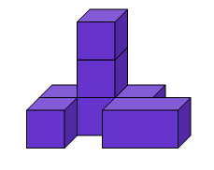

bottom

side

front

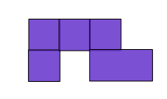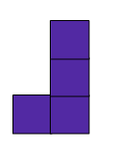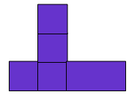

# Right Triangle

c

hypotenuse

leg

a

leg

b

C

B

A

# Pythagorean Theorem

In a right triangle, the hypotenuse is the side opposite the right angle.   
The hypotenuse is the longest side of the right triangle.





**b**

**c**

**a**



a2 + b2 = c2

# Composite Figures

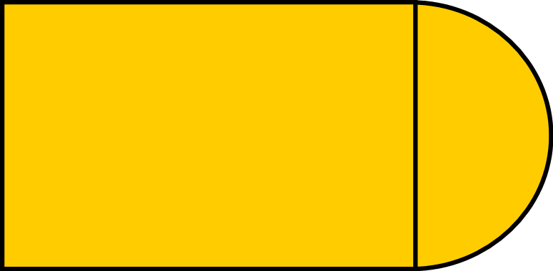

**20 cm**

**14 cm**

Example 1: Subdivide the composite figure into other figures, then determine the perimeter.

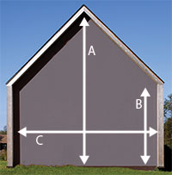

A – 40 ft

B – 21 ft

C – 38 ft

Example 2: Subdivide the composite figure into other figures to determine the area of the side of the house.

Area =  = 798 + 361 = **1159 ft2**

# Probability of Independent Events

The outcome of one event does not affect the outcome of the other event.

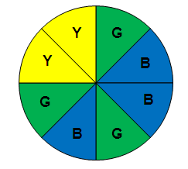

What is the probability of landing on green on the first spin and then landing on yellow on the second spin?

P(green and yellow) =

P(green) $∙$ P(yellow) =



Probability of Dependent Events

The outcome of one event has an impact on the outcome of the other event.

***Candy Jar***

**R**

**R**

**G**

**Y**

**P**

**B**

**R**

**R**

**G**

**Y**

**P**

**B**

What is the probability of choosing a red jelly bean on the first pick and then without replacing it, choosing a green jelly bean on the second pick?

P(red) **∙** P(green after red) =

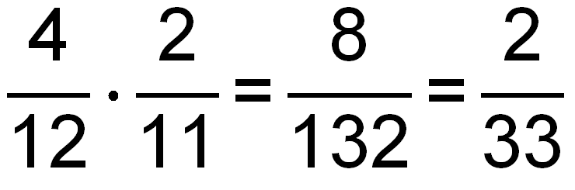

# 

# Boxplots

(Box-and-Whisker Plots)

A graphical representation of the five-number summary

Lower

Quartile (Q1)

Lower

Extreme

Upper

Quartile (Q3)

Upper

Extreme

Median

Interquartile Range (IQR)

5

10

15

20

# Comparing Boxplots

Comparing the heights (inches) of high school boys and girls

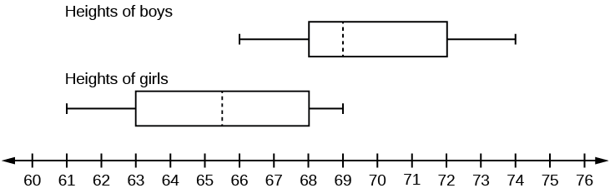

Median

Median

# Scatterplot

Illustrates the relationship between two sets of data.

**x**

**y**

# Positive Linear Relationship

Pattern of points slopes from lower left to upper right.

(Generally, as the *x*-coordinates increase in value, the *y*-coordinates increase in value)

**x**

**y**

# Negative Linear Relationship

Pattern of points slopes from upper left to lower right

(Generally, as the *x*-coordinates increase in value, the *y*-coordinates decrease in value)

**x**

**y**

# No Linear Relationship

no relationship exists between the *x*- and *y*-coordinates

**x**

**y**

# Term

3*x* + 2*y* – 8

3 terms

-5*x*2 + (-2*x*)

2 terms

$\frac{\text{2}}{\text{3}}$*ab*

1 term

# Constant

-12

4*x* – 12

7 – 2*y* + *x* – 6*x* 2

3(*x* + 3.9) +

# Like Terms

4*x* – 3*y* + 6*x* – 7

2*y* 2 – 3*y* + 7*y* 2

-5*r* 2 – 6 + 2*r* + 2

# 

# Order of Operations

( )

{ }

[ ]

Grouping Symbols

Exponents

Multiplication

Left to right

or Division

Addition

Left to right

Subtraction

# Relation

Any set of ordered pairs

Ordered Pairs

{(-3,3), (0,3), (1,5), (1,-1), (2, -1)}

|  |  |
| --- | --- |
| *x*  Table | *y* |
| -3 | 3 |
| 0 | 3 |
| 1 | 5 |
| 1 | -1 |
| 2 | -1 |

# Function

Graph

A relation between a set of inputs, called the domain, and a set of outputs, called the range, with the property that each input is related to exactly one output

{(-1,1), (0,1), (2,3), (4,1)}

|  |  |
| --- | --- |
| *x* | *y* |
| -1 | 1 |
| 0 | 1 |
| 2 | 3 |
| 4 | 1 |

# Domain

The set of all the input values for the independent variable  
 or *x*-values (first number in an ordered pair)

{(-1,1), (0,1), (2,3), (4,1)}

|  |  |
| --- | --- |
| *x* | *y* |
| -1 | 1 |
| 0 | 1 |
| 2 | 3 |
| 4 | 1 |

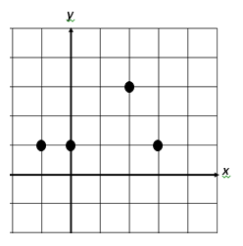

D: {-1, 0, 2, 4}

# Range

The set of all the output values for the dependent variable  
 or *y*-values (second number in an ordered pair)

{(-1,1), (0,1), (2,3), (4,1)}

|  |  |
| --- | --- |
| *x* | *y* |
| -1 | 1 |
| 0 | 1 |
| 2 | 3 |
| 4 | 1 |



R: {1, 3}

# Slope

# Represents the rate of change in a linear function or the “steepness” of the line.

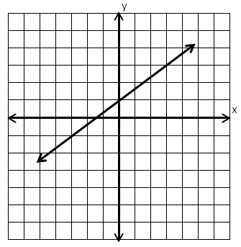

**3**

**2**

Slope = $\frac{\text{2}}{\text{3}}$

slope $=\frac{change in y}{change in x}=\frac{vertical change}{horizontal change}$

# Slope

# 

# 

A horizontal line has a slope of zero (0).

A line with a negative slope slants down to the right.

A line with a positive slope slants up to the right.

# Linear Function

A linear function can be written as *y* = *mx* + *b* and its graph is a straight line. Its slope represents a constant rate of change.

*y* = *mx* + *b*

(slope is *m* and *y*-intercept is *b*)

Example: *y* = $\frac{\text{-}\text{4}}{\text{3}}$*x* + 5

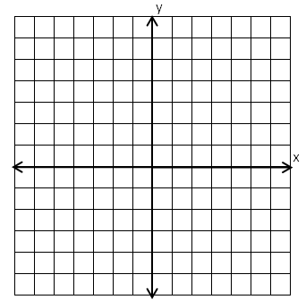

**(0,5)**

**-4**

**3**

# Identifying Slope and

# y-Intercept

+1

+1

+1

+1

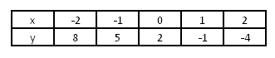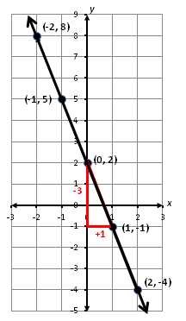

-3

-3

-3

-3

*y*-intercept, *b*, is 2, located at (0,2).

slope = *m* = $\frac{-3}{1}$ = -3

*y* = -3*x* + 2

# Dependent/

# Independent Variable

Determine the distance (*d*) a car will travel going 55 mph.

|  |  |
| --- | --- |
| *h* | *d* |
| 0 | 0 |
| 1 | 55 |
| 2 | 110 |
| 3 | 165 |

*d* = 55*h*

dependent

independent

# Independent Variable

*y* = 2*x* + 7

*x* represents the

independent variable

(input values or domain)

# Dependent Variable

*y* = 2*x* + 7

*y* represents the

dependent variable

(output values or range)

# 

# Connecting Representations

A bike rents for $4 plus $1.50 per hour.

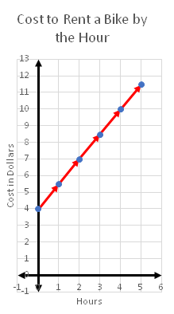

*c* = 1.5*h* + 4

|  |  |
| --- | --- |
| *h* | *c* |
| 0 | 4 |
| 1 | 5.5 |
| 2 | 7 |
| 3 | 8.5 |
| 4 | 10 |
| 5 | 11.5 |

Multistep Equations

2*x* – 5.7 = -3.4*x* + 11.04

$\frac{\text{2}}{\text{3}}$ (*n* + 9) = - $\frac{\text{5}}{\text{6}}$*n*

25 = $\frac{\text{6}\text{p}\text{ - 5}}{\text{-4}}$

Multistep Equation

3*x* + 5 = -3 – *x*

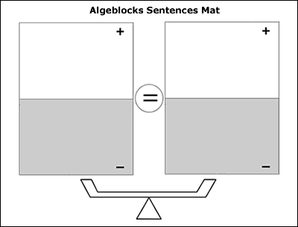

Verbal and Algebraic Expressions and Equations

| Verbal | Algebraic |
| --- | --- |
| A number multiplied by five | 5*n* |
| The sum of negative two and a number | -2 + *n* |
| The sum of half a number and two is five times the number | $\frac{1}{2}$*y* + 2 = 5*y* |
| Negative three times a number is one-fifth the difference of four times the number and ten | -3*x* = $\frac{1}{5}(4$*x* – 10) |

# 

# Inequality

-3(n – 4) < 0

-3n + 12 < 0

-3n < -12

n > 4

**0 1 2 3 4 5**



**0 1 2 3 4 5**