Grade 7 Mathematics

Vocabulary Word Wall Cards

Mathematics vocabulary word wall cards provide a display of mathematics content words and associated visual cues to assist in vocabulary development. The cards should be used as an instructional tool for teachers and then as a reference for all students.

## Number and Number Sense

Powers of Ten

Scientific Notation

Comparing Numbers in Scientific Notation

Rational Numbers

Comparing Rational Numbers

Perfect Squares

Square Root

Absolute Value

**Computation and Estimation**

Proportion

Ratio Table

Scale Factor

Proportional Reasoning

Proportional Reasoning: Using Benchmarks

**Measurement and Geometry**

Rectangular Prism

Volume of a Rectangular Prism

Surface Area of a Rectangular Prism

Cylinder

Similar Figures

Similar Figures and Proportions

Quadrilateral Relationships

Parallelogram

Rhombus

Rectangle

Square

Trapezoid

Line of Symmetry

Reflection

Translation

**Probability and Statistics**

Probability

Theoretical Probability

Experimental Probability

Histogram

Comparing Graphs: Histogram and Stem and Leaf Graph

Comparing Graphs: Histogram and Circle Graph

Comparing Graphs: Histogram and Line Plot

**Patterns, Functions and Algebra**

Slope

Unit Rate

Proportional Relationship: y = mx

Proportional Relationship

Additive Relationship: y = x + b

Additive Relationship

Graphing Linear Relationships

Connecting Representations: Proportional Relationship

Connecting Representations: Additive Relationship

Order of Operations

Verbal and Algebraic Expressions and Equations

Equation

Inequality

# Powers of Ten

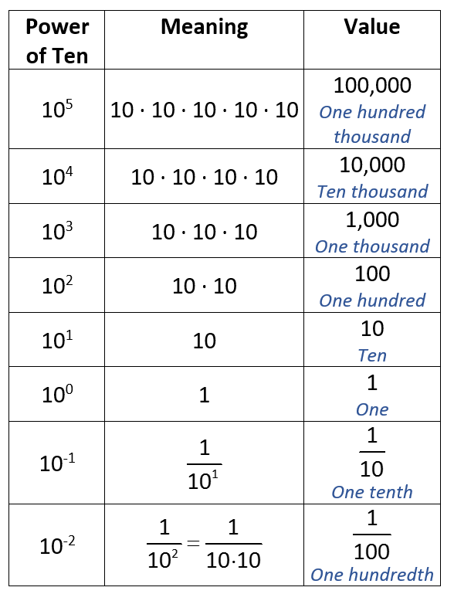

# Scientific Notation

Exponent

Coefficient

*a* x 10*n*

Base

*a* = Coefficient (a number that is greater than or equal to 1 and less than 10)

10 = Base

*n* = Exponent (a number that is an integer)

|  |
| --- |
| Examples  17,500,000 = 1.75 x 107  0.0000026 = 2.6 x 10-6  5.3 x 1010 = 53,000,000,000  4,421.952 = 4.421952 x 103 |

# Comparing Numbers in Scientific Notation

Planet Diameter Table (km)

| **Planet** | **Diameter (km)** | **Scientific Notation** |
| --- | --- | --- |
| Mercury | 4,879 km | 4.879 x 103 km |
| Venus | 12,104 km | 1.2104 x 104 km |
| Earth | 12,756 km | 1.2756 x 104 km |
| Mars | 6,792 km | 6.792 x 103 km |
| Jupiter | 142,984 km | 1.42984 x 105 km |
| Saturn | 120,536 km | 1.20536 x 105 km |
| Uranus | 51,118 km | 5.1118 x 104 km |
| Neptune | 49,528 km | 4.9528 x 104 km |

<https://nssdc.gsfc.nasa.gov/planetary/factsheet/>

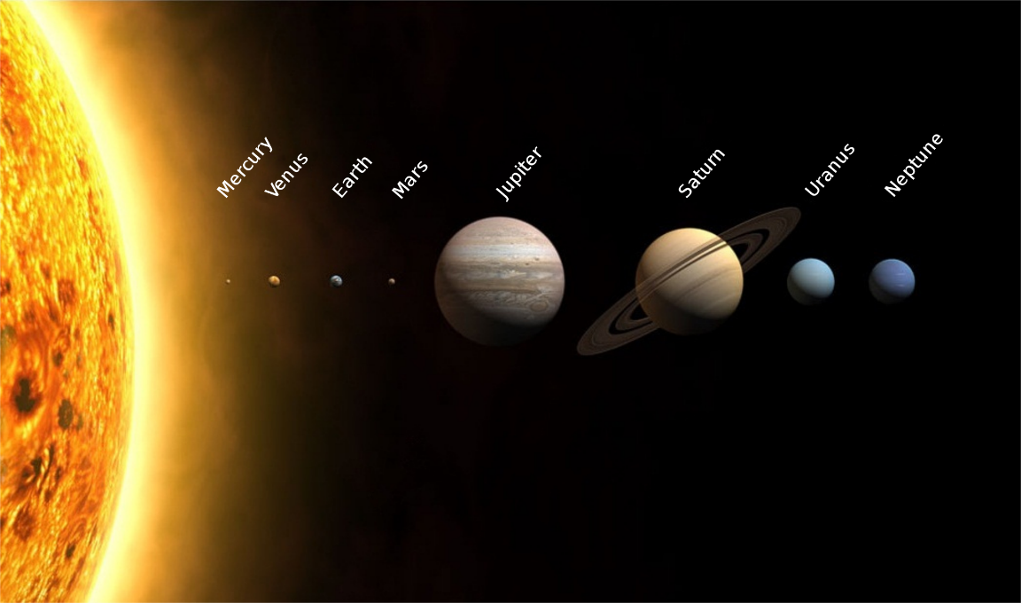

<https://en.wikipedia.org/wiki/Solar_System>

# Rational Numbers

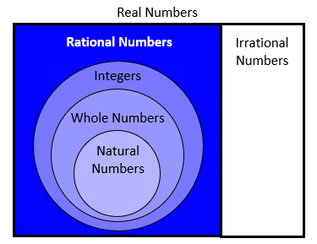

The set of all numbers that can be written as the ratio of two integers with a non-zero denominator

|  |
| --- |
| Examples 2 $\frac{\text{3}}{\text{5}}$, -5 , 0, $\text{0.3}$, $\sqrt{\text{16}}$,  , $\frac{\text{13}}{\text{7}}$ |

# Comparing Rational Numbers

$$2\frac{1}{2}$$

$$\frac{1}{2}$$

$$-2$$

$$-\frac{5}{2}$$

Values for numbers get smaller as move further to the left on the number line

Values for numbers get larger as move further to the right on the number line

-3 -2 -1 0 1 2 3

$-\frac{5}{2}$ < $\frac{1}{2}$ or >

- > or < -

- < or $2\frac{1}{2}$ > - $2$

Perfect Squares

02 = 0  0 = **0**

12 = 1  1 = **1**

22 = 2  2 = **4**

32 = 3  3 = **9**

42 = 4  4 = **16**

52 = 5  5 = **25**



perfect square

# Square Root

any number which, when multiplied by itself,   
equals the number

radical symbol

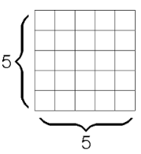

$\sqrt{25}$ = 5

$\sqrt{\text{25}}$ = $\sqrt{\text{5∙5}}$ = $\sqrt{{\text{5}}^{\text{2}}}$ = 5

Squaring a number and taking a square root are inverse operations.

# Absolute Value

distance a number is from zero

$\left|\frac{9}{2}\right|$ = $\frac{9}{2}$ $\left|-\frac{9}{2}\right|$ = $\frac{9}{2}$

$4\frac{1}{2}$**units**

$4\frac{1}{2}$**units**

-6 -5 -4 -3 -2 -1 0 1 2 3 4 5 6

# Proportion

a statement of equality   
between two ratios



*a:b = c:d*

*a is to b*

*as c is to d*

Example



2 is to 5 as

4 is to 10

2:5 = 4:10

# Ratio Table

a table of values representing a proportional relationship that includes pairs of values that represent equivalent rates or ratios

Example

Terry’s neighbor pays him $17 for every 2 hours he works. Terry works for 8 hours on Saturday.

A ratio table represents the proportional relationship:

| Hours | 1 | 2 $$∙8.5$$ | 4 $$∙8.5$$ | 8 |
| --- | --- | --- | --- | --- |
| Pay in $ | ? | 17 | 34 | ? |

## How much does Terry earn per hour?

## $\frac{17}{2}=\frac{?}{1}$ Terry earns $8.50 per hour

## How much will Terry earn in 8 hours?

## $ He will earn $68.00 in 8 hours.

# Scale Factor

a number which scales, or multiplies, a quantity

Figures A and B are similar

14

5 $\frac{1}{4}$

**B**

8

3

**A**

What is the scale factor (scaling up) from figure A to figure B?

Scale factor $=\frac{14}{8}=\frac{7}{4}=1.75$

What is the scale factor (scaling down) from figure B to figure A?

Scale factor $=\frac{8}{14}=\frac{\text{4}}{\text{7}}$

# Proportional Reasoning

About how many centimeters are in 2 feet if 1 inch is about 2.5 centimeters?



2 feet = 24 inches

There are approximately 60 centimeters in 2 feet

About how many liters are in 3 gallons

if 1 quart is approximately 0.95 liters?



3 gallons = 12 quarts

There are approximately 11.4 liters in 3 gallons.

# Proportional Reasoning

Using benchmarks

A meal at a restaurant costs a total of $35.00. Sharon wants to leave a tip.

| Percent | Cost of meal | Percentage or tip |
| --- | --- | --- |
| 5% | $35.00 | $1.75 |
| 10% | $35.00 | $3.50 |
| 15% | $35.00 | $5.25 |
| 20% | $35.00 | $7.00 |

To find 10% of $35.00 calculate 0.10($35.00) = $3.50

Using $3.50 as a benchmark, for example, we can then determine the 20% tip by doubling to $7.00 or the 5% tip by halving to $1.75.

Rectangular Prism

a polyhedron in which all six faces are rectangles

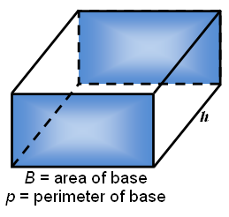

Volume = area of the base times the height

*V = Bh*

Surface area = height times the perimeter plus   
twice the area of the base

*S.A. = hp+ 2B*

# Volume of a Rectangular Prism

# Surface Area of a Rectangular Prism

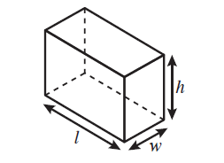

Volume = *length · width · height*

*V = lwh*

Volume = area of the base x height

measured in cubic units

height

length

width

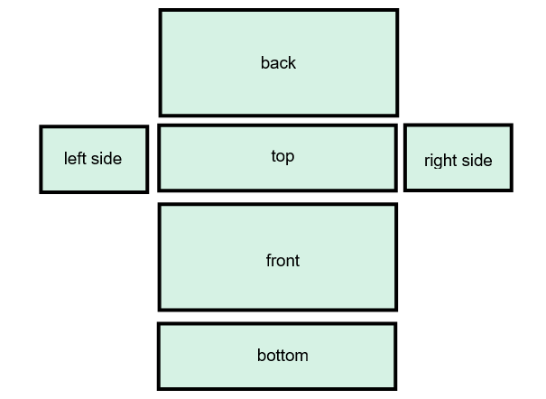

***h***

***w***

Cylinder

*S.A.* = 2*lw* + 2*lh* + 2*wh*

**Surface Area (*S*.*A*.) *=* sum of areas of faces**

***l***

a solid figure formed by two congruent parallel faces called bases joined by a curved surface

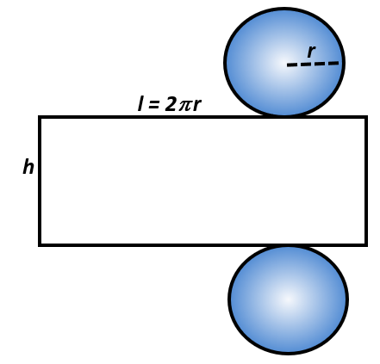

***r***

***h***

Volume = area of the base x height

*V = π r 2h*

*S.A. = 2π r 2 + 2π r h*

# Similar Figures

**A**

**B**

**D**

**C**

**E**

**F**

**G**

**H**

2

4

6

12

|  |  |
| --- | --- |
| ABCD **~** HGFE | |
| **Angles** | **Sides** |
| ∠A corresponds to ∠H | $\overline{\text{AB}}$ corresponds to $\overline{\text{HG}}$ |
| ∠B corresponds to ∠G | $\overline{\text{BC}}$ corresponds to $\overline{\text{GF}}$ |
| ∠C corresponds to ∠F | $\overline{\text{CD}}$ corresponds to $\overline{\text{FE}}$ |
| ∠D corresponds to ∠E | $\overline{\text{DA}}$ corresponds to $\overline{\text{EH}}$ |

Corresponding angles are congruent.

Corresponding sides are proportional.

# Similar Figures and Proportions

**A**

**B**

**D**

**C**

**E**

**F**

**G**

**H**

2

4

6

12

ABCD **~** HGFE

$\frac{\text{DC}}{\text{EF}}$ = $\frac{\text{AD}}{\text{HE}}$

$\frac{\text{4}}{\text{2}}$ = $\frac{\text{12}}{\text{6}}$

# Quadrilaterals Relationships

Quadrilaterals

# 

No sides parallel

Trapezoid

1 pair parallel sides

# 

Rhombus

4 congruent sides

Parallelogram

2 pairs of parallel sides

Rectangle

4 right

angles

Square

# Parallelogram

* opposite angles are congruent
* opposite sides are parallel and congruent
* diagonals bisect each other

# Rhombus

* 4 congruent sides
* 2 pairs of parallel sides
* opposite angles are congruent
* diagonals bisect each other at right angles

# Rectangle

* 4 right angles
* opposite sides are parallel and congruent
* diagonals are congruent and bisect each other

# Square

* regular polygon
* 4 right angles
* 4 congruent sides
* 2 pairs of parallel sides
* diagonals are congruent and bisect each other at right angles

# Trapezoid

* exactly one pair of parallel sides
* may have zero or two right angles
* may have zero or one pair of congruent sides

# Line of Symmetry

divides a figure into two congruent parts, each of which are mirror images of the other

# 

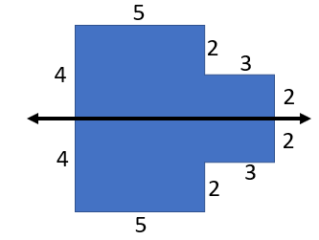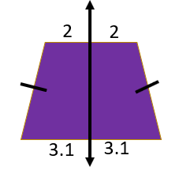

# Reflection

a transformation in which an image is formed by reflecting the preimage over a line called the line of reflection   
(all corresponding points in the image and preimage are equidistant from the line of reflection)

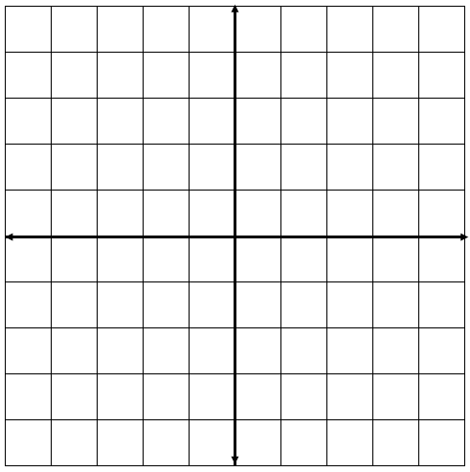

***y***

***x***

D

F

E

D′

E′

F′

|  |  |
| --- | --- |
| Preimage | Image |
| D(1,-2) | D′(-1,-2) |
| E(3,-2) | E′(-3,-2) |
| F(3,2) | F′(-3,2) |

Translation

The preimage of triangle DEF is reflected across the *y*-axis to create the image D’E’F’

a transformation in which an image is formed by moving every point on the preimage the same distance in the same direction

***y***



A

C

B

D

B′

A′

D′

C′

***x***

|  |  |
| --- | --- |
| Preimage | Image |
| A(1,2) | A′(-4,-1) |
| B(4,2) | B′(-1,-1) |
| C(4,4) | C′(1, 1) |
| D(1,4) | D′(-4, 1) |

The preimage of rectangle ABCD is translated 5 units to the left and 3 units down to create the image A’B’C’D’

# Probability

if all outcomes of an event are equally likely, the probability of an event occurring is equal to the ratio (between 0 and 1) of desired outcomes to the total number of possible outcomes in the sample space

A B A B

A C C

P(A) = $\frac{\text{3}}{\text{7}}$

likely

unlikely

$$\frac{\text{3}}{\text{7}}$$

0 $\frac{\text{1}}{\text{2}}$ 1

certain

impossible

# Theoretical Probability

the expected probability of an event

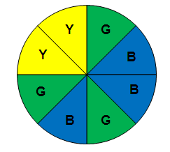

Theoretical probability of spinning the spinner and landing on blue (B) =



# Experimental Probability

the probability of an event determined by carrying out a simulation or experiment



Jane spun the spinner 20 times. Her result is shown in the table.

| **Color** | **Number** |
| --- | --- |
| Yellow (Y) | 4 |
| Green (G) | 6 |
| Blue (B) | 10 |

Experimental probability of spinning the spinner and landing on blue =



# Histogram

a graph that provides a visual interpretation of numerical data by indicating the number of data points that lie within a range of values, called a class or a bin (the frequency of the data that falls in each class or bin is depicted by the use of a bar)

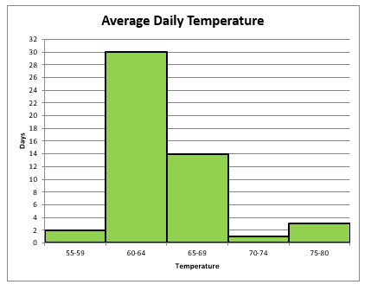

frequency

intervals

# Comparing Graphs



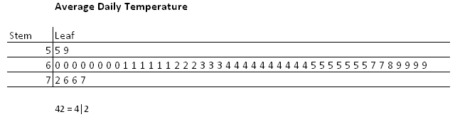

The histogram provides a visual interpretation of numerical data.

The stem and leaf chart shows all the data in a set.

The stem and leaf chart can be used to find the mean, median or mode.

# Comparing Graphs

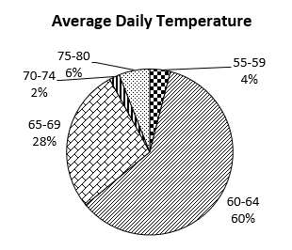

Neither chart displays the entire data set.

The mode and the median can not be found without knowing all the data in a set.

The histogram displays trends. The circle graph shows parts to the whole.

# Comparing Graphs

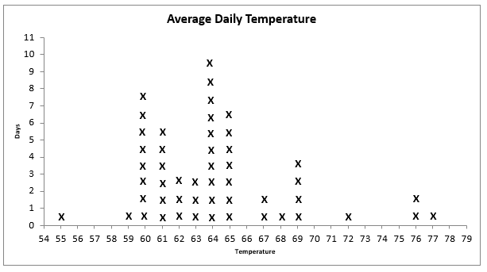

The histogram provides a visual interpretation of numerical data.

The line plot displays all data in the set.

The line plot can be used to find the mean, median, or mode.

# Slope

a rate of change in a proportional relationship between two quantities

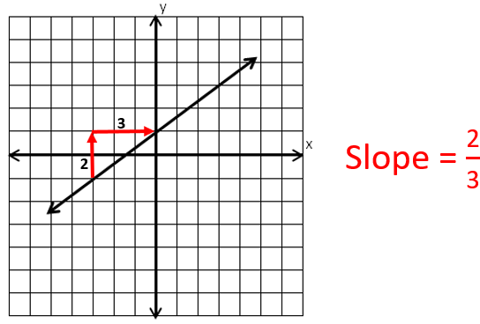

$$Slope=\frac{change in y}{change in x}=\frac{vertical change}{horizontal change}$$

# Unit Rate

number of units of the first quantity of a ratio compared to 1 unit of the second quantity   
(also called the constant of proportionality)

A student walks 2 miles per hour

Unit rate =

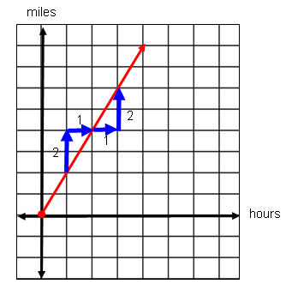

# Proportional Relationship

$$y =mx$$

(*m* is the slope)

Example: *y* = $\frac{\text{4}}{\text{3}}$*x*

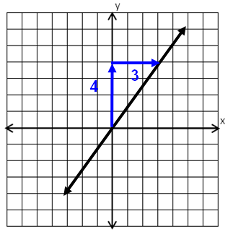

*m* = $\frac{\text{4}}{\text{3}}$

# Proportional Relationship

Points representing a proportional relationship: {(0, 0), (6, 1.5), (10, 2.5),

(20, 5), and (24, 6)}.

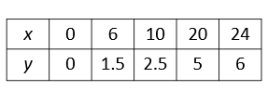

The slope, rate of change, or ratio of *y* to *x* is

$\frac{y}{x }$ = $\frac{1.5}{6}$ = $\frac{2.5}{10}$ = $\frac{5}{20 }$ = $\frac{6}{24 }$ = $\frac{1}{4 }$ = 0.25

The equation representing the proportional relationship of *y* to *x* is

$y =mx$ or *y* = $\frac{1}{4 }$*x* or *y* = 0.25*x.*

# Additive Relationship

a relationship between two quantities in which one quantity is a result of adding a value to the other quantity

$$y =x+b$$

(*b* is the *y*-intercept)

*b* = -2

Example: *y* = *x* + (-2)

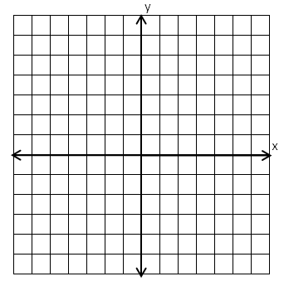

|  |  |
| --- | --- |
| ***x*** | ***y*** |
| -3 | -5 |
| -2 | -4 |
| -1 | -3 |
| **0** | **-2** |
| 1 | -1 |
| 2 | 0 |
| 3 | 1 |

(**0,-2**)

# Additive Relationship

Tomas is three years younger than his sister, Maria. The table represents their ages at various times.

| Maria (*x*) | 4 | 5 | 6 | 11  **–3** |
| --- | --- | --- | --- | --- |
| Tomas (*y*) | 1 | 2 | 3 | 8 |

The difference in their ages is always -3.

The equation representing the relationship between their ages is

*y* = *x* + (-3) or *y* = *x* - 3

# Graphing Linear Relationships

Graph the line representing the additive relationship with slope of 2 and passing through the point (0,4).

Graph the line representing the proportional relationship with slope of 2 and passing through the point (2,4).

**2**

**1**

**(0,4)**



*x*

*y*

**1 2 3 4 5 6 7**

**1 2 3 4 5 6 7 8 9 10**



*x*

*y*

**1 2 3 4 5 6 7**

**1 2 3 4 5 6 7 8 9 10**

**(2,4)**

**2**

**1**

Slope = 2 = $\frac{vertical change}{horizontal change}=\frac{2}{1}$

# Connecting Representations

Proportional Relationship

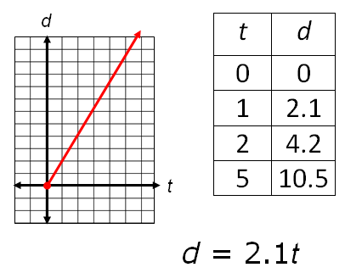The total distance Sam walks depends on how long he walks. If he walks at a rate of 2.1 mph, show multiple representations of the relationship.

The scale on the x-axis needs to be moved over a little to the right.

**1 2 3 4 5 6 7 8 9 10**

**1 2 3 4 5 6 7**

# Connecting Representations

Additive Relationship

Janice started with $5 in her piggybank. If she adds $1 each week, show the total amount in her piggybank any week using multiple representations.

|  |  |
| --- | --- |
| *w* | *a* |
| 0 | 5 |
| 1 | 6 |
| 2 | 7 |
| 5 | 10 |



**1 2 3 4 5 6 7 8 9 10**

**1 2 3 4 5 6 7**

*a* = *w* + 5

*w*

*a*

# Order of Operations

( )

[ ]

Grouping Symbols

Exponents

Multiplication

Left to right

or Division

Addition

Left to right

Subtraction

Verbal and Algebraic Expressions and Equations

| Verbal | Algebraic |
| --- | --- |
| A number multiplied by 5 | 5*n* |
| The sum of negative two and a number | -2 + *n* |
| The sum of five times a number and two is five | *5y* + 2 = 5 |
| Negative three is one-fifth of a number increased by negative three fifths | -3 = $\frac{1}{5}$*x* + ($-\frac{3}{5}$) |

# Equation

a mathematical sentence stating that two expressions are equal

6 + 2*x* = 10

2.76 + 3 = n + 2.76

3*x* + (-5.1) = $3\frac{3}{4}$

# Inequality

Example 1

$-3r≤7.5$

$$\frac{-3r}{-3}≥\frac{7.5}{-3}$$

$$r≥-2.5$$

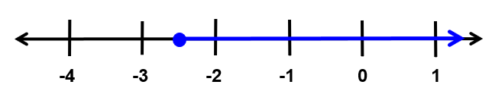

Example 2

$$-3(n-4)<0$$

$$-3n+12<0$$

$$-3n+12-12<0-12$$

$$-3n<-12$$

$$\frac{-3n}{-3}>\frac{-12}{-3}$$

$$n>4$$

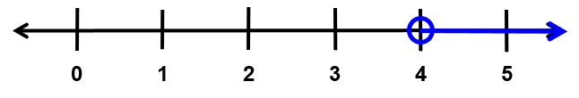

Example 3

$$\frac{x-7}{-3}≥4$$

$$-3∙\frac{x-7}{-3}≤-3∙4$$

$$x-7≤-12$$

$$x-7+7≤-12+7$$

$$x≤-5$$

