**Grade 6 Mathematics**

**Vocabulary Word Wall Cards**

Mathematics vocabulary word wall cards provide a display of mathematics content words and associated visual cues to assist in vocabulary development. The cards should be used as an instructional tool for teachers and then as a reference for all students. **The cards are designed for print use only.**

## Table of Contents

### Number and Number Sense

Ratio

Equivalent Relationships

Equivalent Relationships

Absolute Value

Perfect Squares

Exponential Form

Powers of Ten

### Computation and Estimation

Fraction Multiplication

Fraction Division

Fraction Division

Multiplication and Division of Decimals

Comparing Integers

Integer Operations: Addition and Subtraction

Integer Operations: Model Addition and Subtraction

Integer Operations: Multiplication and Division

Order of Operations

### Measurement and Geometry

Pi

Circumference

Area of a Circle

Perimeter

Area

Coordinate Plane

Coordinate Plane

Congruent Figures

Regular Polygons

Line of Symmetry

### Probability and Statistics

Mean

Median

Mode

Range

Circle Graph

Comparing Graphs: Circle and Bar graph

Comparing Graphs: Circle and Pictograph

Comparing Graphs: Circle and Line Plot

### Patterns, Functions and Algebra

Ratio Table

Proportional Relationship

Unit Rate: Definition

Unit Rate: Examples

Connecting Representations

Equation

Expression

Variable

Coefficient

Term

Verbal and Algebraic Expressions and Equations

Inequality

Ratio

a comparison of any two quantities

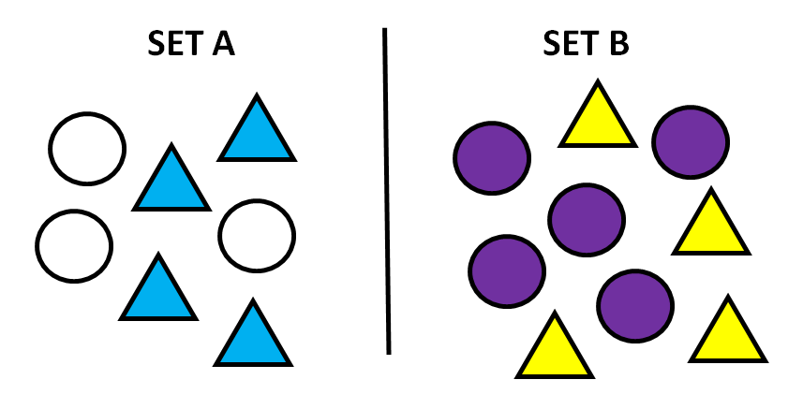

|  |  |
| --- | --- |
| to | **4 to 3 or 4:3** |
| to all of set A | **4 to 7 or 4:7 or $\frac{\text{4}}{\text{7}}$** |
| (set A) to (set B) | **3 to 5 or 3:5** |
| set B to set A | **9 to 7 or 9:7** |

Equivalent Relationships



 



Equivalent Relationships

Fraction: 

Decimal: 0.4

Percent: 40%

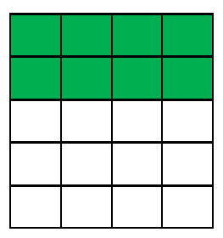

Absolute Value

distance a number is from zero

|5| = 5 |-5| = 5

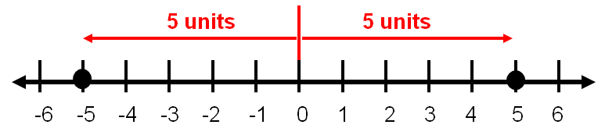

Perfect Squares

02 = 00 = **0**

12 = 11 = **1**

22 = 22 = **4**

32 = 33 = **9**

42 = 44 = **16**

52 = 55 = **25**

62 = 66 = **36**

72 = 77 = **49**

82 = 88 = **64**

92 = 99 = **81**

102 = 1010 = **100**

Exponential Form

exponent

23 = 2 2 2

base

n4 = n n n n

factors

Powers of Ten

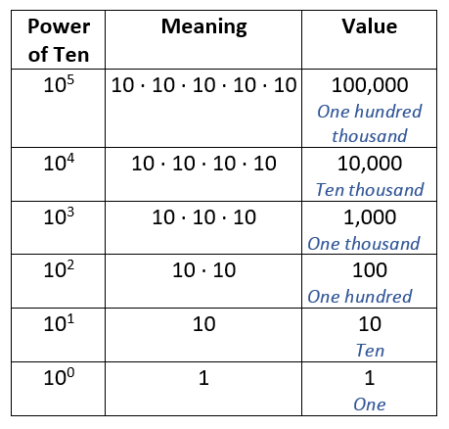

Fraction Multiplication

How much is $\frac{\text{3}}{\text{8}}$ of $\frac{\text{2}}{\text{3}}$?

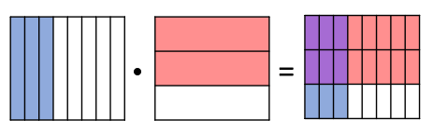

$$\frac{\text{6}}{\text{24}}$$

$$\frac{\text{2}}{\text{3}}$$

$$\frac{\text{3}}{\text{8}}$$

**·**

**=**

$\frac{\text{3}}{\text{8}}\text{ · }\frac{\text{2}}{\text{3}}\text{ = }\frac{\text{6}}{\text{24}}\text{ = }\frac{\text{1}}{\text{4}}$

Fraction Division

$$\frac{\text{3}}{\text{4}}\text{÷}\frac{\text{1}}{\text{2}}$$

How many halves are in three-fourths?

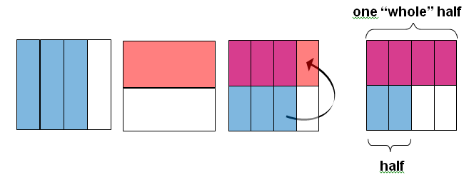

There are 1 $\frac{\text{1}}{\text{2}}$ halves in three-fourths.

$\frac{\text{3}}{\text{4}}\text{÷}\frac{\text{1}}{\text{2}}\text{=1}\frac{\text{1}}{\text{2}}$ Fraction Division

$$\frac{\text{3}}{\text{4}}\text{÷}\frac{\text{1}}{\text{2}}$$

How many halves are in three-fourths?

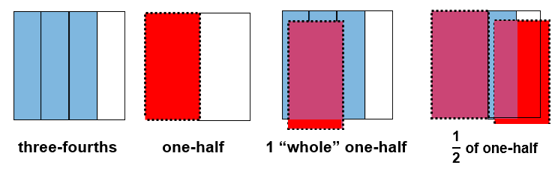

There are 1 $\frac{\text{1}}{\text{2}}$ halves in three-fourths.

$$\frac{\text{3}}{\text{4}}\text{÷}\frac{\text{1}}{\text{2}}\text{=1}\frac{\text{1}}{\text{2}}$$

Multiplication and Division of Decimals

|  |  |  |
| --- | --- | --- |
| Multiplier | Multiply | Value |
| 1 | $$27∙1$$ | 27 |
| 0.1 | $$27∙0.1$$ | 2.7 |
| 0.01 | $$27∙0.01$$ | 0.27 |
| 0.001 | $$27∙0.001$$ | 0.027 |

|  |  |  |
| --- | --- | --- |
| Divisor | Divide | Value |
| 1 | $$27÷1$$ | 27 |
| 0.1 | $$27÷0.1$$ | 270 |
| 0.01 | $$27÷0.01$$ | 2,700 |
| 0.001 | $$27÷0.001$$ | 27,000 |

Comparing Integers

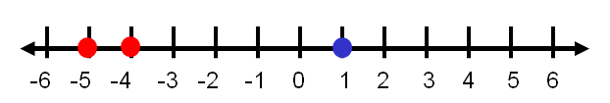

-5 < 1 or 1 > -5

-5 < -4 or -4 > -5

Integer Operations

Addition

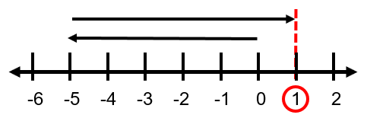-5 + 6 = 1

Subtraction

1 – 6 = -5

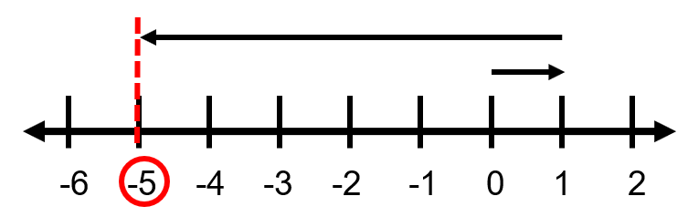

Integer Operations



Key:

Addition

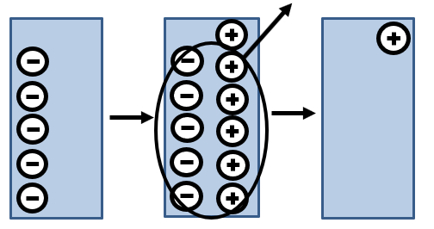-5 + 6 = 1

Subtraction

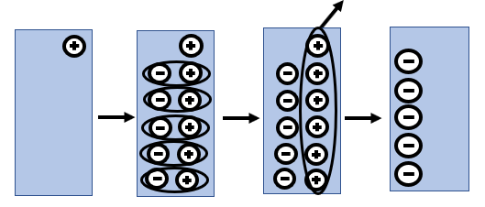1 – 6 = -5

Integer Operations

Multiplication

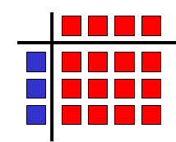3 $∙$ (-4) = -12

How many tiles are in 3 groups of -4 tiles?

Division

-12 $÷$-4 = 3

How many groups of -4 tiles are in -12 tiles?

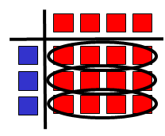

Order of Operations

( )

Grouping Symbols

Exponents

Multiplication

Left to right

or Division

Addition

Left to right

or Subtraction

Pi

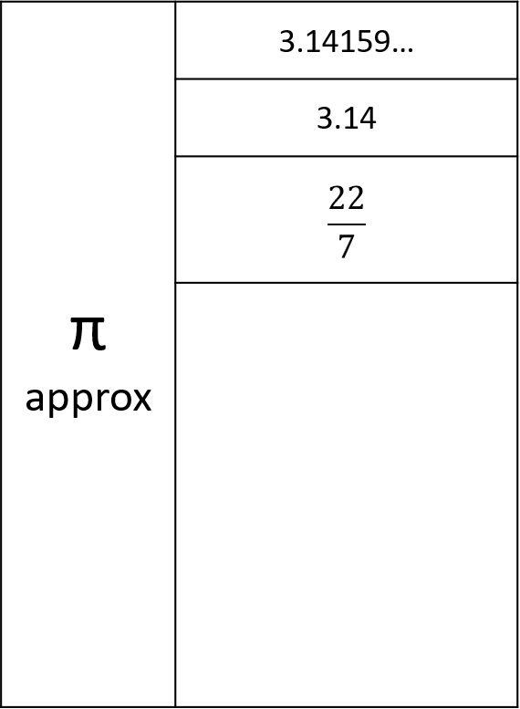

circumference

diameter

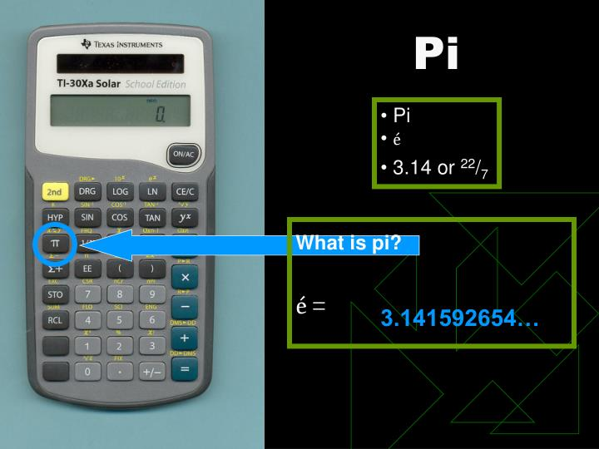

π = $\frac{\text{circumference}}{\text{diameter}}$

Circumference

radius

diameter

C = 2πr

C = πd

C = perimeter of a circle

Area of a Circle

*A* = π*r* 2

Perimeter

the measure of the distance around a figure

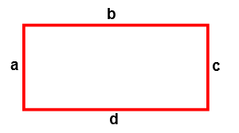

P = a + b + c + d

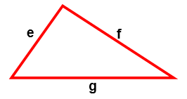

P = e + f + g

Area

the number of square units needed to cover a surface or figure

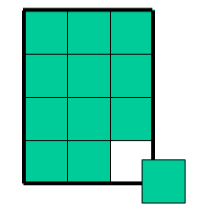

Area = 12 Square Units

Coordinate Plane

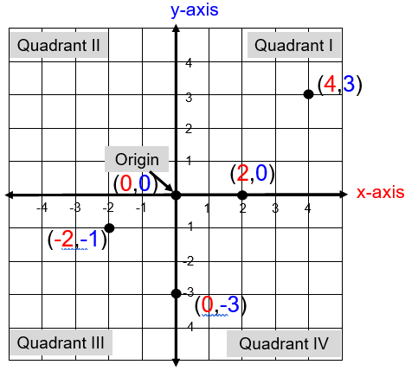

ordered pair (*x*,y)

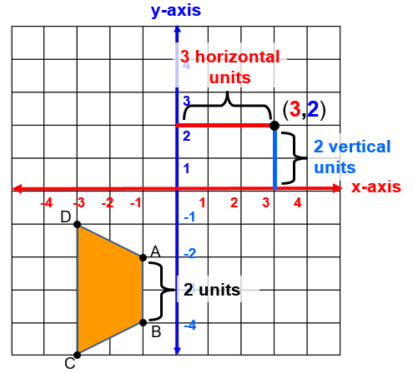Coordinate Plane

What is the length of side AB in the figure ABCD?

A(-1,-2) and B(-1,-4)

The length of AB is |-2 – (-4)| or |-4 – (-2)| or 2 units.

Congruent Figures

have exactly the

same shape and size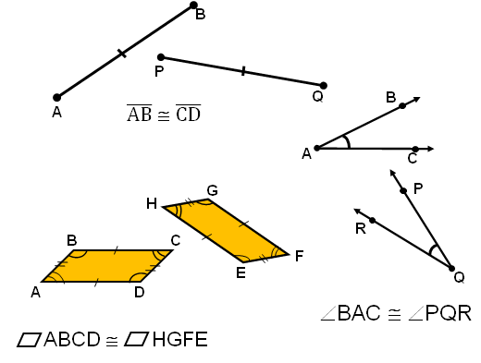

Regular Polygons

have congruent sides and congruent interior angles

Line of Symmetry

divides a figure into two congruent parts, each of which are mirror images of the other

SQUARE

SQUARE

Mean

a measure of central tendency

(the numerical average of a data set)

2, 3, 4, 7

Balance Point

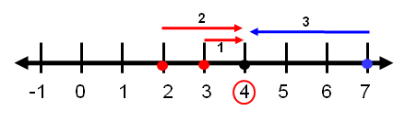

Numerical Average

$\frac{2+3+4+7}{4}=\frac{16}{4}=4$ Median

a measure of central tendency

(the middle value of a data set ranked in order)

6, 7, 8, 9, 9

8 = median

5, 6, 8, 9, 11, 12

8.5 = median

Mode

|  |  |
| --- | --- |
| **Data Sets** | **Mode** |
| 2, 3, 3, 3, 5, 5, 9, 10 | 3 |
| 5.2, 5.4, 5.5, 5.6, 5.8, 5.9, 6.0 | none |
| 1, 1, 2, 5, 6, 7, 7, 9, 11, 12 | 1, 7 |

a measure of central tendency (the data value that occurs most frequently)

bimodal

Range

difference between the greatest and least values in a data set

Data set

2 $\frac{\text{1}}{\text{2}}$, 3, 3 $\frac{\text{3}}{\text{4}}$, 3 $\frac{\text{7}}{\text{8}}$, 5, 5 $\frac{\text{1}}{\text{2}}$, 9 $\frac{\text{1}}{\text{6}}$, 10 $\frac{\text{4}}{\text{5}}$, 15 $\frac{\text{1}}{\text{2}}$, 20

20 – 2 $\frac{\text{1}}{\text{2}}$ = 17 $\frac{\text{1}}{\text{2}}$

Range = 17 $\frac{\text{1}}{\text{2}}$

Circle Graph

**Types of Animals on**

**Mr. Segal’s Farm**

Comparing Graphs

Pigs

Chickens

Cows

Sheep

Goats

Circle Graph

**Types of Animals on**

**Mr. Segal’s Farm**

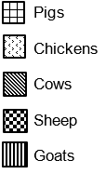

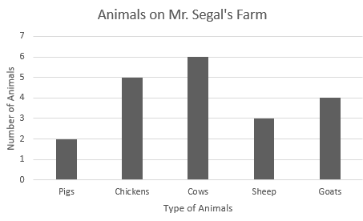

Which graph(s) shows the type of animal that is most common on Mr. Segal’s farm?

Which graph(s) shows how many pigs are on Mr. Segal’s farm?

Which graph(s) help(s) determine the total number of animals on Mr. Segal’s farm?

Which graph(s) help(s) determine for which type of animals there are 3 or more?

Which graph(s) help(s) determine the percent of animals with four legs?

Bar Graph

Comparing Graphs

**Types of Animals on**

**Mr. Segal’s Farm**

Circle Graph



Pictograph

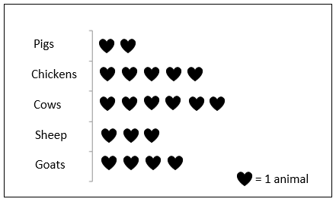

Which graph(s) shows the type of animal that is most common on Mr. Segal’s farm?

Which graph(s) shows how many pigs are on Mr. Segal’s farm?

Which graph(s) help(s) determine the total number of animals on Mr. Segal’s farm?

Which graph(s) help(s) determine for which type of animals there are 3 or more?

Which graph(s) help(s) determine the percent of animals with four legs?

Comparing Graphs

**Types of Animals on**

**Mr. Segal’s Farm**

Circle Graph

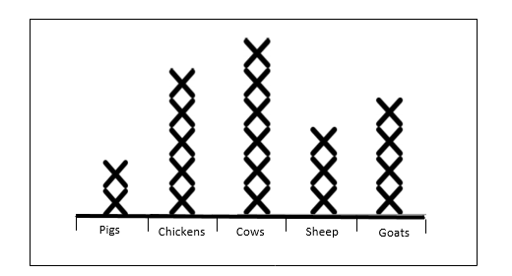

Line Plot

Which graph(s) shows the type of animal that is most common on Mr. Segal’s farm?

Which graph(s) shows how many pigs are on Mr. Segal’s farm?

Which graph(s) help(s) determine the total number of animals on Mr. Segal’s farm?

Which graph(s) help(s) determine for which type of animals there are 3 or more?

Which graph(s) help(s) determine the percent of animals with four legs?

Ratio Table

## a table of values representing a proportional relationship that includes pairs of equivalent ratios

## The ratio of *y* to *x* in a proportional relationship is 8:4, create a ratio table.

|  |  |
| --- | --- |
| *x* | *y* |
| 1 | 2 |
| 2 | 4 |
| 3 | 6 |
| 4 | 8 |
| 11 | 22 |

$\frac{y}{x}=\frac{2}{1}=\frac{6}{3}=\frac{8}{4}=\frac{22}{11}$

Proportional Relationship

Ratio Table Example

Terry’s neighbor pays him $17 for every 2 hours he works. Terry works for 8 hours on Saturday.

A ratio table represents the proportional relationship:

| Hours | 1 | 2 $$∙8.5$$ | 4 $$∙8.5$$ | 8 |
| --- | --- | --- | --- | --- |
| Pay in $ | ? | 17 | 34 | ? |

## How much does Terry earn per hour?

## $\frac{17}{2}=\frac{?}{1}$ Terry earns $8.50 per hour

## How much will Terry earn in 8 hours?

$ He will earn $68.00 in 8 hours.

Unit Rate

number of units of the first quantity of a ratio compared to 1 unit of the second quantity

Example: A store advertises $25 for 5 DVDs. Find the cost for 1 DVD or unit rate.

$$\frac{25}{5}=\frac{?}{1}$$

The unit rate is $5.00 for 1 DVD

Unit Rate

Examples

$2 per gallon = $\frac{\text{\$2}}{\text{1 gallon}}$

70 miles per hour = $\frac{\text{70 miles}}{\text{1 hour}}$

Connecting Representations

The ratio of gallons of yellow paint to gallons of blue paint is 3:1.

Find three equivalent ratios.

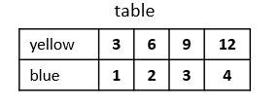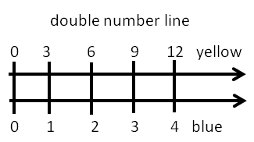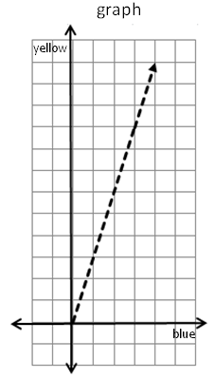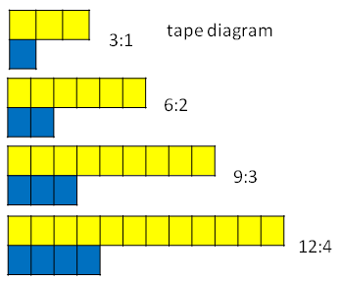

Equation

a mathematical sentence stating that two expressions are equal

2*x* = 10

-38 = *y* – (-21)

$\frac{1}{3}$*x* = -16

Expression

a representation of quantity

16

*x*

2 + 34

3(2 + 3.9) –

Variable

a symbol used to represent an unknown quantity

*y*

3 + *x* = 2.08

*A* = π *r* 2

Coefficient

the numerical factor in a term

(-4) = 2*x*

-7*y*

$\frac{\text{1}}{\text{3}}$*a* = -5

Term

a number, variable, product, or quotient in an expression of sums and/or differences

3*y*2 + 2*y* – 8

3 terms

-5*x* + (-2)

2 terms

$\frac{\text{2}}{\text{3}}$*a*

1 term

Verbal and Algebraic Expressions and Equations

| Verbal | Algebraic |
| --- | --- |
| A number multiplied by 5 | 5*n* |
| The sum of negative two and a number | -2 + *n* |
| The sum of a number and two is five | *y* + 2 = 5 |
| Negative three is one-fifth of a number | -3 = $\frac{1}{5}$*x* |

Inequality

*y* < 4 or 4 > *y*

**0 1 2 3 4 5**

*x* + (-5) $≥$-7

*x $≥$* -2

**-4 -3 -2 -1 0 1**

-3 < *a* – 7

4 < *a* or  *a* > 4

**0 1 2 3 4 5**