Grade 5 Mathematics
Vocabulary Word Wall Cards

Mathematics vocabulary word wall cards provide a display of mathematics content words and associated visual cues to assist in vocabulary development. The cards should be used as an instructional tool for teachers and then as a reference for all students. The cards are designed for print use only.

Table of Contents

Number and Number Sense
Decimal Place Value
Round
Mixed Number
Equivalent
Prime Number
Composite Number
Even and Odd Numbers

Computation and Estimation
Fraction: Addition
Fraction: Subtraction
Least Common Multiple
Greatest Common Factor
Unit Fraction Multiplication
Addition
Subtraction
Multiply: Product
Divide: Quotient

Measurement and Geometry
Area: Square units
Perimeter: Units
Volume: Height, Width, Length
Equivalent Measurements: Kilometer, Meter, Centimeter
Equivalent Measurements: Kilogram, Grams
Equivalent Measurements: Liter, Milliliters
Millimeter: Centimeter
Chord
Diameter
Radius
Circumference
Acute Angle
Obtuse Angle
Right Angle
Straight Angle
Acute Triangle
Right Triangle
Obtuse Triangle
Equilateral Triangle
Scalene Triangle
Isosceles Triangle
Rectangle: Right Angle
Square: Right Angle
Parallelogram
Rhombus
Trapezoid
Translation
Reflection
Rotation
Subdivide
Combine

Probability and Statistics
Sample Space
Line Graph
Fundamental Counting Principle
Line Plot
Stem-and-Leaf Plot
Mean
Mean: Fair Share
Median
Mode
Range: Measure of Spread

Patterns, Functions and Algebra
Patterns
Expression
Variable Expression
Equation
Equality
Inequality

Decimal

Place Value Position

Ones |  | Tenths | Hundredths | Thousandths
3 | . | 7 | 2 | 1

decimal point

Round

1.24
1.2
1.3

Round 1.24 to the
nearest tenth.

Mixed Number

fraction
whole

$$\frac{16}{10}=1\frac{6}{10}=1.6$$

Equivalent

$\frac{75}{100}$ $\frac{3}{4}$
=
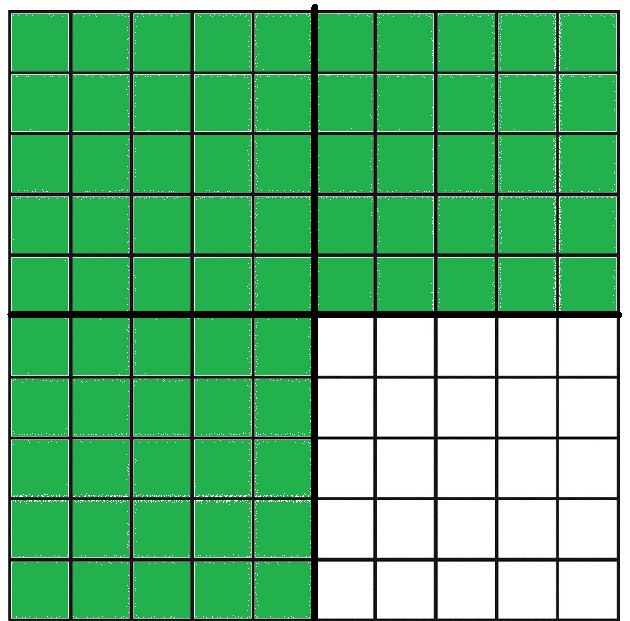
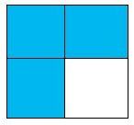
=

0.75 $\frac{3}{4}$
=

Prime Number

has exactly two different factors, 1 and itself

Prime numbers to 100
2 | 3 | 5 | 7 | 11
13 | 17 | 19 | 23 | 29
31 | 37 | 41 | 43 | 47
53 | 59 | 61 | 67 | 71
73 | 79 | 83 | 89 | 97

Composite Number

has factors other than one and itself
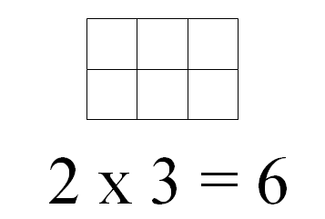
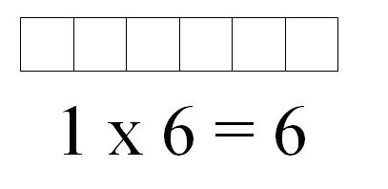

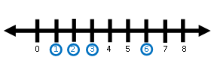

factors of 6: 1, 2, 3, 6

Even and Odd Numbers

4 – even

3 - odd

Fraction:
Addition

$\frac{1}{2}$

⁺ $\frac{3}{8}$

$\frac{7}{8}$
Fraction:
Subtraction

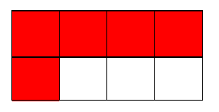
$$\frac{5}{8}$$
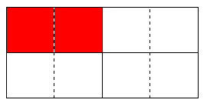
$\frac{1}{4}$

$\frac{3}{8}$

Least Common Multiple

Multiples of 12 | Multiples of 18
1 x 12 = 12 | 1 x 18 = 18
2 x 12 = 24 | 2 x 18 = 36
3 x 12 = 36 | 3 x 18 = 54
4 x 12 = 48

LCM is 36.

Greatest Common Factor

Factors of 12 | Factors of 18
1 x 12 = 12 | 1 x 18 = 18
2 x 6 = 12 | 2 x 9 = 18
3 x 4 = 12 | 3 x 6 = 18
1, 2, 3, 4, 6, 12 | 1, 2, 3, 6, 9, 18

GCF is 6.
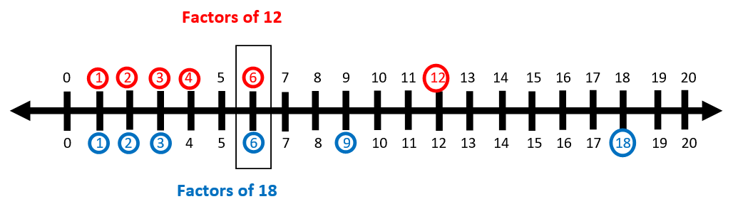

Unit Fraction Multiplication
How much is $\frac{\text{1}}{\text{2}}$ x 6?

$$\frac{\text{1}}{\text{2}}\text{ × 6 = 3}$$
How much is 6 x $\frac{\text{1}}{\text{2}}$?
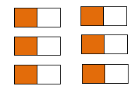

$6 × \frac{1}{2}\text{ = }\frac{6}{2}=3$
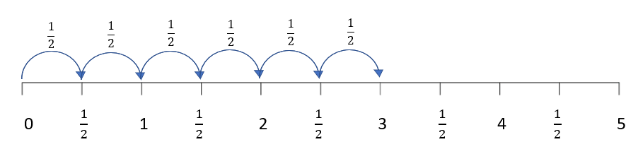

Addition

4.65 + 1.24 = 5.89

sum
+
plus

Subtraction

4.65 – 1.24 = 3.41

difference

minus

Multiply:
Product

32 × 48 = 1,536

product
×

Divide:
Quotient

14 $\frac{280}{14}$ $=20$

280 ÷ 14 = 20

Area:
Square Units

the number of square units needed to cover a surface or plane figure

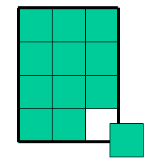

l x w
4 x 3 = 12
Area = 12 square units

Perimeter:
Units

the measure of the path or distance around any plane figure in units
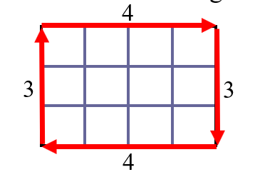

3 + 4 + 3 + 4
Perimeter = 14 units

Volume:
Height, Width, Length

the measure of capacity of a 3-D figure, measured in cubic units
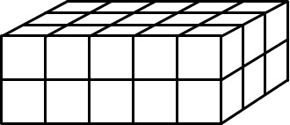
height
width
length

l x w x h
5 x 3 x 2
Volume = 30 cubic units

Equivalent Measurements:
Kilometer, Meter, and Centimeter

1 kilometer (km) = 1,000 meters (m)
1 meter (m) = 100 centimeters (cm)
1 centimeter (cm) = 10 millimeters (mm)

Equivalent Measurements:
Kilogram and Grams

1 kilogram (kg) = 1,000 grams (g)

Equivalent Measurements:
Liter and Milliliters

1 liter (l) = 1,000 milliliters (ml)

Millimeters:
Centimeters

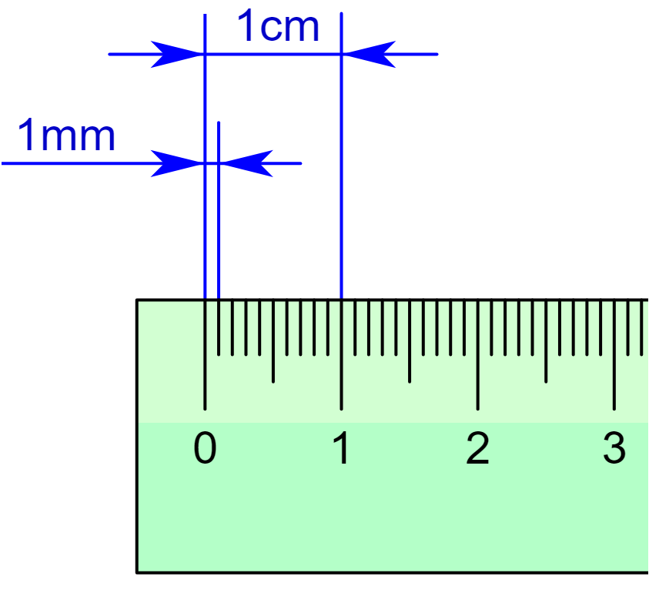
millimeter (mm)
centimeter (cm)

10 millimeters (mm) = 1 centimeter (cm)

Chord
a line segment connecting any two points on a circle

Diameter
a chord that passes through the center of a circle

Radius
a line segment joining the center of a circle to any point on the circle

Circumference
the distance around or “perimeter” of a circle

Acute Angle

less than 90º

Obtuse Angle

greater than 90º, but less than 180º

Right Angle

exactly 90º

Straight Angle

.

exactly 180º

Acute Triangle
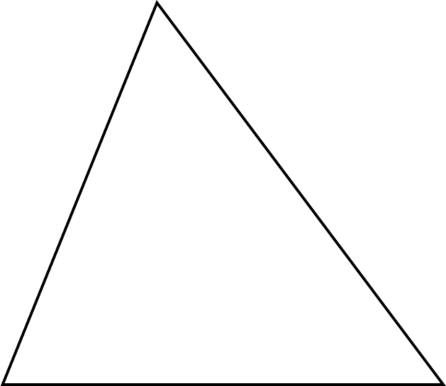

all angles less than 90º

Right Triangle

one 90º angle

Obtuse Triangle
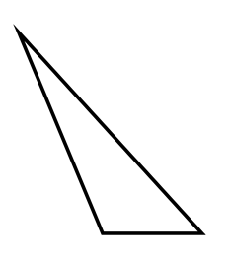

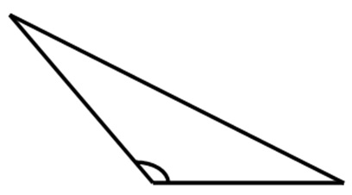

one angle greater than 90º

Equilateral

Triangle

3
3

3

Scalene

Triangle

2
6
5

Isosceles

Triangle

5
5

Rectangle:
Right Angle
7
3

- 4 right angles
- opposite sides are parallel and congruent

Square:
Right Angle
3

3
3

3

- 4 right angles
- 4 congruent sides
- 2 pairs of parallel sides

Parallelogram
7

4
4

7

- opposite sides are parallel and congruent

Rhombus
3

3
3

3

- 4 congruent sides
- 2 pairs of parallel sides
- opposite angles are congruent

Trapezoid

- exactly one pair of parallel sides

Translation

an image formed by moving every point on the preimage the same distance in the same direction
image
pre-image

Reflection

an image formed by reflecting the preimage over a line called the line of reflection
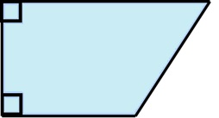
image
pre-image

Rotation

an image formed by rotating the preimage about a point called the center of rotation
pre-image
image

Subdivide

trapezoid
parallelogram
triangle

Combine

Sample Space

Pizza Choices

Tree Diagram

Line Graph
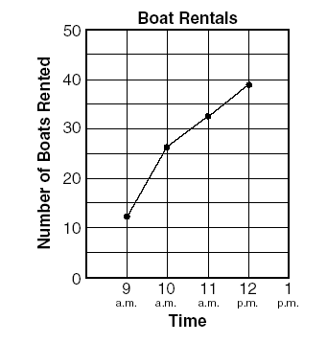
Temperature Over Time
Temperature (°F)

Fundamental Counting Principle

If Joe has 4 different color shirts (green, blue, white, and yellow) and 2 different color shorts (tan and black), then he has 4 x 2 or 8 different outfits to wear.
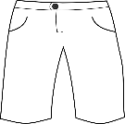
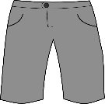
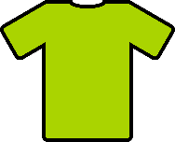
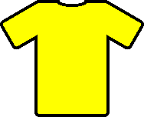

Line Plot

Number of Pets

x x
x x x

1 2 3 4 5

x represents 1 student

Stem-and-Leaf Plot
Stem | Leaf
1 | 7, 8
2 | 2, 4, 5, 6, 9
3 | 3, 7, 9, 9

4
5 | 0

Key: 1| 8 means 18

Mean

fair share or
average

6, 9, 8, 8, 9

6 + 9 + 8 + 8 + 9 = 40
40 ÷ 5 = 8

mean = 8
Mean:
Fair Share

4, 7, 6, 6, 7

The mean is 6.
Median
the middle value of a data set in ranked order

6, 7, 8, 9, 9

8 = median

5, 6, 8, 9, 11, 12

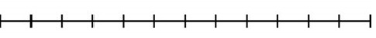
8
9
7
10
11

8.5 = median
Mode
data that occurs most frequently

6, 7, 8, 9, 9
9 = mode

6, 8, 10, 11, 15, 20
no mode

2, 2, 2, 3, 7, 9, 9, 9
2 and 9 = mode

Range

the spread of a set of data

6, 7, 8, 9, 9

6 least value in the data set
9 greatest value in the data set

range = 9 – 6 = 3

Patterns

8, 10, 13, 17, __

Rule: ______ |  |  | Rule: ______ |  |  | Rule: ______
Input | Output |  | Input | Output |  | Input | Output
4 | 11 |  | 145 | 130 |  | 2 | 8
5 | 12 |  | 100 | 85 |  | 4 | 16
6 | 13 |  | 75 | 60 |  | ? | 20
10 | 17 |  | 50 | ? |  | 8 | 32

Expression
a representation of a quantity

12.8
14 × 351
45 ÷ 8

Variable Expression
an expression that contains numbers, operations, and variables

4 + s

variable

Equation

3 + 5 = 10 – 2

6 – x = 4

12 ÷ 4 = y

8n = 56

Equality
=
400 – 177 = 399 – 176
25 x 5 = 250 $÷$ 2
1.8 x 5 = 18 $÷$ 2

Inequality
≠

5 + 6 ≠ 11 – 5
9 – $\frac{8}{9}$ ≠ 2$\frac{2}{3}$ × 3
0.5 x 7 ≠ 3.5 + 5

