**Grade 4 Mathematics**

**Vocabulary Word Wall Cards**

Mathematics vocabulary word wall cards provide a display of mathematics content words and associated visual cues to assist in vocabulary development. The cards should be used as an instructional tool for teachers and then as a reference for all students. **The cards are designed for print use only.**

**Table of Contents**

**Number and Number Sense**

Place Value Position

Decimal Place Value Position

Round

Less Than

Greater Than

Equal To

Equivalent

Fraction: Models for one-half/one-fourth

Fraction: Models for two-thirds

Fraction: Model for five-sixths

Fraction: Models for three-eighths

Numerator/Denominator

Proper Fraction

Improper Fraction

Mixed Number

**Computation and Estimation**

Fraction: Addition

Fraction: Subtraction

Multiple

Least Common Multiple

Factor

Greatest Common Factor

Addition

Subtraction

Multiply: Product

Divide: Quotient

Multiplication: Array Model

Multiplication: Number Line Model

Multiplication: Set Model

Division: Array Model

Division: Number Line Model

**Measurement and Geometry**

Area: Square Units

Perimeter: Units

Balance Scale: Weight/ Mass

Scale: Weight/ Mass

Ounce

Pound: Ounces

Gram

Kilogram: Grams

Ruler: Centimeter and Inch

Millimeter: Centimeter

Inches, Feet, and Yards

Mile: Yards

Cup: Ounces

Pint: Cups and Ounces

Quart: Pints, Cups, and Ounces

Gallon: Ounces

Liter

Elapsed Time

Point

Line

Ray: Endpoint

Line Segment: Endpoint

Angle

Vertex

Intersecting Lines

Parallel Lines

Perpendicular Lines

Symbolic Notation

Plane Figures

Solid Figures

Polygons: Triangle, Quadrilateral, and Pentagon

Polygons: Hexagon, Heptagon, and Octagon

Polygons: Nonagons and Decagons

Quadrilaterals

Geometric Markings

Parallelogram

Rectangle: Right Angle

Square: Right Angle

Rhombus

Trapezoid

Triangle: Side and Vertex

Sphere

Cube

Rectangular Prism: Vertices

Square Pyramid

Cylinder

Cone

**Probability and Statistics**

Probability Number Line

Certain

Likely

Unlikely

Equally Likely

Impossible

Bar Graph

Line Graph

**Patterns, Functions, and Algebra**

Pattern: Growing Patterns and In/Out Table

Equality

Inequality

Expression

# Place Value Position

|  |  |  |  |  |  |  |  |  |  |  |
| --- | --- | --- | --- | --- | --- | --- | --- | --- | --- | --- |
| Hundred Millions | Ten Millions | One Millions |  | Hundred Thousands | Ten Thousands | One Thousands |  | Hundreds | Tens | Ones |
| 7 | 9 | 1 | , | 2 | 3 | 5 | , | 4 | 8 | 6 |

# Decimal

# Place Value Position

|  |  |  |  |  |
| --- | --- | --- | --- | --- |
| Ones |  | Tenths | Hundredths | Thousandths |
| 3 | . | 7 | 2 | 1 |

decimal point

# Round

1.2

1.3

1.24

Round 1.24 to the

nearest tenth.

# Less than

**<**

0 1 2 3 4 5 6 7 8

2 **<** 7

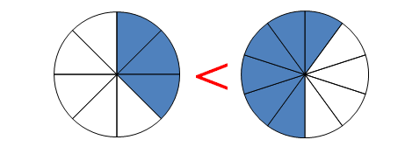

$\frac{3}{8}$**< $\frac{6}{10}$**

# Greater than

**>**

0 1 2 3 4 5 6 7 8

8 **>** 4

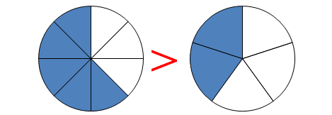

$\frac{5}{8}$**> $\frac{2}{5}$**

# Equal to

**=**

0 1 2 3 4 5 6 7 8

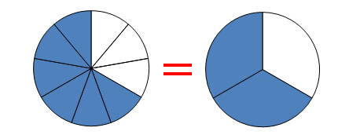4 **=** 4

$\frac{6}{9}$**= $\frac{2}{3}$**

# Equivalent

$\frac{75}{100}$ $\frac{3}{4}$

=

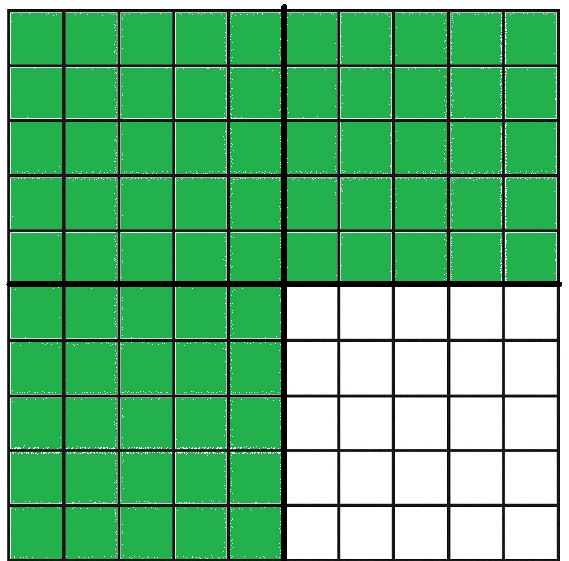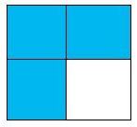

=

# 0.75 $\frac{3}{4}$

=

# Fraction:

Models for one-half and one-fourth

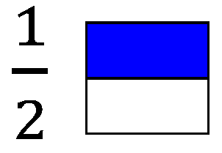

0

1

$$\frac{1}{2}$$

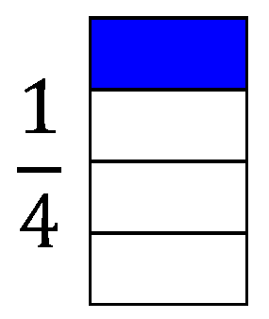

0

1

$$\frac{1}{2}$$

$\frac{1}{4}$

# Fraction:

Models for two-thirds

|  |
| --- |
|  |
|  |
|  |

$\frac{2}{3}$

$$\frac{1}{3}$$

0

1

$$\frac{2}{3}$$

$$\frac{1}{2}$$

Fraction:

Models for five-sixths

|  |
| --- |
|  |
|  |
|  |
|  |
|  |
|  |

$$\frac{5}{6}$$

$$\frac{1}{6}$$

0

1

$$\frac{5}{6}$$

$$\frac{1}{2}$$

$$\frac{2}{6}$$

$$\frac{4}{6}$$

# Fraction:

Models for three-eighths

|  |
| --- |
|  |
|  |
|  |
|  |
|  |
|  |
|  |
|  |

$\frac{3}{8}$

$$\frac{1}{2}$$

$\frac{3}{8}$

0

1

# Numerator/ Denominator

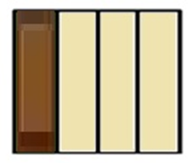 $\frac{2}{3}$

The candy bar was divided into 4 equal parts. Three friends ate 3 pieces of the candy bar, so $\frac{3}{4}$ of the candy bar has been eaten.

numerator

(number of equal parts being

considered)

denominator

(number of equal parts in the whole)

# Proper Fraction:

Fraction less than one

(numerator is less than the denominator)

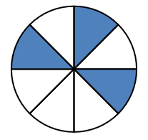

$\frac{3}{8}$

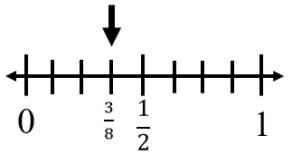

# Improper Fraction:

Fraction greater than or equal to one

(numerator is equal to or greater than the denominator)

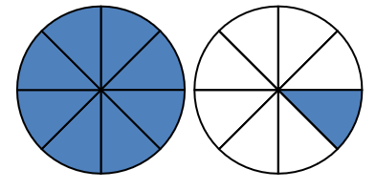

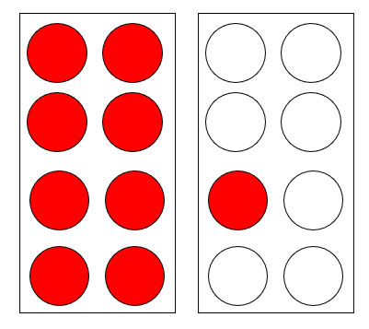 $\frac{9}{8}$

$\frac{10}{8}$

$\frac{3}{8}$

$\frac{1}{8}$

$\frac{2}{8}$

$\frac{5}{8}$

0

1

$$\frac{1}{2}$$

$\frac{9}{8}$

$\frac{6}{8}$

$\frac{7}{8}$

# Mixed Number

|  |  |  |  |  |
| --- | --- | --- | --- | --- |
|  |  |  |  |  |
|  |  |  |  |  |

|  |  |  |  |  |
| --- | --- | --- | --- | --- |
|  |  |  |  |  |
|  |  |  |  |  |

whole

fraction

### 1 $\frac{6}{10}$

Fraction:

Addition

|  |  |  |  |
| --- | --- | --- | --- |
|  |  |  |  |
|  |  |  |  |

|  |  |  |  |
| --- | --- | --- | --- |
|  |  |  |  |
|  |  |  |  |

+

Fraction:

Subtraction

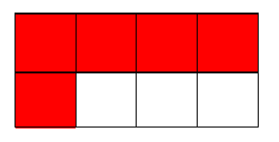

$$\frac{5}{8}$$

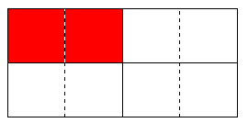

$\frac{1}{4}$

$\frac{3}{8}$

# Multiple

Multiples of 5

1 x 5 = 5

2 x 5 = 10

3 x 5 = 15

4 x 5 = 20

5, 10, 15, 20, …

# 

# Least Common Multiple

|  |  |
| --- | --- |
| Multiples  of 12 | Multiples  of 18 |
| 1 x 12 = 12 | 1 x 18 = 18 |
| 2 x 12 = 24 | 2 x 18 = 36 |
| 3 x 12 = 36 | 3 x 18 = 54 |
| 4 x 12 = 48 |  |

LCM is 36.

# Factor

Factors of 12

1, 2, 3, 4, 6, 12

1 x 12

2 x 6

### 3 x 4

# Greatest Common Factor

|  |  |
| --- | --- |
| Factors of 12 | Factors of 18 |
| 1 x 12 = 12 | 1 x 18 = 18 |
| 2 x 6 = 12 | 2 x 9 = 18 |
| 3 x 4 = 12 | 3 x 6 = 18 |
| 1, 2, 3, 4, 6, 12 | 1, 2, 3, 6, 9, 18 |

GCF is 6.

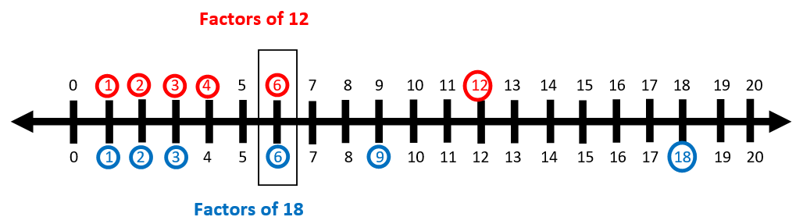

# Addition

4.65 + 1.74 = 6.39

sum

**+**

plus

# Subtraction

4.25 – 1.64 = 2.61

difference

minus

# Multiply:

Product

32 x 48 = 1,536

product

x

# Divide:

Quotient

 

280 ÷ 7 = 40

# Multiplication: Array Model

**(an arrangement of objects in rows and columns)**

5 x 3

3 x 5

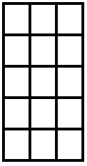

3 rows of 5

5 rows of 3

# Multiplication:

Number Line Model

4 x 3

15

14

13

12

11

10

9

8

7

5

4

3

1

2

0

6

4 x 3 = 12

# Multiplication:

# Set Model

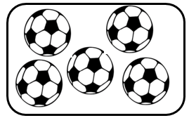

2 x 5

2 groups of 5 soccer balls in each group



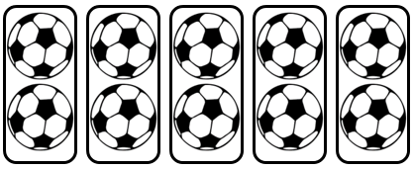

5 x 2

5 groups of 2 soccer balls in each group

# Division:

Array Model

15 candies – if each friend is given 3, there is enough to share with 5 friends

15 candies to be shared among 3 friends means each friend will receive 5 candies

# Division:

Number Line

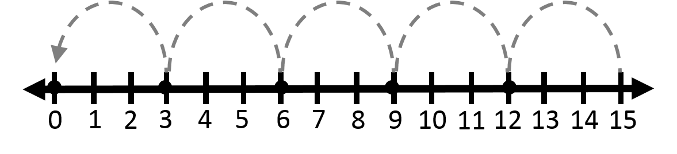

15 ÷ 3 = 5

The race is 15 miles long. If each team member will run 3 miles, 5 team members will be needed.

# Area:

Square Units

|  |  |  |  |
| --- | --- | --- | --- |
| 1 | 2 | 3 | 4 |
| 5 | 6 | 7 | 8 |
| 9 | 10 | 11 | 12 |

length x width

3 x 4 = 12

12 square units

# Perimeter:

Units

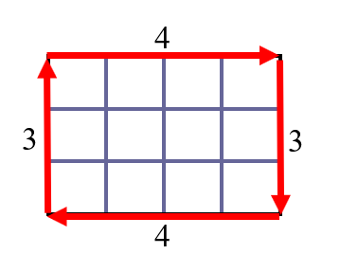

3 + 4 + 3 + 4

14 units

# Balance

Scale:

Weight/Mass



weight/mass

# Scale:

Weight/Mass

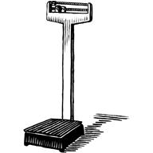

weight/mass

# Ounce (oz.):

Pounds



16 ounces = 1 pound

# Pound (lb):

Ounces

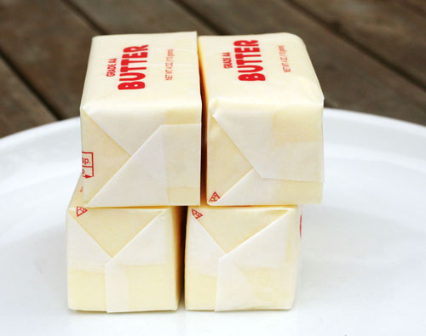

1 pound = 16 ounces

# Gram (g):

Kilograms



1,000 grams = 1 kilogram

# Kilogram (kg):

Grams



1 kilogram = 1,000 grams

# Ruler:

Centimeter and Inch

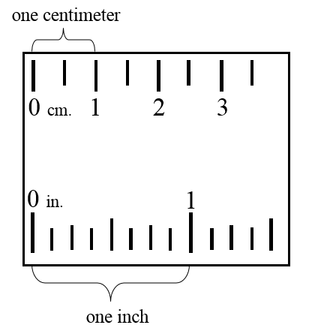

1 inch

# Millimeter (mm):

Centimeter

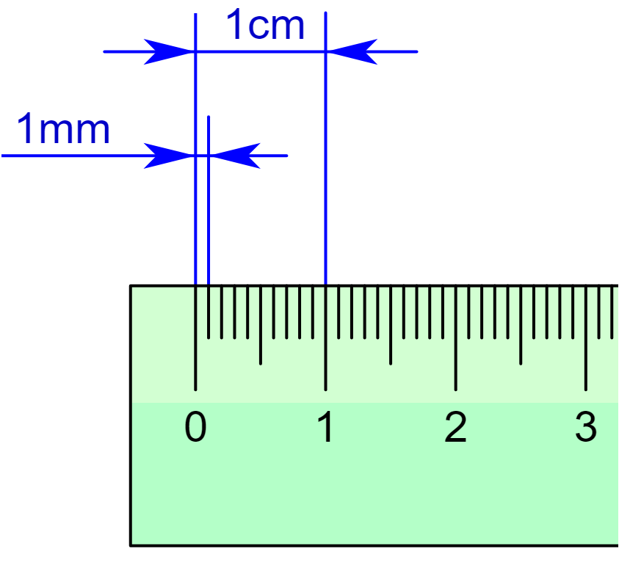

Millimeter

Centimeter

10 millimeters = 1 centimeter

# Inches, Feet, and Yards



1 foot = 12 inches

1 yard = 36 inches

1 yard = 3 feet

# 

# Mile (mi):

Yards

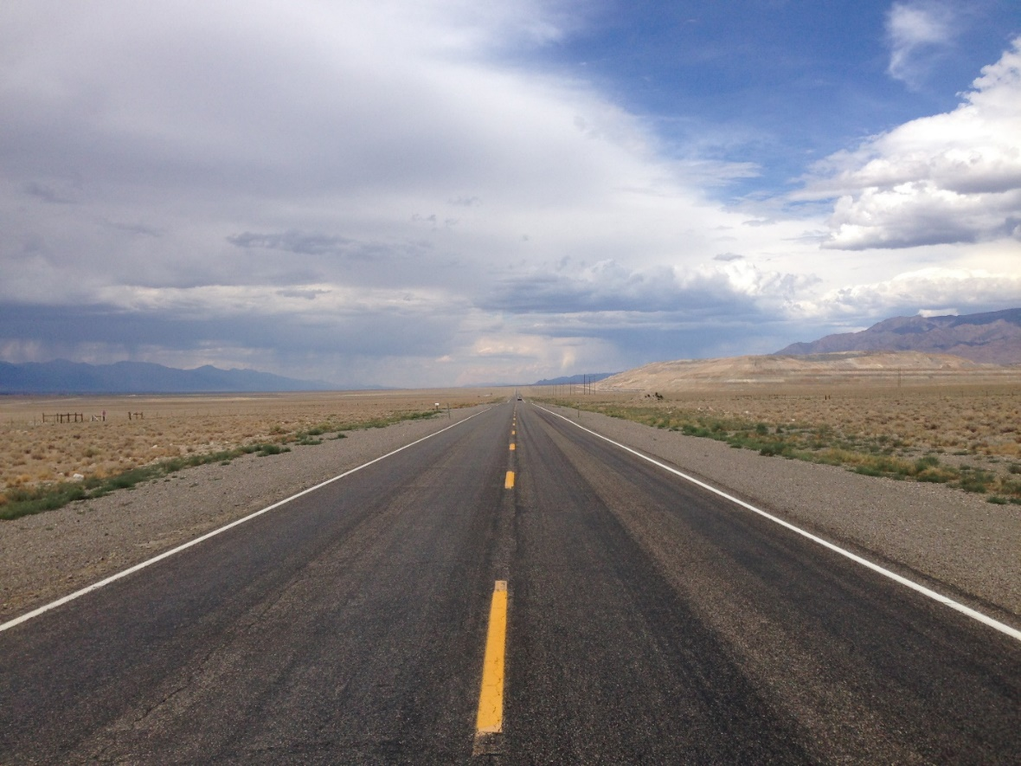

1 mile =1,760 yards

# Cup:

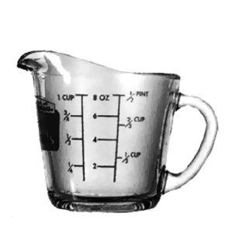Ounces

1 cup = 8 ounces

# Pint:

Cups and Ounces

1 pint = 2 cups

1 pint = 16 ounces

# Quart:

Pints, Cups, and Ounces

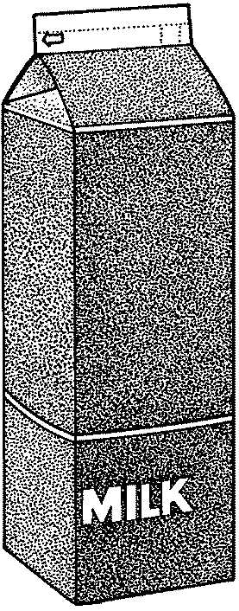

1 quart = 2 pints

1 quart = 4 cups

1 quart = 32 ounces

# Gallon:

Ounces

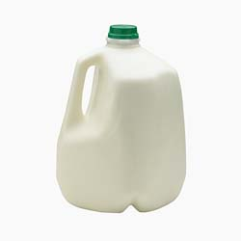

1 gallon = 128 ounces

1 gallon = 16 cups

1 gallon = 8 pints

1 gallon = 4 quarts

# Liter





1 liter

2 liter

# Elapsed Time

amount of time that has passed between two given times

STOP

START

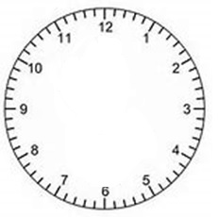

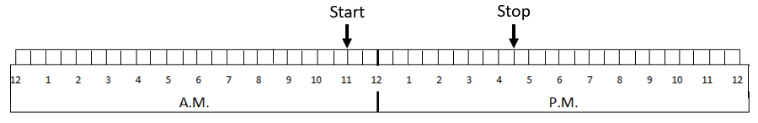

# Point

2 liters

A

point A

# Line

A

B

line AB

$\overset{⃡}{AB}$

# Ray:

Endpoint

R

S

endpoint

ray RS

$$\vec{RS}$$

# Line Segment:

Endpoint

C

D

endpoints

line segment CD

$\overline{CD}$

# Angle



Y

X

Z

1

angle *YXZ*, angle *X*, or angle 1

∠YXZ, ∠X, or ∠1

# Vertex

vertex

vertices

# Intersecting Lines

# 

# Parallel

Lines

A

X

B

Y

line *AB* is parallel to line *XY*

||

# Perpendicular Lines

S

T

U

V

line ST is perpendicular to line UV

$\overset{⃡}{ST}$ ⊥ $\overset{⃡}{UV}$

# Symbolic Notations

|  |  |  |
| --- | --- | --- |
| Figure | Notation | Read |
| Point | A | Point A |
| Line | $$\overset{⃡}{AB}$$ | Line AB |
| Line  segment | $$\overline{CD}$$ | Line segment CD |
| Ray | $$\vec{RS}$$ | Ray RS |
| Angle | ∠YXZ,  ∠X, or  ∠1 | Angle YXZ,  Angle X, or  Angle 1 |
| Parallel  lines | || | Line AB is parallel to line CD |
| Perpendicular lines | $\overset{⃡}{ST}$ ⊥ $\overset{⃡}{UV}$ | Line ST is perpendicular to line UV |

# Plane

Figures

# Solid Figures

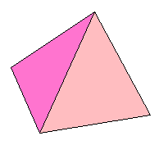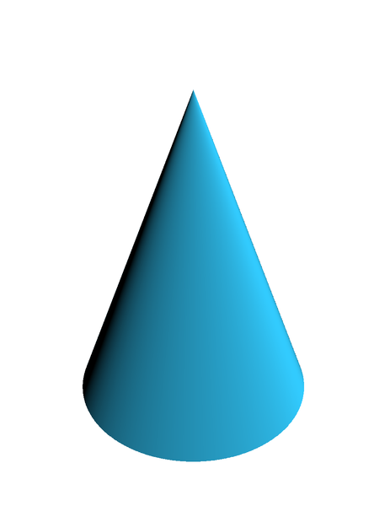

# Polygons:

# Triangle, Quadrilateral, and Pentagon

# Polygons:

Hexagon, Heptagon, and Octagon

**Octagon**

**Hexagon**

**Heptagon**

## Polygons:

Nonagon and Decagon

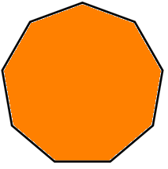

**Decagon**

**Nonagon**

Nonagon

# Quadrilaterals

# Geometric Markings

rhombus

square

parallelogram

trapezoid

rectangle

Right angle Parallel sides

Congruent sides

# Parallelogram

* opposite sides are parallel and congruent

# Rectangle:

Right Angle

* 4 right angles
* opposite sides are parallel and congruent

# Square:

Right Angle

* 4 right angles
* 4 congruent sides
* 2 pairs of parallel sides

# Rhombus

* 4 congruent sides
* 2 pairs of parallel sides
* opposite angles are congruent

# Trapezoid

* exactly one pair of parallel sides

# Triangle:

Side and Vertex

side vertex

# Sphere

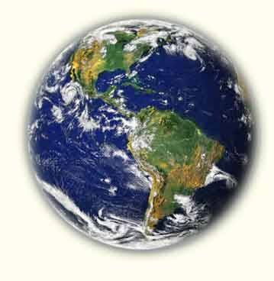

# Cube

face vertex edge

# Rectangular Prism:

Vertices

vertices

# Square Pyramid

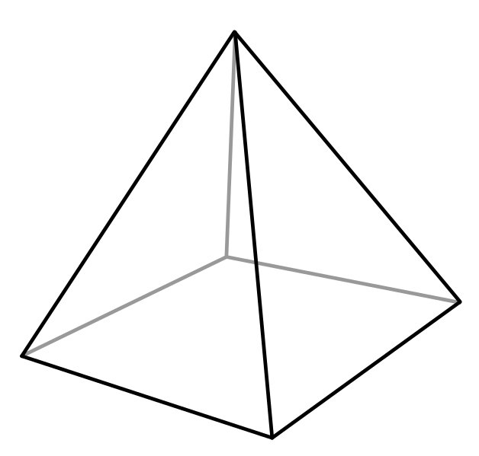

# Cylinder

3

3

# Cone

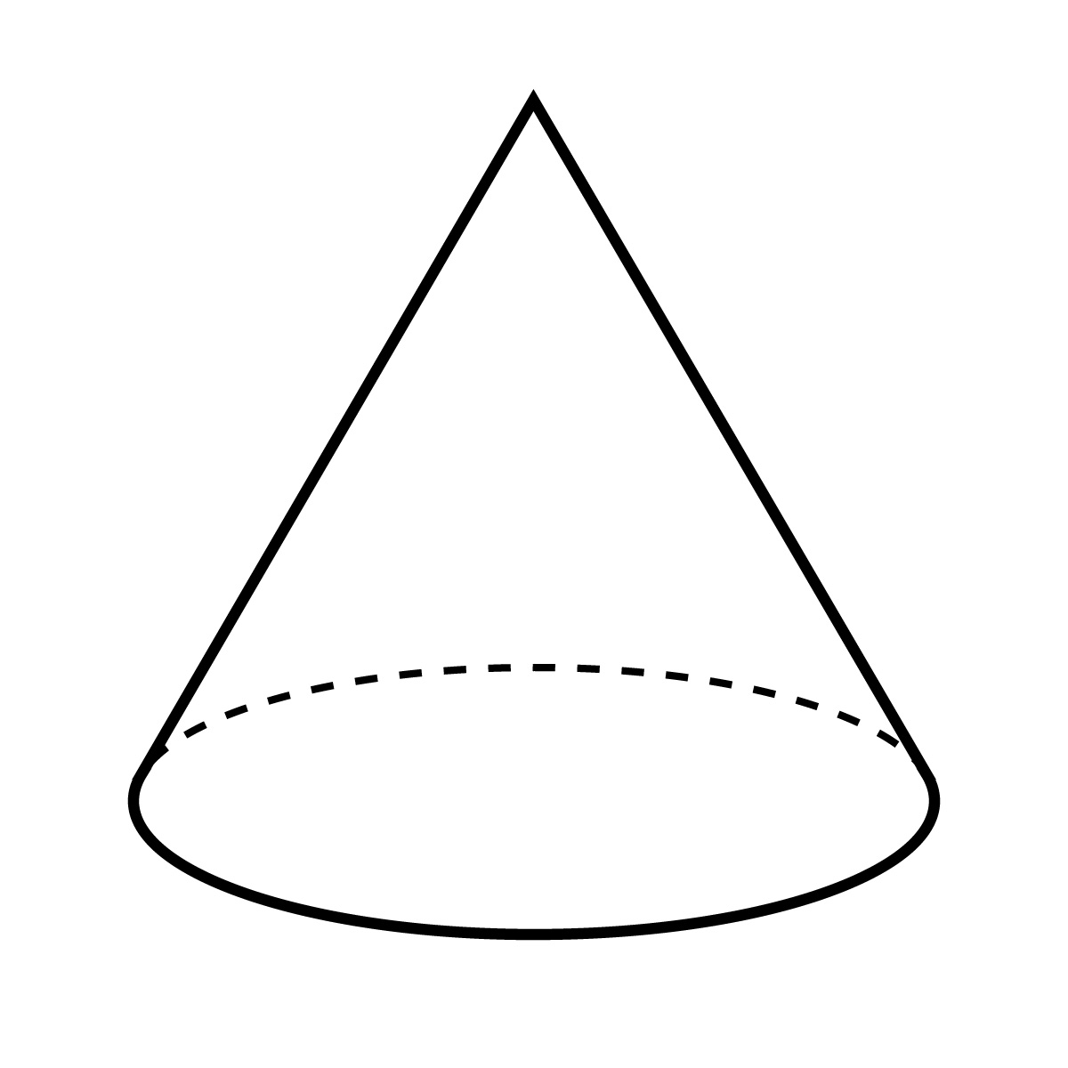

# Probability Number Line

certain

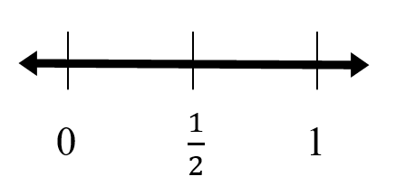

impossible

# Certain

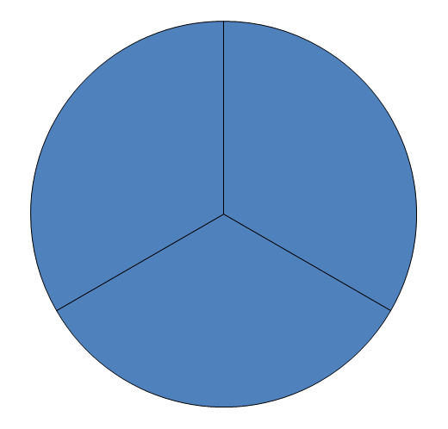

# is certain

# Likely

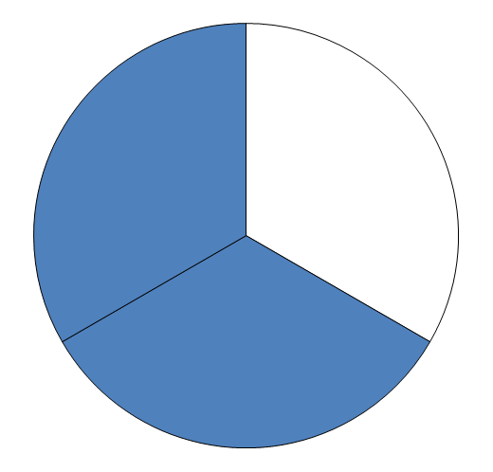

# is likely

# Unlikely

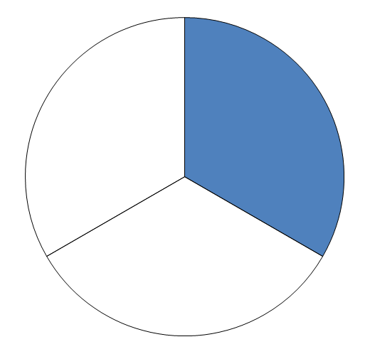

# is unlikely

# Equally likely

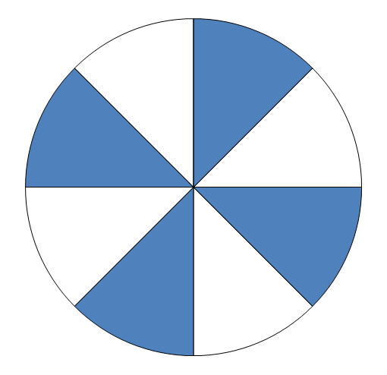

and are equally likely

# Impossible

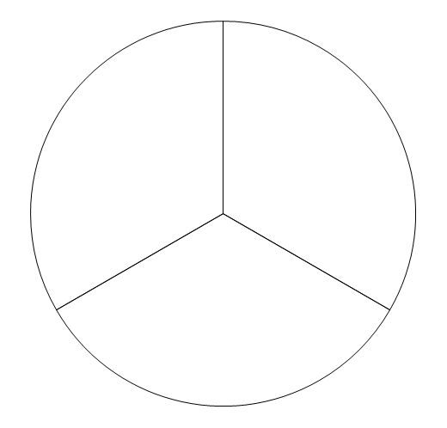

is impossible



# Bar Graph

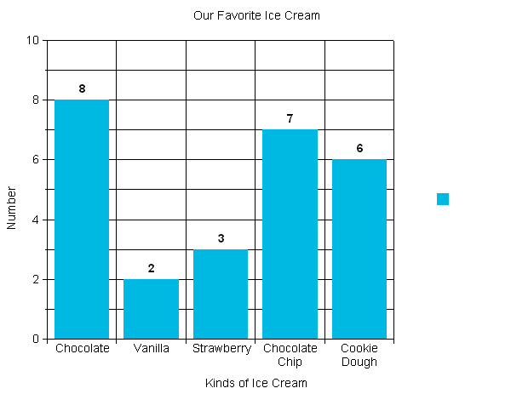

Number

Kinds of Ice Cream

Our Favorite Ice Cream

# Line Graph

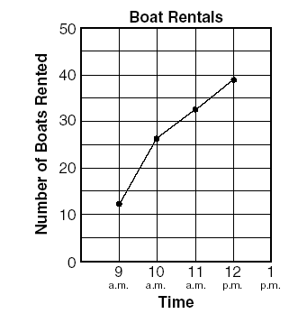

**Temperature Over Time**

**Temperature (°F)**

# Pattern:

Growing patterns and input/output table

🞭⯄🞭⯄⯄🞭⯄⯄⯄

8, 10, 13, 17, __

|  |  |  |  |  |  |  |  |
| --- | --- | --- | --- | --- | --- | --- | --- |
| **Rule: ______** | |  | **Rule: ______** | |  | **Rule: ______** | |
| **Input** | **Output** |  | **Input** | **Output** |  | **Input** | **Output** |
| **4** | **11** |  | **145** | **130** |  | **2** | **8** |
| **5** | **12** |  | **100** | **85** |  | **4** | **16** |
| **6** | **13** |  | **75** | **60** |  | **?** | **20** |
| **10** | **17** |  | **50** | **?** |  | **8** | **32** |

# Equality

**=**

10 + 8 = 36 $÷$ 2

8 x 4 = 190 – 158

16 x 3 = 8 x 6

# Inequality

**≠**

5 + 6 ≠ 4 + 8

9 – 4 ≠ 3 × 3

5 x 7 ≠ 35 +5

# Expression

a representation of a quantity

5

4 + 3

8 – 2

2 x 7