**Grade 3 Mathematics**

**Vocabulary Word Wall Cards**

Mathematics vocabulary word wall cards provide a display of mathematics content words and associated visual cues to assist in vocabulary development. The cards should be used as an instructional tool for teachers and then as a reference for all students. **The cards are designed for print use only.**

**Table of Contents**

**Number and Number Sense**

Number Line

Round

Less Than

Greater Than

Equal To

Place Value Position

Fraction: Models for one-half/one-fourth

Fraction: Models for two-thirds

Fraction: Models for five-sixths

Fraction: Models for three-eighths

Numerator/Denominator

Proper Fraction

Improper Fraction

Mixed Number

**Computation and Estimation**

Addition

Subtraction

Regroup/Rename

Multiply: Product

Multiplication: Set Model

Multiplication: Array Model

Multiplication: Area (array) Model

Multiplication: Number Line Model

Divide: Quotient

Division: Number Line and Array Models

Related Facts: Addition/Subtraction

Related Facts: Multiplication/Division

Equation: Number Sentence

Fraction: Addition

Fraction: Subtraction

**Measurement and Geometry**

Penny

Nickel

Dime

Quarter

Dollar

Ruler: Centimeter and Inch

Cup

Pint

Quart

Gallon

Liter

Area: Square Units

Perimeter: Units

Clock: Minutes, One-half Hour, One Hour

Elapsed Time

Calendar

Thermometer

Plane Figures

Polygons: Triangles

Polygons: Quadrilaterals

Polygons: Pentagon, Hexagon, Heptagon, and Octagon

Polygons: Nonagon and Decagon

Subdivide

Combine

Rectangle: Right Angle

Square: Right Angle

Triangle: Side and Vertex

Congruent

Noncongruent

Line Segment

Point

Angle

Line

Ray

**Probability and Statistics**

Bar Graph

Pictograph

Certain

Likely

Unlikely

Equally Likely

Impossible

**Patterns, Functions, and Algebra**

Equal

Not equal

Pattern: Growing and Input/output Table

Expression

Calculator

# Number Line

0 1 2 3 4 5 6 7 8

# Round

1,240

1,230

1,234

Round 1,234 to the

nearest ten.

# Less Than

**<**

0 1 2 3 4 5 6 7 8

2 **<** 7

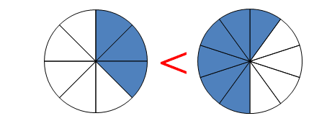

$\frac{3}{8}$**< $\frac{6}{10}$**

# Greater Than

**>**

0 1 2 3 4 5 6 7 8

8 **>** 4

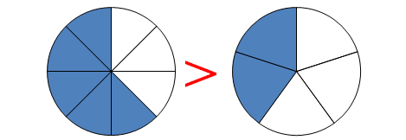

$\frac{5}{8}$**> $\frac{2}{5}$**

# Equal To

**=**

0 1 2 3 4 5 6 7 8

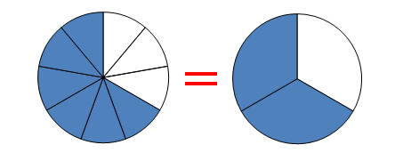4 **=** 4

$\frac{6}{9}$**= $\frac{2}{3}$**

# Place Value Position

|  |  |  |  |  |  |  |
| --- | --- | --- | --- | --- | --- | --- |
| Hundred Thousands | Ten Thousands | One Thousands |  | Hundreds | Tens | Ones |
| 2 | 3 | 5 | , | 4 | 8 | 6 |

# Fraction:

Models for one-half and one-fourth

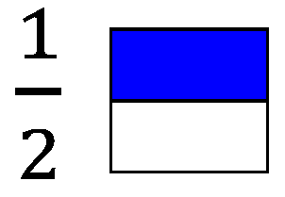

0

1

$$\frac{1}{2}$$

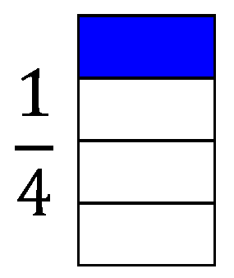

$\frac{1}{4}$

0

1

$$\frac{1}{2}$$

# Fraction:

Models for two-thirds

|  |
| --- |
|  |
|  |
|  |

$\frac{2}{3}$

$$\frac{1}{3}$$

0

1

$$\frac{2}{3}$$

$$\frac{1}{2}$$

# Fraction:

Models for five-sixths

|  |
| --- |
|  |
|  |
|  |
|  |
|  |
|  |

$$\frac{5}{6}$$

$$\frac{1}{6}$$

0

1

$$\frac{5}{6}$$

$$\frac{1}{2}$$

$$\frac{2}{6}$$

$$\frac{4}{6}$$

# Fraction:

Models for three-eighths

|  |
| --- |
|  |
|  |
|  |
|  |
|  |
|  |
|  |
|  |

$\frac{3}{8}$

$$\frac{1}{2}$$

$\frac{3}{8}$

0

1

# Numerator/

# Denominator

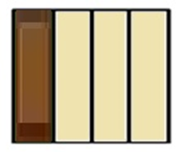 $\frac{2}{3}$

The candy bar was divided into 4 equal parts. Three friends ate 3 pieces of the candy bar, so $\frac{3}{4}$ of the candy bar has been eaten.

numerator

(number of equal parts being

considered)

denominator

(number of equal parts in the whole)

# Proper Fraction:

Fraction less than one

(numerator is less than the denominator)

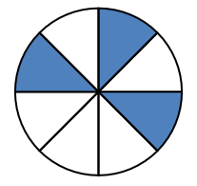

$\frac{3}{8}$

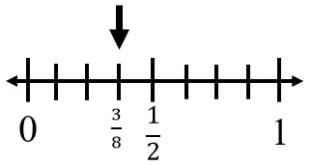

# Improper Fraction:

Fraction greater than or equal to one

(numerator is equal to or greater than the denominator)

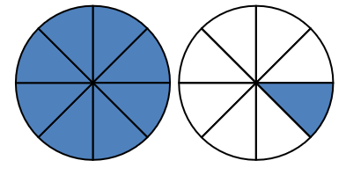

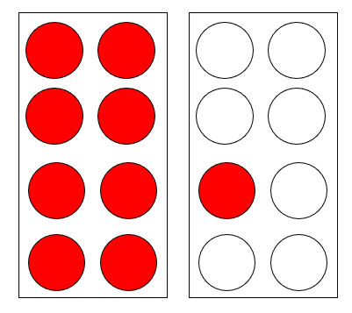 $\frac{9}{8}$

$\frac{10}{8}$

$\frac{3}{8}$

$\frac{1}{8}$

$\frac{2}{8}$

$\frac{5}{8}$

0

1

$$\frac{1}{2}$$

$\frac{9}{8}$

$\frac{6}{8}$

$\frac{7}{8}$

# Mixed Number

|  |  |  |  |  |
| --- | --- | --- | --- | --- |
|  |  |  |  |  |
|  |  |  |  |  |

|  |  |  |  |  |
| --- | --- | --- | --- | --- |
|  |  |  |  |  |
|  |  |  |  |  |

fraction

whole

### 1 $\frac{6}{10}$

# Addition

465 + 124 = 589

sum

**+**

plus

# Subtraction

465 – 124 = 341

difference

minus

# Regroup/

# Rename

26 is 1 ten and 16 ones

1 ten 16 ones

26

- 9

17

# Multiply

3 x 4 = 12

product

×

times

# Multiplication: Set Model

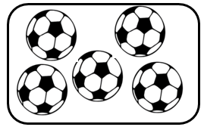

2 x 5

2 groups of 5 soccer balls in each group



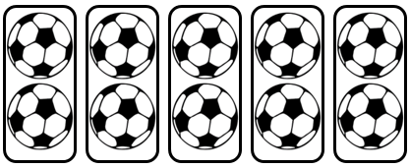

5 x 2

5 groups of 2 soccer balls in each group

# Multiplication: Array Model

**(an arrangement of objects in rows and columns)**

5 x 3

3 x 5

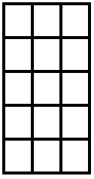

3 rows of 5

5 rows of 3

# Multiplication:

Area (array) Model

12 x 5

5

|  |  |  |  |  |  |  |  |  |  |
| --- | --- | --- | --- | --- | --- | --- | --- | --- | --- |
|  |  |  |  |  |  |  |  |  | 10 x 5 = 50  + 2 x 5 = 10  60 |
|  |  |  |  |  |  |  |  |  |  |
|  |  |  |  |  |  |  |  |  |  |
|  |  |  |  |  |  |  |  |  |  |
|  |  |  |  |  |  |  |  |  |  |
|  |  |  |  |  |  |  |  |  |  |
|  |  |  |  |  |  |  |  |  |  |
|  |  |  |  |  |  |  |  |  |  |
|  |  |  |  |  |  |  |  |  |  |
|  |  |  |  |  |  |  |  |  |  |
|  |  |  |  |  |  |  |  |  |  |
|  |  |  |  |  |  |  |  |  |  |

2

10

12 x 5 = 60

# Multiplication:

###### Number Line Model

4 x 3

4 x 3 = 12

15

14

13

12

11

10

9

8

7

5

4

3

1

2

0

6

# Divide

4

12 ÷ 4 = 3

quotient

÷

divided by

# Division:

Array Model

15 candies – if each friend is given 3, there is enough to share with 5 friends

15 candies to be shared among 3 friends means each friend will receive 5 candies

# Division:

Number Line

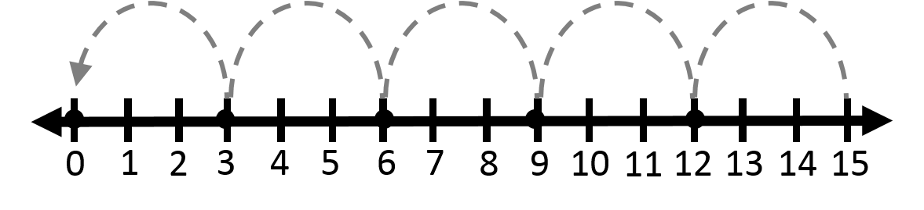

15 ÷ 3 = 5

The race is 15 miles long. If each team member will run 3 miles, 5 team members will be needed.

Related Facts:

Addition /Subtraction

5 + 1 = 6

1 + 5 = 6

6 – 1 = 5

6 – 5 = 1

# Related Facts:

Multiplication/Division

2 x 3 = 6

3 x 2 = 6

6 ÷ 3 = 2

# 6 ÷ 2 = 3Equation:

Number Sentence

8 = 3 + 5

6 – 2 = 4

17 + 13 + 9 = 39

4 x 3 = 14 – 2

# Fraction: Addition

|  |  |  |  |
| --- | --- | --- | --- |
|  |  |  |  |
|  |  |  |  |

|  |  |  |  |
| --- | --- | --- | --- |
|  |  |  |  |
|  |  |  |  |

+

# Fraction:

Subtraction

|  |  |  |  |
| --- | --- | --- | --- |
|  |  |  |  |
|  |  |  |  |

|  |  |  |  |
| --- | --- | --- | --- |
|  |  |  |  |
|  |  |  |  |

# Penny

C:\Documents and Settings\uul54192\Local Settings\Temporary Internet Files\Content.IE5\VWJV0ZMV\MC900019342[1].wmf

1¢

one cent

$0.01

# Nickel

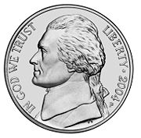

5¢

# five cents

# $0.05Dime

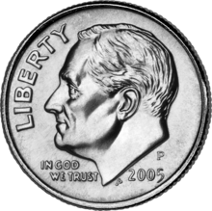

10¢

ten cents

$0.10

# Quarter

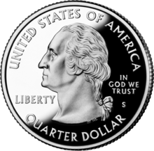

25¢

twenty-five cents

$0.25

# Dollar

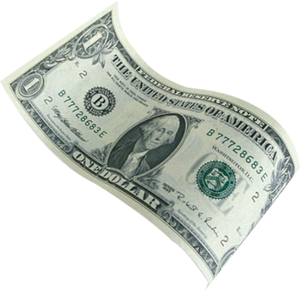

$1.00

One hundred cents

# Ruler:

Centimeter and Inch

0 in. 1

1

one inch

one centimeter

0 cm. 1 2 3

1 inch

# Cup

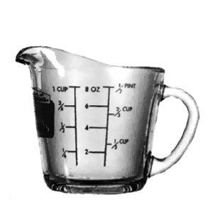

# Pint

# Quart

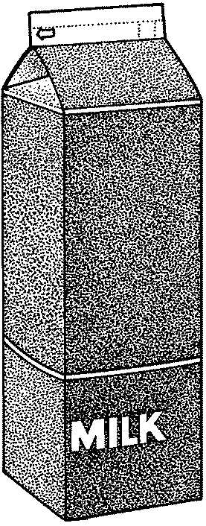

# Gallon

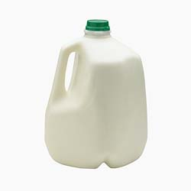

# Liter





1 liter

2 liters

# Area:

Square Units

|  |  |  |  |
| --- | --- | --- | --- |
| 1 | 2 | 3 | 4 |
| 5 | 6 | 7 | 8 |
| 9 | 10 | 11 | 12 |

12 square units

# Perimeter:

Units

4

4

3

3

|  |  |  |  |
| --- | --- | --- | --- |
|  |  |  |  |
|  |  |  |  |
|  |  |  |  |

3 + 4 + 3 + 4

14 units

# Clock:

Minutes, One-half Hour, One Hour

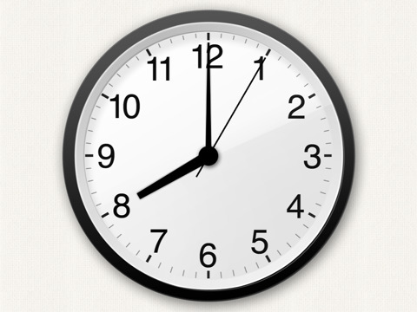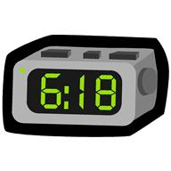

digital analog

30 minutes = one-half hour

60 minutes = 1 hour

24 hours = 1 day

# Elapsed Time

amount of time that has passed between two given times

The movie starts at 2:00 p.m. and ends at 5:00 p.m.

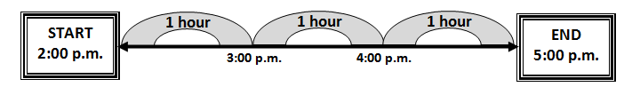

The movie is three hours long.

# Calendar

24 hours = 1 day

7 days = 1 week

About 30 days = 1 month

365 $\frac{1}{4}$ days = 1 year

12 months = 1 year

# Thermometer

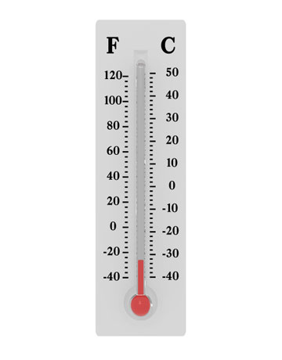

temperature

degrees 🞆

Fahrenheit

Celsius

# Plane Figures

triangle

rectangle

# Polygons:

circle

square

# Triangles

# Polygons:

# Quadrilaterals

# Polygons:

Pentagon, Hexagon, Heptagon, and Octagon

**Pentagon**

**Heptagon**

**Hexagon**

**Octagon**

## Polygons:

Nonagon and Decagon

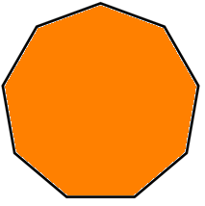

**Decagon**

**Nonagon**

Nonagon

Subdivide

# Combine

# Rectangle:

Right Angle

right angle

# Square:

Right Angle

right angle

# Triangle:

Side and Vertex

 side vertex

# Congruent

same shape and size

# Noncongruent

# Line Segment

# Point

# Angle



Line

A B

# Ray

# Bar Graph

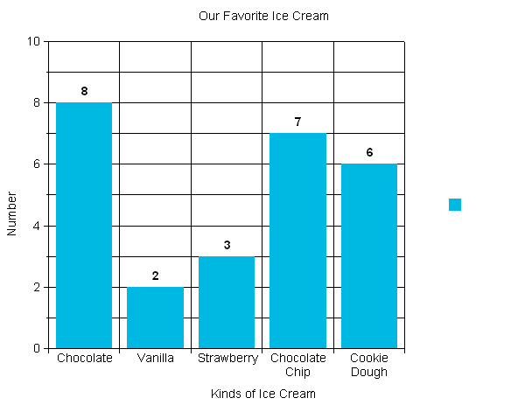

Number of Students

Kinds of Ice Cream

Our Favorite Ice Cream

# Pictograph

Our Favorite Pets

|  |  |  |  |
| --- | --- | --- | --- |
| Cat | Dog | Horse | Fish |
| MCj04382050000[1]  MCj04382050000[1] | MCj04382050000[1] | MCj04382050000[1]  MCj04382050000[1]  MCj04382050000[1]  MCj04382050000[1] | MCj04382050000[1]  MCj04382050000[1]  MCj04382050000[1] |

MCj04382050000[1] = 2 students

# Certain

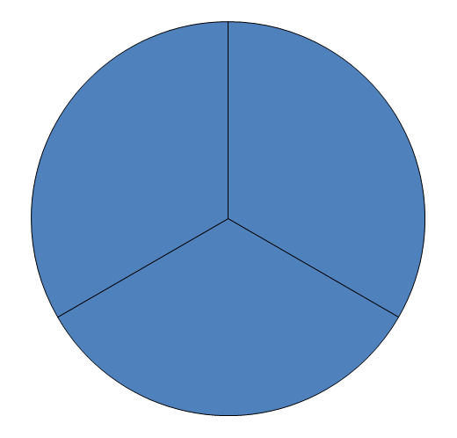

is certain

# Likely

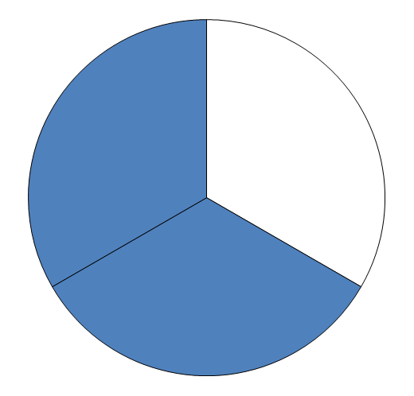

is likely

# Unlikely

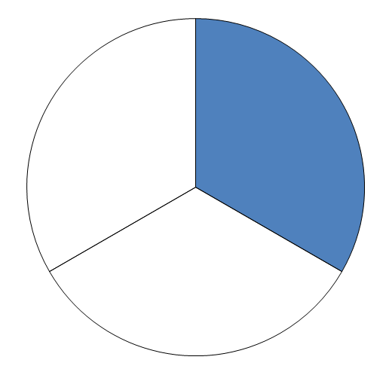

# is unlikelyEqually Likely

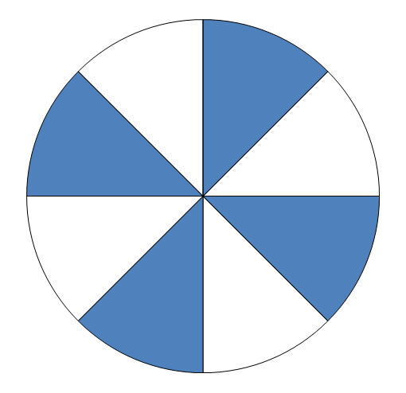

and are equally likely

# Impossible

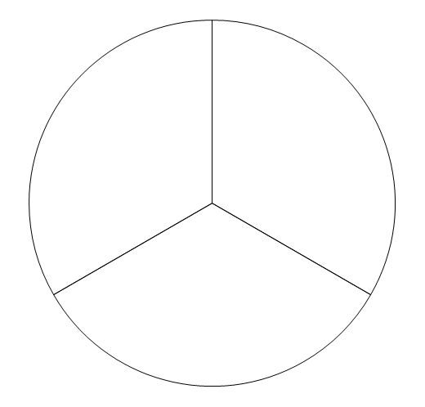

is impossible

# Equal

**=**

2 + 9 = 9 + 2

13 – 4 = 12 – 3

3 x 4 = 1 x 12

# Not Equal

**≠**

5 + 6 ≠ 4 + 8

9 – 4 ≠ 3 × 3

5 x 7 ≠ 35 +5

# Pattern:

Growing patterns and Input/Output table

🞭⯄🞭⯄⯄🞭⯄⯄⯄

3, 5, 7, 9, _, 13, _

Rule: Add 4

Input

Output

4 8

5 9

8 **__**

9 **__**

# Expression

a representation of a quantity

5

4 + 3

8 – 2

2 x 7

# Calculator

