**Grade 2 Mathematics**

**Vocabulary Word Wall Cards**

Mathematics vocabulary word wall cards provide a display of mathematics content words and associated visual cues to assist in vocabulary development. The cards should be used as an instructional tool for teachers and then as a reference for all students. **The cards are designed for print use only.**

**Table of Contents**

**Number and Number Sense**

Number Model of 2

Number Model of 9

Number Model of 14

Place Value

Round

Less Than

Greater Than

Equal To

Even and Odd Numbers

Ten More and Ten Less

Ordinal Numbers

Fraction: Half and Fourth

Fraction: Thirds

Fraction: Sixths

Fraction: Eighths

Compare Unit Fractions

Number Line

**Computation and Estimation**

Addition

Subtraction

Equation: Number Sentence

Regroup/Rename

Estimate

Related Facts

**Measurement**

Penny

Nickel

Nickel = Five Pennies

Dime

Dime = Ten Pennies

Quarter

Quarter = Twenty-Five Pennies

Dollar

Ruler

Pound

Scale: Weight

Clock: Time

Calendar

Thermometer

**Geometry**

Symmetry

Plane Figures

Square: Right Angle

Triangle: Side and Vertex

Rectangle: Right Angle

Sphere

Cube

Rectangular Prism

**Probability and Statistics**

Table

Bar Graph

Pictograph

**Patterns, Functions, and Algebra**

Pattern: Repeating and Growing

Transferring a Repeating Pattern

Transferring a Growing Pattern

Equal

Not Equal

# Number



2

two

numeral

# Number

9

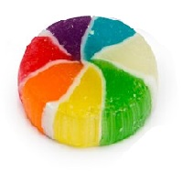



nine



numeral

# Number

|  |  |
| --- | --- |
|  |  |
|  |  |
|  |  |
|  |  |
|  |  |

14

fourteen

numeral

# Place Value

# 

6 4 7

Hundreds Tens Ones

6 0 0

4 0

7

# Round

Round 34 to the

nearest ten.

35

30

40

34 is closer to 30 than it is to 40

# Less than

**<**

0 1 **2** 3 4 5 6 **7**  8

2 **<** 7

# Greater than

**>**

0 1 **2** 3 4 5 6 **7**  8

7 **>** 2

# Equal to

**=**

0 1 2 3 **4**  5 6 7 8

# 4 **=** 4Even and Odd Numbers



9 is odd

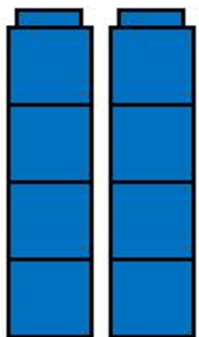

8 is even

# Ten More and Ten Less

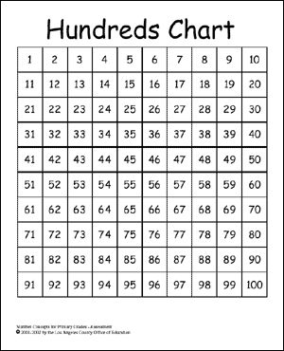

47 is ten more than 37

27 is ten less than 37

# Ordinal Numbers



Lara

Michael

1 2 3 4 5 6 7 8 9 10

1st 2nd 3rd 4th 5th 6th 7th 8th 9th 10th

6th

1st

# Fraction:

Half and Fourth

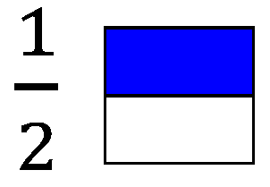

0

1

$$\frac{1}{2}$$

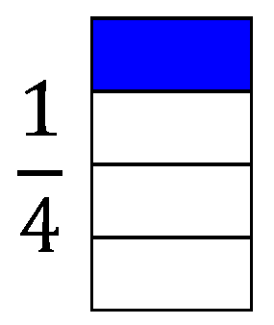

# Fraction:

0

1

$$\frac{1}{2}$$

$\frac{1}{4}$

Thirds

|  |
| --- |
|  |
|  |
|  |

$\frac{2}{3}$

$$\frac{1}{3}$$

0

1

$$\frac{2}{3}$$

$$\frac{1}{2}$$

# Fraction:

Sixths

$$\frac{1}{6}$$

0

1

$$\frac{5}{6}$$

$$\frac{1}{2}$$

$$\frac{2}{6}$$

$$\frac{4}{6}$$

|  |
| --- |
|  |
|  |
|  |
|  |
|  |
|  |

# $\frac{5}{6}$ Fraction:

Eighths

|  |
| --- |
|  |
|  |
|  |
|  |
|  |
|  |
|  |
|  |

$\frac{3}{8}$

$$\frac{1}{8}$$

$$\frac{5}{8}$$

$$\frac{2}{8}$$

$$\frac{3}{8}$$

1

0

$$\frac{4}{8}$$

Compare Unit Fractions

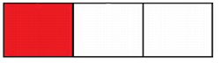

[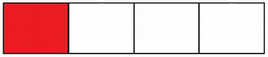](https://www.bing.com/images/search?view=detailV2&ccid=4cIM88Wg&id=37980536A2A059EEC4DA81C93327C89B62E3387F&thid=OIP.4cIM88WgTnvmGNMKaB8lbgIeBz&q=comparing+fractions+one+fourth+and+one+third&simid=608023871829051659&selectedIndex=142)

is greater than $\frac{1}{4}$

# Number Line

0 1 2 3 4 5 6 7 8

# Addition

9 + 3 = 12

plus

|  |  |
| --- | --- |
|  |  |
|  |  |
|  |  |
|  |  |
|  |  |

|  |  |
| --- | --- |
|  |  |
|  |  |
|  |  |
|  |  |
|  |  |

sum

# Subtraction

8 – 2 = 6

minus difference

|  |  |
| --- | --- |
|  |  |
|  |  |
|  |  |
|  | **X** |
|  | **X** |

# Equation

(Number Sentence)

8 = 3 + 5

6 – 2 = 4

75 = 50 + 25

# Regroup/

Rename

26 is 1 ten and 16 ones

1ten 16 ones

26

- 9

17

# Estimate

23 20

+ 12 10

# Related Facts

5 + 1 = 6

1 + 5 = 6

6 – 1 = 5

6 – 5 = 1

# Penny

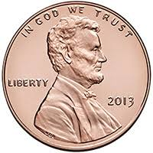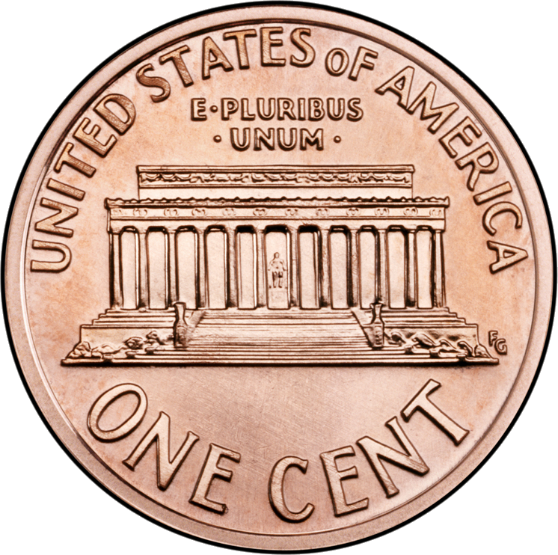

1¢

one cent

$0.01

# Nickel

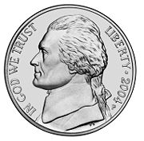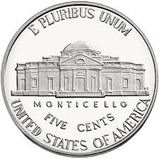

5¢

five cents

$0.05

# Nickel



one nickel equals five pennies

C:\Documents and Settings\uul54192\Local Settings\Temporary Internet Files\Content.IE5\VWJV0ZMV\MC900019342[1].wmfC:\Documents and Settings\uul54192\Local Settings\Temporary Internet Files\Content.IE5\VWJV0ZMV\MC900019342[1].wmfC:\Documents and Settings\uul54192\Local Settings\Temporary Internet Files\Content.IE5\VWJV0ZMV\MC900019342[1].wmfC:\Documents and Settings\uul54192\Local Settings\Temporary Internet Files\Content.IE5\VWJV0ZMV\MC900019342[1].wmfC:\Documents and Settings\uul54192\Local Settings\Temporary Internet Files\Content.IE5\VWJV0ZMV\MC900019342[1].wmf

5 cents

# Dime

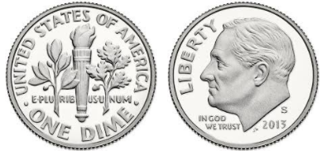

10¢

ten cents

$0.10

# Dime

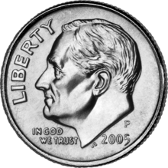

one dime equals ten pennies

C:\Documents and Settings\uul54192\Local Settings\Temporary Internet Files\Content.IE5\VWJV0ZMV\MC900019342[1].wmfC:\Documents and Settings\uul54192\Local Settings\Temporary Internet Files\Content.IE5\VWJV0ZMV\MC900019342[1].wmfC:\Documents and Settings\uul54192\Local Settings\Temporary Internet Files\Content.IE5\VWJV0ZMV\MC900019342[1].wmfC:\Documents and Settings\uul54192\Local Settings\Temporary Internet Files\Content.IE5\VWJV0ZMV\MC900019342[1].wmfC:\Documents and Settings\uul54192\Local Settings\Temporary Internet Files\Content.IE5\VWJV0ZMV\MC900019342[1].wmf

C:\Documents and Settings\uul54192\Local Settings\Temporary Internet Files\Content.IE5\VWJV0ZMV\MC900019342[1].wmfC:\Documents and Settings\uul54192\Local Settings\Temporary Internet Files\Content.IE5\VWJV0ZMV\MC900019342[1].wmfC:\Documents and Settings\uul54192\Local Settings\Temporary Internet Files\Content.IE5\VWJV0ZMV\MC900019342[1].wmfC:\Documents and Settings\uul54192\Local Settings\Temporary Internet Files\Content.IE5\VWJV0ZMV\MC900019342[1].wmfC:\Documents and Settings\uul54192\Local Settings\Temporary Internet Files\Content.IE5\VWJV0ZMV\MC900019342[1].wmf

10 cents

# Quarter

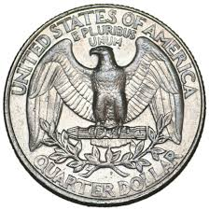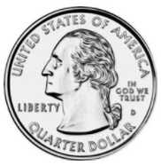

25¢

twenty-five cents

$0.25

# Quarter



one quarter equals twenty-five pennies

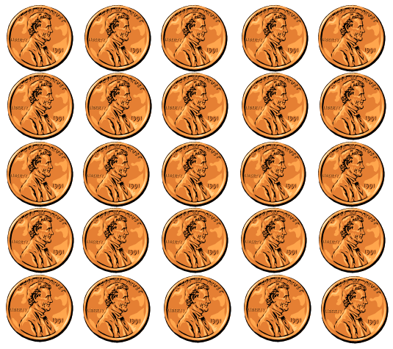

25 cents

# Dollar

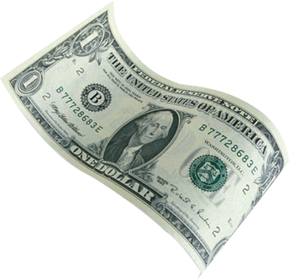

100¢

one hundred cents

$1.00

# Ruler

one inch

1 inch

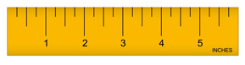

one inch

# Pound

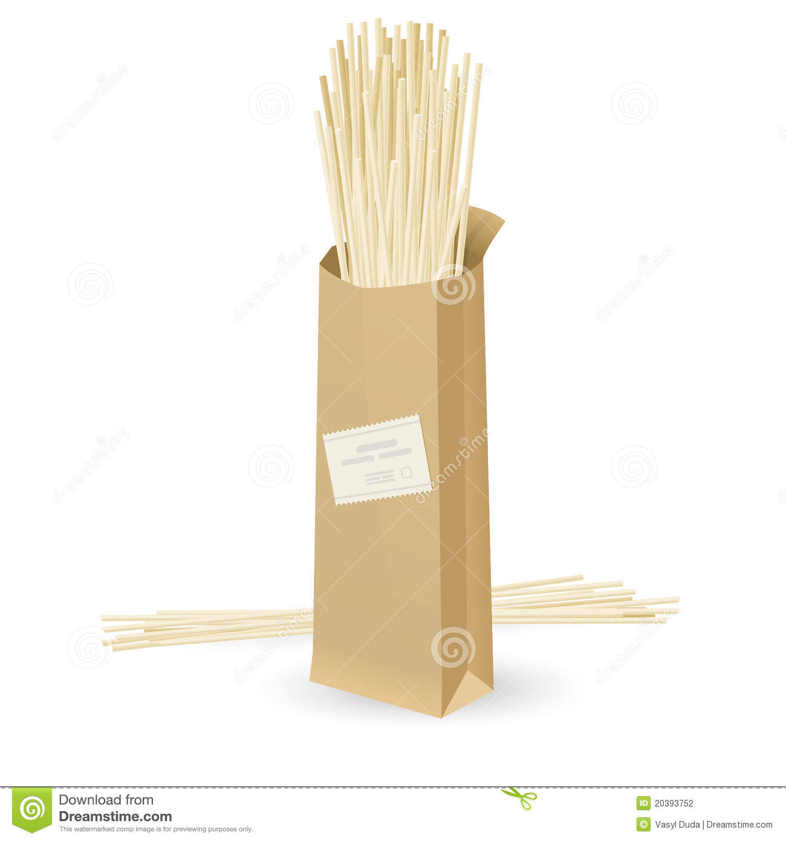

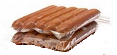

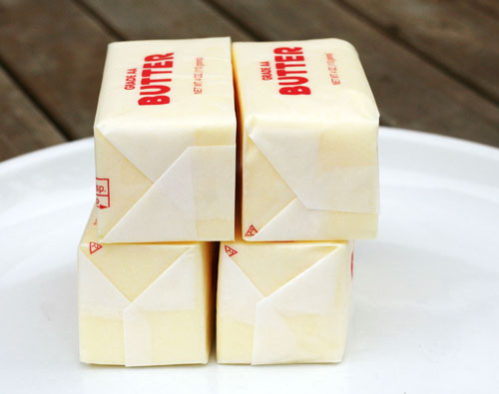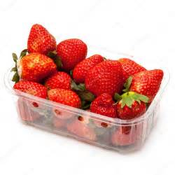

# Scale:

Measures Weight

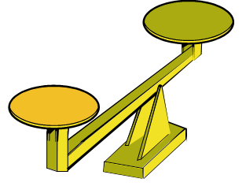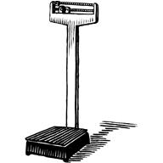

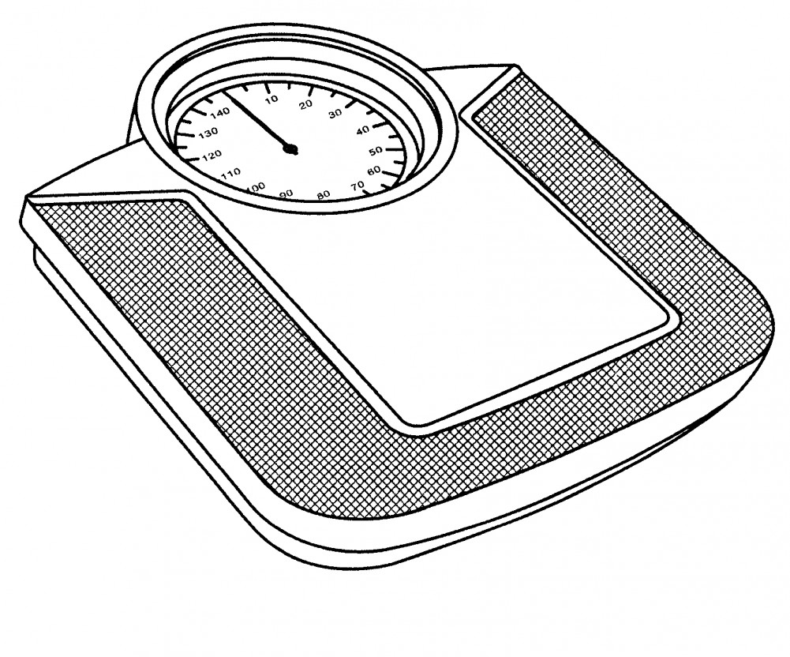

# Clock:

2 liters

Time

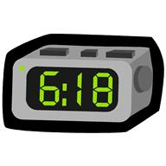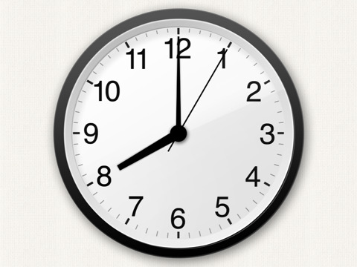

7:25

digital analog

# Calendar

# Thermometer

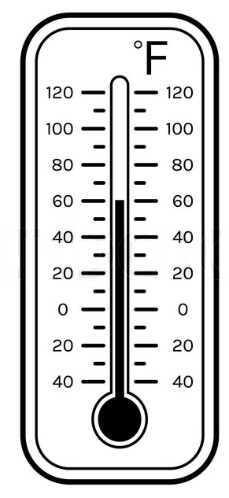

temperature

degrees 🞆

Fahrenheit

# Symmetry

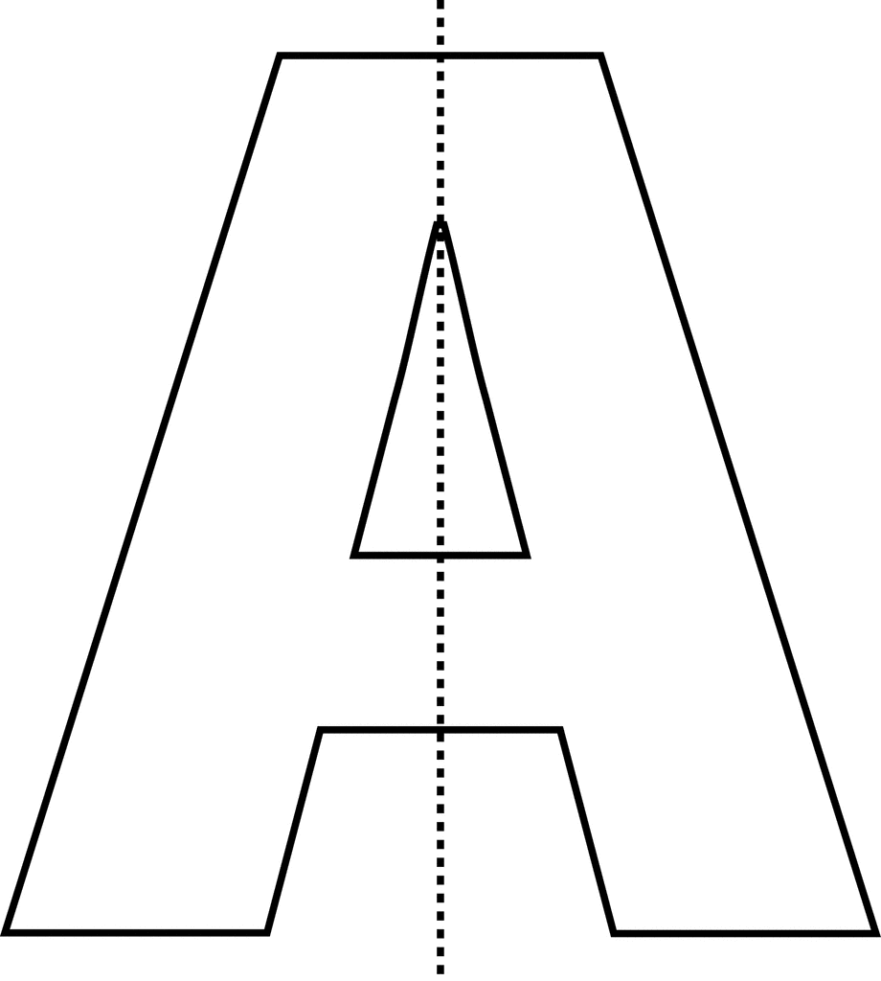

line of symmetry

# Plane Figures

triangle

rectangle

# Square:

circle

square

Right Angle

4 right angles

# Triangle:

Side and Vertex

 side vertex

# Rectangle:

Right Angle

4 right angles

# Sphere

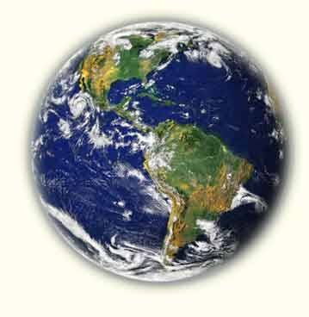

# Cube

has 6 square faces,

8 vertices, and 12 edges

# Rectangular Prism

has 6 rectangular faces,

8 vertices, 12 edges

# Table

Pets

|  |  |
| --- | --- |
| Animals | Number |
| Dogs | 12 |
| Cats | 9 |
| Birds | 5 |
| Lizards | 9 |

# Bar Graph

Number

Kinds of Ice Cream

Our Favorite Ice Cream

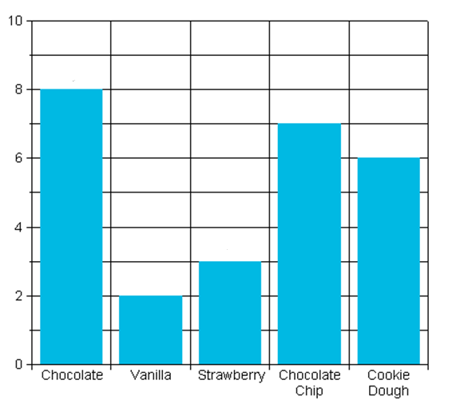

# Pictograph

Our Favorite Pets

|  |  |  |  |
| --- | --- | --- | --- |
| Cat | Dog | Horse | Fish |
| MCj04382050000[1]  MCj04382050000[1] | MCj04382050000[1] | MCj04382050000[1]  MCj04382050000[1]  MCj04382050000[1]  MCj04382050000[1] | MCj04382050000[1]  MCj04382050000[1]  MCj04382050000[1] |

MCj04382050000[1] = 2 students

# Pattern

🞇■🞇■🞇■🞇

#### repeating pattern

🞭⯄🞭⯄⯄🞭⯄⯄⯄

#### growing pattern

# Transfer a Repeating Pattern

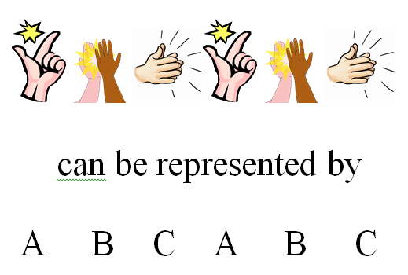

# Transfer a Growing Pattern

|  |  |  |  |  |  |  |  |  |  |  |
| --- | --- | --- | --- | --- | --- | --- | --- | --- | --- | --- |
|  |  |  |  |  |  |  |  |  |  |  |
|  |  |  |  |  |  |  |  |  |  |  |
|  |  |  |  |  |  |  |  |  |  |  |
|  |  |  |  |  |  |  |  |  |  |  |

can be represented by

2 4 6 8

# Equal

has the same value

**=**

9 + 24 = 10 + 23

45 – 9 = 46 – 10

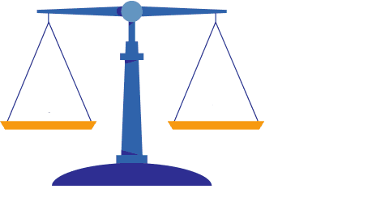

36 – 3

9 + 24

# Not Equal

# does not have the same value **≠**

# 15 + 16 ≠ 31 + 15

14 + 3 ≠ 8

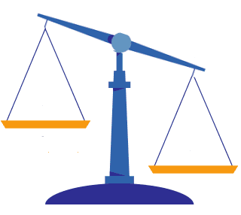

15 + 16

31 – 5