**Grade 1 Mathematics**

**Vocabulary Word Wall Cards**

Mathematics vocabulary word wall cards provide a display of mathematics content words and associated visual cues to assist in vocabulary development. The cards should be used as an instructional tool for teachers and then as a reference for all students. **The cards are designed for print use only.**

**Table of Contents**

**Number and Number Sense**

Number Model of 2

Number Model of 9

Number Model of 14

Number Path

Counting by Ones

Counting by Twos

Counting by Fives

Counting by Tens

Place Value

Ordinal Numbers

Less Than

Greater Than

Equal To

Estimate

Fair Share

Fraction: Half and Fourth

**Computation and Estimation**

Addition

Subtraction

Related Facts

Number Sentence

Join

Separate

Compare

Part/Whole

**Measurement**

Penny

Nickel

Nickel = Five Pennies

Dime

Dime = Ten Pennies

Quarter

Quarter = Twenty-five Pennies

Dollar

Clock

Length: Longer/Shorter

Height: Taller/Shorter

Weight: Heavier/Lighter

Balance Scale: Weight

Volume: Less and More

Volume: Equivalent

Calendar

**Geometry**

Plane Figures

Square: Right Angle

Triangle: Side and Vertex

Rectangle: Right Angle

**Probability and Statistics**

Picture Graph

Table

Tally Marks

**Patterns, Functions, and Algebra**

Core

Pattern: Repeating and Growing

Transfer a Repeating Pattern

Transfer a Growing Pattern

Equal

Not Equal

# Number



2

two

numeral

# Number

9

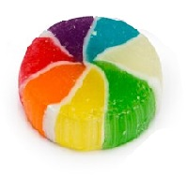



nine



numeral

# Number

|  |  |
| --- | --- |
|  |  |
|  |  |
|  |  |
|  |  |
|  |  |

14

fourteen

numeral

# Number Path

|  |  |  |  |  |  |  |  |  |  |
| --- | --- | --- | --- | --- | --- | --- | --- | --- | --- |
| **1** | **2** | **3** | **4** | **5** | **6** | **7** | **8** | **9** | **10** |

# Counting by Ones



**0 1 2 3 4 5 6**

# Place Value

# 

Tens

Ones

# 

4 7

40 and 7

# Counting by Twos

0

2



4

6

8

# Counting by Fives

0

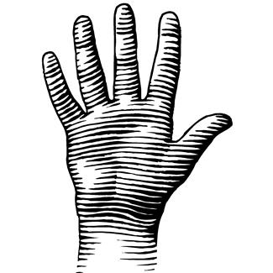

5

10

15

# Counting by Tens

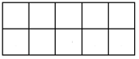

0

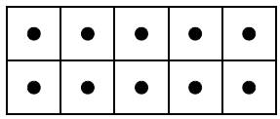

10



20





30

# Ordinal Numbers



Lara

Michael

1 2 3 4 5 6 7 8 9 10

1st 2nd 3rd 4th 5th 6th 7th 8th 9th 10th

6th

1st

# Less Than

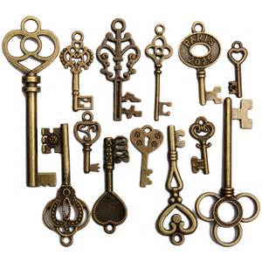

13 keys

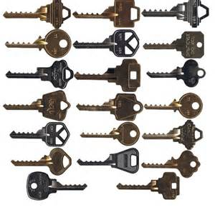

20 keys

13 is less than 20

# Greater Than

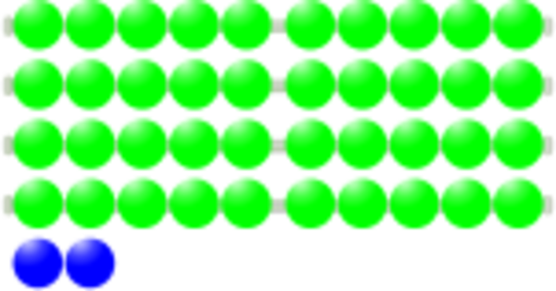

42

[](https://www.bing.com/images/search?view=detailV2&ccid=K4InWPkg&id=CBC9F5478B2F3E98A244A62981E7D2B2C9D7BAD6&thid=OIP.K4InWPkgPwh1ogImV_1HKQHECK&q=25+beads+mathematics&simid=608013551074607757&selectedIndex=22)

25

42 is greater than 25

# Equal To

[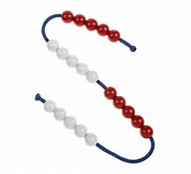](https://www.bing.com/images/search?view=detailV2&ccid=ZWTz18Rc&id=BA9733E2AE954641F1F3A6BC8F3AAC31D46F3CBD&thid=OIP.ZWTz18Rcd5KTVO9Bn0UpGgEsER&q=20+beads&simid=607989984541279965&selectedIndex=0)

20 beads 20 keys

20 is equal to 20

# Estimate

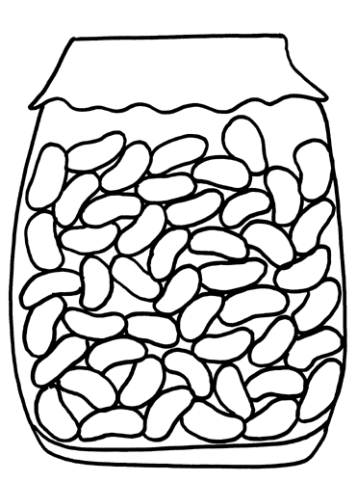

About how many beans are in the jar?

# Fair Share

Sam and Beth have three cupcakes to share equally.





How much will each get?

They each will get one and a half cupcakes.

# Fraction:

Half and Fourth

one-half

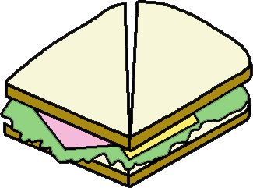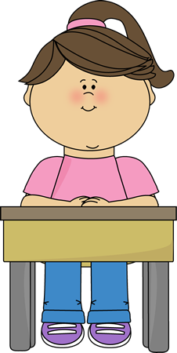

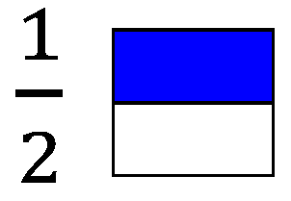

one-fourth

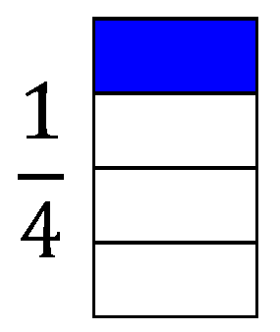



# Addition

9 + 3 = 12

plus

|  |  |
| --- | --- |
|  |  |
|  |  |
|  |  |
|  |  |
|  |  |

|  |  |
| --- | --- |
|  |  |
|  |  |
|  |  |
|  |  |
|  |  |

sum

# Subtraction

8 – 2 = 6

minus difference

|  |  |
| --- | --- |
|  |  |
|  |  |
|  |  |
|  | **X** |
|  | **X** |

# Related Facts

## 5 + 1 = 6

1 + 5 = 6

6 – 1 = 5

6 – 5 = 1

# Number Sentence

(Equation)

3 + 5 = 8

10 = 1 + 9

6 – 2 = 4

# Join

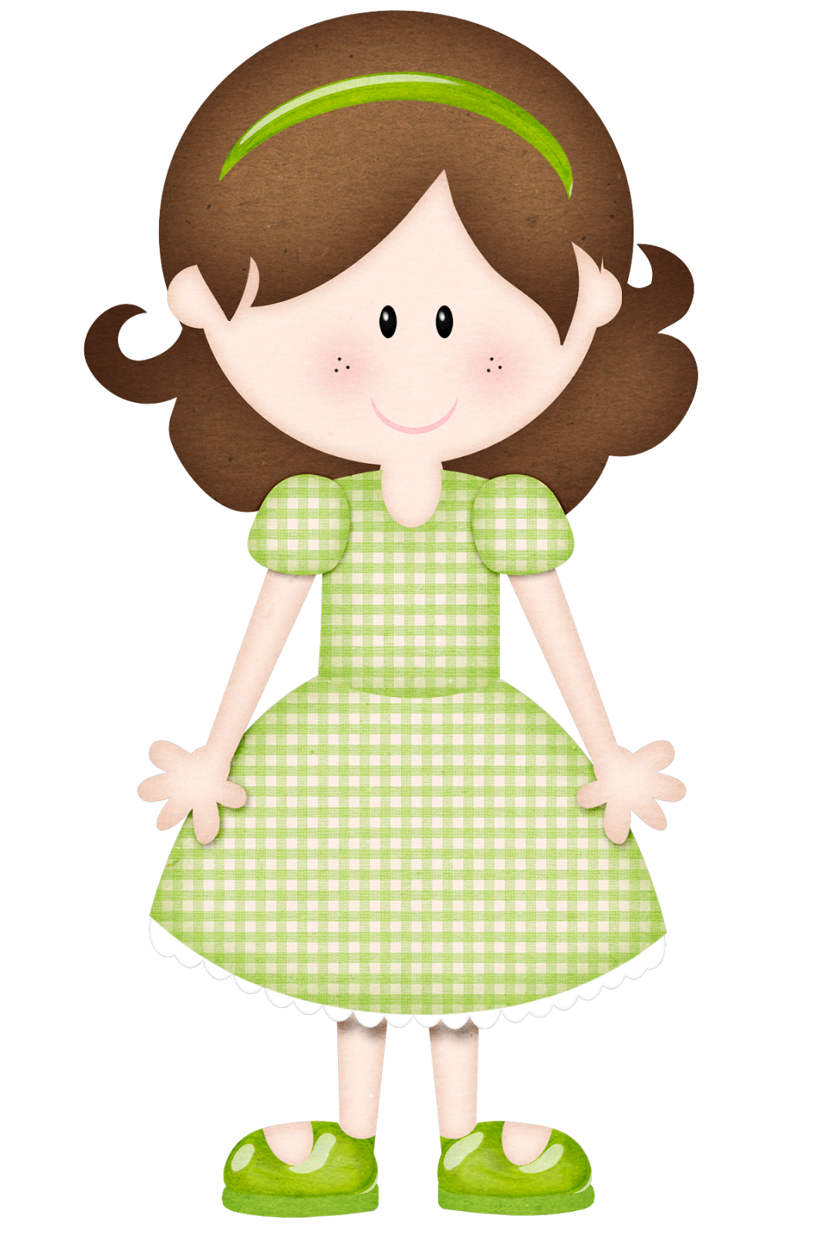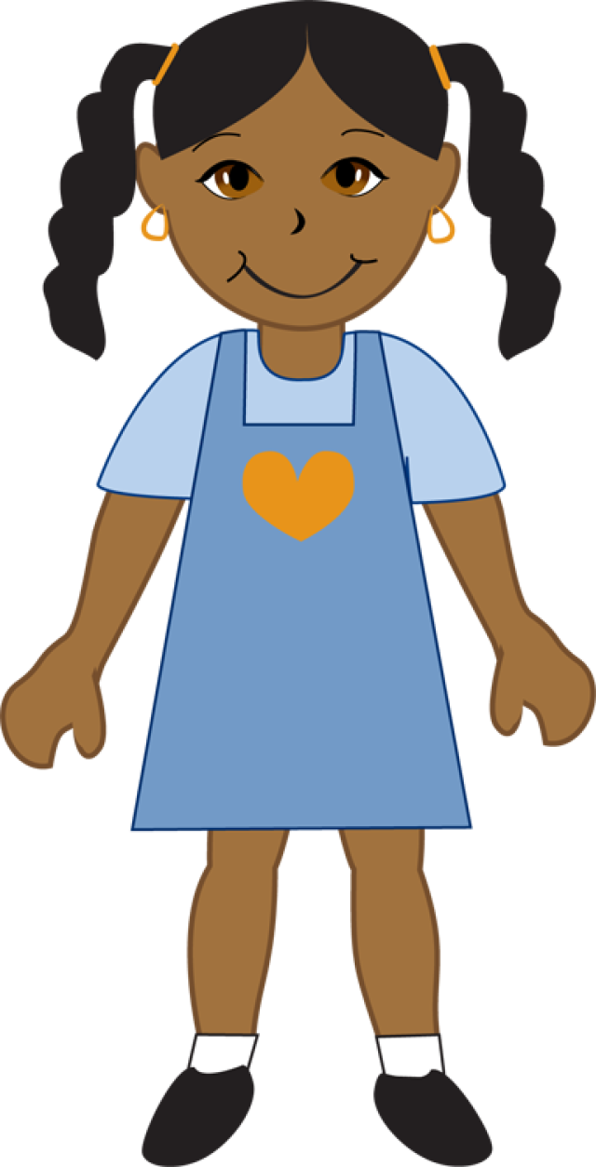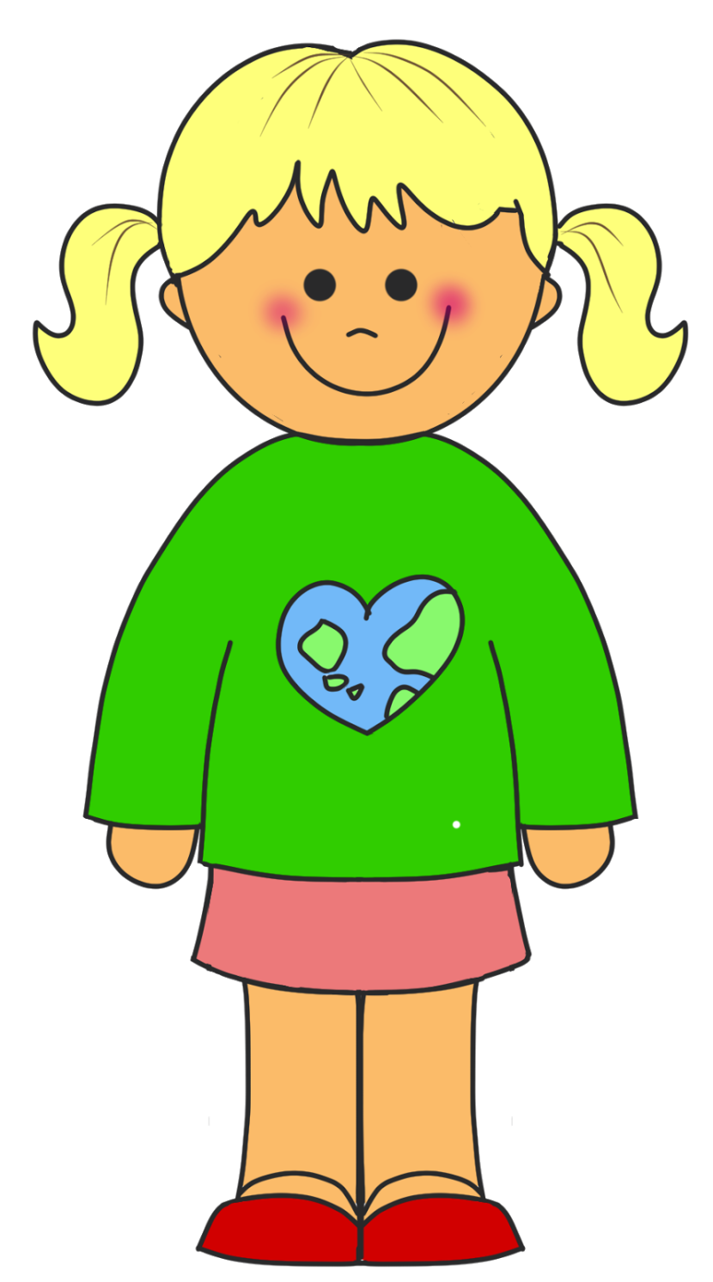



How many girls and boys are there?

# Separate

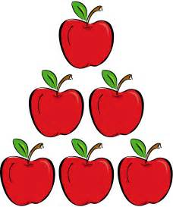

6 apples

3 were eaten

How many are there now?

# Compare



Ryan’s books Joe’s books

How many more books does Ryan have than Joe?

# Part-Whole



9 red and yellow balloons

How many could be red and how many could be yellow?

# Penny

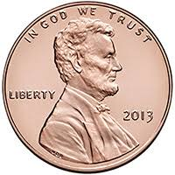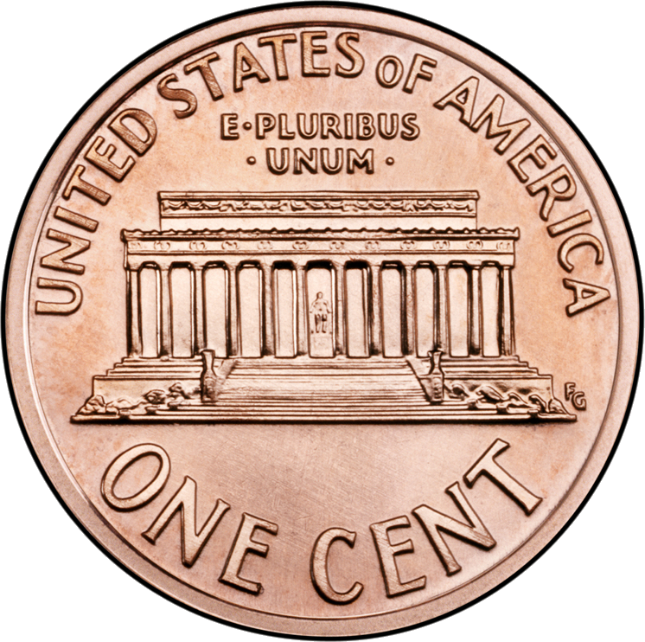

1¢

one cent

# Nickel

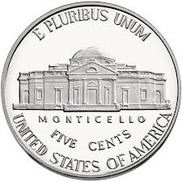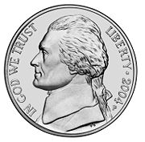

5¢

five cents

# Nickel



one nickel equals five pennies

C:\Documents and Settings\uul54192\Local Settings\Temporary Internet Files\Content.IE5\VWJV0ZMV\MC900019342[1].wmfC:\Documents and Settings\uul54192\Local Settings\Temporary Internet Files\Content.IE5\VWJV0ZMV\MC900019342[1].wmfC:\Documents and Settings\uul54192\Local Settings\Temporary Internet Files\Content.IE5\VWJV0ZMV\MC900019342[1].wmfC:\Documents and Settings\uul54192\Local Settings\Temporary Internet Files\Content.IE5\VWJV0ZMV\MC900019342[1].wmfC:\Documents and Settings\uul54192\Local Settings\Temporary Internet Files\Content.IE5\VWJV0ZMV\MC900019342[1].wmf

5 cents

# Dime

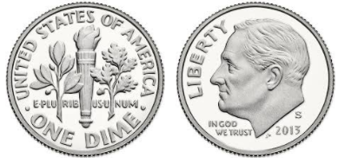

10¢

ten cents

# Dime

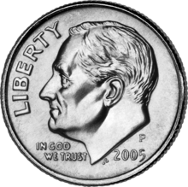

one dime equals ten pennies

C:\Documents and Settings\uul54192\Local Settings\Temporary Internet Files\Content.IE5\VWJV0ZMV\MC900019342[1].wmfC:\Documents and Settings\uul54192\Local Settings\Temporary Internet Files\Content.IE5\VWJV0ZMV\MC900019342[1].wmfC:\Documents and Settings\uul54192\Local Settings\Temporary Internet Files\Content.IE5\VWJV0ZMV\MC900019342[1].wmfC:\Documents and Settings\uul54192\Local Settings\Temporary Internet Files\Content.IE5\VWJV0ZMV\MC900019342[1].wmfC:\Documents and Settings\uul54192\Local Settings\Temporary Internet Files\Content.IE5\VWJV0ZMV\MC900019342[1].wmf

C:\Documents and Settings\uul54192\Local Settings\Temporary Internet Files\Content.IE5\VWJV0ZMV\MC900019342[1].wmfC:\Documents and Settings\uul54192\Local Settings\Temporary Internet Files\Content.IE5\VWJV0ZMV\MC900019342[1].wmfC:\Documents and Settings\uul54192\Local Settings\Temporary Internet Files\Content.IE5\VWJV0ZMV\MC900019342[1].wmfC:\Documents and Settings\uul54192\Local Settings\Temporary Internet Files\Content.IE5\VWJV0ZMV\MC900019342[1].wmfC:\Documents and Settings\uul54192\Local Settings\Temporary Internet Files\Content.IE5\VWJV0ZMV\MC900019342[1].wmf

10 cents

# Quarter

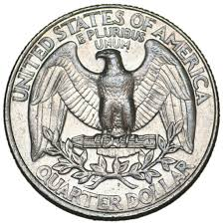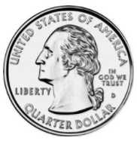

25¢

twenty-five cents

# Quarter



one quarter equals twenty-five pennies



25 cents



# Dollar

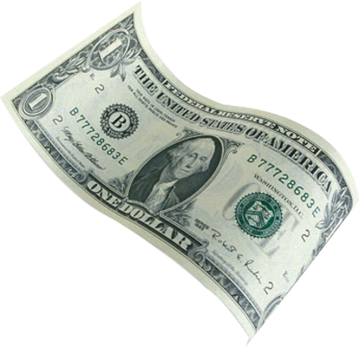

one hundred cents

$1.00

# Clock

time

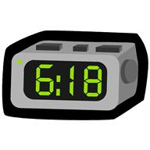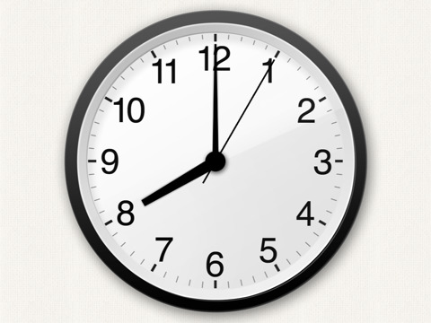

8:00

digital analog

# Length:

Longer/Shorter

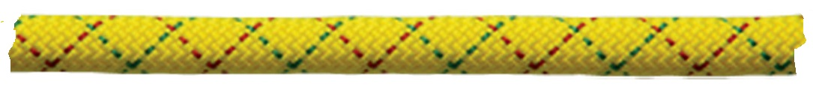

longer



shorter

longer





shorter

# Height:

Taller/Shorter





taller shorter

# Weight: Heavier/Lighter

# See the source image

# Image result for cat free clipart

lighter

heavier

# Balance Scale

### 

measures weight

# Volume:

Less /More

less more

# Volume:

Equivalent

# Calendar

# Plane Figures

triangle

rectangle

# Square:

circle

square

Right Angle

right angle

# Triangle:

Side and Vertex

 side vertex

# Rectangle:

Right Angle

right angle

# Picture Graph

Our Favorite Pets

|  |  |  |  |
| --- | --- | --- | --- |
| Cat | Dog | Horse | Fish |
| MCj04406680000[1]  MCj04406680000[1] | MCj04406660000[1] | MCj03438250000[1]  MCj03438250000[1]  MCj03438250000[1]  MCj03438250000[1] | MCj04125000000[1]  MCj04125000000[1]  MCj04125000000[1] |

# Table

Pets

|  |  |
| --- | --- |
| Animals | Number |
| Dogs | 12 |
| Cats | 9 |
| Birds | 5 |
| Lizards | 9 |

# Tally Marks

|  |  |
| --- | --- |
| Animals | Number |
| Dogs |  |
| Cats |  |
| Birds |  |
| Lizards |  |

# Core

part of the pattern that repeats

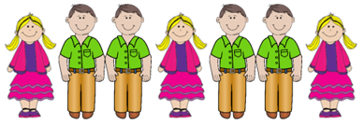

core

# Pattern

🞇■🞇■🞇■🞇

#### repeating pattern

🞭⯄🞭⯄⯄🞭⯄⯄⯄growing pattern

# Transfer a Repeating Pattern

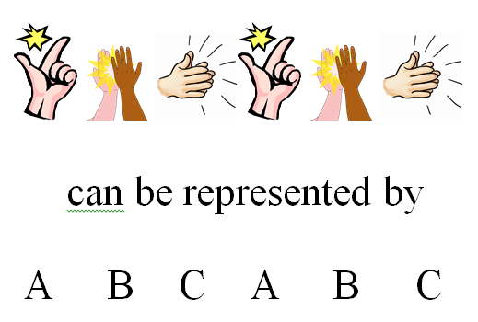

# Transfer a Growing Pattern

|  |  |  |  |  |  |  |  |  |  |  |
| --- | --- | --- | --- | --- | --- | --- | --- | --- | --- | --- |
|  |  |  |  |  |  |  |  |  |  |  |
|  |  |  |  |  |  |  |  |  |  |  |
|  |  |  |  |  |  |  |  |  |  |  |
|  |  |  |  |  |  |  |  |  |  |  |

can be represented by

2 4 6 8

# Equal

has the same value

### **=**

### 6 = 6

1 + 5 = 2 + 4

6 = 3 + 3

# Not Equal

# does not have the same value

# **≠**

# 5 ≠ 6

# 5 + 2 ≠ 1 + 5

4 + 3 ≠ 8

15 + 16