**Geometry**

**Vocabulary Word Wall Cards**

Mathematics vocabulary word wall cards provide a display of mathematics content words and associated visual cues to assist in vocabulary development. The cards should be used as an instructional tool for teachers and then as a reference for all students.

**Table of Contents**

**Reasoning, Lines, and**

**Transformations**

Basics of Geometry 1

Basics of Geometry 2

Geometry Notation

Logic Notation

Set Notation

Conditional Statement

Converse

Inverse

Contrapositive

Symbolic Representations in Logical Arguments

Conditional Statements and Venn Diagrams

Deductive Reasoning

Inductive Reasoning

Direct Proofs

Properties of Congruence

Law of Detachment

Law of Syllogism

Counterexample

Perpendicular Lines

Parallel Lines

Skew Lines

Transversal

Corresponding Angles

Alternate Interior Angles

Alternate Exterior Angles

Consecutive Interior Angles

Parallel Lines

Midpoint (definition)

Midpoint Formula

Find a Missing Endpoint

Slope Formula

Slope of Lines in Coordinate Plane

Distance Formula

Line Symmetry (Examples)

Point Symmetry (Examples)

Rotation (Origin)

Reflection

Translation

Dilation

Perpendicular Bisector

Constructions:

* A line segment congruent to a given line segment
* Perpendicular bisector of a line segment
* A perpendicular to a given line from a point not on the line
* A perpendicular to a given line at a point on the line
* A bisector of an angle
* An angle congruent to a given angle
* A line parallel to a given line through a point not on the given line
* An equilateral triangle inscribed in a circle
* A square inscribed in a circle
* A regular hexagon inscribed in a circle

**Triangles**

Classifying Triangles by Sides

Classifying Triangles by Angles

Triangle Sum Theorem

Exterior Angle Theorem

Pythagorean Theorem

Angle and Sides Relationships

Triangle Inequality Theorem

Congruent Triangles

SSS Triangle Congruence Postulate

SAS Triangle Congruence Postulate

HL Right Triangle Congruence

ASA Triangle Congruence Postulate

AAS Triangle Congruence Theorem

Similar Polygons

Similar Polygons and Proportions

AA Triangle Similarity Postulate

SAS Triangle Similarity Theorem

SSS Triangle Similarity Theorem

Altitude of a Triangle

Median of a Triangle

Concurrency of Medians of a Triangle

30°-60°-90° Triangle Theorem

45°-45°-90° Triangle Theorem

Trigonometric Ratios

Inverse Trigonometric Ratios

Area of a Triangle

**Polygons and Circles**

Polygon Exterior Angle Sum Theorem

Polygon Interior Angle Sum Theorem

Regular Polygon

Properties of Parallelograms

Rectangle

Rhombus

Square

Trapezoid

Isosceles Trapezoid

Circle

Circles – Inscribed

Circle Equation

Lines and Circles

Secant

Tangent

Central Angle

Measuring Arcs

Arc Length

Secants and Tangents

Inscribed Angle

Area of a Sector

Inscribed Angle Theorem 1

Inscribed Angle Theorem 2

Inscribed Angle Theorem 3

Segments in a Circle

Segments of Secants Theorem

Segment of Secants and Tangents Theorem

**Three-Dimensional Figures**

Cone

Cylinder

Polyhedron

Similar Solids Theorem

Sphere

Hemisphere

Pyramid

# Basics of Geometry 1

P

point P

|  |
| --- |
| **Point** – A point has no dimension.  It is a location on a plane. It is  represented by a dot. |
| **Line** – A line has one dimension. It is an infinite set of points represented by a line with two arrowheads that extend without end.  **A B**  *m*  AB or BA or line *m* |
| **Plane** – A plane has two dimensions extending without end. It is often represented by a parallelogram.  ***N***  *A*  *B*  *C*  plane ABC or plane *N* |

# Basics of Geometry 2

|  |
| --- |
| **Line segment** – A line segment consists of two endpoints and all the points between them.  AB or BA  **B**  **A** |
| **Ray** – A ray has one endpoint and extends without end in one direction.  **C**  BC  Note: Name the endpoint first.  BC and CB are different rays.  **B** |

# Geometry Notation

Symbols used to represent statements or operations in geometry.

|  |  |
| --- | --- |
| BC | segment BC |
| BC | ray BC |
| BC | line BC |
| BC | length of BC |
| **∠** | angle ABC |
| m**∠** | measure of angle ABC |
|  | triangle ABC |
| || | is parallel to |
| **⊥** | is perpendicular to |
| **≅** | is congruent to |
| **~** | is similar to |

# Logic Notation

|  |  |
| --- | --- |
| **⋁** | or |
| **⋀** | and |
| **→** | read “implies”, if… then… |
| **↔** | read “if and only if” |
| iff | read “if and only if” |
| **~** | not |
| **∴** | therefore |

# Set Notation

|  |  |
| --- | --- |
| **{ }** | empty set, null set |
| **∅** | empty set, null set |
| ***x*|** | read “*x* such that” |
| ***x*:** | read “*x* such that” |
| **⋃** | union, disjunction, or |
| **⋂** | intersection, conjunction, and |

# Conditional Statement

a logical argument consisting of

a set of premises,

hypothesis (p), and conclusion (q)

hypothesis

If an angle is a right angle,

then its measure is 90°.

conclusion

Symbolically:

if p, then q p**→**q

# Converse

formed by interchanging the hypothesis and conclusion of a conditional statement

Conditional: If an angle is a right angle,

then its measure is 90°.

Converse: If an angle measures 90°,

then the angle is a right angle.

Symbolically:

if q, then p q**→**p

# Inverse

formed by negating the hypothesis and conclusion of a conditional statement

Conditional: If an angle is a right angle, then its measure is 90°.

Inverse: If an angle is not a right angle, then its measure is not 90°.

Symbolically:

if ~p, then ~q ~p**→**~q

# Contrapositive

formed by interchanging and negating the hypothesis and conclusion of a conditional statement

Conditional: If an angle is a right angle, then its measure is 90°.

Contrapositive: If an angle does not measure 90°, then the angle is not a right angle.

Symbolically:

if ~q, then ~p ~q**→**~p

# Symbolic Representations in Logical Arguments

|  |  |  |
| --- | --- | --- |
| Conditional | if p, then q | p**→**q |
| Converse | if q, then p | q**→**p |
| Inverse | if not p, then not q | ~p**→**~q |
| Contrapositive | if not q, then not p | ~q**→**~p |

# Conditional Statements and Venn Diagrams

|  |  |
| --- | --- |
| Original Conditional Statement | Converse - Reversing the Clauses |
| If an animal is a dolphin, then it is a mammal. mammal  dolphin  True! | If an animal is a mammal, then it is a dolphin. dolphin  mammal  False!  (Counterexample: An  elephant is a mammal but is not a dolphin) |
| Inverse - Negating the Clauses | Contrapositive - Reversing and Negating the Clauses |
| If an animal is not a dolphin, then it is not a mammal. not mammal  not dolphin  False!  (Counterexample: A  whale is not a dolphin but  is still a mammal) | If an animal is not a mammal, then it is not a dolphin. not dolphin  True!  not mammal |

# Deductive Reasoning

method using logic to draw conclusions based upon definitions, postulates, and theorems

**Example of Deductive Reasoning:**

**Statement A:** If a quadrilateral contains only right angles, then it is a rectangle.

**Statement B:** Quadrilateral P contains only right angles.

**Conclusion: Quadrilateral *P* is a rectangle**.

# Inductive Reasoning

method of drawing conclusions from a limited set of observations

Example:

Given a pattern, determine the next figure (set of dots) using inductive reasoning.

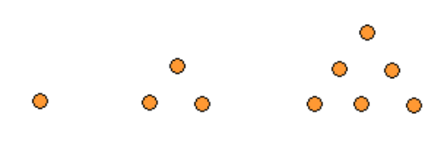

Figure 1 Figure 2 Figure 3

The next figure should look like this:

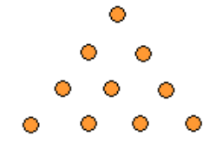

Figure 4

# 

# Direct Proofs

a justification logically valid and based on initial assumptions, definitions, postulates, and theorems

Example: (two-column proof)

Given: ∠1 ≅ ∠2

Prove: ∠2 ≅ ∠1

|  |  |
| --- | --- |
| Statements | Reasons |
| ∠1 ≅ ∠2 | Given |
| m∠1 = m∠2 | Definition of congruent angles |
| m∠2 = m∠1 | Symmetric Property of Equality |
| ∠2 ≅ ∠1 | Definition of congruent angles |

Example: (paragraph proof)

It is given that ∠1 $≅$ ∠2. By the Definition of congruent angles, m ∠1 = m∠2. By the Symmetric Property of Equality, m∠2 = m∠1. By the Definition of congruent angles, ∠2 $≅$ ∠1.

# Properties of Congruence

|  |  |
| --- | --- |
| **Reflexive Property** | $\overline{AB}$ ≅ $\overline{AB}$ |
| $$∠A≅∠A$$ |
| **Symmetric Property** | If $\overline{AB}≅\overline{CD} ,$ then $\overline{CD}≅\overline{AB}.$ |
| If $∠A≅∠B$, then $∠B≅∠A$ |
| **Transitive Property** | If $\overline{AB}≅\overline{CD}$ and $\overline{CD}≅\overline{EF},$ then $\overline{AB}≅\overline{EF}.$ |
| If $∠A≅∠B and ∠B≅∠C,$ then $∠A≅∠C.$ |

# Law of Detachment

deductive reasoning stating that if the hypothesis of a true conditional statement is true then the conclusion is also true

**A**

**120°**

Example:

If m∠A > 90°, then ∠A is an obtuse angle

m∠A = 120°

Therefore, ∠A is an obtuse angle.

If *p*→*q* is a true conditional statement and *p* is true, then *q* is true.

# Law of Syllogism

deductive reasoning that draws a new conclusion from two conditional statements when the conclusion of one is the hypothesis of the other

Example:

1. If a rectangle has four congruent sides,

then it is a square.

1. If a polygon is a square,

then it is a regular polygon.

1. If a rectangle has four congruent sides,

then it is a regular polygon.

If *p*→*q* and *q*→*r* are true conditional statements, then *p*→*r* is true.

# Counterexample

specific case for which a conjecture is false

Example:

Conjecture: “The product of any two numbers is odd.”

Counterexample: **2 ∙ 3 = 6**

One counterexample proves a conjecture false.

# Perpendicular Lines

two lines that intersect to form a right angle

***m***

***n***

Line *m* is perpendicular to line *n.*

*m* ⊥ *n*

Perpendicular lines have slopes that are negative reciprocals.

# Parallel Lines

coplanar lines that do not intersect

***m***

***n***

*m*||*n*

Line *m* is parallel to line *n.*

Parallel lineshave the same slope*.*

# Skew Lines

lines that do not intersect and are not coplanar

# Transversal

*F*

*E*

*C*

*D*

*A*

*B*

a line that intersects at least two other lines

***t***

***x***

***y***

***t***

***b***

***a***

Line *t* is atransversal.

# Corresponding Angles

angles in matching positions when a transversal crosses at least two lines

***t***

***a***

***b***

**4**

**5**

**6**

**3**

**2**

**1**

**7**

**8**

Examples:

1. ∠2 and ∠6 3) ∠1 and ∠5
2. ∠3 and ∠7 4) ∠4 and ∠8

# Alternate Interior Angles

angles inside the lines and on opposite sides of the transversal

***a***

***b***

***t***

**2**

**3**

**4**

**1**

# Alternate Exterior Angles

Examples:

1. ∠1 and ∠4
2. ∠2 and ∠3

angles outside the two lines and on opposite sides of the transversal

***t***

***a***

***b***

**2**

**1**

**3**

**4**

Examples:

1. ∠1 and ∠4
2. ∠2 and ∠3

# Consecutive Interior Angles

angles between the two lines and on the same side of the transversal

**2**

**1**

**3**

**4**

***t***

***a***

***b***

Examples:

1. ∠1 and ∠2
2. ∠3 and ∠4

# Parallel Lines

***a***

***b***

***t***

**4**

**5**

**6**

**3**

**2**

**1**

**7**

**8**

Line *a* is parallel to line *b* when

|  |  |
| --- | --- |
| Corresponding angles are congruent | ∠1 ≅ ∠5, ∠2 ≅ ∠6,  ∠3 ≅ ∠7, ∠4 ≅ ∠8 |
| Alternate interior angles are congruent | ∠3 ≅ ∠6  ∠4 ≅ ∠5 |
| Alternate exterior angles are congruent | ∠1 ≅ ∠8  ∠2 ≅ ∠7 |
| Consecutive interior angles are supplementary | m∠3+ m∠5 = 180°  m∠4 + m∠6 = 180° |

# Midpoint

(Definition)

divides a segment into two congruent segments

**D**

**C**

**M**

Example: M is the midpoint of $\overline{CD}$

$\overline{CM}$ ≅ $\overline{MD}$

*CM* = *MD*

Segment bisector may be a point, ray, line, line segment, or plane that intersects the segment at its midpoint.

# Midpoint Formula $\left(\frac{x_{1}+ x_{2}}{2}, \frac{y_{1}+y_{2}}{2}\right)$

given points A(*x*1, *y*1) and B(*x*2, *y*2)

midpoint M = $(\frac{x_{1}+x_{2}}{2},\frac{y_{1}+y_{2}}{2})$ $\left(\frac{x_{1}+ x_{2}}{2}, \frac{y_{1}+y_{2}}{2}\right)$

Example:

Find the midpoint, M, of the segment with endpoints A(4,1) and B(-2,5).

M = $(\frac{4+-2}{2},\frac{1+5}{2})$ = $\left(\frac{2}{2}, \frac{6}{2}\right)=(1,3)$

# Find a Missing Endpoint $\left(\frac{x_{1}+ x_{2}}{2}, \frac{y_{1}+y_{2}}{2}\right)$

given points A(*x*1, *y*1) and B(*x*2, *y*2)

midpoint M = $(\frac{x_{1}+x_{2}}{2},\frac{y_{1}+y_{2}}{2})$ $\left(\frac{x_{1}+ x_{2}}{2}, \frac{y_{1}+y_{2}}{2}\right)$

Example:

Find the endpoint B(x,y) if A(-2,3) and M(3,8).

$$\left(\frac{-2+x}{2},\frac{3+y}{2}\right)=(3,8)$$

$\frac{-2+x}{2}=3$ and $\frac{3+y}{2}=8$

*x* = 8 and *y* = 13

B (8,13)

# Slope Formula

ratio of vertical change to

horizontal change

|  |  |  |  |  |  |  |  |  |
| --- | --- | --- | --- | --- | --- | --- | --- | --- |
| slope | = | m | = | change in *y* | = | rise | = | *y*2 – *y*1 |
| change in *x* | run | *x*2 – *x*1 |

# Slopes of Lines in Coordinate Plane

**A**

**B**

(*x*1, *y*1)

(*x*2, *y*2)

(run)

*x*2 – *x*1

*y*2 – *y*1

(rise)

Parallel lines have the same slope.

Perpendicular lines have slopes whose product is -1.

Vertical lines have undefined slope.

Horizontal lines have 0 slope.

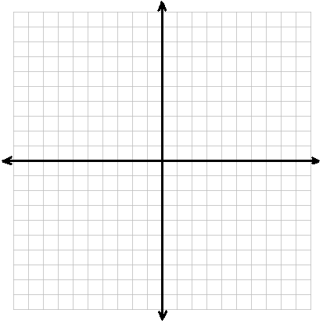

***y***

***x***

***n***

***p***

Example:

The slope of line *n* = -2. The slope of line *p* =.

-2 ∙  = -1, therefore, *n* **⊥** *p*.

# Distance Formula

given points A (*x*1, *y*1) and B (*x*2, *y*2)



**A**

**B**

(*x*1, *y*1)

(*x*2, *y*2)

*x*2 – *x*1

*y*2 – *y*1

The distance formula is derived from the application of the Pythagorean Theorem.

# Examples of

# Line Symmetry

MOM

B X

# Examples of

# Point Symmetry

**A**

**Aˊ**

**C**

**Cˊ**

**P**

pod

S Z

# Rotation

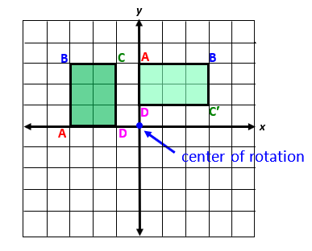(Origin)

**′**

**′**

**′**

|  |  |
| --- | --- |
| Preimage | Image |
| A(-3,0) | A′(0,3) |
| B(-3,3) | B′(3,3) |
| C(-1,3) | C′(3,1) |
| D(-1,0) | D′(0,1) |

Pre-image has been transformed by a   
90° clockwise rotationabout the origin.

# Reflection

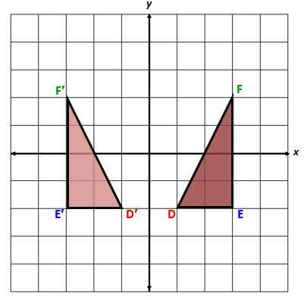

|  |  |
| --- | --- |
| Preimage | Image |
| D(1,-2) | D′(-1,-2) |
| E(3,-2) | E′(-3,-2) |
| F(3,2) | F′(-3,2) |

# Translation

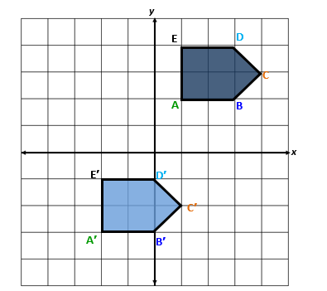

|  |  |
| --- | --- |
| Preimage | Image |
| A(1,2) | A′(-2,-3) |
| B(3,2) | B′(0,-3) |
| C(4,3) | C′(1,-2) |
| D(3,4) | D′(0,-1) |
| E(1,4) | E′(-2,-1) |

# Dilation

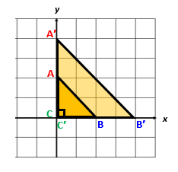

|  |  |
| --- | --- |
| Preimage | Image |
| A(0,2) | A′(0,4) |
| B(2,0) | B′(4,0) |
| C(0,0) | C′(0,0) |

# Perpendicular

Bisector

a segment, ray, line, or plane that is perpendicular to a segment at its midpoint

*s*

*Z*

**Y**

**X**

**M**

Example:

Line *s* is perpendicular to XY.

M is the midpoint, therefore XM ≅ MY.

Z lies on line *s* and is equidistant from X and Y.

Constructions

Traditional constructions involving a compass and straightedge reinforce students’ understanding of geometric concepts. Constructions help students visualize Geometry.

There are multiple methods to most geometric constructions. These cards illustrate only one method. Students would benefit from experiences with more than one method, including dynamic geometry software, and should be able to justify each step of geometric constructions.

Construct

segment *CD* congruent to segment *AB*

***B***

***A***

# Construct

***C***

***D***

**Fig. 2**

**Fig. 1**

a perpendicular bisector of segment *AB*

***B***

***A***

# Construct

***B***

***A***

**Fig. 2**

**Fig. 1**

**Fig. 3**

***A***

***B***

a perpendicular to a line from point P not on the line

# Construct

***P***

**Fig. 3**

***B***

***A***

***B***

***A***

***P***

**Fig. 4**

**Fig. 1**

**Fig. 2**

***B***

***A***

***P***

***B***

***A***

***P***

a perpendicular to a line from point P on the line

# Construct

***P***

***B***

***A***

***P***

***B***

***A***

***P***

**Fig. 2**

***B***

***A***

**Fig. 4**

**Fig. 3**

**Fig. 1**

***B***

***A***

***P***

a bisector of ∠*A*

# Construct

***A***

***A***

**Fig. 4**

**Fig. 3**

**Fig. 1**

**Fig. 2**

***A***

***A***

∠*Y* congruent to ∠*A*

***A***

# Construct

***Y***

***A***

***A***

***A***

***Y***

***Y***

***Y***

**Fig. 4**

**Fig. 3**

**Fig. 1**

**Fig. 2**

line *n* parallel to line *m* through point *P* not on the line

***m***

**P**

***m***

**P**

**Fig. 2**

**Fig. 1**

**Draw a line through point P intersecting line m.**

**Fig. 4**

**Fig. 3**

***m***

**P**

***m***

**P**

***n***

Construct

an equilateral triangle inscribed

in a circle

# Construct

**Fig. 4**

**Fig. 3**

**Fig. 1**

**Fig. 2**

a square inscribed in a circle

**Fig. 2**

**Fig. 1**

**Draw a diameter.**

# Construct

**Fig. 3**

**Fig. 4**

a regular hexagon inscribed

in a circle

**Fig. 4**

**Fig. 3**

**Fig. 1**

**Fig. 2**

# Classifying Triangles by Sides

|  |  |  |
| --- | --- | --- |
| ***Scalene*** | ***Isosceles*** | ***Equilateral*** |
|  |  |  |
| No congruent sides | At least 2 congruent sides | 3 congruent sides |
| No congruent angles | 2 or 3 congruent angles | 3 congruent angles |

All equilateral triangles are isosceles.

# Classifying Triangles

# by Angles

|  |  |  |  |
| --- | --- | --- | --- |
| ***Acute*** | ***Right*** | ***Obtuse*** | ***Equiangular*** |
|  |  |  |  |
| 3 acute angles | 1 right angle | 1 obtuse angle | 3 congruent angles |
| 3 angles, each less than 90° | 1 angle equals 90° | 1 angle greater than 90° | 3 angles,  each measures 60° |

# Triangle Sum Theorem

**B**

**A**

**C**

measures of the interior angles of a triangle = 180°

m∠A + m∠B + m∠C = 180°

# Exterior Angle Theorem

**A**

**B**

**C**

**1**

Exterior angle, m∠1, is equal to the sum of the measures of the two nonadjacent interior angles.

m∠1 = m∠B + m∠C

# Pythagorean Theorem

**b**

**c**

hypotenuse

**a**

**B**

**A**

**C**

If ΔABC is a right triangle, then

a2 + b2 = c2.

Conversely, if a2 + b2 = c2, then

ΔABC is a right triangle.

# Angle and Side Relationships

**A**

**∠**Ais the largest angle,

**12**

**8**

**6**

**88o**

**54o**

**38o**

**B**

**C**

therefore **BC** is the

longest side.

**12**

**8**

**6**

**88o**

**54o**

**38o**

**B**

**C**

**A**

**∠**B is the smallest angle, therefore **AC** is the shortest side.

# Triangle Inequality Theorem

The sum of the lengths of any two sides of a triangle is greater than the length of the third side.

**A**

**B**

**C**

**26 in**

**8 in**

**22 in**

Example:

AB + BC > AC AC + BC > AB

8 + 26 > 22 22 + 26 > 8

# AB + AC > BC

# 8 + 22 > 26

# Congruent Triangles

**A**

**B**

**C**

**F**

**D**

**E**

Two possible congruence statements:

ΔABC ≅ ΔFED

ΔBCA ≅ ΔEDF

Corresponding Parts of Congruent Figures

|  |  |
| --- | --- |
| ∠A ≅ ∠F |  |
| ∠B ≅ ∠E |  |
| ∠C ≅ ∠D |  |

# SSS Triangle Congruence Postulate

**A**

**B**

**C**

**F**

**D**

**E**

Example:

If Side AB ≅ FE,

Side AC ≅ FD, and

Side BC ≅ ED ,

then Δ ABC ≅ ΔFED.

# SAS Triangle Congruence Postulate

**A**

**B**

**C**

**F**

**E**

**D**

Example:

If Side AB ≅ DE,

Angle ∠A ≅ ∠D, and

Side AC ≅ DF ,

then Δ ABC ≅ ΔDEF.

# HL Right Triangle Congruence

**R**

**S**

**T**

**X**

**Y**

**Z**

Example:

If Hypotenuse RS ≅ XY, and

Leg ST ≅ YZ ,

then Δ RST ≅ ΔXYZ.

# ASA Triangle Congruence Postulate

**B**

**C**

**F**

**E**

**D**

**A**

Example:

If Angle ∠A ≅ ∠D,

Side AC ≅ DF , and

Angle ∠C ≅ ∠F

then Δ ABC ≅ ΔDEF.

# AAS Triangle Congruence Theorem

**R**

**S**

**T**

**X**

**Y**

**Z**

Example:

If Angle ∠R ≅ ∠X,

Angle ∠S ≅ ∠Y, and

Side ST ≅ YZ

then Δ RST ≅ ΔXYZ.

# Similar Polygons

**A**

**B**

**D**

**C**

**E**

**F**

**G**

**H**

**2**

**4**

**6**

**12**

|  |  |
| --- | --- |
| ABCD **~** HGFE | |
| **Angles** | **Sides** |
| ∠A corresponds to ∠H | $\overline{\text{AB}}$ corresponds to $\overline{\text{HG}}$ |
| ∠B corresponds to ∠G | $\overline{\text{BC}}$ corresponds to $\overline{\text{GF}}$ |
| ∠C corresponds to ∠F | $\overline{\text{CD}}$ corresponds to $\overline{\text{FE}}$ |
| ∠D corresponds to ∠E | $\overline{\text{DA}}$ corresponds to $\overline{\text{EH}}$ |

Corresponding angles are congruent.

Corresponding sides are proportional.

# Similar Polygons and Proportions

**A**

**B**

**C**

**H**

**G**

**F**

**12**

**6**

**4**

**x**

Corresponding vertices are listed in the same order.

Example: ΔABC **~** ΔHGF

 = 

 $\frac{\text{AD}}{\text{HE}}$

= 

The perimeters of the polygons are also proportional.

# AA Triangle Similarity Postulate

**R**

**S**

**T**

**X**

**Y**

**Z**

Example:

If Angle ∠R ≅ ∠X and

Angle ∠S ≅ ∠Y,

then ΔRST ~ ΔXYZ.

# SAS Triangle Similarity Theorem

**B**

**E**

**14**

**7**

**6**

**F**

**D**

**C**

**12**

**A**

Example:

If ∠A **≅** ∠D and

 = 

then ΔABC **~** ΔDEF.

# SSS Triangle Similarity Theorem

**Y**

**S**

**2.5**

**6.5**

**5**

**13**

**Z**

**X**

**T**

**R**

**6**

**12**

Example:

If  =  = 

then ΔRST ~ ΔXYZ.

# Altitude of a Triangle

a segment from a vertex perpendicular to the line containing the opposite side



**G**

**J**

**H**

altitudes

altitude/height

**B**

**C**

**A**

Every triangle has 3 altitudes.

# Median of a Triangle

A line segment from a vertex to the midpoint of the opposite side

**a**

**D**

median

**A**

**C**

**B**

D is the midpoint of AB; therefore,   
CD is a median of ΔABC.

Every triangle has 3 medians.

# Concurrency of Medians of a Triangle

**A**

**B**

**C**

**D**

**E**

**F**

centroid

**P**

Medians of ΔABC intersect at P (centroid) and

AP = AF, CP = CE , BP = BD.

# 30°-60°-90° Triangle

Theorem

30°

60°

*x*

*2x*

*x*

*x*

60°

30°

Given: short leg = *x*

Using equilateral triangle,

hypotenuse = 2 ∙ *x*

Applying the Pythagorean Theorem,

longer leg = *x* ∙

# 45°-45°-90° Triangle

Theorem

*x*

45°

*x*

45°

*x*

Given: leg = *x,*

then applying the Pythagorean Theorem;

hypotenuse2 = *x*2 + *x*2

hypotenuse = x

# Trigonometric

Ratios

(side adjacent ∠A)

**A**

**B**

**C**

***a***

***b***

***c***

(side opposite ∠A)

(hypotenuse)

*a*

*c*

hypotenuse

side opposite ∠A

sin A = =

*b*

*c*

hypotenuse

side adjacent ∠A

cos A = =

*a*

*b*

side adjacent to ∠A

side opposite ∠A*A*

tan A = =

# Inverse Trigonometric Ratios

**A**

**B**

**C**

***a***

***b***

***c***

|  |  |
| --- | --- |
| **Definition** | **Example** |
| If tan A = *x*, then tan-1 *x* = m∠A. | tan-1  = m∠A |
| If sin A = *y*, then sin-1 *y* = m∠A. | sin-1 = m∠A |
| If cos A = *z*, then cos-1 *z* = m∠A. | cos-1  = m∠A |

# Area of a Triangle

***h***

**A**

**B**

**C**

***a***

***b***

sin C = 

*h* = *a*∙sin C

A = *bh* (area of a triangle formula)

By substitution, A = *b*(*a*∙sin C)

A = *ab*∙sin C

# Polygon Exterior Angle Sum Theorem

The sum of the measures of the exterior angles of a convex polygon is 360°.

5

2

3

4

1

Example:

m∠1 + m∠2 + m∠3 + m∠4 + m∠5 = 360°

# Polygon Interior Angle Sum Theorem

The sum of the measures of the interior angles of a convex *n*-gon is (*n* – 2)∙180°.

S = m∠1 + m∠2 + … + m∠*n* = (*n* – 2)∙180°

5

2

3

4

1

Example:

If *n* = 5, then S = (5 – 2)∙180°

S = 3 ∙ 180° = 540°

# Regular Polygon

a convex polygon that is both equiangular and equilateral

Equilateral Triangle

Each angle measures 60o.

Square

Each angle measures 90o.

Regular Pentagon

Each angle measures 108o.

Regular Hexagon

Each angle measures 120o.

# Properties of Parallelograms

Regular Octagon

Each angle measures 135o.

* Opposite sides are parallel.
* Opposite sides are congruent.
* Opposite angles are congruent.
* Consecutive angles are supplementary.
* The diagonals bisect each other.

# Rectangle

A parallelogram with four right angles

* Diagonals are congruent.
* Diagonals bisect each other.

# Rhombus

A parallelogram with four congruent sides

* Diagonals are perpendicular.
* Each diagonal bisects a pair of opposite angles.

# Square

A parallelogram and a rectangle with four congruent sides

* Diagonals are perpendicular.
* Every square is a rhombus.

# Trapezoid

A quadrilateral with exactly one pair of parallel sides

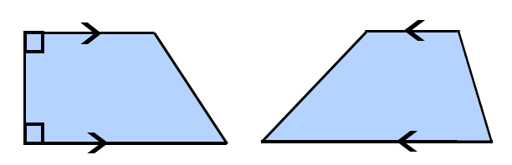 Bases

Legs

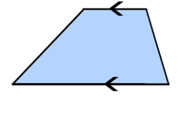

Median

* Two pairs of supplementary angles
* Median joins the midpoints of the nonparallel sides (legs)
* Length of median is half the sum of the lengths of the parallel sides (bases)

# Isosceles Trapezoid

A quadrilateral where the two base angles are equal and therefore the sides opposite the base angles are also equal

* Legs are congruent
* Diagonals are congruent

# Circle

all points in a plane equidistant from a given point called the center

radius

diameter

chord

**P**

**O**

**N**

**M**

**R**

**S**

* Point O is the center.
* MN passes through the center O and therefore, MN is a diameter.
* OP, OM, and ON are radii and

OP ≅ OM ≅ ON.

* RS and MN are chords. 

# Circles

A polygon is an inscribed polygon if all of its vertices lie on a circle.

A circle is considered

“inscribed” if it is

tangent to each side

of the polygon.

# Circle Equation

*y*

*x*

(*x,y*)

***x***

***y***

***r***

*x*2 + *y*2 = *r*2

circle with radius r and center at

the origin

standard equation of a circle

(*x* – *h*)2 + (*y* – *k*)2 = r2

with center (*h,k*) and radius r

# Lines and Circles

**C**

**D**

**A**

**B**

* Secant (AB) – a line that intersects a circle in two points.

* Tangent (CD) – a line (or ray or segment) that intersects a circle in exactly one point, the point of tangency, D.

# Secant

*y****°***

1

*x****°***

If two lines intersect in the interior of a circle, then the measure of the angle formed is one-half the sum of the measures of the intercepted arcs.

m∠1 = (*x*° + *y*°)

# Tangent

**Q**

**S**

**R**

A line is tangent to a circle if and only if the line is perpendicular to a radius drawn to the point of tangency.

QS is tangenttocircle R at point Q.

Radius RQ ⊥ QS

# Tangent

**C**

**B**

**A**

If two segments from the same exterior point are tangent to a circle, then they are congruent.

AB and AC are tangent to the circle

at points B and C.

Therefore, AB ≅ AC and AC = AB.

# Central Angle

an angle whose vertex is the center of the circle

**A**

**B**

**C**

minor arc AB

major arc ADB

**D**



∠ACB is a central angle of circle C.

Minor arc **–** corresponding central angle is less than 180°

Major arc **–** corresponding central angle is greater than 180°

# Measuring Arcs

**D**

**B**

**R**

**C**

70°

110°

**A**

|  |  |  |
| --- | --- | --- |
| Minor arcs | Major arcs | Semicircles |
| m AB = 110° | m BDA = 250° | m ADC = 180° |
| m BC = 70° | m BAC = 290° | m ABC = 180° |

The measure of the entire circle is 360o.

The measure of a minor arc is equal to   
its central angle.

The measure of a major arc is the difference between 360° and the measure of the related minor arc.

# Arc Length

4 cm

**A**

**B**

**C**

120°

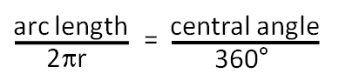

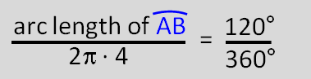Example:

# Secants and Tangents

Two secants

**1**

***x*°**

***y*°**

Secant-tangent

**1**

***x*°**

***y*°**

Two tangents

**1**

***x*°**

***y*°**

m∠1 = (*x*°- *y*°)

# Inscribed Angle

angle whose vertex is a point on the circle and whose sides contain chords of the circle

B

A

C

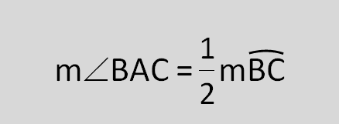

# Area of a Sector

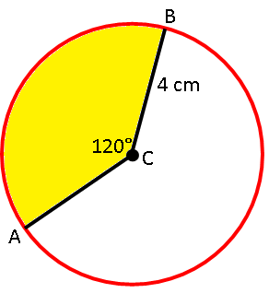region bounded by two radii and their intercepted arc

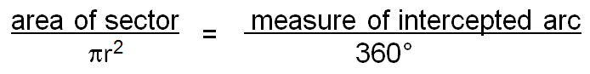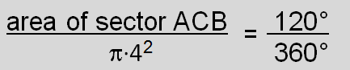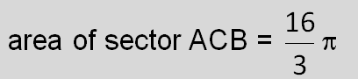

cm

Example:

# Inscribed Angle Theorem 1

**A**

**D**

**B**

**C**

If two inscribed angles of a circle intercept the same arc, then the angles are congruent.

# ∠BDC ≅ ∠BACInscribed Angle Theorem 2

**O**

**A**

**C**

**B**

m∠BAC = 90° if and only if BC is a diameter of the circle.

# Inscribed Angle Theorem 3

88°

92°

95°

85°

**M**

**J**

**T**

**H**

**A**

**92°**

M, A, T, and H lie on circle J if and only if

m∠A + m∠H = 180° and

m∠T + m∠M = 180°.

(opposite angles are supplementary)

# Segments in a Circle

**85°**

**a**

**b**

**c**

**d**

If two chords intersect in a circle,

then a∙b = c∙d.

Example:

**12**

**6**

***x***

**9**

12(6) = 9*x*

72 = 9*x*

8 = *x*

# Segments of Secants Theorem

B

**A**

**C**

D

**E**

AB ∙ AC = AD ∙ AE

Example:

9

6

*x*

16

6(6 + *x*) = 9(9 + 16)

36 + 6*x* = 225

*x* = 31.5

# Segments of Secants and Tangents Theorem

**A**

**B**

**C**

**E**

AE**2** = AB ∙ AC

25

20

*x*

Example:

252 = 20(20 + *x*)

625 = 400 + 20*x*

*x* = 11.25

# Cone

solid that has one circular base, an apex, and a lateral surface

**apex**

**slant height (l)**

**lateral surface**

**(curved surface of cone)**

**radius(*r*)**

**height (*h*)**

**base**

# Cylinder

V = π*r*2*h*

L.A. (lateral surface area) = π*r*l

S.A. (surface area) = π*r*2 + π*r*l

solid figure with two congruent circular bases that lie in parallel planes

**height (h)**

**radius (r)**

**base**

**base**

V = π*r*2*h*

L.A. (lateral surface area) = 2π*rh*

S.A. (surface area) = 2π*r*2 + 2π*rh*

# Polyhedron

solid that is bounded by polygons, called faces

[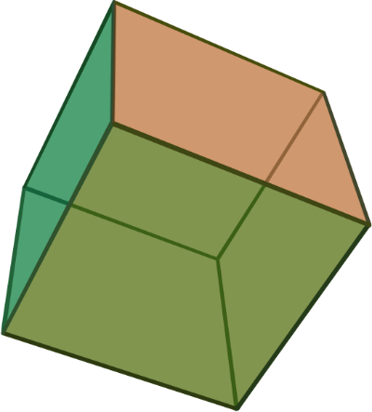](http://upload.wikimedia.org/wikipedia/commons/a/a5/Hexahedron.svg)[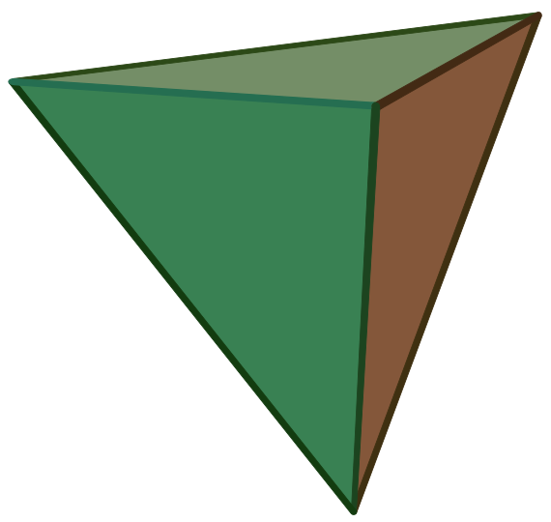](http://upload.wikimedia.org/wikipedia/commons/f/fc/Tetrahedron.svg)

[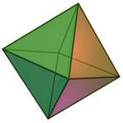](http://www.mathsisfun.com/geometry/octahedron.html)

[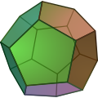](http://en.wikipedia.org/wiki/File:POV-Ray-Dodecahedron.svg) [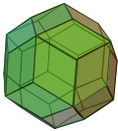](http://en.wikipedia.org/wiki/File:Rhombictriacontahedron.svg)

# Similar Solids Theorem

If two similar solids have a scale factor of **a:b**, then their corresponding surface areas have a ratio of **a2: b2**, and their corresponding

volumes have a ratio of **a3: b3**.

cylinder A ~ cylinder B

|  |  |  |
| --- | --- | --- |
| Example | | |
| scale factor | **a : b** | **3:2** |
| ratio of  surface areas | **a2: b2** | **9:4** |
| ratio of volumes | **a3: b3** | **27:8** |

**A**

**B**

# Sphere

a three-dimensional surface of which all points are equidistant from

a fixed point

**radius**

V = πr3

S.A. (surface area) = 4πr2

# Hemisphere

a solid that is half of a sphere with one flat, circular side

r

r

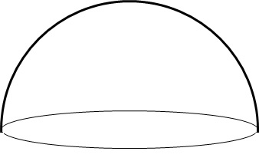

V = πr3

S.A. (surface area) = 3πr2

# Pyramid

polyhedron with a polygonal base and triangular faces meeting in a common vertex

**vertex**

**base**

**slant height (*l*)**

**height (*h*)**

**area of base (*B*)**

**perimeter of base (*p*)**

V (volume) = $\frac{1}{3}$*Bh*

L.A. (lateral surface area) = 

S.A. (surface area) = + *B*