Algebra I
Vocabulary Word Wall Cards

Mathematics vocabulary word wall cards provide a display of mathematics content words and associated visual cues to assist in vocabulary development. The cards should be used as an instructional tool for teachers and then as a reference for all students. The cards are designed for print use only.

Table of Contents

Expressions and Operations
Real Numbers
Absolute Value
Order of Operations
Expression
Variable
Coefficient
Term
Scientific Notation
Exponential Form
Negative Exponent
Zero Exponent
Product of Powers Property
Power of a Power Property
Power of a Product Property
Quotient of Powers Property
Power of a Quotient Property
Polynomial
Degree of Polynomial
Leading Coefficient
Add Polynomials (group like terms)
Add Polynomials (align like terms)
Subtract Polynomials (group like terms)
Subtract Polynomials (align like terms)
Multiply Binomials
Multiply Polynomials
Multiply Binomials (model)
Multiply Binomials (graphic organizer)
Multiply Binomials (squaring a binomial)
Multiply Binomials (sum and difference)
Factors of a Monomial
Factoring (greatest common factor)
Factoring (by grouping)
Factoring (perfect square trinomials)
Factoring (difference of squares)
Difference of Squares (model)
Divide Polynomials (monomial divisor)
Divide Polynomials (binomial divisor)
Square Root
Cube Root
Simplify Numerical Expressions Containing Square or Cube Roots
Add and Subtract Monomial Radical Expressions
Product Property of Radicals
Quotient Property of Radicals

Equations and Inequalities
Zero Product Property
Solutions or Roots
Zeros
x-Intercepts
Coordinate Plane
Literal Equation
Vertical Line
Horizontal Line
Quadratic Equation (solve by factoring)
Quadratic Equation (solve by graphing)
Quadratic Equation (number of real solutions)
Inequality
Graph of an Inequality
Transitive Property for Inequality
Addition/Subtraction Property of Inequality
Multiplication Property of Inequality
Division Property of Inequality
Linear Equation (standard form)
Linear Equation (slope intercept form)
Linear Equation (point-slope form)
Equivalent Forms of a Linear Equation
Slope
Slope Formula
Slopes of Lines
Perpendicular Lines
Parallel Lines
Mathematical Notation
System of Linear Equations (graphing)
System of Linear Equations (substitution)
System of Linear Equations (elimination)
System of Linear Equations (number of solutions)
Graphing Linear Inequalities
System of Linear Inequalities
Dependent and Independent Variable
Dependent and Independent Variable (application)
Graph of a Quadratic Equation
Vertex of a Quadratic Function
Quadratic Formula

Functions
Relations (definition and examples)
Function (definition)
Functions (examples)
Domain
Range
Function Notation
Parent Functions - Linear, Quadratic
Transformations of Parent Functions
- Translation
- Reflection
- Dilation
Linear Functions (transformational graphing)
- Translation
- Dilation (m>0)
- Dilation/reflection (m<0)
Quadratic Function (transformational graphing)
- Vertical translation
- Dilation (a>0)
- Dilation/reflection (a<0)
- Horizontal translation
Multiple Representations of Functions

Statistics
Direct Variation
Inverse Variation
Scatterplot
Positive Linear Relationship
Negative Linear Relationship
No Linear Relationship
Curve of Best Fit (linear)
Curve of Best Fit (quadratic)
Outlier Data (graphic)

Real Numbers
The set of all rational and irrational numbers
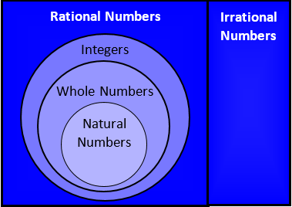
Natural Numbers | {1, 2, 3, 4 …}
Whole Numbers | {0, 1, 2, 3, 4 …}
Integers | {… -3, -2, -1, 0, 1, 2, 3 …}
Rational Numbers | the set of all numbers that can be written as the ratio of two integers with a non-zero denominator  (e.g., $2\frac{\text{3}}{\text{5}}$, -5, $\text{0.3}$, $\sqrt{\text{16}}$ , $\frac{\text{13}}{\text{7}}$)
Irrational Numbers | the set of all nonrepeating, nonterminating decimals  (e.g, $\sqrt{\text{7}}$ , $\text{π}$, -.23223222322223…)

Absolute Value

|5| = 5 |-5| = 5

-6 -5 -4 -3 -2 -1 0 1 2 3 4 5 6
5 units
5 units

The distance between a number
and zero

Order of Operations
Grouping Symbols | ( )  { }  [ ]
Exponents | a^{n}
Multiplication  Division | Left to Right
Addition  Subtraction | Left to Right

Expression
A representation of a quantity that may contain numbers, variables or operation symbols
x

-$\sqrt{\text{26}}$

3⁴ + 2m

ax² + bx + c

3(y + 3.9)² – $\frac{\text{8}}{\text{9}}$

Variable

2(y + $\sqrt{\text{3}}$)

9 + x = 2.08

d = 7c - 5

A = π r ²

Coefficient

(-4) + 2x

-7$y\sqrt{5}$

$\frac{\text{2}}{\text{3}}$ ab – $\frac{\text{1}}{\text{2}}$

πr²

Term

3x + 2y – 8

3 terms

-5x² – x

2 terms

$\frac{\text{2}}{\text{3}}$ab

1 term

Scientific Notation

a x 10^{n}

$\text{1} \text{≤}\text{ |}\text{a}\text{|} \text{<} \text{10}$ and n is an integer
Examples:
Standard Notation | Scientific Notation
17,500,000 | 1.75 x 10⁷
-84,623 | -8.4623 x 10⁴
0.0000026 | 2.6 x 10⁻⁶
-0.080029 | -8.0029 x 10⁻²
(4.3 x 10⁵) (2 x 10⁻²) | (4.3 x 2) (10⁵ x 10⁻²) =  8.6 x 10⁵⁺⁽⁻²⁾ = 8.6 x 10³
$$\frac{6.6 ×{10}^{6}}{2×{10}^{3}}$$ | $\frac{6.6}{2}×\frac{{10}^{6}}{{10}^{3}}=3.3 ×{10}^{6-3}$=  $$3.3 ×{10}^{3}$$

Exponential Form
exponent
a^{n} = a∙a∙a∙a…, a≠0
n factors
base

Examples:
2 ∙ 2 ∙ 2 = 2³ = 8
n ∙ n ∙ n ∙ n = n⁴
3∙3∙3∙x∙x = 3³x² = 27x²

Negative Exponent

a^{-n} = $\frac{\text{1}}{{\text{a}}^{\text{n}}}$ , a ≠ 0

Examples:
4⁻² = $\frac{\text{1}}{{\text{4}}^{\text{2}}}$ = $\frac{\text{1}}{\text{16}}$
$\frac{{\text{x}}^{\text{4}}}{{\text{y}}^{\text{-2}}}$ = $\frac{{\text{x}}^{\text{4}}}{\frac{\text{1}}{{\text{y}}^{\text{2}}}}$ = $\frac{{\text{x}}^{\text{4}}}{1}∙ \frac{{\text{y}}^{\text{2}}}{1}$ = ${\text{x}}^{\text{4}}{\text{y}}^{\text{2}}$
(2 – a)⁻² = $\frac{\text{1}}{{\text{(2 – }\text{a}\text{)}}^{\text{2}}}$ , a$≠\text{2}$

Zero Exponent

a⁰ = 1, a ≠ 0
Examples:
(-5)⁰ = 1
(3x + 2)⁰ = 1
(x²y⁻⁵z⁸)⁰ = 1
4m⁰ = 4 ∙ 1 = 4

Product of Powers Property

a^{m} ∙ a^{n} = a^{m + n}

Examples:
x⁴ ∙ x² = x⁴⁺² = x⁶
a³ ∙ a = a³⁺¹ = a⁴
w⁷ ∙ w⁻⁴ = w⁷ ⁺ ⁽⁻⁴⁾ = w³

Power of a Power Property

(a^{m})^{n} = a^{m · n}

Examples:

(y⁴)² = y^{4∙2} = y⁸

(g²)⁻³ = g^{2∙(-3)} = g⁻⁶ = $\frac{\text{1}}{{\text{g}}^{\text{6}}}$

Power of a Product Property

(ab)^{m} = a^{m} · b^{m}

Examples:

(-3a⁴b)² = (-3)²∙(a⁴)²∙b² = 9a⁸b²

$\frac{\text{-1}}{{\text{(2}\text{x}\text{)}}^{\text{3}}}$ = $\frac{\text{-1}}{{\text{2}}^{\text{3}}∙ {\text{x}}^{\text{3}}}$ = $\frac{\text{-1}}{{\text{8}\text{x}}^{\text{3}}}$
Quotient of Powers Property

$\frac{{\text{a}}^{\text{m}}}{{\text{a}}^{\text{n}}}$ = a^{m – n}, a ≠0
Examples:

$\frac{{\text{x}}^{\text{6}}}{{\text{x}}^{\text{5}}}$ = ${\text{x}}^{\text{6} \text{–} \text{5}}$ = ${\text{x}}^{\text{1}}$ = x
$\frac{{\text{y}}^{\text{-3}}}{{\text{y}}^{\text{-5}}}$= ${\text{y}}^{\text{-3} \text{–} \text{(}\text{-5}\text{)}}$ = y²
$\frac{{\text{a}}^{\text{4}}}{{\text{a}}^{\text{4}}}$ = a⁴⁻⁴ = a⁰ = 1

Power of Quotient Property

${\left(\frac{\text{a}}{\text{b}}\right)}^{\text{m}}$= $\frac{{\text{a}}^{\text{m}}}{{\text{b}}^{\text{m}} } ,$b≠0

Examples:

${\left(\frac{\text{y}}{\text{3}}\right)}^{\text{4}}$= $\frac{{\text{y}}^{\text{4}}}{{\text{3}}^{\text{4}}}$ = $\frac{\text{y}}{\text{81}}$

${\left(\frac{\text{5}}{\text{t}}\right)}^{\text{-3}}$= $\frac{{\text{5}}^{\text{-3}}}{{\text{t}}^{\text{-3}}}$ = $\frac{\frac{\text{1}}{{\text{5}}^{\text{3}}}}{\frac{\text{1}}{{\text{t}}^{\text{3}}}}$ = $\frac{\text{1}}{{\text{5}}^{\text{3}}}$∙$\frac{{\text{t}}^{\text{3}}}{\text{1}}$ = $\frac{{\text{t}}^{\text{3}}}{{\text{5}}^{\text{3}}}$ = $\frac{{\text{t}}^{\text{3}}}{\text{125}}$

Polynomial
Example | Name | Terms
7  6x | monomial | 1 term
3t – 1  12xy³ + 5x⁴y | binomial | 2 terms
2x² + 3x – 7 | trinomial | 3 terms

Nonexample | Reason
5m^{n} – 8 | variable exponent
n⁻³ + 9 | negative exponent

Degree of a Polynomial
Polynomial | Degree of  Each Term | Degree of Polynomial
-7m³n⁵ | -7m³n⁵ $→$ degree 8 | 8
2x + 3 | 2x $→$ degree 1  3 $→$ degree 0 | 1
6a³ + 3a²b³ – 21 | 6a³ $→$ degree 3  3a²b³ $→$ degree 5  -21 $→$ degree 0 | 5
The largest exponent or the largest sum of exponents of a term within a polynomial

Leading Coefficient

The coefficient of the first term of a polynomial written in descending order of exponents

Examples:

7a³ – 2a² + 8a – 1

-3n³ + 7n² – 4n + 10

16t – 1

Add Polynomials
(Group Like Terms – Horizontal Method)

Example:

(2g² + 6g – 4) + (g² – g)
= 2g² + 6g – 4 + g² – g
(Group like terms and add)

= (2g² + g²) + (6g – g) – 4
= 3g² + 5g – 4

Add Polynomials
(Align Like Terms –
Vertical Method)

Example:

(2g³ + 6g² – 4) + (g³ – g – 3)
(Align like terms and add)

2g³ + 6g² – 4
+ g³ – g – 3

3g³ + 6g² – g – 7
Subtract Polynomials
(Group Like Terms - Horizontal Method)

Example:
(4x² + 5) – (-2x² + 4x -7)
(Add the inverse.)
= (4x² + 5) + (2x² – 4x +7)
= 4x² + 5 + 2x² – 4x + 7
(Group like terms and add.)
= (4x² + 2x²) – 4x + (5 + 7)
= 6x² – 4x + 12

Subtract Polynomials
(Align Like Terms -
Vertical Method)

Example:
(4x² + 5) – (-2x² + 4x -7)
(Align like terms then add the inverse
and add the like terms.)
4x² + 5 4x² + 5
–(-2x² + 4x – 7) + 2x² – 4x + 7
6x² – 4x + 12

Multiply Binomials
Apply the distributive property.
(a + b)(c + d) =
a(c + d) + b(c + d) =
ac + ad + bc + bd

Example: (x + 3)(x + 2)

= (x + 3)(x + 2)
= x(x + 2) + 3(x + 2)
= x² + 2x + 3x + 6
= x² + 5x + 6

Multiply Polynomials
Apply the distributive property.

(x + 2)(3x² + 5x + 1)

(x + 2)( 3x² + 5x + 1)

= x(3x² + 5x + 1) + 2(3x² + 5x + 1)

= x·3x² + x·5x + x·1 + 2·3x² + 2·5x + 2·1

= 3x³ + 5x² + x + 6x² + 10x + 2

= 3x³ + 11x² + 11x + 2
Multiply Binomials
(Model)

Apply the distributive property.

Example: (x + 3)(x + 2)
x + 3
x + 2
1 =
x =
Key:
x² =

x² + 2x + 3x + = x² + 5x + 6
6

Multiply Binomials
(Graphic Organizer)
Apply the distributive property.

Example: (x + 8)(2x – 3)
= (x + 8)(2x + -3)
2x + -3
x + 8
2x² | -3x
16x | -24

2x² + 16x + -3x + -24 = 2x² + 13x – 24

Multiply Binomials
(Squaring a Binomial)

(a + b)² = a² + 2ab + b²
(a – b)² = a² – 2ab + b²
Examples:
(3m + n)² = 9m² + 2(3m)(n) + n²

= 9m² + 6mn + n²

(y – 5)² = y² – 2(5)(y) + 25
= y² – 10y + 25

Multiply Binomials

(Sum and Difference)

(a + b)(a – b) = a² – b²

Examples:

(2b + 5)(2b – 5) = 4b² – 25

(7 – w)(7 + w) = 49 – w²

Factors of a Monomial

The number(s) and/or variable(s) that are multiplied together to form a monomial
Examples: | Factors | Expanded Form
5b² | 5∙b² | 5∙b∙b
6x²y | 6∙x²∙y | 2∙3∙x∙x∙y
$$\frac{\text{-5}{\text{p}}^{\text{2}}{\text{q}}^{\text{3}}}{\text{2}}$$ | $\frac{\text{-5}}{\text{2}}$ ∙p²∙q³ | $\frac{\text{1}}{\text{2}}$ ·(-5)∙p∙p∙q∙q∙q

Factoring

(Greatest Common Factor)

Find the greatest common factor (GCF) of all terms of the polynomial and then apply the distributive property.

Example: 20a⁴ + 8a

2 ∙ 2 ∙ 5 ∙ a ∙ a ∙ a ∙ a + 2 ∙ 2 ∙ 2 ∙ a
common factors
GCF = 2 ∙ 2 ∙ a = 4a

20a⁴ + 8a = 4a(5a³ + 2)

Factoring

(By Grouping)

For trinomials of the form
$$ax^{2}+bx+c$$

Example: $3x^{2}+8x+4$

ac = 3 • 4 = 12
Find factors of ac that add to equal b
12 = 2 • 6 2 + 6 = 8

Factor out a common binomial
Group factors
Rewrite $8x$ as $2x$ + $6x$
$$3x^{2}+2x+6x+4$$
$$(3x^{2}+2x)+(6x+4)$$
$$x(3x+2)+2(3x+2)$$
$(3x+2)(x+2)$

Factoring

(Perfect Square Trinomials)

a² + 2ab + b² = (a + b)²
a² – 2ab + b² = (a – b)²

Examples:

x² + 6x +9 = x² + 2∙3∙x +3²
= (x + 3)²

4x² – 20x + 25 = (2x)² – 2∙2x∙5 + 5² = (2x – 5)²

Factoring

(Difference of Squares)

a² – b² = (a + b)(a – b)

Examples:

x² – 49 = x² – 7² = (x + 7)(x – 7)

4 – n² = 2² – n² = (2 – n) (2 + n)

9x² – 25y² = (3x)² – (5y)²
= (3x + 5y)(3x – 5y)

Difference of Squares (Model)

a² – b² = (a + b)(a – b)
b
a
a
b
a² – b²

a(a – b) + b(a – b)
(a + b)(a – b)
b
a
a – b
a – b
a + b
a – b

Divide Polynomials
(Monomial Divisor)

Divide each term of the dividend by the monomial divisor

Example:
(12x³ – 36x² + 16x) ÷ 4x

= $\frac{\text{12}\text{x}\text{3}\text{ – 36}\text{x}\text{2}\text{ + 16}\text{x}}{\text{4}\text{x}}$

= $\frac{{\text{12}\text{x}}^{\text{3}}}{\text{4}\text{x}}$ $\text{–}$ $\frac{\text{36}{\text{x}}^{\text{2}}}{\text{4}\text{x}}$ + $\frac{\text{16}\text{x}}{\text{4}\text{x}}$

= 3x² – 9x + 4

Divide Polynomials (Binomial Divisor)

Factor and simplify

Example:
(7w² + 3w – 4) ÷ (w + 1)

= $\frac{\text{7}\text{w}\text{2}\text{ + 3}\text{w}\text{ – 4}}{\text{w}\text{ + 1}}$

= $\frac{\left(\text{7}\text{w} \text{–}\text{ 4}\right)\text{(}\text{w} \text{+} \text{1)}}{\text{w} \text{+} \text{1}}$

= 7w – 4

Square Root

$\sqrt{{\text{x}}^{\text{2}}}$
radical symbol

radicand or argument

Simplify square root expressions.
Examples:

$\sqrt{{\text{9}\text{x}}^{\text{2}}}$ = $\sqrt{{\text{3}}^{\text{2}}\text{∙}{\text{x}}^{\text{2}}}$ = $\sqrt{{\text{(3x)}}^{\text{2}}}$ = 3x

-$\sqrt{{\text{(}\text{x} \text{–} \text{3)}}^{\text{2}}}$ = -(x – 3) = -x + 3

Squaring a number and taking a square root are inverse operations.

Cube Root
index

$\sqrt[\text{3}]{{\text{x}}^{\text{3}}}$
radicand or argument

radical symbol

Simplify cube root expressions.
Examples:

$\sqrt[\text{3}]{\text{64}}$ = $\sqrt[\text{3}]{{\text{4}}^{\text{3}}}$ = 4

$\sqrt[\text{3}]{\text{-27}}$ = $\sqrt[\text{3}]{{\text{(-3)}}^{\text{3}}}$ = -3

$\sqrt[\text{3}]{{\text{x}}^{\text{3}}}$ = x

Cubing a number and taking a cube root are inverse operations.

Simplify Numerical Expressions Containing
Square or Cube Roots

Simplify radicals and combine like terms where possible.
Examples:

$$\frac{1}{2}-\sqrt{32}-\frac{11}{2}+\sqrt{8}$$
$$=-\frac{10}{2}-4\sqrt{2}+2\sqrt{2}$$
$$=-5-2\sqrt{2}$$

$$\sqrt{18}-2\sqrt[3]{27}=3\sqrt{2}-2\left(3\right)$$
$=3\sqrt{2}-6$

Add and Subtract Monomial Radical Expressions

Add or subtract the numerical factors of the like radicals.
Examples:
$$6\sqrt[3]{5}-4\sqrt[3]{5}-\sqrt[3]{5}$$
$$=\left(6-4-1\right)\sqrt[3]{5}=\sqrt[3]{5}$$
$$2x\sqrt{3}+5x\sqrt{3}$$
$$=\left(2+5\right)x\sqrt{3}=7x\sqrt{3}$$
$$2\sqrt{3}+7\sqrt{2}-2\sqrt{3}=\left(2-2\right)\sqrt{3}+7\sqrt{2}=7\sqrt{2}$$

Product Property of Radicals

The nth root of a product equals
the product of the nth roots.

$\sqrt[n]{ab}= \sqrt[n]{a} ∙ \sqrt[n]{b}$
a ≥ 0 and b ≥ 0
Examples:
$\sqrt{\text{4}\text{x}}$ = $\sqrt{\text{4}}$ ∙ $\sqrt{\text{x}}$= 2$\sqrt{\text{x}}$
$\sqrt{{\text{5}\text{a}}^{\text{3}}}$ = $\sqrt{\text{5}}$ ∙ $\sqrt{{\text{a}}^{\text{3}}}$ = a$\sqrt{\text{5}\text{a}}$
$\sqrt[\text{3}]{16}$= $\sqrt[\text{3}]{\text{8∙2}}$ = $\sqrt[\text{3}]{\text{8}}$ ∙ $\sqrt[\text{3}]{\text{2}}$ = 2$\sqrt[\text{3}]{\text{2}}$

Quotient Property
of Radicals

The nth root of a quotient equals the quotient of the nth roots of the numerator and denominator.
$\sqrt[n]{\frac{a}{b}}=\frac{\sqrt[n]{a}}{\sqrt[n]{b}}$
a ≥ 0 and b ˃ 0
Example:
$\sqrt{\frac{\text{5}}{{\text{y}}^{\text{2}}}}$ = $\frac{\sqrt{\text{5}}}{\sqrt{{\text{y}}^{\text{2}}}}$ = $\frac{\sqrt{\text{5}}}{\text{y}}$, y ≠ 0

Zero Product Property

If ab = 0,
then a = 0 or b = 0.

Example:
(x + 3)(x – 4) = 0
(x + 3) = 0 or (x – 4) = 0
x = -3 or x = 4

The solutions or roots of the polynomial equation are -3 and 4.

Solutions or Roots

x² + 2x = 3
Solve using the zero product property.

x² + 2x – 3 = 0
(x + 3)(x – 1) = 0
x + 3 = 0 or x – 1 = 0
x = -3 or x = 1
The solutions or roots of the polynomial equation are -3 and 1.

Zeros
The zeros of a function f(x) are the values of x where the function is equal to zero.
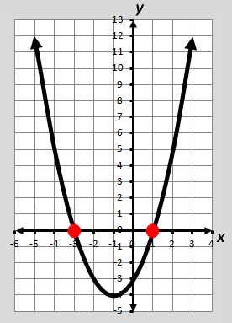
f(x) = x² + 2x – 3
Find f(x) = 0.

0 = x² + 2x – 3
0 = (x + 3)(x – 1)
x = -3 or x = 1

The zeros of the function f(x) = x² + 2x – 3
are -3 and 1 and are located at the
x-intercepts (-3,0) and (1,0).

The zeros of a function are also the solutions or roots of the related equation.

x-Intercepts

The x-intercepts of a graph are located where the graph crosses the x-axis and where f(x) = 0.

f(x) = x² + 2x – 3

0 = (x + 3)(x – 1)
0 = x + 3 or 0 = x – 1
x = -3 or x = 1

The zeros are -3 and 1.
The x-intercepts are:
-3 or (-3,0)
and
1 or (1,0)

Coordinate Plane
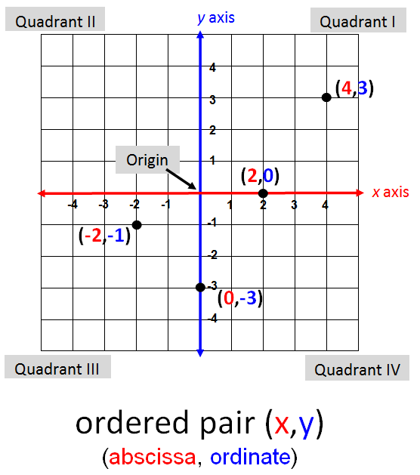

Literal Equation

A formula or equation that consists primarily of variables

Examples:
Ax + By = C
A = $\frac{\text{1}}{\text{2}}\text{bh}$
V = lwh
F = $\frac{\text{9}}{\text{5}}$ C + 32

A = πr²
Vertical Line
x = a
(where a can be any real number)

Example: x = -4
y

x

Horizontal Line
Vertical lines have undefined slope.

y = c
(where c can be any real number)

Example: y = 6
y

x

Horizontal lines have a slope of 0.

Quadratic Equation
(Solve by Factoring)

ax² + bx + c = 0
a ≠ 0

Example solved by factoring:
x² – 6x + 8 = 0 | Quadratic equation
(x – 2)(x – 4) = 0 | Factor
(x – 2) = 0 or (x – 4) = 0 | Set factors equal to 0
x = 2 or x = 4 | Solve for x

Solutions to the equation are 2 and 4.
Solutions are {2, 4}

Quadratic Equation
(Solve by Graphing)
ax² + bx + c = 0
a ≠ 0

Example solved by graphing:
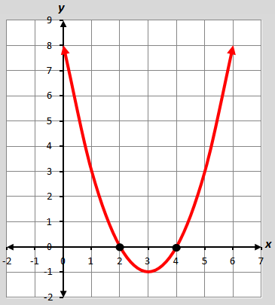
x² – 6x + 8 = 0

Quadratic Equation
Solutions to the equation are the x-coordinates
{2, 4} of the points where the function crosses the x-axis.
Graph the related function
f(x) = x² – 6x + 8.
(Number/Type of Real Solutions)
ax² + bx + c = 0, a ≠ 0
Examples | Graph of the related function | Number and Type of Solutions/Roots
x² – x = 3 | 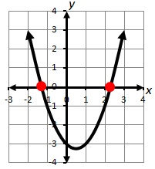 | 2 distinct Real roots  (crosses x-axis twice)
x² + 16 = 8x | 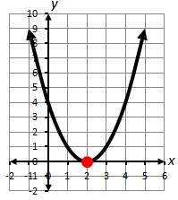 | 1 distinct Real root with a multiplicity of two (double root)  (touches x-axis but does not cross)
$\frac{1}{2}$x² – 2x + 3 = 0 | 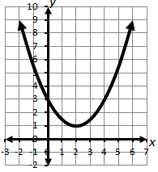 | 0 Real roots

Inequality

An algebraic sentence comparing two quantities

Symbol | Meaning
< | less than
≤ | less than or equal to
> | greater than
≥ | greater than or equal to
≠ | not equal to

Examples: -10.5 ˃ -9.9 – 1.2
8 < 3t + 2
x – 5y ≥ -12
x ≤ -11
r ≠ 3

Graph of an Inequality

Symbol | Example | Graph
< ; > | x < 3 | 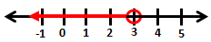
≤ ; ≥ | -3 ≥ y | 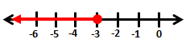
≠ | t ≠ -2 | 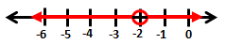

Transitive Property of Inequality

If | Then
a < b and b < c | a < c
a > b and b > c | a > c

Examples:
If 4x < 2y and 2y < 16,
then 4x < 16.

If x > y – 1 and y – 1 > 3,
then x > 3.

Addition/Subtraction Property of Inequality

If | Then
a > b | a + c > b + c
a ≥ b | a + c ≥ b + c
a < b | a + c < b + c
a ≤ b | a + c ≤ b + c

Example:
d – 1.9 ≥ -8.7
d – 1.9 + 1.9 ≥ -8.7 + 1.9

d ≥ -6.8
Multiplication Property of Inequality

If | Case | Then
a < b | c > 0, positive | ac < bc
a > b | c > 0, positive | ac > bc
a < b | c < 0, negative | ac > bc
a > b | c < 0, negative | ac < bc

Example: If c = -2
5 > -3
5(-2) < -3(-2)
-10 < 6

Division Property of Inequality
If | Case | Then
a < b | c > 0, positive | $\frac{\text{a}}{\text{c}}$ < $\frac{\text{b}}{\text{c}}$
a > b | c > 0, positive | $\frac{\text{a}}{\text{c}}$ > $\frac{\text{b}}{\text{c}}$
a < b | c < 0, negative | $\frac{\text{a}}{\text{c}}$ > $\frac{\text{b}}{\text{c}}$
a > b | c < 0, negative | $\frac{\text{a}}{\text{c}}$ < $\frac{\text{b}}{\text{c}}$

Example: If c = -4
-90 ≥ -4t
$\frac{\text{-90}}{\text{-4}}$ ≤ $\frac{\text{-4}\text{t}}{\text{-4}}$

22.5 ≤ t
Linear Equation
(Standard Form)
Ax + By = C
(A, B and C are integers; A and B cannot both equal zero)
y
Example:

-2x + y = -3
x

The graph of the linear equation is a straight line and represents all solutions (x, y) of the equation.

Linear Equation (Slope-Intercept Form)
y = mx + b
(slope is m and y-intercept is b)

Example: y = $\frac{\text{-}\text{4}}{\text{3}}$ x + 5
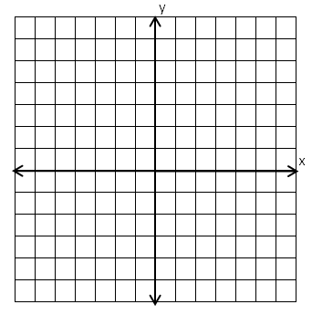
(0,5)
-4
3
m = $\frac{\text{-4}}{\text{3}}$

b = 5

Linear Equation (Point-Slope Form)

y – y₁ = m(x – x₁)
where m is the slope and (x₁,y₁) is the point

Example:
Write an equation for the line that passes through the point (-4,1) and has a slope of 2.
y – 1 = 2(x – (-4))
y – 1 = 2(x + 4)
y = 2x + 9

Equivalent Forms of a Linear Equation

Forms of a Linear Equation

Example | $$3y = 6 – 4x$$
Slope-Intercept  y = mx + b | $y=-\frac{4}{3}x+2$
Point-Slope  y – y₁ = m(x – x₁) | $$y-\left(-2\right)=-\frac{4}{3}(x-3)$$
Standard  Ax + By= C | $$4x+3y=6$$

Slope

A number that represents the rate of change in y for a unit change in x

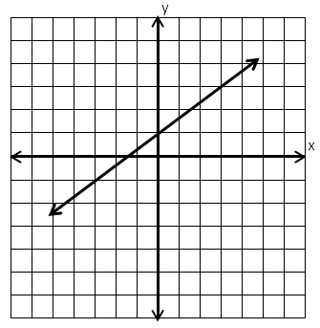

Slope = $\frac{\text{2}}{\text{3}}$
3
2

The slope indicates the
steepness of a line.

Slope Formula

The ratio of vertical change to
horizontal change
A
B
(x₁, y₁)
(x₂, y₂)
x₂ – x₁
y₂ – y₁
x
y

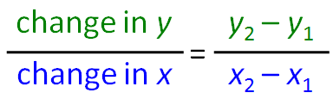
slope = m =

Slopes of Lines
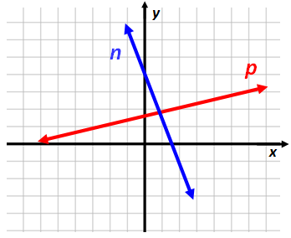
Line p
has a positive slope.

Line n
has a negative slope.

Vertical line s has an undefined slope.

Horizontal line t
has a zero slope.

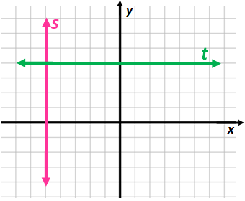

Perpendicular Lines
Lines that intersect to form a right angle
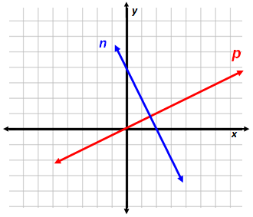

Perpendicular lines (not parallel to either of the axes) have slopes whose product is -1.
Example:
The slope of line n = -2. The slope of line p = $\frac{\text{1}}{\text{2}}$.
-2 ∙ $\frac{\text{1}}{\text{2}}$ = -1, therefore, n is perpendicular to p.

Parallel Lines

Lines in the same plane that do not intersect are parallel.
Parallel lines have the same slopes.
y
x
b
a

Example:
The slope of line a = -2.
The slope of line b = -2.
-2 = -2, therefore, a is parallel to b.

Mathematical Notation

Equation/Inequality | Set Notation
$$x=-5$$ | $$\left\{-5\right\}$$
$$x=5 or x=-3.4$$ | $$\left\{5, -3.4\right\}$$
$$y>\frac{8}{3}$$ | $$\left\{y∶y>\frac{8}{3}\right\}$$
$$x≤2.34$$ | $$\left\{x| x≤2.34\right\}$$
Empty (null) set $∅$ | { }
All Real Numbers | $$\left\{x∶x \right\}$$  $$\left\{All Real Numbers\right\}$$
System of Linear Equations

(Graphing)
-x + 2y = 3
2x + y = 4
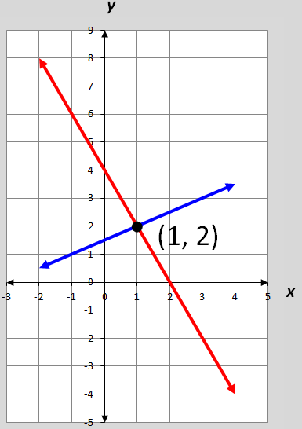
The solution,
(1, 2), is the only ordered pair that satisfies both equations
(the point of intersection).

System of Linear Equations

(Substitution)
x + 4y = 17
y = x – 2

Substitute x – 2 for y in the first equation.
x + 4(x – 2) = 17
x = 5
Now substitute 5 for x in the second equation.
y = 5 – 2
y = 3
The solution to the linear system is (5, 3),
the ordered pair that satisfies both equations.

System of Linear Equations

(Elimination)
-5x – 6y = 8
5x + 2y = 4

Add or subtract the equations to eliminate one variable.
-5x – 6y = 8
+ 5x + 2y = 4
-4y = 12
y = -3
Now substitute -3 for y in either original equation to find the value of x, the eliminated variable.
-5x – 6(-3) = 8
x = 2
The solution to the linear system is (2,-3), the ordered pair that satisfies both equations.

System of Linear Equations

(Number of Solutions)
Number of Solutions | Slopes and  y-intercepts | Graph  x  y
One solution | Different slopes | x  y
No solution | Same slope and  different -intercepts | x  y
Infinitely many solutions | Same slope and  same y-intercepts

Graphing Linear Inequalities
Example | Graph
y ≤ x + 2 | 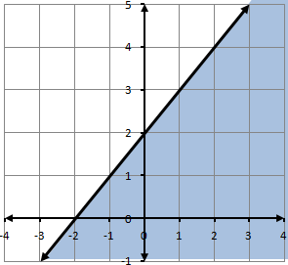  x  y
y > -x – 1 | 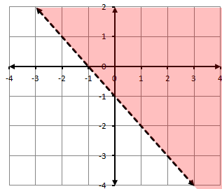  x  y
The graph of the solution of a linear inequality is a half-plane bounded by the graph of its related linear equation. Points on the boundary are included unless the inequality contains only < or >.

System of Linear Inequalities

Solve by graphing:
y > x – 3
y ≤ -2x + 3
y
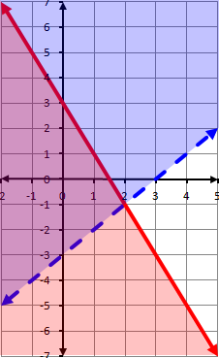
The solution region contains all ordered pairs that are solutions to both inequalities in the system.

(-1,1) is one of the solutions to the system located in the solution region.

x

Dependent and

Independent Variable

x, independent variable
(input values or domain set)

y, dependent variable
(output values or range set)
Example:
y = 2x + 7

Dependent and

Independent Variable
(Application)

Determine the distance a car will travel going 55 mph.
h | d
0 | 0
1 | 55
2 | 110
3 | 165

d = 55h
independent
dependent

Graph of a Quadratic Equation
y = ax² + bx + c
a ≠ 0
Example:
y
y = x² + 2x – 3

line of symmetry
x
vertex
The graph of the quadratic equation is a curve (parabola) with one line of symmetry and one vertex.
Vertex of a Quadratic Function
For a given quadratic y = ax²+ bx + c, the vertex (h, k) is found by computing
h =$\frac{-b}{2a}$ and then evaluating y at h to find k.

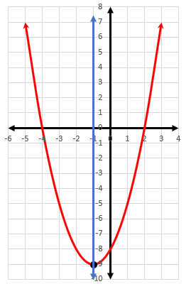
Example: $y=x^{2}+2x-8$

$$h=\frac{-b}{2a}=\frac{-2}{2(1)}=-1$$
$$k={\left(-1\right)}^{2}+2\left(-1\right)-8$$
$$k=-9$$
The vertex is (-1,-9).

Line of symmetry is $x=h$.
$$x=-1$$
Quadratic Formula

Used to find the solutions to any quadratic equation of the form,
f(x) = ax² + bx + c

x = $\frac{\text{-}\text{b}\text{ ±} \sqrt{{\text{b}}^{\text{2}}\text{-}\text{ 4}\text{a}\text{c} }}{\text{2}\text{a}}$

Example: $g(x)=2x^{2}-4x-3$

$$x=\frac{-\left(-4\right)±\sqrt{{\left(-4\right)}^{2}-4\left(2\right)\left(-3\right)}}{2\left(2\right)}$$
$$x=\frac{2+\sqrt{10}}{2}, \frac{2-\sqrt{10}}{2}$$

Relation
A set of ordered pairs

Examples:

x | 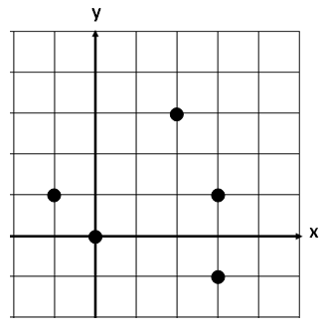  y
-3 | 4
0 | 0
1 | -6
2 | 2
5 | -1  Example 2
Example 1

{(0,4), (0,3), (0,2), (0,1)}
Example 3

Function
(Definition)

A relationship between two quantities in which every input corresponds to exactly one output
y
x
2

4

6

8

10
10

7

5

3

A relation is a function if and only if each element in the domain is paired with a unique element of the range.

Functions
(Examples)
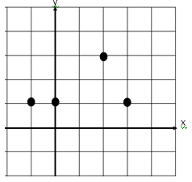
x | y
3 | 2
2 | 4
0 | 2
-1 | 2

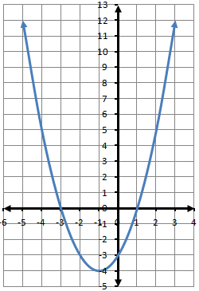
Domain
Example 4
{(-3,4), (0,3), (1,2), (4,6)}

Example 3
Example 2
Example 1
x
y

A set of input values of a relation

Examples:
f(x)
x
input | output
x | g(x)
-2 | 0
-1 | 1
0 | 2
1 | 3

Range
The domain of g(x) is {-2, -1, 0, 1}.
The domain of f(x) is all real numbers.

A set of output values of a relation

Examples:
f(x)
input | output
x | g(x)
-2 | 0
-1 | 1
0 | 2
1 | 3

x
The range of f(x) is all real numbers greater than or equal to zero.
The range of g(x) is {0, 1, 2, 3}.

Function Notation

f(x)

f(x) is read
“the value of f at x” or “f of x”

Example:
f(x) = -3x + 5, find f(2).
f(2) = -3(2) + 5
f(2) = -6 + 5
f(2) = -1

Letters other than f can be used to name functions, e.g., g(x) and h(x)

Parent Functions
(Linear, Quadratic)
y
x
Linear
f(x) = x

y
x
Quadratic
f(x) = x²

Transformations of Parent Functions
(Translation)
Parent functions can be transformed to create other members in a family of graphs.
Translations | g(x) = f(x) + k  is the graph of f(x) translated vertically – | k units up when k > 0.
 |  | k units down when k < 0.
 | g(x) = f(x − h)  is the graph of f(x) translated horizontally – | h units right when h > 0.
 |  | h units left when h < 0.

Transformations of Parent Functions
(Reflection)
Parent functions can be transformed to create other members in a family of graphs.
Reflections | g(x) = -f(x)  is the graph of f(x) – | reflected over the x-axis.
 | g(x) = f(-x)  is the graph of f(x) – | reflected over the y-axis.

Transformations of Parent Functions
(Vertical Dilations)
Parent functions can be transformed to create other members in a family of graphs.

Dilations | g(x) = a · f(x)  is the graph of f(x) – | vertical dilation (stretch)  if a > 1.  Stretches away  from the x-axis
vertical dilation (compression) if 0 < a < 1.
Compresses toward
the x-axis

Linear Function
(Transformational Graphing)
Translation
g(x) = x + b
Examples:
f(x) = x
t(x) = x + 4
h(x) = x – 2
y
x

Vertical translation of the parent function, f(x) = x

Linear Function
(Transformational Graphing)
Vertical Dilation (m > 0)
g(x) = mx

Examples:
f(x) = x
t(x) = 2x
h(x) = $\frac{\text{1}}{\text{2}}$x
y
x

Vertical dilation (stretch or compression) of the parent function, f(x) = x
Linear Function
(Transformational Graphing)
Vertical Dilation/Reflection (m < 0)
g(x) = mx
y
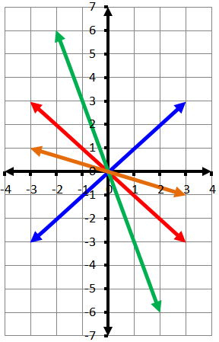
Examples:
f(x) = x
t(x) = -x
h(x) = -3x
d(x) = -$\frac{\text{1}}{\text{3}}$x

x

Vertical dilation (stretch or compression) with a reflection of f(x) = x
Quadratic Function
(Transformational Graphing)
Vertical Translation
h(x) = x² + c
y

Examples:
f(x) = x²
g(x) = x² + 2
t(x) = x² – 3

x

Vertical translation of f(x) = x²
Quadratic Function
(Transformational Graphing)
Vertical Dilation (a>0)
h(x) = ax²
y

x
Examples:
f(x) = x²
g(x) = 2x²
t(x) = $\frac{\text{1}}{\text{3}}$x²

Vertical dilation (stretch or compression) of f(x) = x²
Quadratic Function
(Transformational Graphing)
Vertical Dilation/Reflection (a<0)
h(x) = ax²
y
Examples:
f(x) = x²
g(x) = -2x²
t(x) = $\text{-}\frac{\text{1}}{\text{3}}$x²

x

Vertical dilation (stretch or compression) with a reflection of f(x) = x²
Quadratic Function
(Transformational Graphing)
Horizontal Translation
h(x) = (x ± c)²
y

Examples:
f(x) = x²
g(x) = (x + 2)²
t(x) = (x – 3)²

x
Horizontal translation of f(x) = x²

Multiple Representations of Functions
Equation
$$y=\frac{1}{2}x-2$$
Table
$$x$$ | $$y$$
-2 | -3
0 | -2
2 | -1
4 | 0

Graph
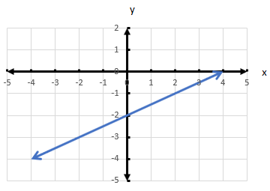

Words
y equals one-half x minus 2

Direct Variation
y = kx or k = $\frac{\text{y}}{\text{x}}$
constant of variation, k ≠ 0
y
Example:
y = 3x or 3 = $\frac{\text{y}}{\text{x}}$
x | y
-2 | -6
-1 | -3
0 | 0
1 | 3
2 | 6

x

3 = $\frac{-6}{-2}=\frac{-3}{-1}=\frac{3}{1}=\frac{6}{2}$

The graph of all points describing a direct variation is a line passing through the origin.

Inverse

Variation
y = $\frac{\text{k}}{\text{x}}$ or k = xy
constant of variation, k ≠ 0
x
y

Example:
y = $\frac{\text{3}}{\text{x}}$ or xy = 3

The graph of all points describing an inverse variation relationship are two curves that are reflections of each other.

Scatterplot

Graphical representation of the relationship between two numerical sets of data
x
y

Positive Linear Relationship (Correlation)

In general, a relationship where the dependent (y) values increase as independent values (x) increase
x
y

Negative Linear Relationship (Correlation)

In general, a relationship where the dependent (y) values decrease as independent (x) values increase.
x
y

No Linear Relationship
(Correlation)

No relationship between the dependent (y) values and independent (x) values.
x
y

Curve of Best Fit
(Linear)
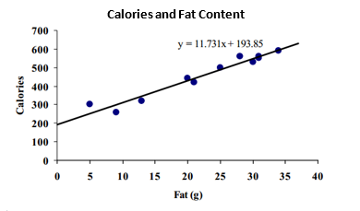

Equation of Curve of Best Fit
$y$ = 11.731x + 193.85

Curve of Best Fit
(Quadratic)
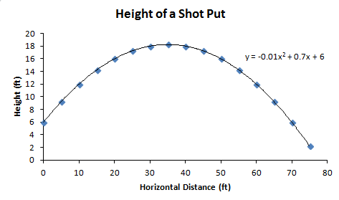

Equation of Curve of Best Fit
$y$ = -0.01x² + 0.7x + 6

Outlier Data

(Graphic)

