Algebra, Functions, and Data Analysis

**Vocabulary Word Wall Cards**

Mathematics vocabulary word wall cards provide a display of mathematics content words and associated visual cues to assist in vocabulary development. The cards should be used as an instructional tool for teachers and then as a reference for all students.

**Table of Contents**

**Expressions and Operations**

Real Numbers

Complex Numbers

Complex Number (examples)

Absolute Value

Order of Operations

Expression

Variable

Coefficient

Term

Scientific Notation

Exponential Form

Negative Exponent

Zero Exponent

Product of Powers Property

Power of a Power Property

Power of a Product Property

Quotient of Powers Property

Power of a Quotient Property

Polynomial

Degree of Polynomial

Leading Coefficient

Add Polynomials (group like terms)

Add Polynomials (align like terms)

Subtract Polynomials (group like terms)

Subtract Polynomials (align like terms)

Multiply Binomials

Multiply Polynomials

Multiply Binomials (model)

Multiply Binomials (graphic organizer)

Multiply Binomials (squaring a binomial)

Multiply Binomials (sum and difference)

Factors of a Monomial

Factoring (greatest common factor)

Factoring (perfect square trinomials)

Factoring (difference of squares)

Difference of Squares (model)

Factoring (sum and difference of cubes)

Factor by Grouping

Divide Polynomials (monomial divisor)

Divide Polynomials (binomial divisor)

Prime Polynomial

Square Root

Cube Root

*n*th Root

Simplify Radical Expressions

Add and Subtract Radical Expressions

Product Property of Radicals

Quotient Property of Radicals

**Equations and Inequalities**

Zero Product Property

Solutions or Roots

Zeros

x-Intercepts

Coordinate Plane

Literal Equation

Vertical Line

Horizontal Line

Quadratic Equation (solve by factoring and graphing)

Quadratic Equation (number of solutions)

Inequality

Graph of an Inequality

Transitive Property for Inequality

Addition/Subtraction Property of Inequality

Multiplication Property of Inequality

Division Property of Inequality

Linear Equation (standard form)

Linear Equation (slope intercept form)

Linear Equation (point-slope form)

Equivalent Forms of a Linear Equation

Slope

Slope Formula

Slopes of Lines

Perpendicular Lines

Parallel Lines

Mathematical Notation

System of Linear Equations (graphing)

System of Linear Equations (substitution)

System of Linear Equations (elimination)

System of Linear Equations (number of solutions)

Graphing Linear Inequalities

System of Linear Inequalities

Linear Programming

Dependent and Independent Variable

Dependent and Independent Variable (application)

Graph of a Quadratic Equation

Vertex of a Quadratic Function

Quadratic Formula

**Relations and Functions**

Relations (definition and examples)

Functions (definition)

Function (example)

Domain

Range

Function Notation

End Behavior

Increasing/Decreasing

Extrema

Parent Functions

* Linear, Quadratic
* Exponential, Logarithmic

Transformations of Parent Functions

* Translation
* Reflection
* Dilation

Linear Function (transformational graphing)

* Translation
* Dilation (m>0)
* Dilation/reflection (m<0)

Quadratic Function (transformational graphing)

* Vertical translation
* Horizontal translation
* Dilation (a>0)
* Dilation/reflection (a<0)

Arithmetic Sequence

Geometric Sequence

**Statistics**

Probability

Probability of Independent Events

Probability of Dependent Events

Probability (mutually exclusive events)

Fundamental Counting Principle

Permutation

Permutation (formula)

Combination

Combination (formula)

Statistics Notation

Mean

Median

Mode

Summation

Variance

Standard Deviation (definition)

Standard Deviation (graphic)

z-Score (definition)

z-Score (graphic)

Empirical Rule

Elements within One Standard Deviation of the Mean (graphic)

Scatterplot

Positive Linear Relationship (Correlation)

Negative Linear Relationship (Correlation)

No Correlation

Curve of Best Fit (linear)

Curve of Best Fit (quadratic)

Curve of Best Fit (exponential)

Outlier Data (graphic)

Real Numbers

The set of all rational and irrational numbers

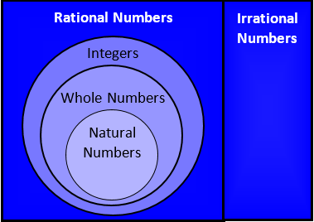

|  |  |
| --- | --- |
| **Natural Numbers** | {1, 2, 3, 4 …} |
| **Whole Numbers** | {0, 1, 2, 3, 4 …} |
| **Integers** | {… -3, -2, -1, 0, 1, 2, 3 …} |
| **Rational Numbers** | the set of all numbers that can be written as the ratio of two integers with a non-zero denominator  (e.g., $2\frac{\text{3}}{\text{5}}$, -5, $\text{0.3}$, $\sqrt{\text{16}}$, $\frac{\text{13}}{\text{7}}$) |
| **Irrational Numbers** | the set of all nonrepeating, nonterminating decimals  (e.g, $\sqrt{\text{7}}$, $\text{π}$, -.23223222322223…) |

# Complex Numbers

**Imaginary** **Numbers**

**Real** **Numbers**

The set of all real and

imaginary numbers

# Complex Number

(Examples)

$$\text{a} \text{±} \text{b}\text{i}$$

*a* and *b* are real numbers and *i* = $\sqrt{1}$

A complex number consists of both real (*a*) and imaginary (*bi*) but either part can be 0

|  |  |
| --- | --- |
| **Case** | **Examples** |
| *a* = 0 | -*i,* 0.01*i*, |
| *b* = 0 | $\sqrt{\text{5}}$, 4, -12.8 |
| *a* ≠ 0, *b* ≠ 0 | 39 – 6*i,* -2 + π*i* |

# Absolute Value

|5| = 5 |-5| = 5

-6 -5 -4 -3 -2 -1 0 1 2 3 4 5 6

**5 units**

**5 units**

The distance between a number

and zero

# Order of Operations

|  |  |
| --- | --- |
| Grouping Symbols | ( )  { }  [ ] |
| Exponents | *an* |
| Multiplication  Division | **Left to Right** |
| Addition  Subtraction | **Left to Right** |

# Expression

A representation of a quantity that may contain numbers, variables or operation symbols

*x*





3(*y* + 3.9)4 –

# Variable



9 + *log* *x* = 2.08

*d* = 7*c* - 5

*A* = π *r* 2

# Coefficient

(-4) + *2 log x*



*ab* –

π*r*2

# Term

3 *log x* + 2*y* – 8

3 terms

-5*x*2 – *x*

2 terms

**

1 term

# Scientific Notation

*a* x 10*n*

and *n* is an integer

Examples:

|  |  |
| --- | --- |
| Standard Notation | Scientific Notation |
| 17,500,000 | 1.75 x 107 |
| -84,623 | -8.4623 x 104 |
| 0.0000026 | 2.6 x 10-6 |
| -0.080029 | -8.0029 x 10-2 |
| (4.3 x 105) (2 x 10-2) | (4.3 x 2) (105 x 10-2) =  8.6 x 105+(-2) = 8.6 x 103 |
|  | = |

# Exponential Form

exponent

*an*= *a∙a∙a∙a*…, *a*≠0

*n* factors

base

Examples:

|  |
| --- |
| 2 ∙ 2 ∙ 2 = 23 = 8 |
| *n* ∙ *n* ∙ *n* ∙ *n* = *n*4 |
| 3∙3∙3∙x∙x = 33x2 = 27x2 |

# Negative Exponent

*a-n* = , *a* ≠ 0

Examples:

|  |
| --- |
| 4-2 = = |
| = = = |
| (2 – *a*)-2 = , *a* |

# Zero Exponent

*a*0 = 1, *a* ≠ 0

Examples:

|  |
| --- |
| (-5)0 = 1 |
| (3*x* + 2)0 = 1 |
| (*x*2*y-*5*z*8)0 = 1 |
| 4*m*0 = 4 ∙ 1 = 4 |
|  |

# Product of Powers Property

*am*∙ *a*n = *am + n*

Examples:

|  |
| --- |
| *x*4 ∙ *x*2= *x*4+2 = *x*6 |
| *a*3 ∙ *a* = *a*3+1 = *a*4 |
| *w*7 ∙ *w*-4= *w*7 + (-4) = *w*3 |

# Power of a Power Property

(*am*)*n* = *am* ***·*** *n*

Examples:

(*y*4)2 = *y*4∙2 = *y*8

(*g*2)-3 = *g*2∙(-3) = *g*-6 =

# Power of a Product Property

(*ab*)*m* = *am* · *bm*

Examples:

|  |
| --- |
|  |
|  |

Quotient of Powers Property

$\frac{{\text{a}}^{\text{m}}}{{\text{a}}^{\text{n}}}$ = *am – n*, *a* ≠0

Examples:

= = = *x*

= = *y*2

= *a*4-4 = *a*0 = 1

# Power of Quotient Property

${\left(\frac{\text{a}}{\text{b}}\right)}^{\text{m}}$ = $\frac{{\text{a}}^{\text{m}}}{{\text{b}}^{\text{m}} } ,$*b*≠0

Examples:

${\left(\frac{\text{y}}{\text{3}}\right)}^{\text{4}}$ = $\frac{{\text{y}}^{\text{4}}}{{\text{3}}^{\text{4}}}$ = $\frac{\text{y}}{\text{81}}$

# ${\left(\frac{\text{5}}{\text{t}}\right)}^{\text{-3}}$ = $\frac{{\text{5}}^{\text{-3}}}{{\text{t}}^{\text{-3}}}$ = $\frac{\frac{\text{1}}{{\text{5}}^{\text{3}}}}{\frac{\text{1}}{{\text{t}}^{\text{3}}}}$ = $\frac{\text{1}}{{\text{5}}^{\text{3}}}$ ∙ $\frac{{\text{t}}^{\text{3}}}{\text{1}}$ = $\frac{{\text{t}}^{\text{3}}}{{\text{5}}^{\text{3}}}$ = $\frac{{\text{t}}^{\text{3}}}{\text{125}}$

# Polynomial

|  |  |  |
| --- | --- | --- |
| **Example** | **Name** | **Terms** |
| 7  6*x* | monomial | 1 term |
| 3*t* – 1  12*xy*3 + 5*x*4*y* | binomial | 2 terms |
| *2x*2 + 3*x* – 7 | trinomial | 3 terms |

|  |  |
| --- | --- |
| **Nonexample** | **Reason** |
| 5*mn* – 8 | variable exponent |
| *n*-3 + 9 | negative exponent |

# Degree of a Polynomial

|  |  |  |
| --- | --- | --- |
| Polynomial | Degree of  Each Term | Degree of Polynomial |
| -7*m*3*n*5 | -7*m*3*n*5  degree 8 | 8 |
| 2*x*+ 3 | 2*x $→$* degree 1  3 degree 0 | 1 |
| 6*a*3 + 3*a*2*b*3 – 21 | 6*a*3 degree 3  3*a*2*b*3 degree 5  -21 $→$ degree 0 | 5 |

The largest exponent or the largest sum of exponents of a term within a polynomial

# Leading Coefficient

The coefficient of the first term of a polynomial written in descending order of exponents

Examples:

|  |
| --- |
| 7*a*3 – 2*a*2 + 8*a* – 1 |
| -3*n*3 + 7*n*2 – 4*n* + 10 |
| 16*t* – 1 |

# Add Polynomials

(Group Like Terms – Horizontal Method)

Example:



(2*g*2 + 6*g* – 4) + (*g*2 – *g*)

= 2*g*2 + 6*g* – *4* + *g*2 – *g*

(Group like terms and add)

= (2g2 + g2) + (6g – g) – 4

 3g2 + 5g – 4

# Add Polynomials

(Align Like Terms –   
Vertical Method)

Example:



 (2*g*3 + 6*g2* – 4) + (*g*3 – *g* – 3)

(Align like terms and add)

2*g*3 + 6*g*2 – 4

+  *g*3 – *g* – 3

# 3*g*3 + 6*g*2 – *g* – 7Subtract Polynomials

(Group Like Terms - Horizontal Method)

Example:

  (4*x*2 + 5) – (-2*x*2 + 4*x* -7)

(Add the inverse)

= (4*x*2 + 5) + (2*x*2 – 4x +7)

= 4*x*2 + 5 + 2x2 – 4*x* + 7

(Group like terms and add.)

= (4*x*2 + 2*x*2) – 4*x* + (5 + 7)

 6x2 – 4*x* + 12

# Subtract Polynomials

(Align Like Terms -

Vertical Method)

Example:



 (4*x*2 + 5) – (-2*x*2 + 4*x* -7)

(Align like terms then add the inverse   
and add the like terms.)

4*x*2 + 5 4*x*2 + 5

–(-2*x*2  + 4*x* – 7) + 2*x*2 – 4*x* + 7

 6*x*2 – 4*x* + 12

# Multiply Binomials

Apply the distributive property.

(*a* + *b*)(*c* + *d*) =

*a*(*c* + *d*) + *b*(*c* + *d*) =

*ac* + *ad* + *bc* + *bd*

Example: (*x* + 3)(*x* + 2)

= (*x* + 3)(*x* + 2)

= *x*(*x* + 2) + 3(*x* + 2)

= x2 + 2*x* + 3*x* + 6

= *x*2 + 5*x* + 6

# Multiply Polynomials

Apply the distributive property.

(*a* + *b*)(*d* + *e* + *f*)

(*a* + *b*)( *d* + *e* + *f* )

= *a*(*d* + *e* + *f*) + *b*(*d* + *e* + *f*)

= *ad* + *ae* + *af* + *bd* + *be* + *bf*Multiply Binomials

(Model)

Apply the distributive property.

Example: (*x* + 3)(*x* + 2)

1 =

*x* =

Key:

*x*2 =

*x* + 3

*x* + 2

*x*2 + 2*x* + 3*x* + **6** = *x*2 + 5*x* + 6

# Multiply Binomials

(Graphic Organizer)

Apply the distributive property.

Example: (*x* + 8)(2*x* – 3)

= (*x* + 8)(2*x* + -3)

2*x* + -3

*x* + 8

|  |  |
| --- | --- |
| 2*x*2 | -3*x* |
| 16*x* | -24 |

2*x*2 + 16*x* + -3*x* + -24 = 2*x*2 + 13*x* – 24

# Multiply Binomials

(Squaring a Binomial)

(*a* **+** *b*)2 = *a*2 **+** **2***ab* + *b*2

(*a* **–** *b*)2 = *a*2 **–** **2***ab* + *b*2

Examples:

(3*m* + *n*)2 = 9*m*2 **+ 2**(3*m*)(*n*) + *n*2

= 9*m*2 + 6*mn* + *n*2

(*y* – 5)2 = *y*2 **– 2**(5)(*y*) + 25

= *y*2 – 10*y* + 25

# Multiply Binomials

# (Sum and Difference)

(*a* + *b*)(*a* – *b*) = *a*2 – *b*2

Examples:

(2*b* + 5)(2*b* – 5) = 4*b*2 – 25

(7 – *w*)(7 + *w*) = 49 – *w*2

# Factors of a Monomial

The number(s) and/or variable(s) that are multiplied together to form a monomial

|  |  |  |
| --- | --- | --- |
| **Examples:** | **Factors** | **Expanded Form** |
| 5*b*2 | 5∙*b2* | 5∙*b∙b* |
| 6*x*2*y* | 6∙*x*2∙*y* | 2∙3∙*x∙x∙y* |
|  | ∙*p*2∙*q*3 | ·(-5)∙*p∙p*∙*q∙q∙q* |

# Factoring

# (Greatest Common Factor)

Find the greatest common factor (GCF) of all terms of the polynomial and then apply the distributive property.

Example: 20*a*4 + 8*a*

2 ∙ 2 ∙ 5 ∙ *a ∙ a ∙ a ∙ a* + 2 ∙ 2 ∙ 2 ∙ *a*

common factors

GCF = 2 ∙ 2 ∙ a = 4*a*

20*a*4 + 8*a* = 4*a*(5*a*3+ 2)

# Factoring

# (Perfect Square Trinomials)

*a*2 **+ 2***ab* + *b*2 = (*a* **+** *b*)2

*a*2 **– 2***ab*+ *b*2 = (*a* **–** *b*)2

Examples:

*x*2 **+** 6*x* +9 = *x*2 **+ 2**∙3∙*x* +32

= (*x* **+** 3)2

4*x*2 **–** 20*x* + 25 = (2*x*)2 **– 2**∙2*x*∙5 + 52 = (2*x* **–** 5)2

# Factoring

# (Difference of Squares)

*a*2 – *b*2 = (*a* + b)(*a* – *b*)

Examples:

*x*2 – 49= *x*2 – 72 = (*x* + 7)(*x* – 7)

4 – *n*2 = 22 – *n*2 = (2 – *n*) (2 + *n*)

9*x*2 – 25*y*2 = (3*x*)2 – (5*y*)2

= (3*x* + 5*y*)(3*x* – 5*y*)

# Difference of Squares

(Model)

*a*2 – *b*2 = (*a* + *b*)(*a* – *b*)

*b*

*a*

*a*

*b*

*a*2 – *b*2

*a*(*a* – *b*)+ *b*(*a* – *b*)

(*a + b*)(*a* – *b*)

*a* + *b*

*a – b*

*b*

*a*

*a – b*

*a – b*

# Factoring

# (Sum and Difference of Cubes)

*a*3 + *b*3 = (*a* + *b*)(*a2* – *ab* + *b2*)

*a*3 – *b*3 = (*a* – *b*)(*a2* + *ab + b2*)

Examples:

|  |
| --- |
| 27*y*3 + 1= (3*y*)3 + (1)3  = (3*y* + 1)(9*y*2 – 3y + 1) |
| *x*3 – 64 = *x*3 – 43 = (*x* – 4)(*x*2 + 4*x* + 16) |

# Factoring

# (By Grouping)

For trinomials of the form

$$ax^{2}+bx+c$$

# Example: $3x^{2}+8x+4$

ac = 3 • 4 = 12

Find factors of ac that add to equal b

12 = 2 • 6 2 + 6 = 8

Rewrite $8x$ as $2x$ + $6x$

Factor out a common binomial

Group factors

$$3x^{2}+2x+6x+4$$

$$(3x^{2}+2x)+(6x+4)$$

$$x(3x+2)+2(3x+2)$$

$(3x+2)(x+2)$

# Divide Polynomials

(Monomial Divisor)

Divide each term of the dividend by the monomial divisor

Example:



 (12*x*3 – 36*x*2 + 16*x*) ÷ 4*x*

=

= +

 3*x*2 – 9*x* + 4

# Divide Polynomials (Binomial Divisor)

Factor and simplify

Example:



 (7*w*2 + 3*w* – 4) ÷ (*w* + 1)

=

=

 7*w* – 4

# Prime Polynomial

Cannot be factored into a product of lesser degree polynomial factors

|  |
| --- |
| **Example** |
| *r* |
| 3*t* + 9 |
| *x*2+ 1 |
| 5*y*2 – 4*y* + 3 |

|  |  |
| --- | --- |
| **Nonexample** | **Factors** |
| *x*2 – 4 | (*x* + 2)(*x* – 2) |
| 3*x*2 – 3*x* + 6 | 3(*x* + 1)(*x* – 2) |
| *x*3 | *xx*2 |

# Square Root

$\sqrt{{\text{x}}^{\text{2}}}$

radical symbol

radicand or argument

Simplify square root expressions.

Examples:

|  |
| --- |
| $\sqrt{{\text{9}\text{x}}^{\text{2}}}$ = $\sqrt{{\text{3}}^{\text{2}}\text{∙}{\text{x}}^{\text{2}}}$ = $\sqrt{{\text{(3x)}}^{\text{2}}}$ = 3*x* |
| - $\sqrt{{\text{(}\text{x} \text{–} \text{3)}}^{\text{2}}}$ = -(*x* – 3) = -*x* + 3 |

Squaring a number and taking a square root are inverse operations.

# Cube Root

index

$\sqrt[\text{3}]{{\text{x}}^{\text{3}}}$

radicand or argument

radical symbol

Simplify cube root expressions.

Examples:

$\sqrt[\text{3}]{\text{64}}$ = $\sqrt[\text{3}]{{\text{4}}^{\text{3}}}$ = 4

$\sqrt[\text{3}]{\text{-27}}$ = $\sqrt[\text{3}]{{\text{(-3)}}^{\text{3}}}$ = -3

$\sqrt[\text{3}]{{\text{x}}^{\text{3}}}$ = *x*

Cubing a number and taking a cube root are inverse operations.

# *n*th Root

index

$\sqrt[\text{n}]{{\text{x}}^{\text{m}}}$ = ${\text{x}}^{\frac{\text{m}}{\text{n}}}$

radicand or argument

radical symbol

Examples:

|  |
| --- |
| $\sqrt[\text{5}]{\text{64}}$ = $\sqrt[\text{5}]{{\text{4}}^{\text{3}}}$ = ${\text{4}}^{\frac{\text{3}}{\text{5}}}$ |
| $\sqrt[\text{6}]{\text{729}{{\text{x}}^{\text{9}}\text{y}}^{\text{6}}}$ = $\text{3}{\text{x}}^{\frac{\text{3}}{\text{2}}}\text{y}$ |

# Simplify Radical Expressions

Simplify radicals and combine like terms where possible.

Examples:

$$\frac{1}{2}+\sqrt[3]{-32}-\frac{11}{2}-\sqrt{8}=-\frac{10}{2}-2\sqrt[3]{4}-2\sqrt{2}=-5-2\sqrt[3]{4}-2\sqrt{2}$$

$$\sqrt{18}-2\sqrt[3]{27}=2\sqrt{3}-2\left(3\right)$$

$=2\sqrt{3}-6$

# Add and Subtract Radical Expressions

Add or subtract the numerical factors of the like radicals.

Examples:

|  |
| --- |
| $$2\sqrt{a}+5\sqrt{a}$$ $$=\left(2+5\right)\sqrt{a}=7\sqrt{a}$$ |
| $$6\sqrt[3]{xy}-4\sqrt[3]{xy}-\sqrt[3]{xy}$$ $$=\left(6-4-1\right)\sqrt[3]{xy}=\sqrt[3]{xy}$$ |
| $$2\sqrt[4]{c}+7\sqrt{2}-2\sqrt[4]{c}=\left(2-2\right)\sqrt[4]{c}+7\sqrt{2}=7\sqrt{2}$$ |

# Product Property of Radicals

The nth root of a product equals

the product of the nth roots.

$\sqrt[n]{ab}= \sqrt[n]{a} ∙ \sqrt[n]{b}$

*a* ≥ 0 and *b* ≥ 0

Examples:

|  |
| --- |
| $\sqrt{\text{4}\text{x}}$ = $\sqrt{\text{4}}$ ∙ $\sqrt{\text{x}}$ = 2 $\sqrt{\text{x}}$ |
| $\sqrt{{\text{5}\text{a}}^{\text{3}}}$ = $\sqrt{\text{5}}$ ∙ $\sqrt{{\text{a}}^{\text{3}}}$ = *a $\sqrt{\text{5}\text{a}}$* |
| $\sqrt[\text{3}]{16}$ = $\sqrt[\text{3}]{\text{8∙2}}$ = $\sqrt[\text{3}]{\text{8}}$ ∙ $\sqrt[\text{3}]{\text{2}}$ = 2 $\sqrt[\text{3}]{\text{2}}$ |

# Quotient Property

of Radicals

The nth root of a quotient equals the quotient of the nth roots of the numerator and denominator.

$\sqrt[n]{\frac{a}{b}}=\frac{\sqrt[n]{a}}{\sqrt[n]{b}}$

*a* ≥ 0 and *b* ˃ 0

Examples:

|  |
| --- |
| $\sqrt{\frac{\text{5}}{{\text{y}}^{\text{2}}}}$ = $\frac{\sqrt{\text{5}}}{\sqrt{{\text{y}}^{\text{2}}}}$ = $\frac{\sqrt{\text{5}}}{\text{y}}$, *y* ≠ 0 |
| $$\frac{\sqrt{25}}{\sqrt{3}}=\frac{5}{\sqrt{3}}∙\frac{\sqrt{3}}{\sqrt{3}}=\frac{5\sqrt{3}}{3}$$ |

# Zero Product Property

If *ab* = 0,

then *a* = 0 or *b* = 0.

Example:

(*x* + 3)(*x* – 4) = 0

(*x* + 3) = 0 or (*x* – 4) = 0

*x* = -3 or *x* = 4

The solutions or roots of the polynomial equation are -3 and 4.

# Solutions or Roots

*x*2 + 2*x* = 3

Solve using the zero product property.

*x*2 + 2*x* – 3 = 0

(*x* + 3)(*x* – 1) = 0

*x* + 3 = 0 or *x* – 1 = 0

*x* = -3 or *x* = 1

The solutions or roots of the polynomial equation are -3 and 1.

# Zeros

The zeros of a function *f*(x) are the values of x where the function is equal to zero.

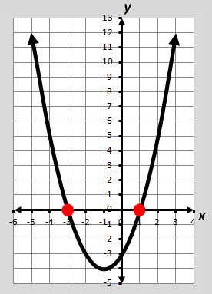

*f(x)* = *x*2 + 2*x* – 3

Find *f*(*x*) = 0.

0 = *x*2 + 2*x* – 3

0 = (*x* + 3)(*x* – 1)

*x* = -3 or *x* = 1

The zeros of the function *f(x)* = *x*2 + 2*x* – 3   
are -3 and 1 and are located at the   
*x*-intercepts (-3,0) and (1,0).

The zeros of a function are also the solutions or roots of the related equation

# *x*-Intercepts

The *x*-intercepts of a graph are located where the graph crosses the x-axis and where *f*(*x*) = 0.

*f(x)* = *x*2 + 2*x* – 3

0 = (*x* + 3)(*x* – 1)

0 = *x* + 3 or 0 = *x* – 1

*x* = -3 or *x* = 1

The zeros are -3 and 1.

The *x*-intercepts are:

* -3 or (-3,0)
* 1 or (1,0)



# Coordinate Plane

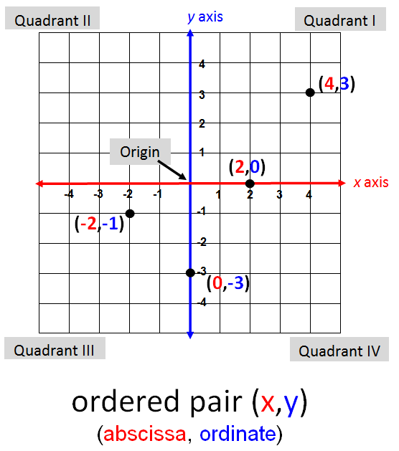

# Literal Equation

A formula or equation that consists primarily of variables

Examples:

*Ax* + *By* = *C*

*A* = $\frac{\text{1}}{\text{2}}\text{bh}$

*V* = *lwh*

*F* = $\frac{\text{9}}{\text{5}}$*C* + 32

# *A =* π*r2*Vertical Line

*x* = *a*

(where *a* can be any real number)

Example: *x* = -4

***y***

***x***

# Horizontal Line

Vertical lines have undefined slope.

*y* = *c*

(where *c* can be any real number)

Example: *y* = 6

***y***

***x***

# Quadratic Equation

Horizontal lines have a slope of 0.

*ax*2 + b*x* + c = 0

*a* ≠ 0

Example: *x*2 – 6*x* + 8 = 0

|  |  |
| --- | --- |
| **Solve by factoring** | **Solve by graphing** |
| *x*2 – 6*x* + 8 = 0  (*x* – 2)(*x* – 4) = 0  (*x* – 2) = 0 or (*x* – 4) = 0  *x* = 2 or *x* = 4 | Graph the related function *f*(*x*) = *x*2 – 6*x* + 8.  ***x***  ***y*** |

Solutions (roots) to the equation are 2 and 4;   
the *x*-coordinates where the function crosses the   
x-axis.

# Quadratic Equation (Number/Type of Solutions)

*ax*2 + *bx* + *c* = 0, *a* **≠** 0

|  |  |  |
| --- | --- | --- |
| **Examples** | **Graph of the related function** | **Number and Type of Solutions/Roots** |
| *x*2 – *x* = 3 |  | 2 Real roots |
| *x*2 + 16 = 8*x* |  | 1 distinct Real root  with a multiplicity of two |
| *2x*2 – 2*x* + 3 = 0 |  | 0 Real roots;  2 Complex roots |

# Inequality

An algebraic sentence comparing two quantities

|  |  |
| --- | --- |
| **Symbol** | **Meaning** |
| < | less than |
| **≤** | less than or equal to |
| **>** | greater than |
| **≥** | greater than or equal to |
| **≠** | not equal to |

Examples:

-10.5 ˃ -9.9 – 1.2

8 > 3*t* + 2

*x* – 5*y* **≥** -12

*r* **≠** 3

# Graph of an Inequality

|  |  |  |
| --- | --- | --- |
| **Symbol** | **Examples** | **Graph** |
| < ; **>** | *x* < 3 |  |
| **≤** ; **≥** | -3 **≥** *y* |  |
| **≠** | *t* **≠** -2 |  |

# Transitive Property of Inequality

|  |  |
| --- | --- |
| If | Then |
| *a* **<** *b* and *b* **<** *c* | *a* **<** *c* |
| *a* **>** *b* and *b* **>** *c* | *a* **>** *c* |

Examples:

If 4*x* < 2*y* and 2*y* < 16,

then 4*x* < 16.

If *x* > *y* – 1 and *y* – 1 > 3,

then *x* > 3.

# Addition/Subtraction Property of Inequality

|  |  |
| --- | --- |
| If | Then |
| *a* > *b* | *a* + *c* > *b* + *c* |
| *a* **≥** *b* | *a* + *c* **≥** *b* + *c* |
| *a* < *b* | *a* + *c* < *b* + *c* |
| *a* **≤** *b* | *a* + *c* **≤** *b* + *c* |

Example:

*d* – 1.9 **≥** -8.7

*d* – 1.9 + 1.9 **≥** -8.7 + 1.9

# *d* **≥** -6.8Multiplication Property of Inequality

|  |  |  |
| --- | --- | --- |
| **If** | **Case** | **Then** |
| *a* < *b* | *c* > 0, positive | *a*c **<** *bc* |
| *a* > *b* | *c* > 0, positive | *ac* **>** *bc* |
| *a* < *b* | *c* < 0, negative | *ac* **>** *bc* |
| *a* > *b* | *c* < 0, negative | *ac* **<** *bc* |

Example: If *c* = -2

5 > -3

5(-2) < -3(-2)

# -10 < 6Division Property of Inequality

|  |  |  |
| --- | --- | --- |
| **If** | **Case** | **Then** |
| a < b | c > 0, positive | $\frac{\text{a}}{\text{c}}$**< $\frac{\text{b}}{\text{c}}$** |
| a > b | c > 0, positive | $\frac{\text{a}}{\text{c}}$**> $\frac{\text{b}}{\text{c}}$** |
| a < b | c < 0, negative | $\frac{\text{a}}{\text{c}}$**> $\frac{\text{b}}{\text{c}}$** |
| a > b | c < 0, negative | $\frac{\text{a}}{\text{c}}$**< $\frac{\text{b}}{\text{c}}$** |

Example: If c = -4

-90 **≥** -4*t*

$\frac{\text{-90}}{\text{-4}}$**≤ $\frac{\text{-4}\text{t}}{\text{-4}}$**

22.5 **≤** *t*

# Absolute Value Inequalities

|  |  |
| --- | --- |
| **Absolute Value Inequality** | **Equivalent Compound Inequality** |
|  | “*and*” statement |
|  | “*or*” statement |

Example: 







# Linear Equation (Standard Form)

*Ax* + *By* = *C*

(*A*, *B* and *C* are integers; *A* and *B* cannot both equal zero)

***y***

Example:

-2*x* + *y* = -3

***x***

# The graph of the linear equation is a straight line and represents all solutions (*x, y*) of the equation.

# Linear Equation (Slope-Intercept Form)

*y* = *mx* + *b*

(slope is *m* and *y*-intercept is *b*)

Example: *y* = $\frac{\text{-}\text{4}}{\text{3}}$*x* + 5

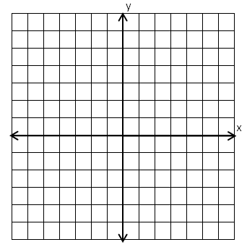

**(0,5)**

**-4**

**3**

*m* = $\frac{\text{-4}}{\text{3}}$

*b* = 5

# Linear Equation

# (Point-Slope Form)

*y* – *y*1 = *m*(*x* – *x*1)

where *m* is the slope and (*x*1,*y*1) is the point

Example:

Write an equation for the line that passes through the point (-4,1) and has a slope of 2.

*y* – 1 = 2(*x* – -4)

*y* – 1 = 2(*x* + 4)

*y* = 2*x* + 9

# Equivalent Forms of a Linear Equation

|  |  |
| --- | --- |
| Forms of a Linear Equation | $$3y = 2 – 4x$$ |
| Slope-Intercept | *y* = $-\frac{4}{3}x+2$ |
| Point-Slope | $$y-\left(-2\right)=-\frac{4}{3}(x-3)$$ |
| Standard | $$4x+3y=2$$ |

# Slope

A number that represents the rate of change in *y* for a unit change in *x*

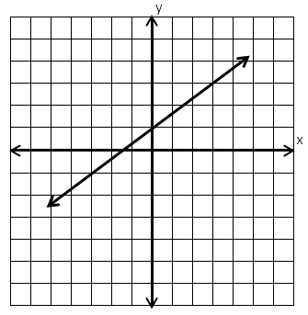

Slope = $\frac{\text{2}}{\text{3}}$

**3**

**2**

The slope indicates the   
steepness of a line.

# Slope Formula

The ratio of vertical change to

horizontal change

**A**

**B**

(*x*1, *y*1)

(*x*2, *y*2)

***x*2 – *x*1**

***y*2 – *y*1**

***x***

***y***

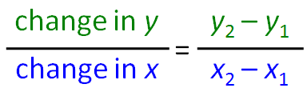

slope = *m* =

# Slopes of Lines

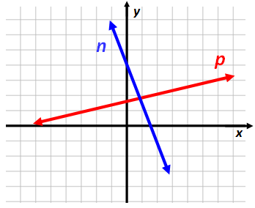

Line ***p***

has a positive slope.

Line ***n***

has a negative slope.

Vertical line ***s*** has an undefined slope.

Horizontal line ***t***

has a zero slope.

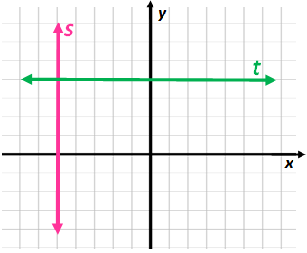

# Perpendicular Lines

Lines that intersect to form a right angle

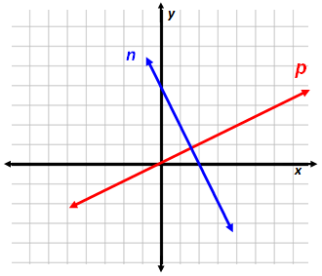

Perpendicular lines (not parallel to either of the axes) have slopes whose

product is -1.

Example:

The slope of line *n* = -2. The slope of line *p* = $\frac{\text{1}}{\text{2}}$.

-2 ∙ $\frac{\text{1}}{\text{2}}$ = -1, therefore, *n* is perpendicular to*p*.

# Parallel Lines

Lines in the same plane that do not intersect are parallel.

Parallel lines have the same slopes.

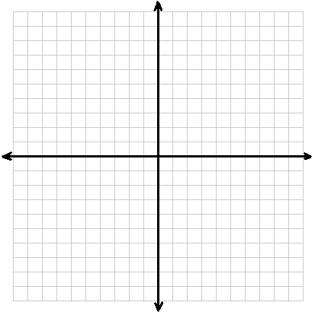

***y***

***x***

***b***

***a***

Example:

The slope of line *a* = -2.

The slope of line *b* = -2.

-2 = -2, therefore, *a* is parallel to*b*.

# Mathematical Notation

|  |  |  |
| --- | --- | --- |
| **Equation or Inequality** | **Set Notation** | **Interval Notation** |
| 0 < *x* **≤** 3 | {*x*|} | (0, 3] |
| *y* ≥ -5 | {*y*: *y* ≥ -5} | [-5, +∞) |
| *z*<-1 or *z* ≥ 3 | {*z*| *z*<-1 or *z* ≥ 3} | (- $∞,$-1) $∪[$ 3, + $∞)$ |
| *x* < 5 or *x* > 5 | {x: x ≠ 5} | (- $∞,5)∪(5,$ + $∞)$ |

# System of Linear Equations

(Graphing)

-*x* + 2*y* = 3

2*x* + *y* = 4

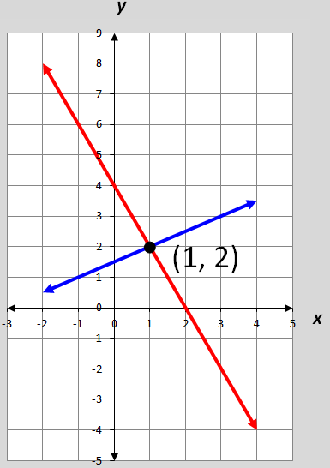

The solution,

(1, 2), is the only ordered pair that satisfies both equations

(the point of intersection).

# System of Linear Equations

(Substitution)

*x* +4*y* = 17

*y* = *x* – 2

Substitute *x* – 2 for *y* in the first equation.

*x* + 4(*x* – 2) = 17

*x* = 5

Now substitute 5 for *x* in the second equation.

*y* = 5 – 2

*y* = 3

The solution to the linear system is (5, 3),

the ordered pair that satisfies both equations.

# System of Linear Equations

(Elimination)

-5*x* – 6*y* = 8

5*x* + 2*y* = 4

Add or subtract the equations to eliminate one variable.

-5*x* – 6*y* = 8

+ 5*x* + 2*y* = 4

-4*y* = 12

*y* = -3

Now substitute -3 for *y* in either original equation to find the value of *x*, the eliminated variable.

-5*x* – 6(-3) = 8

*x* = 2

The solution to the linear system is (2,-3), the   
ordered pair that satisfies both equations.

# System of Linear Equations

(Number of Solutions)

|  |  |  |
| --- | --- | --- |
| **Number of Solutions** | **Slopes and**  ***y*-intercepts** | **Graph**  *x*  *y* |
| One solution | Different slopes | *x*  *y* |
| No solution | Same slope and  different -intercepts | *x*  *y* |
| Infinitely many solutions | Same slope and  same *y*-intercepts |  |

# Graphing Linear Inequalities

The graph of the solution of a linear inequality is a half-plane bounded by the graph of its related linear equation. Points on the boundary are included unless the inequality contains only < or >.

|  |  |
| --- | --- |
| Example | Graph |
| *y* ≤ *x* + 2 | ***y***  ***x*** |
| *y* > -*x* – 1 | ***y***  ***x*** |

# System of Linear Inequalities

Solve by graphing:

*y* **>** *x* – 3

*y* **≤** -2*x* + 3

***y***

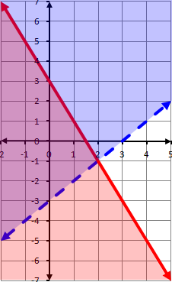

The solution region contains all ordered pairs that are solutions to both inequalities in the system.

(-1,1) is one solution to the system located in the solution region.

***x***

# Linear Programming

An optimization process consisting of a system of constraints and an objective quantity that can be maximized or minimized

Example:

Find the minimum and maximum value of the objective function C = 4x + 5y, subject to the following constraints.

*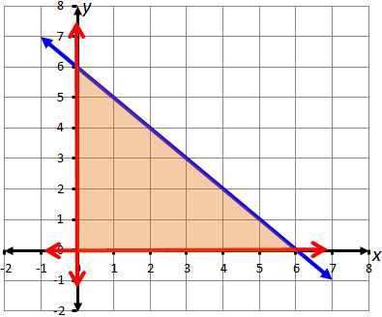x* **≥** 0

*y* **≥** 0

**(6,0)**

**(0,0)**

**(0,6)**

feasible region

*x* + *y* **≤** 6

***x* + *y* ≤ 6**

The maximum or minimum value for C = 4*x* + 5*y* will occur at a corner point of the feasible region.

# Dependent and

# Independent Variable

***x****,* independent variable

(input values or domain set)

***y****,* dependent variable

(output values or range set)

Example:

*y* = 2*x* + 7

# Dependent and

# Independent Variable

(Application)

Determine the distance a car will travel going 55 mph.

|  |  |
| --- | --- |
| *h* | *d* |
| 0 | 0 |
| 1 | 55 |
| 2 | 110 |
| 3 | 165 |

*d* = 55*h*

dependent

independent

# Graph of a Quadratic Equation

*y* = *ax*2 + *bx* + *c*

*a* ≠ 0

Example:

*y*

*y* = *x*2 + 2x – 3

line of symmetry

*x*

vertex

The graph of the quadratic equation is a curve (parabola) with one line of symmetry and one vertex.

Vertex of a Quadratic Function

For a given quadratic *y* = *ax*2+ *bx* + *c*, the vertex (*h*, *k*) is found by computing   
*h* = $\frac{-b}{2a}$ and then evaluating *y* at *h* to find *k*.

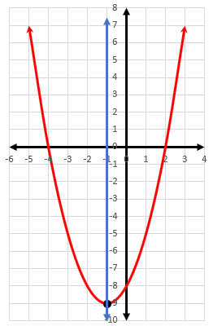Example: $y=x^{2}+2x-8$

$$h=\frac{-b}{2a}=\frac{-2}{2(1)}=-1$$

$$k={\left(-1\right)}^{2}+2\left(-1\right)-8$$

$$=-9$$

The vertex is (-1,-9).

Line of symmetry is $x=h$.

$$x=-1$$

Quadratic Formula

Used to find the solutions to any quadratic equation of the form,

*f*(*x*) = *ax*2 + *bx* + *c*

*x* =

Example: $g(x)=2x^{2}-4x-3$

$$x=\frac{-\left(-4\right)±\sqrt{{\left(-4\right)}^{2}-4\left(2\right)\left(-3\right)}}{2\left(2\right)}$$

$$x=\frac{2+\sqrt{10}}{2}, \frac{2-\sqrt{10}}{2}$$

# Relation

A set of ordered pairs

Examples:

|  |  |
| --- | --- |
| *x* | *y* |
| -3 | 4 |
| 0 | 0 |
| 1 | -6 |
| 2 | 2 |
| 5 | -1  Example 2 |

Example 1

{(0,4), (0,3), (0,2), (0,1)}

# Function

Example 3

(Definition)

A relationship between two quantities in which every input corresponds to exactly one output

*y*

range

*x*

domain

2

4

6

8

10

10

7

5

3

A relation is a function if and only if each element in the domain is paired with a unique element of the range.

# Functions

(Examples)

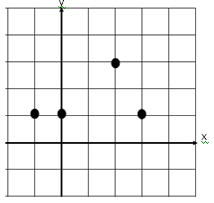

|  |  |
| --- | --- |
| *x* | *y* |
| 3 | 2 |
| 2 | 4 |
| 0 | 2 |
| -1 | 2 |

# 

Example 1

{(-3,4), (0,3), (1,2), (4,6)}

Example 4

Example 3

Example 2

***x***

***y***

# Domain

the set of all possible values of the independent variable

Examples:

|  |  |
| --- | --- |
| input | output |
| ***x*** | ***g*(*x*)** |
| **-2** | **0** |
| **-1** | **1** |
| **0** | **2** |
| **1** | **3** |

***f(x)***

***x***

The **domain** of *g*(*x*) is {**-2, -1, 0, 1**}.

The **domain** of *f*(*x*) is **all real numbers**.

# Range

the set of all possible values of the dependent variable

Examples:

***f(x)***

***f(x)***

|  |  |
| --- | --- |
| input | output |
| ***x*** | ***g*(*x*)** |
| **-2** | **0** |
| **-1** | **1** |
| **0** | **2** |
| **1** | **3** |

***x***

The **range** of *f*(*x*) is **all real numbers greater than or equal to zero**.

The **range** of g(x) is {**0, 1, 2, 3**}.

# Function Notation

*f(x)*

*f(x)* is read

“the value of *f* at *x*” or “*f* of *x*”

Example:

*f(x)* = -3*x* + 5, find *f(2).*

*f(2)* = -3(2) + 5

*f(2)* = -6

Letters other than f can be used to name functions, e.g., *g*(*x*) and *h(x*)

# End Behavior

The value of a function as x approaches positive or negative infinity

Examples:

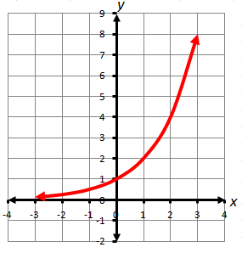

*f(x)* approaches 0 as the values of *x* approach $-∞$.

*f(x)* is approaches $+∞$ as the values of *x* approach $+∞$.

*f(x)* approaches $+∞$ as the values of *x* approach $-∞$.

*f(x)* is approaches $+∞$ as the values of *x* approach $+∞$.

Increasing/ Decreasing

A function can be described as increasing, decreasing, or constant over a specified interval or the entire domain.

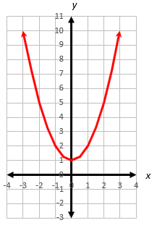 Examples:

*y*

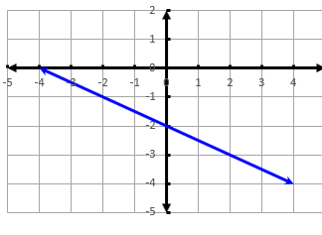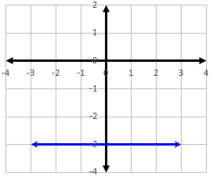

*y*

*y*

Absolute Extrema

*f(x)* is decreasing over {*x*|} because the values of *f(x)* decrease as the values of *x* increase.

*f(x)* is increasing over {*x*|} because the values of *f(x)* increase as the values of *x* increase.

*x*

*f(x)* is decreasing over the entire domain because the values of *f(x)* decrease as the values of *x* increase.

*f(x)* is constant over the entire domain because the values of *f(x)* remain constant as the values of *x* increase.

*x*

The largest (maximum) and smallest (minimum)   
value of a function on the entire [domain of a function](https://en.wikipedia.org/wiki/Domain_of_a_function) (the absolute or global extrema)

*y*

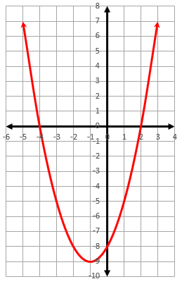 Examples:

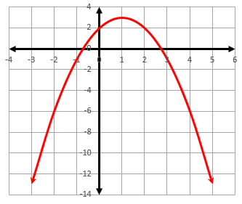

* A function, *f*, has an absolute maximum located at *x* = *a* if *f(a)* is the largest value of *f* over its domain.
* A function, *f*, has an absolute minimum located at *x* = *a* if f(a) is the smallest value of *f* over its domain.

absolute maximum

*x*

*y*

absolute minimum

*x*

Parent Functions

(Linear, Quadratic)

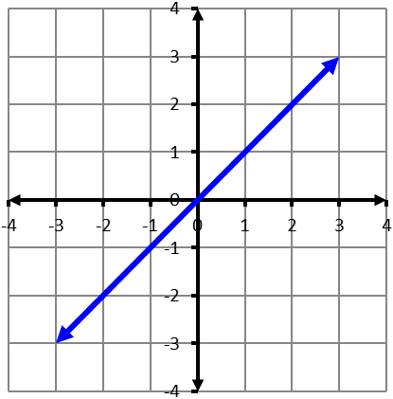

*y*

*x*

Linear

*f(x)* = *x*

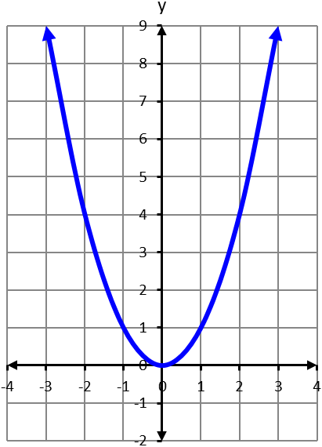

*y*

*x*

Quadratic

*f(x)* = *x*2

# Parent Functions

(Exponential, Logarithmic)

Exponential

*f(x)* = *bx*

*b* > 1

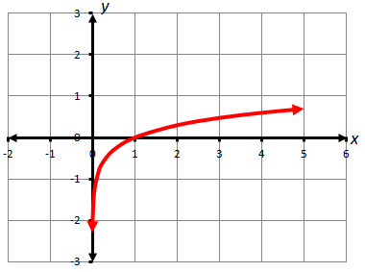Logarithmic

*f(x)* = ${\text{log}}_{\text{b}}{\text{x}}$

*b* > 1

# Transformations of Parent Functions

(Translation)

Parent functions can be transformed to create other members in a family of graphs.

|  |  |  |
| --- | --- | --- |
| **Translations** | ***g*(*x*) = *f*(*x*) + *k***  is the graph of *f*(*x*) **translated** **vertically** – | ***k*** units **up** when ***k* > 0**. |
| ***k*** units **down** when ***k* < 0**. |
| ***g*(*x*) = *f*(*x* − *h*)**  is the graph of *f*(*x*) **translated horizontally** – | ***h*** units **right** when ***h* > 0**. |
| ***h*** units **left** when ***h* < 0**. |

# Transformations of Parent Functions

(Reflection)

Parent functions can be transformed to create other members in a family of graphs.

|  |  |  |
| --- | --- | --- |
| **Reflections** | ***g*(*x*) = -*f*(*x*)**  is the graph of *f*(*x*) – | **reflected** over the ***x*-axis**. |
| ***g*(*x*) = *f*(-*x*)**  is the graph of *f*(*x*) – | **reflected** over the ***y*-axis**. |

# Transformations of Parent Functions

(Dilations)

Parent functions can be transformed to create other members in a family of graphs.

|  |  |  |
| --- | --- | --- |
| **Dilations** | ***g*(*x*) = *a* · *f*(*x*)**  is the graph of *f*(*x*) – | **vertical dilation** (stretch)  if ***a* > 1**. |
| **vertical dilation** (compression) if **0 < *a* < 1**. |
| ***g(x) = f(ax)***  is the graph of *f*(*x*) – | **horizontal dilation** (compression) if ***a* > 1**. |
| **horizontal dilation** (stretch) if **0 < *a* < 1**. |

# Linear Function

(Transformational Graphing)

Translation

*g(x)* = *x* + *b*

***y***

Examples:

*f(x)* = *x*

*t(x)* = *x* + 4

*h(x)* = *x* – 2

***x***

Vertical translation of the parent function, *f(x)* = *x*

# Linear Function

(Transformational Graphing)

Dilation (*m*>0)

*g(x)* = *mx*

***y***

Examples:

*f(x)* = *x*

*t(x)* = 2*x*

*h(x)* = $\frac{\text{1}}{\text{2}}$*x*

***x***

# Vertical dilation (stretch or compression) of the parent function, *f(x)* = *x* Linear Function

(Transformational Graphing)

Dilation/Reflection (*m*<0)

*g(x)* = *mx*

***y***

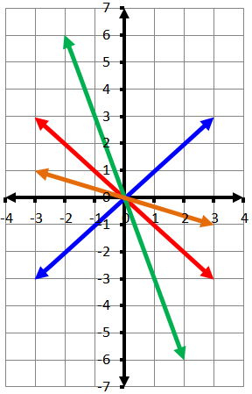

Examples:

*f(x)* = *x*

*t(x)* = -*x*

*h(x)* = -3*x*

*d(x)* = - $\frac{\text{1}}{\text{3}}$*x*

***x***

# Vertical dilation (stretch or compression) with a reflection of *f(x)* = *x* Quadratic Function

(Transformational Graphing)

Vertical Translation

*h(x)* = *x*2 + *c*

***y***

***x***

Examples:

*f(x)* = *x*2

*g(x)* = *x*2 + 2

*t(x)* = *x*2 – 3

# Vertical translation of *f(x)* = *x*2Quadratic Function

(Transformational Graphing)

Horizontal Translation

*h(x)* = (*x* + *c*)2

***y***

Examples:

*f(x)* = *x*2

*g(x)* = (*x* + 2)2

*t(x)* = (*x* – 3)2

***x***

Horizontal translation of *f(x)* = *x*2

# Quadratic Function

(Transformational Graphing)

Dilation (*a*>0)

*h(x)* = *ax*2

***y***

***x***

Examples:

*f(x)* = *x*2

*g(x)* = 2*x*2

*t(x)* = *x*2

# Vertical dilation (stretch or compression) of *f(x)* = *x*2Quadratic Function

(Transformational Graphing)

Dilation/Reflection (*a*<0)

*h(x)* = *ax*2

***y***

Examples:

*f(x)* = *x*2

*g(x)* = -2*x*2

*t(x)* = *x*2

***x***

# Vertical dilation (stretch or compression) with a reflection of *f(x)* = *x*2

# Arithmetic Sequence

A sequence of numbers that has a common difference between every two consecutive terms

Example: -4, 1, 6, 11, 16 …

+5

+5

+5

+5

common difference

*y*

|  |  |
| --- | --- |
| Position  *x* | Term  *y* |
| 1 | -4  +5  +5  +5  +5 |
| 2 | 1 |
| 3 | 6 |
| 4 | 11 |
| 5 | 16 |

1

5

1

5

*x*

# Geometric Sequence

The common difference is the slope of the line of best fit.

A sequence of numbers in which each term after the first term is obtained by multiplying the previous term by a constant ratio

# 

# Probability

The likelihood of an event occurring

Probability of an event = $\frac{\text{number of favorable outcomes}}{\text{number of possible outcomes}}$

Example: What is the probability of drawing an A from the bag of letters shown?



P(A) = $\frac{\text{3}}{\text{7}}$

**A C C**

**A B A B**

$$\frac{\text{3}}{\text{7}}$$

0 $\frac{\text{1}}{\text{2}}$ 1

# Probability of Independent Events

Example:

What is the probability of landing on green on the first spin and then landing on yellow on the second spin?

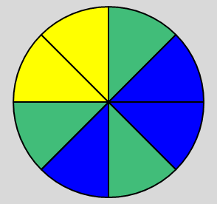

**Y**

**G**

**B**

**Y**

**B**

**G**

**B**

**G**

P(green and yellow) =

# P(green) **∙** P(yellow) = $\frac{\text{3}}{\text{8}}\text{∙}\frac{\text{1}}{\text{4}}$ = $\frac{\text{3}}{\text{32}}$ Probability of Dependent Events

Example:

***Candy Jar***

**R**

**R**

**G**

**Y**

**P**

**B**

**R**

**R**

**G**

**Y**

**P**

**B**

What is the probability of selecting a red jelly bean on the first pick and without replacing it, selecting a blue jelly bean on the second pick?

P(red and blue) =

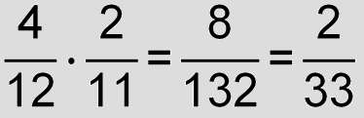

P(red) **∙** P(blue|red) =

“blue after red”

# Probability

(Mutually Exclusive)

Events that cannot occur at the same time

Examples:

1. A. Tossing a coin and getting heads.

B. Tossing a coin and getting tails.

1. A. Turning left.

B. Turning right.

[](https://www.bing.com/images/search?view=detailV2&ccid=eQCGENG6&id=93B2EDAD78B0654E7941A032495E404564843E88&thid=OIP.eQCGENG6VOxcn-6Uu8w-8QHaHa&mediaurl=https://d35gqh05wwjv5k.cloudfront.net/media/catalog/product/cache/4/image/85e4522595efc69f496374d01ef2bf13/1421181124/r/e/reflective-traffic-signs-left-right-turn-arrows-ff0328-lg.jpg&exph=400&expw=400&q=turn+left+and+right&simid=608054078468328747&selectedIndex=5)

0

If two events are mutually exclusive, then the probability of them both occurring at the same time is 0.

# Fundamental Counting Principle

If there are *m* ways for one event to occur and *n* ways for a second event to occur, then there are $m∙n$ ways for both events to occur.

Example:

How many outfits can Joey make using

3 pairs of pants and 4 shirts?

3 ∙ 4 = 12 outfits

# Permutation



An ordered arrangement of a group of objects

1st

2nd

3rd

1st

2nd

3rd

is different from

Both arrangements are included in possible outcomes.

Example:

5 people to fill 3 chairs (**order matters**).   
How many ways can the chairs be filled?

1st chair – 5 people to choose from

2nd chair – 4 people to choose from

3rd chair – 3 people to choose from

# possible arrangements are 5 ∙ 4 ∙ 3 = 60

# Permutation

(Formula)

To calculate the number of permutations

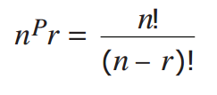

*n* and *r* are positive integers, *n* ≥ *r*, and *n* is the total number of elements in the set and *r* is the number to be ordered.

Example: There are 30 cars in a car race. The first-, second-, and third-place finishers win a prize.   
How many different arrangements (**order matters**)  
of the first three positions are possible?

30P3 = = = 24360

# Combination

The number of possible ways to select or arrange objects when there is no repetition and **order does not matter**

Example: If Sam chooses 2 selections from triangle, square, circle and pentagon. How many different combinations are possible?

**Order (position) does not matter** so

is the same as

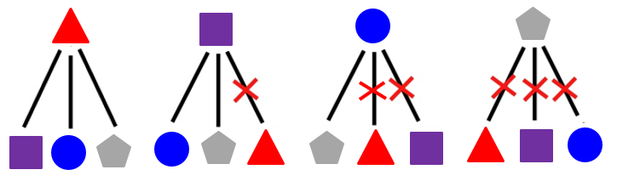

There are 6 possible combinations.

# Combination

(Formula)

To calculate the number of possible combinations using a formula

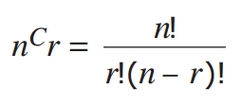

*n* and *r* are positive integers, n ≥ r, and *n* is the total number of elements in the set and *r* is the number to be ordered.

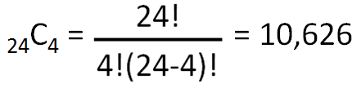Example: In a class of 24 students, how many ways can a group of 4 students be arranged (**order does not matter**)?

# Statistics Notation

|  |  |
| --- | --- |
| **Symbol** | **Representation** |
|  | th element in a data set |
| $$μ$$ | mean of the data set |
| $$σ^{2}$$ | variance of the data set |
| $$σ$$ | standard deviation of the data set |
| $$n$$ | number of elements in the data set |

# Mean

A measure of central tendency

Example:

Find the mean of the given data set.

Data set: 0, 2, 3, 7, 8

Balance Point

**4**

**4**

**2**

**3**

**1**

0 1 2 3 4 5 6 7 8

Numerical Average



# Median

A measure of central tendency

Examples:

Find the median of the given data sets.

Data set: 6, 7, 8, 9, 9

The median is 8.

Data set: 5, 6, 8, 9, 11, 12

The median is 8.5.

# Mode

|  |  |
| --- | --- |
| **Data Sets** | **Mode** |
| 3, 4, 6, 6, 6, 6, 10, 11, 14 | 6 |
| 0, 3, 4, 5, 6, 7, 9, 10 | none |
| 5.2, 5.2, 5.2, 5.6, 5.8, 5.9, 6.0 | 5.2 |
| 1, 1, 2, 5, 6, 7, 7, 9, 11, 12 | 1, 7  bimodal |

A measure of central tendency

Examples:

# Summation

A1, A2, AFDA

stopping point

upper limit

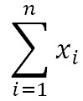

summation sign

typical element

index of summation

starting point

lower limit

This expression means sum the values of *x*, starting at *x*1 and ending at *xn*.



= *x*1 + *x*2 + *x*3 + … + *xn*

Example: Given the data set {3, 4, 5, 5, 10, 17}

$$\sum_{i=1}^{6}{x_{i}}=\text{3} \text{+} \text{4} \text{+} \text{5} \text{+} \text{5} \text{+} \text{10} \text{+}\text{ 1}\text{7} \text{=} \text{44}$$

# Variance

A measure of the spread of a data set

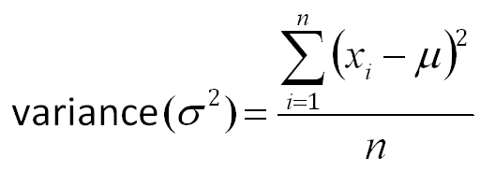

The mean of the squares of the differences between each element and the mean of the data set

Note: The square root of the variance is equal to the standard deviation.

# Standard Deviation

(Definition)

A measure of the spread of a data set

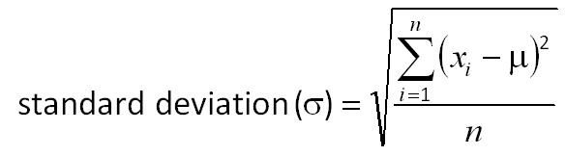

The square root of the mean of the squares of the differences between each element and the mean of the data set or the square root of the variance

# Standard Deviation

(Graphic)

A measure of the spread of a data set



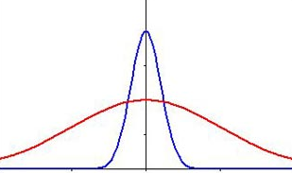

Smaller Larger

μ

Comparison of two distributions with same mean (μ) and different standard deviation (σ) values

# z-Score

(Definition)

The number of standard deviations an element is away from the mean

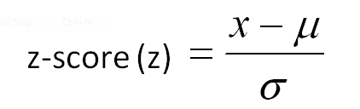

where *x* is an element of the data set, *μ* is the mean of the data set, and *σ* is the standard deviation of the data set.

Example: Data set A has a mean of 83 and a standard deviation of 9.74. What is the *z*‐score for the element 91 in data set A?

*z* = $\frac{\text{91-83}}{\text{9.74}}$ = 0.821

# z-Score

(Graphic)

The number of standard deviations an element is from the mean



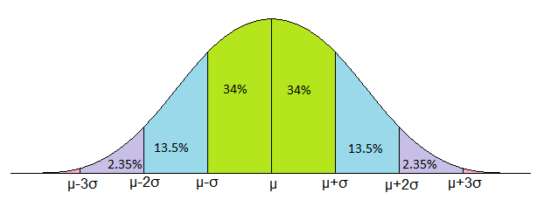

*z* = 1

*z* = 2

z = 3

*z* = -1

*z* = -2

*z* = -3

*z* = 0

# Empirical Rule

# 

# Elements within One Standard Deviation (*σ*) of the Mean (*µ*)

Normal Distribution Empirical Rule (68-95-99.7 rule) – approximate percentage of element distribution

Z=1

Given *μ* = 45 and *σ* = 24

Elements within one standard deviation of the mean

(Graphic)

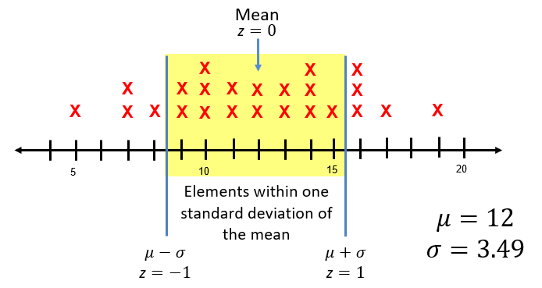

# Scatterplot

Graphical representation of the relationship between two numerical sets of data

***x***

***y***

# Positive Linear Relationship (Correlation)

In general, a relationship where the dependent (*y*) values increase as independent values (*x*) increase

***x***

***y***

# Negative Linear Relationship (Correlation)

In general, a relationship where the dependent (*y*) values decrease as independent (*x*) values increase.

***x***

***y***

# No Correlation

No relationship between the dependent (*y*) values and independent (*x*) values.

**x**

**y**

# Curve of Best Fit

(Linear)

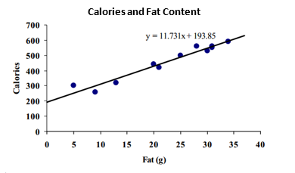

Equation of Curve of Best Fit

$y$ = 11.731x + 193.85

# Curve of Best Fit

(Quadratic)

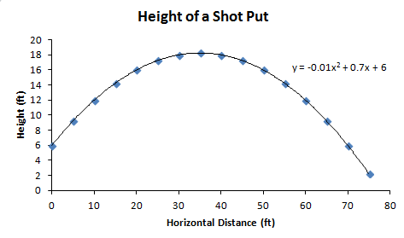

Equation of Curve of Best Fit

= -0.01x2 + 0.7x + 6

# Curve of Best Fit

(Exponential)

# Outlier Data

Equation of Curve of Best Fit



**Bacteria Growth Over Time**

# (Graphic)

