English Instructional Plan – Text Features
Primary Strand: Reading 4.6a
Integrated Strand/s: Science 4.2a and 4.2b
Essential Understanding:
- understand text features serve a purpose
Essential Knowledge, Skills, and Processes:
- explain how written text and accompanying graphics connect to convey meaning (e.g. charts, graphs, diagrams, timelines, animations)

Primary SOL: 4.6 The student will read and demonstrate comprehension of nonfiction texts.
a) Use text features such as type, headings, and graphics to predict and categorize
information.

Reinforced (Related Standard) SOL:
- 4.1c) Orally summarize information expressing ideas clearly.
- 4.1h) Demonstrate the ability to collaborate with diverse teams
- 4.1i) Work respectfully with others, and show value for individual contributions

Academic Background/Language: Students will need to be familiar with content vocabulary related to living systems and processes [4.2 a/b] including: photosynthesis, chlorophyll, carbon dioxide, and organisms. Students will need to be familiar with types of text features [4.6a] including type, headings, graphics, pictures, caption, diagram, and labels.

Materials
- What is a Hurricane? by, Robin Johnson (or another nonfiction book that includes text features)
- Copies of the attached plan/organizer
- Digital exit activity template

Student/Teacher Actions: What should students be doing? What should teachers be doing?
Day 1
- Students will complete nonfiction text features sort to access background knowledge on text features and their purpose.
- Teacher will introduce National Geographic Readers: Water. While reading to the class, the teacher will point out the different text features and explain how it helps the reader organize and understand the content.
- While reading, teachers can use the: Teacher Template - Text Features as an instructional tool.
- During instruction, teachers should pose questions to give the students an opportunity to identify and describe text features as they are found throughout the text. Questions should encourage students to think critically about the text features and how authors use them to enhance reader comprehension. For example: Teacher has shown the Heading of Chapter 1 and asked students: What do we already know about what we are about to read because of this heading? Students will explain how the reader can use Headings to make predictions about what they will read/learn in text.

Day 2
- Teacher introduces the Nonfiction Text Features Project. In this project, students will read a piece of nonfiction plain text and synthesize what they have learned about the science content as well as how to use text features to organize information. They will design and create text features to make the given text more accessible to the reader.
- Teacher will review science content including how plants and animals obtain energy and the processes related. Key concepts include the critical role of photosynthesis in an ecosystem and the parts of a plant and role of each.(4.2 a, b)
- Teacher will give students Plain Text Articles: What is Photosynthesis? or Plant Structure as their original text and arrange for students to work with partners and/or groups.
Days 3-4
- Partner groups will read the text and use the: Nonfiction Text Features Planning Guide to collaborate and plan the text features needed to make the text more organized and easier to understand. They will follow this: Project Guide - Nonfiction Text Features.
- Teacher will circulate, monitor progress, and conference with partner groups as needed.
- Partner groups will use their completed graphic organizer to create a final project using: Student Final Project Template.
- Students will complete a peer evaluation and give feedback on their own performance as well as their partner’s performance.
Day 5 [or 6]
- Partner groups will present their final product in an oral presentation.

Teacher Assessment (Diagnostic, Formative, Summative):
- NF Text Features sort - Formative
- Graphic Organizer - Formative
- Final Product Rubric - Summative [Literacy and Science]
- Teacher Conferencing - Diagnostic
- Peer evaluation

Writing Connections:
- Students will write the text included in text features they create for the project. They will also write to explain their thinking and reasoning as to why they selected that text feature to represent that component of the text.

Extensions and Connections (for all students)
- Using information learned, students will write their own scientific summary on plants. Students will use their own text, or trade with a partner, to complete the text feature project.

Strategies for Differentiation

Purposeful pairing so all students can contribute to the final product.

Provide additional support to targeted small groups as needed.

Student text will have 3 highlighted sections (highlighted in different colors). Each color will correlate with a different text feature that is given to the student. For example: Create a heading for the blue highlighted text.
Nonfiction Text Features Project Guide

You are being given a piece of nonfiction text without text features. It is hard to understand! You can help by creating text features that will make this text easier to understand. Choose four text features from the table below. Your final project will be creating those text features to accompany this plain text.

Choices for the final project:
- Create a digital slide deck with each text feature.
- Use a file folder or tri-fold board and other materials to display the text features.

Special Print
• Find at least two words that are important to your text.
•Write the sentences containing those words and bold them on your project.

Picture and Caption
• You can either draw or find a picture online to represent your topic.
• Write a brief description of the picture as it relates to your text.

Diagram
• Include a diagram that shows the main topic of your text.
• Label your diagram and remember that it is not just a picture.

Map
• Include a map that shows a place mentioned in your text.

Headings
• Include at least three headings that help the reader understand the main idea of each section.

What is Photosynthesis?

When you get hungry, you grab a snack from your fridge or pantry. But what can plants do when they get hungry? You are probably aware that plants need sunlight, water, and a home (like soil) to grow, but where do they get their food? They make it themselves!
Plants can use energy from light to synthesize, or make, their own food source. Many people believe they are “feeding” a plant when they put it in soil, water it, or place it outside in the Sun, but none of these things are considered food. Rather, plants use sunlight, water, and the gases in the air to make glucose, which is a form of sugar that plants need to survive. This process is called photosynthesis and is performed by all plants, algae, and even some microorganisms. To perform photosynthesis, plants need three things: carbon dioxide, water, and sunlight.
Just like you, plants need to take in gases in order to live. Animals take in gases through a process called respiration. During the respiration process, animals inhale all of the gases in the atmosphere, but the only gas that is retained and not immediately exhaled is oxygen. Plants, however, take in and use carbon dioxide gas for photosynthesis. Carbon dioxide enters through tiny holes in a plant’s leaves, flowers, branches, stems, and roots. Plants also require water to make their food.
Depending on the environment, a plant’s access to water will vary. For example, desert plants, like a cactus, have less available water than a lilypad in a pond, but every photosynthetic organism has some sort of adaptation, or special structure, designed to collect water. For most plants, roots are responsible for absorbing water.
The last requirement for photosynthesis is an important one because it provides the energy to make sugar. How does a plant take carbon dioxide and water molecules and make a food molecule? The Sun! The energy from light causes a chemical reaction that breaks down the molecules of carbon dioxide and water and reorganizes them to make the sugar (glucose) and oxygen gas. After the sugar is produced, it is then broken down into energy that can be used for growth and repair. The oxygen that is produced is released from the same tiny holes through which the carbon dioxide entered. Even the oxygen that is released serves another purpose. Other organisms, such as animals, use oxygen to aid in their survival.

Reference:
Smithsonian Science Education Center [SSEC] Written by, Science and Technology Concepts Middle School (2017, April 12). What is Photosynthesis. https://ssec.si.edu/stemvisions-blog/what-photosynthesis

Plant Structure

Plants are the beauty of nature. They look very beautiful and give us fresh oxygen. There are many types of plants on the Earth including flowering plants and non-flowering plants. These plants differ in their structure, but the basic structures of these plants are similar.

Roots are the part of a plant that are buried in the soil. They grow out of the seeds during germination. Roots perform very important tasks, which include:
- Absorbing the water and the necessary nutrients and sending them to different parts of the plant.
- They provide a good grip to the stem of a plant so that it can stand against the wind.
- Some plants store food in their roots. Examples of these types of pants are carrots and potatoes.

Stems are connected with the roots and grow outside of the soil. All the parts of the plants are connected to the stems. When a plant is young, its stems are green. But as they grow older, their stems turn their color and become hard. The stem performs functions which include:
- Providing support to the leaves, flowers, and fruits.
- Carrying the water and nutrients absorbed by the roots to all parts of a plant.
- Stems also store food in many plants, like the sugar cane.

Buds look like a bump on the stem of a plant. These are the developing shoots, which will become branches of a plant.

Leaves are the most important part of a plant, which have green color - but not all plants have green colored leaves. They produce the food for the whole plant by the process of photosynthesis. In photosynthesis, plants take the carbon dioxide from the air and light from the Sun.

When a plant becomes mature, flowering plants will produce flowers. Flowers have beautiful colors with an attractive fragrance. They play an important role in the reproduction of the flowering plants. They also make seeds, fruits, and produce oxygen for us to breathe.

Nonfiction Text Features Planning Guide

Use this graphic organizer to plan the text features you will add to the text to help the reader understand.

Text Feature | Why does this text feature make sense? | Sketch
Ex:  map | It would be helpful to see the different parts of the country where butterflies go when they migrate. | 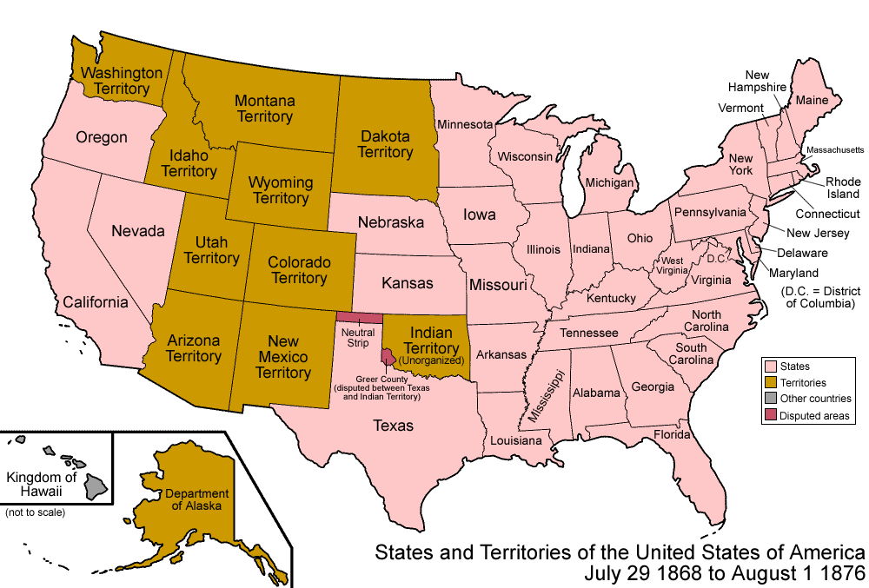

WORD | DESCRIPTION | EXAMPLE
Text Features  (no picture) | Helps readers understand where something is in the world | 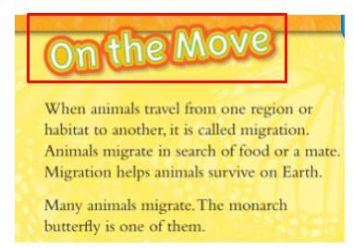
Captions | When a word is bold, italicized, or underlined it is an important word for readers to know | 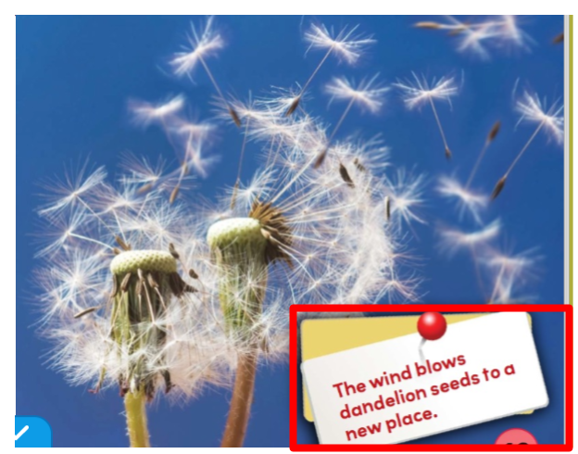
Headings | Drawing that labels the parts that make up the item shown | 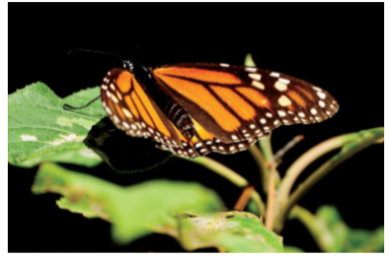
Pictures | A title that helps the reader understand the main idea of the section | 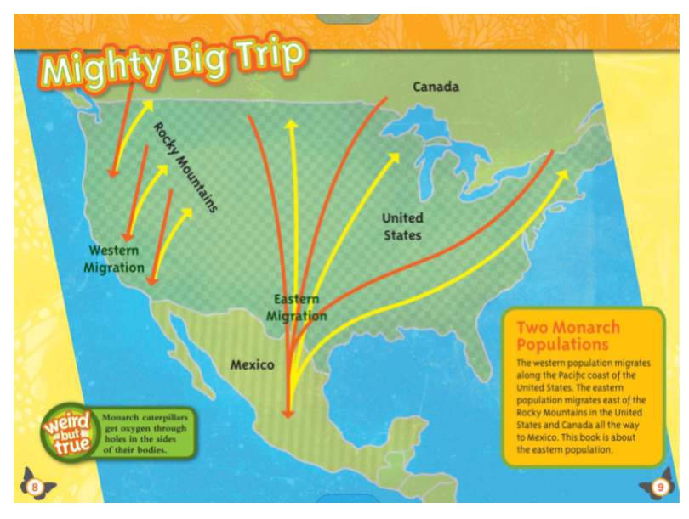
Maps | Words near a picture to help readers better understand it | 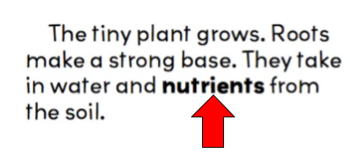
Special Print | Help organize information in the text so readers know what is important | 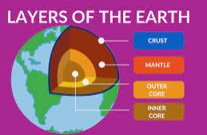
Diagram | Help readers see exactly what something or someone looks like

Text Features Project Rubric

 | 4 | 3 | 2 | 1
Applying  Student demonstrates application of text features by | Including all required components  4-5 Text Features | Including most of the required components  3 Text Features | Including some of the required components  2 Text Features | Including little to no required components  1 or 0 Text Features
Analyzing  Student applies knowledge of text feature purpose | All text features created by the student support the text  4-5 Text Features | Most text features created by the student support the text  3 Text Features | Some text features created by the student support the text  2 Text Features | Little to no text features created by the student support the text  1 or 0 Text Features
Evaluating  Student shows evidence of planning and supports thinking for text feature placement | Graphic Organizer supports organization of all text features.  Connection between the organizer and the final project is clear. | Graphic Organizer supports organization of most text features.  Connection between organizer and final project is present. | Graphic Organizer supports organization of some text features.  Connection between organizer and final project is difficult to identify. | Graphic Organizer supports organization of 1 or no text features.  Connection between organizer and final project is not present or incomplete.
Creating  Final project demonstrates overall understanding of text features and their purpose. | Text is organized thoughtfully with all text features.  Final project demonstrates explicit knowledge of text features, and contains 1 or no grammatical errors. | Text is organized using most text features.  Final project demonstrates understanding of text features, and contains 2-4 grammatical errors. | Text is organized using some text features.  Final project demonstrates some understanding of text features, and contains 5-7 grammatical errors. | Text is organized using little or no text features.  Final project demonstrates minimal understanding of text features, and contains many grammatical errors.

Total Score: | Comments:

Sample Grading Scale

Project Score | Correlating Grade
16 | 100
15 | 92
14 | 86
13 | 80
12 | 74
11 | 72
10 | 68
9 | 64
8 | 60
7 | 56
6 | 54
5 | 52
4 | 50

Note: The following pages are intended for classroom use for students as a visual aid to learning.

