English Instructional Plan
Primary Strand: 1.7
Integrated Strand/s: K.7, 2.5
Essential Understanding:

- understand that word meanings can be comprehended through context, discussion, connections to familiar words, and knowledge of vocabulary from other content areas
- understand and discuss the meanings of new words as presented in context.

Essential Knowledge, Skills, and Processes:
- develop vocabulary by listening to and reading a variety of texts
- ask for the meaning of unknown words and make connections to familiar words by
  - sorting words into categories (e.g., colors, animals)
  - defining words by category and by one or more attributes (e.g., a swan is a bird that swims, a cardinal is a red bird)
  - identifying real-life connections between words and their use (e.g., places that are safe)
- use vocabulary from other content areas in literacy tasks
- ask for meanings and clarification of unfamiliar words and ideas
- use common irregular plural forms, such as man/men, child/children, and mouse/mice.

Primary SOL: 1.7 b) Develop vocabulary by listening to and reading a variety of texts.

Reinforced (Related Standard) SOL: 1.9 The student will read and demonstrate comprehension of a variety of fictional texts. 1.10 The student will read and demonstrate comprehension of a variety of nonfiction texts.

Academic Background/Language:
Students' reading comprehension is dependent on their vocabulary knowledge. Even at the earliest grades, teachers need to provide direct, explicit vocabulary instruction. Students need the most support in learning Tier 3, content specific words, and Tier 2, academic vocabulary. Teachers should provide student friendly definitions, examples and nonexamples and allow students time to discuss word meanings daily. Teachers are encouraged to elevate their oral vocabulary to include taught words throughout the school day in various settings and contents.

Materials
- Reading text
  - above grade level text for read aloud
  - can include, narratives, expository, nonfiction, poems, songs, and visual literacy texts
- Teacher script for vocabulary words from specific text (See below)
- Chart paper to write vocabulary words or index cards with words and definitions
- Markers
- Written Extension Activities

Student/Teacher Actions: What should students be doing? What should teachers be doing?
- Select an above grade level text to use as a read aloud
- Read the text and select one or two vocabulary words that are critical to understanding of the story
  - Tier 2 words- academic language
  - Tier 3 words- content specific
- Use the script below to create your teaching script
“A word from our book today was __________. (show student written word) What word? __________ means (short student friendly definition) (1 sentence giving an example or expanding the definition) What word? Turn and talk about how you show/a time when ______________ Here’s the sentence from our book, “________”. ​
- During the lesson use the script to explicitly teach the vocabulary you selected.
  - For Tier 2 vocabulary introduce after you read the book
  - For Tier 3 vocabulary introduce before you read the book
- Provide follow up written extension activities around taught vocabulary.
Assessment (Diagnostic, Formative, Summative)
- Lead a classroom discussion and provide feedback on students’ understanding of the word’s meaning.
Writing Connections:
- Provide students written extension activities such as a modified Frayer Model
Extensions and Connections (for all students)
- Discuss other words that may be synonyms and antonyms with this vocabulary word
- Highlight over words that may be related to the new vocabulary, for example categories it would belong in
- Draw attention to multiple meanings of the word. Where have they heard this word but in a different context?
Strategies for Differentiation
- For students who need additional support, you can preview the text and introduce the vocabulary in a small group prior to the whole group lesson
- Students can draw a picture to demonstrate understanding of the definition of the vocabulary word
- Be purposeful when creating student pairs, so that students feel supported and have a peer role model

Note: The following pages are intended for classroom use for students as a visual aid to learning.
Example:
Vocabulary Protocol for Clara Caterpillar
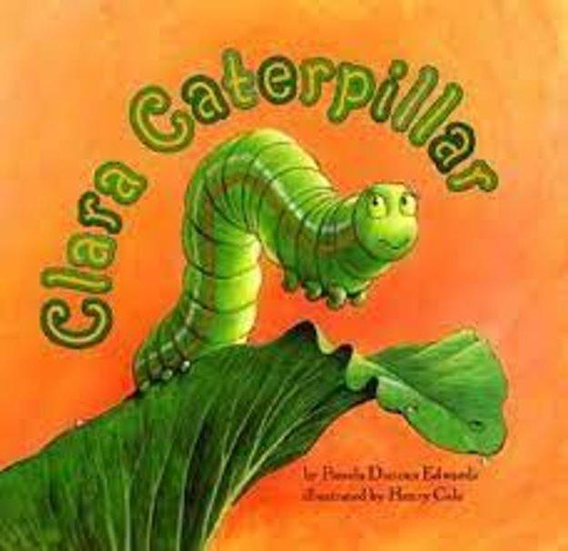
Clara Caterpillar
Vocabulary:
common
crisis

One word from our book today was common. What word? ______ Common means when something is regular or ordinary. If you see something common, you are used to it. It isn’t fancy. What word?______ Let’s practice. Get ready to put your thumb up or down if this would be a common pet in someone’s home. Ready? A cat is a common pet. Yes! Your thumb should be up. A cat is an ordinary pet. Let’s try another one. A dog is a common pet. Yes! Your thumb should be up! A dog would be a normal and usual ordinary pet. One more: An iguana is an ordinary pet. Your thumb should be down. Most people do not have an iguana for a pet. That would be unusual. Now let’s turn and talk about something that would be a common sight in a school. You can start your sentence like this. A common sight at school is __________. Allow students to tell their partners about a common sight in school. Examples include: pencils, teachers, kids, books, etc. Here’s the sentence from our book, ‘Cabbage caterpillars are so common.’ Remember how Catisha was making fun of Clara and saying she was a very regular looking and ordinary caterpillar? Catisha thought Clara was common.

Another word from our story today is crisis. A crisis is when someone is having a difficult time. You might have a crisis if you left your lunch at home and didn’t have anything to eat. You might also have a crisis if you missed the bus for school. In the story, the butterflies had a crisis when a crow tried to eat them for a snack. What’s the word? ______ Here’s the sentence from our book: “The coast is clear!” Cornelius shouted. “The crisis is over!” Can you think of a time you had a crisis? Here’s how you can start your sentence: I had a crisis when….because…. Now turn to a partner and tell about a time you had a crisis. Don’t forget to tell why it was a crisis.
Listen in to students and share a few examples.

Extension Activities:
Fill in the Frayer Model for one of your words from today’s story. You can choose common or crisis.

See on next page.

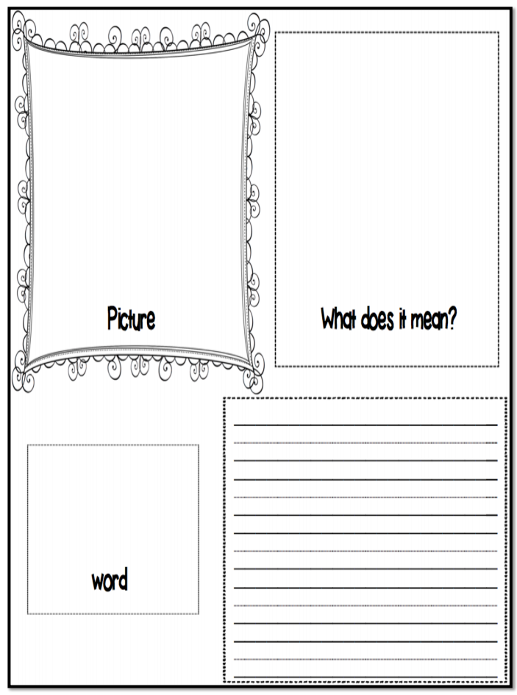
Post these words along with a picture of the book cover on a classroom bulletin board. This allows you to refer to the words continuously.
crisis

a difficult time
common
regular or ordinary

