Probability – A Co-Teaching Lesson Plan

Co-Teaching Approaches
A “(Y)” in front of the following list items indicates the approach is outlined in the lesson. An “(N)” in front of the following list items indicates the approach is not outlined in the lesson.

- (N) Parallel Teaching
- (Y) Team Teaching
- (Y) Station Teaching
- (N) One Teach/One Observe
- (N) Alternative Teaching
- (Y) One Teach/One Assist

Subject
Algebra, Functions, and Data Analysis (AFDA)

Strand
AFDA.6 Probability

Topic
Probability

SOL
AFDA.6 The student will calculate probabilities. Key concepts include
a) Conditional probability;
b) Dependent and independent events;
c) Mutually exclusive events;
d) Counting techniques (permutations and combinations); and
e) Law of Large Numbers.

Outcomes
Students will identify examples of complementary, dependent, independent, and mutually exclusive events. Students will use the addition rule for calculating the probabilities of mutually exclusive events. Students will determine probabilities from Venn diagrams. Students will calculate the number of possible events using the concept of permutations. Students recognize that as an experiment is repeated over and over, the relative frequency probability tends to approach the actual probability.

Materials
- Applications: NCTM Illuminations for spinner simulator
- Name the Event worksheet (attached)
- Activity II: Teacher Notes – Students with an Earring; Band and Choir (Venn Diagram Analysis) (attached)
- Students with an Earring worksheet (attached)
- Students in Band, Students in Choir worksheet (attached)
- Activity III: Teacher’s Notes - Permutations (attached)
- Permutations (attached)
- Activity VI: Teacher’s Notes – Law of Large Numbers (attached)
- Law of Large Numbers (attached)
- Sample Resource (attached)

Vocabulary

complementary events, complements, conditional probability, dependent events, experimental probability, factorial notation, factorials, independent events, Law of Large Numbers, mutually exclusive events, permutation, probability notation, relative frequency, sample space, Venn diagrams

Co-Teacher Actions
Lesson Component | Co-Teaching Approach(es) | General Educator (GE) | Special Educator (SE)
Anticipatory Set | Team Teaching | Teachers facilitate a discussion with students about what they know/remember about probability. Use props to help aid the discussion (dice, cards, coins, spinners, etc.)  Explain that students need to understand the difference between independent, dependent, mutually exclusive, and complementary events. Explain that two events, A and B, are independent if the occurrence of one does not affect the probability of the occurrence of the other. If events A and B are not independent, then they are said to be dependent. Therefore, two events are dependent if the outcome of the first affects the outcome of the second.  Explain that mutually exclusive events cannot occur simultaneously. The complement of Event A consists of all outcomes in which event A does not occur. Complementary events are always mutually exclusive, but mutually exclusive events are not necessarily complementary. Give an experiment rolling two dice, the event of the dice dots having a sum of six and the event of the dice dots having a sum of eight are mutually exclusive. In that same experiment, the event of the dice dots having an even sum is the complement of the event of the dice dots having an odd sum.  Give another experiment involving two dice where the probability of the first die showing six dots does not affect the probability of the second die showing six dots. Therefore, the rolls of each die are independent; one roll does not affect the other.  Give a third experiment involving two dice where the probability of rolling a sum greater than ten greatly improves when the first roll produces a six. Therefore, the probability of rolling a sum greater than ten depends on the number from the first roll. | Teachers facilitate discussion with students about what they know/remember about probability. Use props to help aid discussion (dice, cards, coins, spinners, etc.).  Explain that students need to understand the difference between independent, dependent, mutually exclusive, and complementary events. Explain that two events, A and B, are independent if the occurrence of one does not affect the probability of the occurrence of the other. If events A and B are not independent, then they are said to be dependent. Therefore, two events are dependent if the outcome of the first affects the outcome of the second.  Explain that mutually exclusive events cannot occur simultaneously. The complement of Event A consists of all outcomes in which event A does not occur. Complementary events are always mutually exclusive, but mutually exclusive events are not necessarily complementary. Give an experiment rolling two dice, the event of the dice dots having a sum of six and the event of the dice dots having a sum of eight are mutually exclusive. In that same experiment, the event of the dice dots having an even sum is the complement of the event of the dice dots having an odd sum.  Give another experiment involving two dice where the probability of the first die showing six dots does not affect the probability of the second die showing six dots. Therefore, the rolls of each die are independent; one roll does not affect the other.  Give a third experiment involving two dice where the probability of rolling a sum greater than ten greatly improves when the first roll produces a six. Therefore, the probability of rolling a sum greater than ten depends on the number from the first roll.
Lesson Activities/ Procedures | Team Teach | Students now complete 1-10 of Name the Event worksheet on their own. GE reassembles the class to discuss the answers. Once all students have the correct answers, they complete Name the Event worksheet with a partner. Teachers walk around and assist as needed.  GE reassembles class to share each partner’s choice for 15 on the Name the Event worksheet. | Students now complete 1-10 of Name the Event worksheet on their own. GE reassembles the class to discuss the answers. Once all students have the correct answers, they complete Name the Event worksheet with a partner. Teachers walk around and assist as needed.
Guided/ Independent Practice | Station Teaching | GE and SE set up stations – approx. 20 minutes at each station.  Station 1: Since students have an idea of probability and Venn diagrams from previous math classes, Venn diagrams are an independent station. If you feel your class needs a review, go over a few examples first.  Station 3: Led by GE. Lead students through the Law of Large Numbers activity. | GE and SE set up stations – approx. 20 minutes at each station.  Station 1: Since students have an idea of probability and Venn diagrams from previous math classes, Venn diagrams are an independent station. If you feel your class needs a review, go over a few examples first.  Station 2: Led by SE. Lead students through the Permutations activity.
Closure | One teach/One assist | GE explains the exit ticket instructions:  - On a blank sheet of paper, write down a new situation that requires a permutation. Switch with a partner and complete.  GE walks around and assist. | SE walks around and assist.
Formative Assessment Strategies | Team Teaching | GE checks for understanding throughout the lesson.  GE collects and grades station work.  GE assesses exit ticket. | SE checks for understanding throughout the lesson.  GE collects and grades station work.  GE assesses exit ticket.
Homework | Team Teaching | No homework is assigned. | No homework is assigned.

Specially Designed Instruction
- Use multisensory strategies: visual and tactile (dice, cards, etc.) and auditory (discussion)
- Station teaching reduces the teacher-to-student ratio and assures understanding through observation and discussion
- Break the concepts into smaller chunks. Introduce new concepts as smaller chunks are mastered.

Accommodations
- Provide oral and written instructions, per students’ IEP or 504 accommodations.
- Allow extra time for written work.
- Allow discussion response for students with written expression deficits.
- Reduce the number of problems on the activity sheets

Modifications
- For those students who require modifications, the depth of the content can be reduced to theoretical probability with simple events.

Notes
- “Special educator” as noted in this lesson plan might be an EL teacher, speech pathologist, or other specialist co-teaching with a general educator.

Note: The following pages are intended for classroom use for students as a visual aid to learning.

Virginia Department of Education©2018

Activity I: Teacher’s Notes--Name the Event

Students need to understand the difference between independent, dependent, mutually exclusive, and complementary events. Two events, A and B, are independent if the occurrence of one does not affect the probability of the occurrence of the other. If events A and B are not independent, then they are said to be dependent. Therefore, two events are dependent if the outcome of the first affects the outcome of the second.

- Mutually exclusive events cannot occur simultaneously. The complement of event A consists of all outcomes in which event A does not occur.
- Complementary events are always mutually exclusive, but mutually exclusive events are not necessarily complementary. Given an experiment involving rolling two dice, the event of the dice dots having a sum of six and the event of the dice dots having a sum of eight are mutually exclusive. In that same experiment, the event of the dice dots having an even sum is the complement of the event of the dice dots having an odd sum.
- Given another experiment involving two dice, the probability of the first die showing six dots does not affect the probability of the second die showing six dots. Therefore, the rolls of each die are independent; one roll does not affect the other.
- Given a third experiment involving two dice, the probability of rolling a sum greater than ten greatly improves when the first roll produces a six. Therefore, the probability of rolling a sum greater than ten depends on the number from the first roll.
Students may need additional examples to understand the difference between these four types of events. Once students grasp the differences, they should be able to complete the first page of Name the Event. Review these answers before students begin creating their own event pairings. Sports, cars, course schedules, and characteristics of students are topics in which students could find event pairings. Finally, students need partners to share their event pairings. They should avoid reading them in order to make the challenge of identifying the relationship more realistic for their partners. Each partnership then selects one of each kind of relationship to add to a class list. Discuss the nuances of each event pairing that places it in a distinct category.
Name the Event

Given the following events, identify each as dependent, independent, or mutually exclusive. If they are mutually exclusive, say whether or not they are complementary.

- A National Football Conference team wins the Super Bowl and an American Football Conference team wins the Super Bowl.

- The Washington Redskins win the Super Bowl, and the Washington Wizards win the National Basketball Association championship.

- The Washington Redskins win the Super Bowl, and Washington, DC has a parade.

- The first two numbers of your Pick 3 lottery ticket match the winning numbers and the third number does not match.

- Gus takes the bus to school, and he receives a speeding ticket on his way to school.

- Caitlin sings in the school choir, and she is on her school’s soccer team.

- Hope sings in the school choir, and she sings in a concert.

- Alex is a waiter at Olive Garden, and he is a chef at Olive Garden.

- Karissa drives at night, and she hits a deer.

- Lance’s girlfriend has a cold sore, and Lance has a cold sore.

11. Create two different situations that illustrate independent events.
a.

b.

12. Create two different situations that illustrate dependent events.
a.

b.

13. Create two different situations that illustrate mutually exclusive events.
a.

b.

14. With a partner, take turns reading your examples while the other person determines whether each example illustrates independent events, dependent events, or mutually exclusive events.

Record your guesses:
a.

b.

c.

d.

e.

f.

15. With your partner, pick one of each type to share with the whole class.
a. Independent:

b. Dependent:

c. Mutually Exclusive:
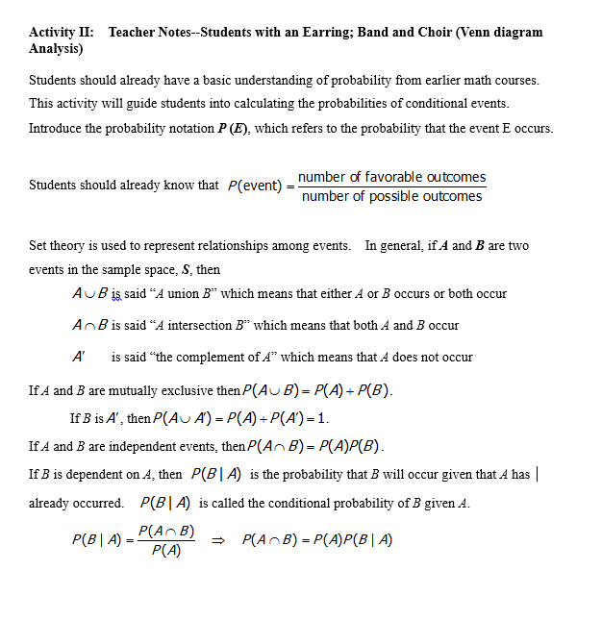

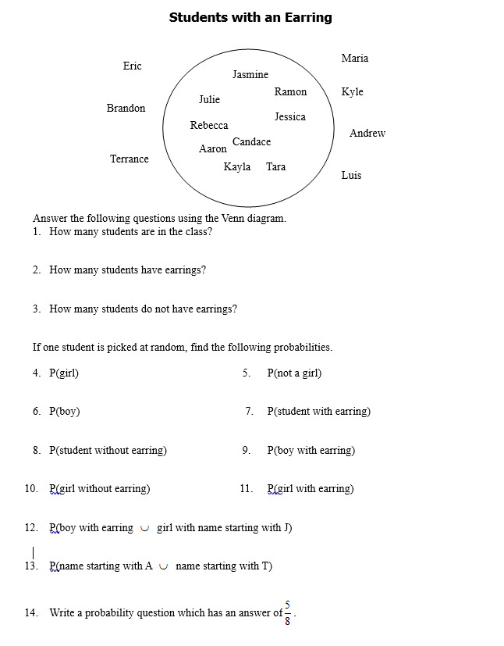

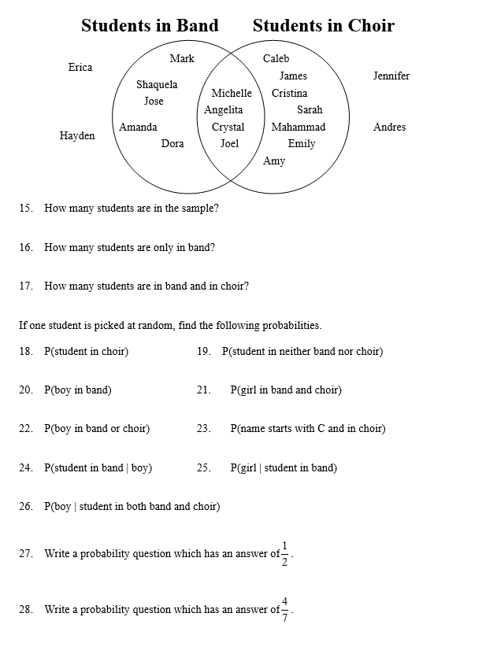

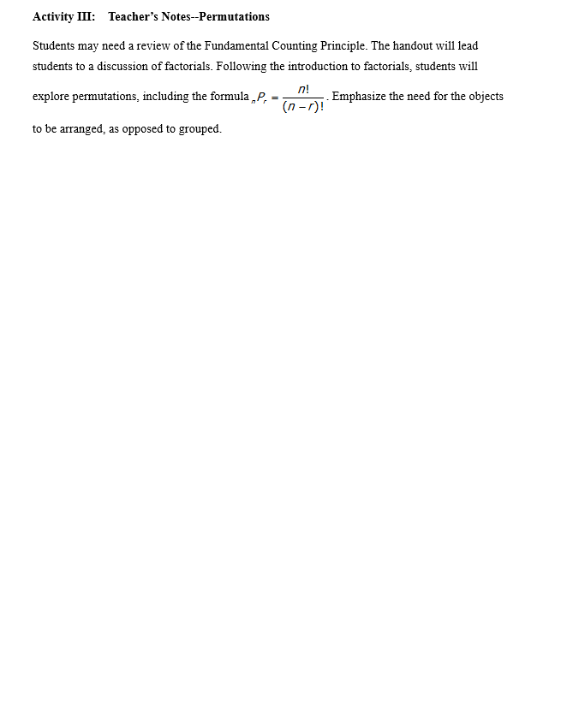
Permutations

Mr. Vandergoobergooten has decided to put Adam, Brianna, Chase, Destiny, and Eduardo in the front row of his classroom. He has five desks in the front row but is undecided about which student should sit at which desk.

1. How many different students could he place in the rightmost desk?

2. After selecting a student for the rightmost desk, how many different students could he place in the next desk?

3. After selecting a student for the first two desks, how many different students could he place in the next desk?

4. After selecting a student for the first three desks, how many different students could he place in the next desk?

5. After selecting a student for the right four desks, how many different students could he place in the leftmost desk?

6. Using the fundamental counting principle, write an expression that would find the number of different ways Mr. Vandergoobergooten could choose to arrange these five students.

7. How many different ways can he arrange the students?

8. If Mr. Vandergoobergooten had six desks in the front row and wanted to put Felicia in the front row too, write an expression that would find the number of different arrangements that are now possible.

9. How many different arrangements are now possible?

The process of multiplying every counting number from 1 to n can be abbreviated as n! which is said “n factorial.” Therefore and .

10. Write 2! as a multiplication problem and then find the value of 2!.

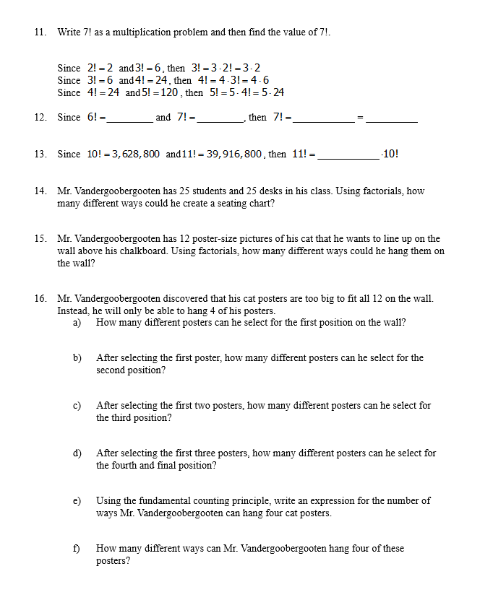
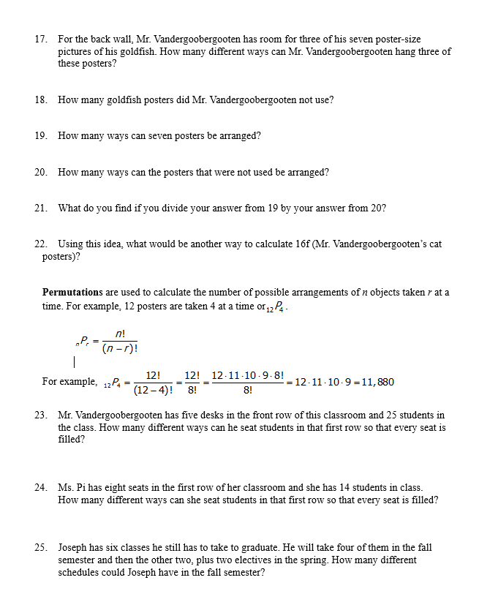
Activity VI: Teacher’s Notes--Law of Large Numbers

Students need a spinner simulator to complete this activity. A simulation tool is available on this website.
At the end of the investigation, discuss students’ conclusions from the last step. Be sure that everyone understands that as a procedure is repeated again and again, the relative frequency probability of an event tends to approach the actual probability.

Law of Large Numbers

Directions: Use a spinner simulator on a calculator or computer. A simulation tool is available at this website.
Set the number of sections on the spinner to 5. Change one of the actual (theoretical) values to 50%.

1. What has to be true of the other four actual (theoretical) values?

2. What happened to the appearance of the spinner?

Select any five probability values that you would like. Record these actual (theoretical) probability values as percentages.

Section: 1 2 3 4 5

3. Theoretical Values _____ _____ _____ _____ _____

Using the calculator, graph the experimental probability values.

4. Experimental Probability (Relative Frequency) as a percentage:

after 1 spin _____ _____ _____ _____ _____

after 2 spins _____ _____ _____ _____ _____

after 5 spins _____ _____ _____ _____ _____

after 10 spins _____ _____ _____ _____ _____

Change the Trial Set or Number of Spins to 10.

after 20 spins _____ _____ _____ _____ _____

5. Compare the relative frequency (experimental) probabilities in #4 with the actual (theoretical) probabilities from #3. Are you surprised by your results? Why or why not?

6. How many spins do you think it will take for the two types of probabilities to be equal? Explain.

7. Probability from Relative Frequency

after 30 spins _____ _____ _____ _____ _____

after 40 spins _____ _____ _____ _____ _____

after 50 spins _____ _____ _____ _____ _____

after 100 spins _____ _____ _____ _____ _____

8. Change the Trial Set or Number of Spins to 100.

after 200 spins _____ _____ _____ _____ _____

after 300 spins _____ _____ _____ _____ _____

after 400 spins _____ _____ _____ _____ _____

after 500 spins _____ _____ _____ _____ _____

9. Change the Trial Set or Number of Spins to 500.

after 1000 spins _____ _____ _____ _____ _____

after 2000 spins _____ _____ _____ _____ _____

after 3000 spins _____ _____ _____ _____ _____

10. Round each of your relative frequency (experimental) probabilities from 3000 spins to the nearest whole percentage.

_____ _____ _____ _____ _____

11. Copy your actual (theoretical) probabilities from step 3.

_____ _____ _____ _____ _____

12. Compare the relative frequency (experimental) probabilities in step 23 with the actual (theoretical) probabilities from step 24.

13. Look at the results from three other people. What conclusion can you make about the relationship between relative frequency probability and actual probability as the number of experiments increases?

Sample Resource

The Virginia Lottery

Illuminations
- Spinner Simulations
- Random Drawing Tool
- Exploration with Chance

