Catapults and Quadratic Regression – A Co-Teaching Lesson Plan

Co-Teaching Approaches
A “(Y)” in front of the following list items indicates the approach is outlined in the lesson. An “(N)” in front of the following list items indicates the approach is not outlined in the lesson.

- (Y) Parallel Teaching | - (Y) Station Teaching | - (N) Alternative Teaching
- (Y) Team Teaching | - (N) One Teach/One Observe | - (Y) One Teach/One Assist

Subject
Algebra, Functions, and Data Analysis (AFDA)

Strand
Algebra and Functions

Topic
Finding and modeling quadratic curve of best fit

SOL
AFDA.3 The student will collect and analyze data, determine the equation of the curve of best fit in order to make predictions, and solve practical problems using models of linear, quadratic, and exponential functions.

Outcomes

Students will use a graphing calculator to find a quadratic curve of best fit. Using a catapult of their own design, students will model a parabolic relationship, collect data, and draw conclusions from data and the quadratic curve of best fit.

Materials
- Computer hooked to a projector (for intro videos)
- Catapult building materials
  - Plastic spoons, rubber bands, clothes pins, tape
- Overhead projector
- Student or teacher phones (for slow-motion recording feature)
- Orange ping pong balls
- Quadratic Regressions (Curve of Best Fit) worksheet (attached)
- Flying Quadratics worksheet (attached)

Vocabulary

curve of best fit, domain, quadratic, range, regression, vertex, x-intercept, y-intercept

Co-Teacher Actions
Lesson Component | Co-Teaching Approach(es) | General Educator (GE) | Special Educator (SE)
Anticipatory Set | Team teaching/ Parallel teaching | GE activates prior knowledge by discussing linear relationships and regression/line of best fit.  GE divides class in half randomly. Leads discussion on “Quadratic Regression” notes with group 1. | Prompts students to verbalize new concept of quadratic regression.  SE leads discussion on “Quadratic Regression” notes with group 2.
Lesson Activities/ Procedures | Team Teach | GE explains to students the task of building a catapult. Each student creates a catapult using the provided materials. Students then choose one person to represent the group. That person launches a ping pong ball against the projected quadrant 1 grid while another student in the group films the trajectory in slow motion.  GE assists students with catapult construction.  GE leads students to the hallway and conducts the launchings with each group. | SE shows students a pre-built catapult model and launches a ping pong ball to ensure understanding.  SE assists students with catapult construction.  SE leads students to the hallway and conducts the launchings with each group.
Guided/ Independent Practice | Team Teaching | GE assists students in gathering data from the slow-motion video and completing the questions on the Flying Quadratics sheets. | SE assists students in gathering data from the slow-motion video and completing the questions on the Flying Quadratics sheets.
Closure | One teach/One assist | GE circulates and assists students with closure activity. | SE instructs students to write on the index card a real-life situation in which a quadratic curve of best fit would be appropriate. SE collects for discussion tomorrow.
Formative Assessment Strategies | Team Teaching | GE checks for understanding during practice.  GE collects and grades the Flying Quadratics worksheet.  GE collects and discusses the closure activity. | SE checks for understanding during practice.  GE collects and grades the Flying Quadratics worksheet.  GE collects and discusses the closure activity.
Homework | Team Teaching | No homework is assigned | No homework is assigned

Specially Designed Instruction
- Using both visual (linear regression examples drawn on board) and auditory (discussion) cues, (GE and SE) activates prior knowledge.
- Using the Catapult activity incorporates kinesthetic connections to mathematical concepts (GE and SE).
- Using real-world situations in the closure activity allows the SE to help students transfer knowledge from class activity to real-world situations.

Accommodations
- Read aloud for all instructions.
- Allow extra time for written work.
- Allow discussion response for students with written expression deficits.
- Providing a shortened Flying Quadratics assignment for those who need it.
- Allowing students unable to fling the catapult to use other students’ data.

Modifications
- For those students requiring a modified curriculum, content could be modified to include only linear functions.

Notes
- “Special educator” as noted in this lesson plan might be an EL teacher, speech pathologist, or other specialist co-teaching with a general educator.

Note: The following pages are intended for classroom use for students as a visual aid to learning.

Virginia Department of Education©2019

Quadratic Regression (Curve of Best Fit)

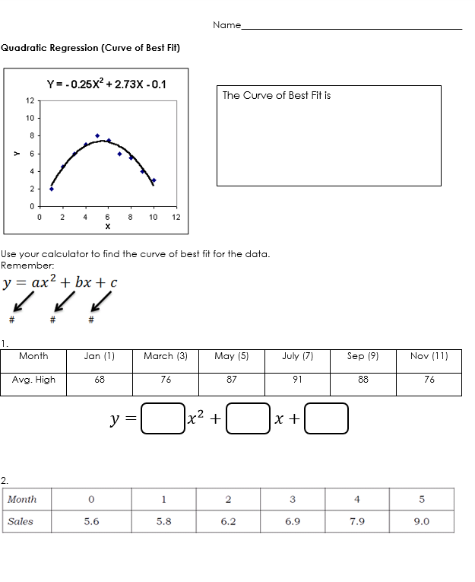

Quadratic Regression (Curve of Best Fit)

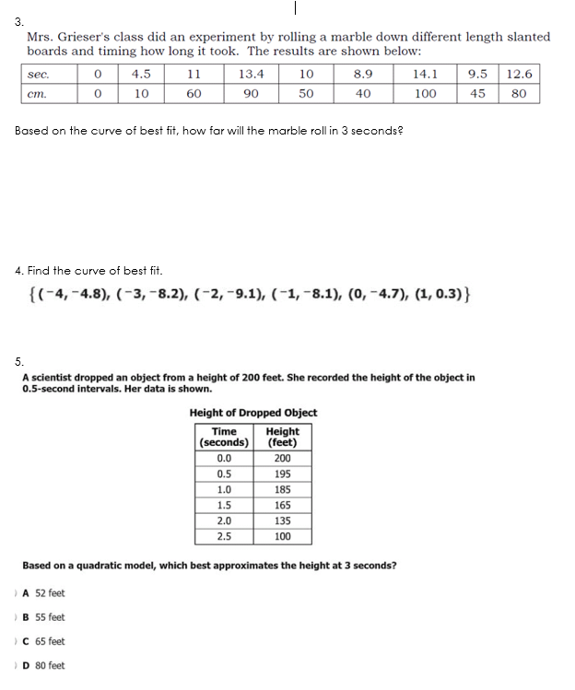
Flying Quadratics

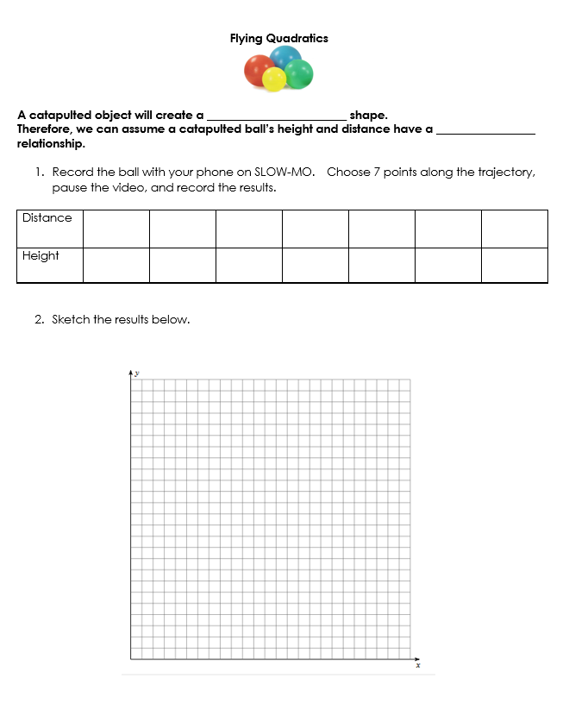

Flying Quadratics, cont.

