Graphing Transformations – A Co-Teaching Lesson Plan

Co-Teaching Approaches
A “(Y)” in front of the following list items indicates the approach is outlined in the lesson. An “(N)” in front of the following list items indicates the approach is not outlined in the lesson.

- (N) Parallel Teaching
- (Y) Team Teaching
- (N) Station Teaching
- (N) One Teach/One Observe
- (N) Alternative Teaching
- (Y) One Teach/One Assist

- (N) Parallel Teaching | - (N) Station Teaching | - (N) Alternative Teaching
- (Y) Team Teaching | - (N) One Teach/One Observe | - (Y) One Teach/One Assist

Subject
Algebra, Functions, and Data Analysis (AFDA)

Strand
AFDA.2 Transformations

Topic
Transformations

SOL
AFDA.2 The student will use knowledge of transformations to write an equation, given the graph of a linear, quadratic, exponential, and logarithmic function.

Outcomes
Students will be able to graph a function using the parent functions and transformations. The student will use knowledge of transformations to write an equation, given the graph of a function (linear, quadratic, exponential, and logarithmic).

Materials
- Graph paper
- Graphing calculator
- Function Family Matching Cards cutout (attached)
- Transformational Graphing handout (attached)

Vocabulary

absolute value, reflection, transformation, vertex

Co-Teacher Actions
Lesson Component | Co-Teaching Approach(es) | General Educator (GE) | Special Educator (SE)
Anticipatory Set | One teach/One assist | GE has students create a table of values in order to graph the following parent functions on graph paper without using their calculators.  After students have graphed each function on a separate graph, GE discusses the general shape of the graph and the zeros of the function. | SE walks around and assists struggling students.
Lesson Activities/ Procedures | One teach/One assist/  Team teach | GE assists struggling students.  GE helps facilitate discussion between partners and whole-class discussion.  GE uses whole-class discussion as a team-teaching activity. | SE has students graph the following functions, referencing the parent function and using a table of values:  f(x)=x²+3  f(x)=(x+3)²  f(x)=x²-3  f(x)=(x-3)²  SE has students discuss with partners how each function differs from the parent function. SE asks them to consider why the horizontal shift would be to the left when a number is being added to x, and to the right when a number is being subtracted.  SE reunites the class and transitions into a discussion about the similarities of transformations on a quadratic function to absolute value, square root, and cubic and cube root functions. SE leads students to surmise the same for other polynomial functions.
Guided/  Independent Practice | Team Teaching | GE introduces the matching activity by giving each student one card. Each student who is holding a graph card writes the equation that corresponds to the graph. Each student holding an algebraic function card draws a rough sketch of the graph that corresponds to the function. GE then directs students to find their partners and checks their responses.  GE monitors and/or assists. | SE monitors and/or assists.  SE distributes copies of the Transformational Graphing handout and has students work with partners to complete it. One partner completes #1 while the other completes #2.  When each student has completed one problem, have partners exchange papers and check each other’s work. If corrections are necessary, the student who did the problem should make the changes. When both students agree on the first two problems, then the student who did #1 does #3, and the student who did #2 does #4. Have them continue in this manner until the handout is complete. Be sure to check students’ work along the way to be sure they are on the right track.
Closure | Team Teach | GE leads a class discussion summarizing each type of transformation.  Exit Ticket  - I am a function. My parent function is .  - My parent function is mapped onto me by a reflection over the line y = 0, then a horizontal shift 3 units to the right, a vertical shift 4 units up, and finally a horizontal stretch with a factor of 2. Who am I? | SE assists in class discussion summarizing each type of transformation.  SE assists with the exit ticket.
Formative Assessment Strategies | Team Teaching | GE checks for understanding of the discussion/independent practice.  GE checks answers on the exit ticket.  GE grades independent/guided practice. | SE checks for understanding of the discussion/independent practice.  SE checks answers on the exit ticket.  SE grades independent/guided practice.
Homework | Team Teaching | No homework is assigned. | No homework is assigned.

Specially Designed Instruction
- Focus on one type of function at time and provide repetitive practice for each
- Reinforce verbally each step that is taken
- For card sort, split into at least two groups and do one group at a time.

Accommodations
- Provide oral and written instructions, per students’ IEP or 504 accommodations.
- Allow extra time for written work.
- Reduce the number of cards in the sort activity
- Reduce the number of problems in the guided and independent practice
- Allow discussion response for students with written expression deficits.

Modifications
- For those students who require a modified curriculum, content can be simplified to identifying linear functions and/or quadratic functions.
- Content could also be changed to identifying transformations around the origin in the coordinate plane.

Notes
- “Special educator” as noted in this lesson plan might be an EL teacher, speech pathologist, or other specialist co-teaching with a general educator.

Note: The following pages are intended for classroom use for students as a visual aid to learning.

Virginia Department of Education©2018

Function Family Matching Cards

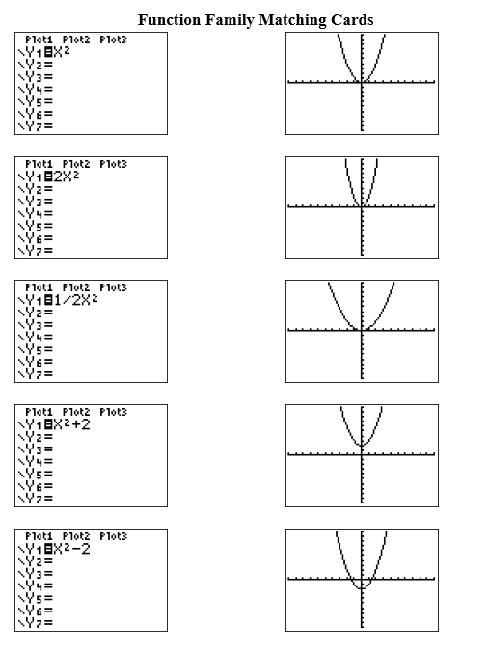
Function Family Matching Cards, cont.

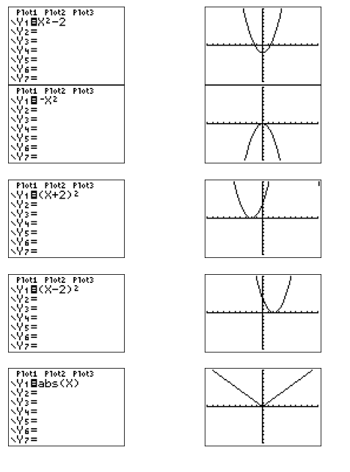
Function Family Matching Cards. cont.
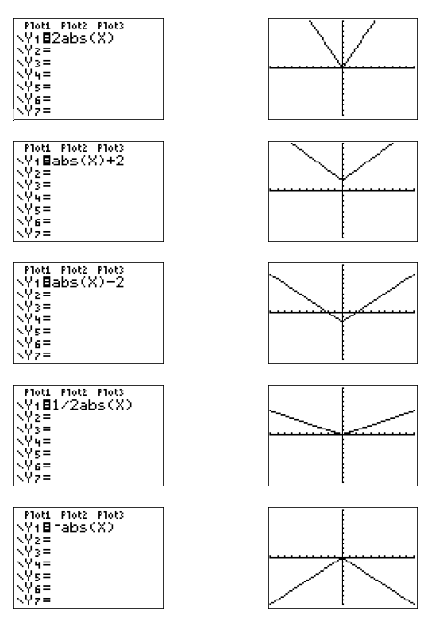

Function Family Matching Cards, cont.

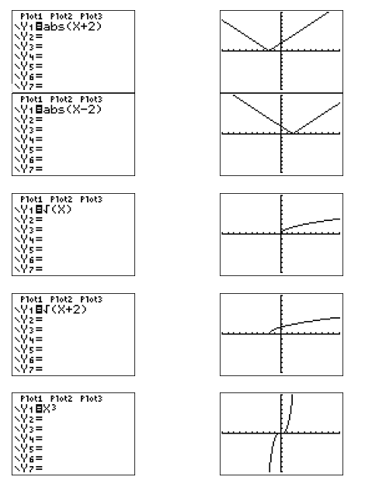

Function Family Matching Cards, cont.
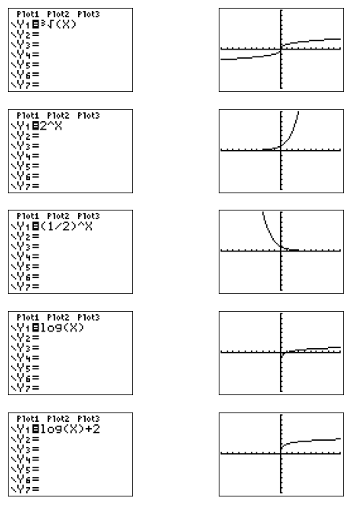

Transformation Graphing
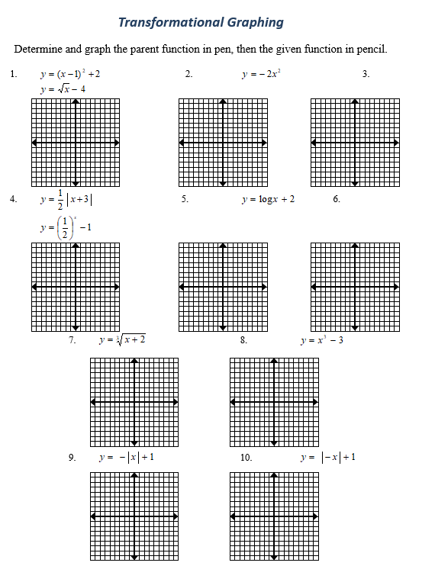
Transformation Graphing, cont.

