Rate of Change – A Co-Teaching Lesson Plan

Co-Teaching Approaches
A “(Y)” in front of the following list items indicates the approach is outlined in the lesson. An “(N)” in front of the following list items indicates the approach is not outlined in the lesson.
- (Y) Parallel Teaching
- (Y) Team Teaching
- (Y) Station Teaching
- (N) One Teach/One Observe
- (N) Alternative Teaching
- (Y) One Teach/One Assist

Subject
Algebra, Functions, and Data Analysis (AFDA)

Strand
AFDA.1 Linear Modeling

Topic
Graphing Quadratic Relationships

Standards
AFDA.1 The student will investigate and analyze linear, quadratic, exponential, and logarithmic function families and their characteristics. Key concepts include
b) intervals on which a function is increasing or decreasing;
g) connections between and among multiple representations of functions using verbal descriptions, tables, equations, and graphs.

Outcomes
Students will be able to identify the differences between positive, negative, zero, and undefined rate of change using multiple representations.

Materials
- Computer hooked to a projector (for intro video)
- Meter stick
- Small ball that will bounce
- The Frame Routine Diagram (attached)
- Da Bounce Activity worksheet (attached)
- Race to the Wall Activity worksheet (attached)
- Zero and Undefined Slope worksheet (attached)
- Identifying and Interpreting Slope worksheet (attached)

Vocabulary
delta notation, function, rate of change

Co-Teacher Actions
Lesson Component | Co-Teaching Approach(es) | General Educator (GE) | Special Educator (SE)
Anticipatory Set | One Teach/One Assist | GE introduces slope dude video.  Class watches slope dude video | SE facilitates class discussion summarizing slope dude.
Lesson Activities/ Procedures | Parallel Teaching/ Station Teaching | GE divides class into two groups. The left side works with teacher 1 and the right side works with teacher 2. Each teacher goes over the Frame Routine Diagram with their group (blank frame and answer key attached).  Class reconvenes and GE answers any remaining questions.  GE divides class into four groups (randomly select members of each group). The four groups rotate stations every 15 minutes (this may continue to the next day, depending on the schedule). Two stations are teacher assisted, two stations are independent.  Facilitate station 1 – Positive Rate of Change – Da Bounce Lab activity worksheet (attached). Students use a small bouncy ball to drop the ball from various heights (given) and record the number of bounces. They then answer the questions given.  Stations 3 and 4 are explained in the Guided/Independent Practice Section. | SE facilitates station 2 - Negative Rate of Change – Race to the Wall lab worksheet (attached). Students stand against one wall and measure their distance to the opposite wall. They record their data on the attached sheet. Students then take one step toward the opposite wall and measure their distance to the opposite wall and record their data on the attached sheet. This continues until students have completed six steps. Students answer the questions given.  Stations 3 and 4 are explained in Guided/Independent Practice Section.
Guided/Independent Practice | Team Teaching | Station 3 – Zero and Undefined Rate of Change worksheet (attached). Students work with their group to complete the zero and undefined rate of change worksheet.  Station 4 – Identifying and Interpreting Slope worksheet (attached). Students work with their group to complete the Identifying and Interpreting Slope Worksheet. | Station 3 – Zero and Undefined Rate of Change worksheet (attached). Students work with their group to complete the zero and undefined rate of change worksheet.  Station 4 – Identifying and Interpreting Slope worksheet (attached). Students work with their group to complete the Identifying and Interpreting Slope Worksheet.
Closure | One Teach, One Assist | Exit ticket  Think of a real life situation (that we haven’t used already) for each type of rate of change (positive, negative, zero, and undefined) and write each on a separate index card. Be prepared to share.  GE assists students with the exit ticket. | SE assists students with the exit ticket.
Formative Assessment Strategies | Team Teaching | GE checks for understanding during station teaching.  GE collects and grades stations activities.  GE collects and grades exit tickets. | SE checks for understanding during station teaching.  SE collects and grades stations activities.  SE collects and grades exit tickets.
Homework | Team Teaching | No homework is assigned | No homework is assigned

Specially Designed Instruction
- Teachers use the SIM Framing Routine taught through parallel teaching, thus reducing the teacher-to-student ratio and assuring understanding through observation and discussion (GE and SE)..
- Teachers use Walk Toward the Wall and Da Bounce activities which reinforce kinesthetic connections to mathematical concepts.

Accommodations
- Provide oral and written instructions (GE and SE), per students’ IEP and 504 accommodations.
- Supply a graphic organizer (GE and SE), per students’ IEP and 504 accommodations.
- Allow extra time for written work.
- Allow discussion responses for students with written expression deficits (SE).

Modifications
- For those students requiring a modified curriculum, content can be modified to include one type of function.

Notes
- “Special educator” as noted in this lesson plan might be an EL teacher, speech pathologist, or other specialist co-teaching with a general educator.
- The co-teachers who developed this lesson plan received required professional development in the use of specialized instructional techniques which combine an explicit instructional routine with the co-construction of a visual device (graphic organizer). The Framing Routine in conjunction with “The Frame” helps to develop understanding of information and procedures by associating their main ideas and details. These Content Enhancement Routines were developed at the Center for Research on Learning at the University of Kansas.
- Other graphic organizers should be used by teachers who have not received professional development in the Framing Routine. If Virginia teachers would like to learn the Content Enhancement Routines, contact your regional TTAC.

Note: The following pages are intended for classroom use for students as a visual aid to learning.

Virginia Department of Education©2018

The Frame Routine Organizer

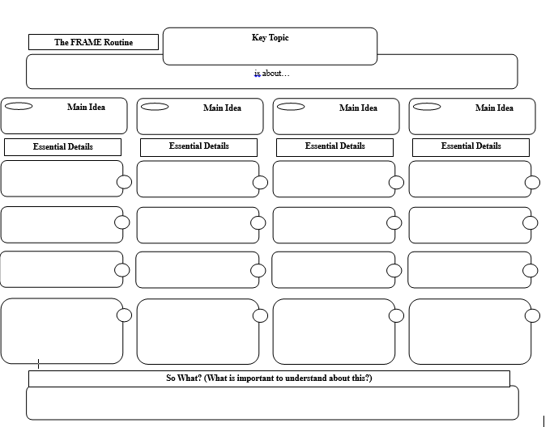
The Frame Routine Organizer (Sample)

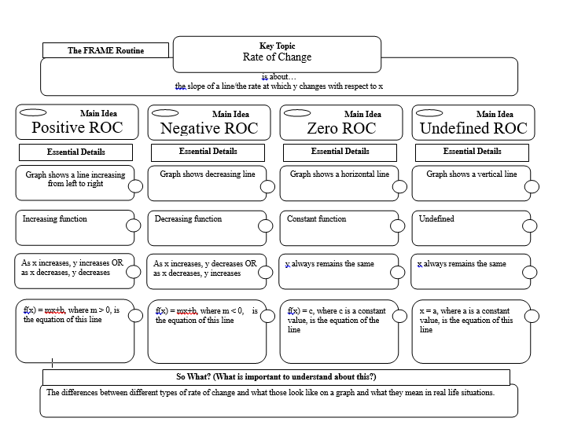
Rate and Change Bouncy Balls

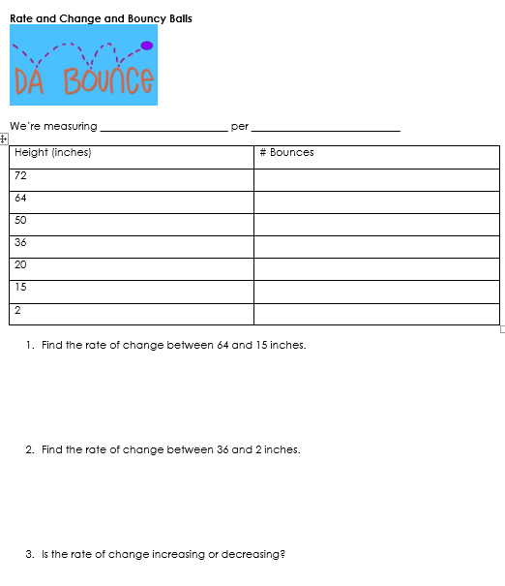
Rate and Change Bouncy Balls, cont.

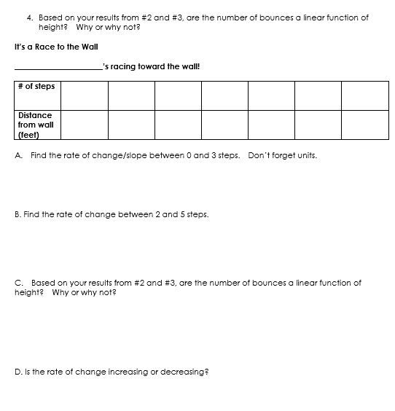

Zero and Undefined Rate of Change

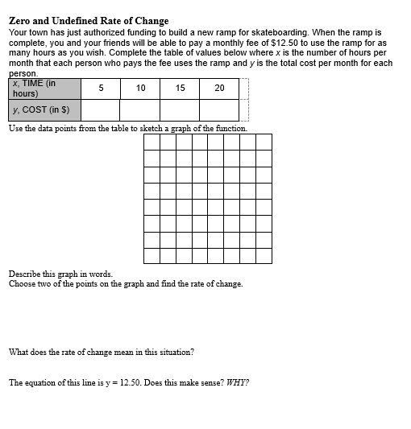

Zero and Undefined Rate of Change, cont.

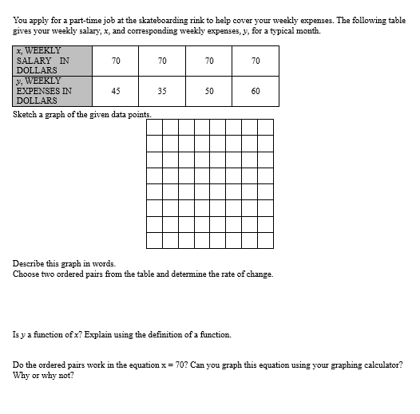

Zero and Undefined Rate of Change, cont.

