Quadratic Modeling – A Co-Teaching Lesson Plan

Co-Teaching Approaches
A “(Y)” in front of the following list items indicates the approach is outlined in the lesson. An “(N)” in front of the following list items indicates the approach is not outlined in the lesson.

- (Y) Parallel Teaching
- (Y) Team Teaching
- (Y) Station Teaching
- (N) One Teach/One Observe
- (N) Alternative Teaching
- (Y) One Teach/One Assist

Subject
Algebra, Functions, and Data Analysis (AFDA)

Strand
AFDA.1 Quadratic Modeling

Topic
Graphing Quadratic Relationships

Standards
AFDA.1 The student will investigate and analyze linear, quadratic, exponential, and logarithmic function families and their characteristics. Key concepts include
- domain and range;
- intervals on which a function is increasing or decreasing;
- absolute maxima and minima;
- intercepts;
- end behavior.

Outcomes
- Student will be able to:
- Find and interpret the intercepts and vertex of a quadratic relationship
- Find and interpret practical domain and range of a quadratic relationship
- Determine end behavior of a quadratic function
- Determine intervals on which a quadratic function is increasing and intervals on which a quadratic function is decreasing.

Materials
- AFDA book
- Computer hooked to a projector (for intro videos)
- Measuring tape Softball
- LINCS Table Diagram (attached)
- Let’s Shot Put activity worksheet (attached)

Vocabulary

domain, quadratic, range, vertex, x-intercept, y-intercept

Co-Teacher Actions
Lesson Component | Co-Teaching Approach(es) | General Educator (GE) | Special Educator (SE)
Anticipatory Set | Team Teaching/ Parallel Teaching | GE reviews the concept of a vertex video  clip  GE leads a discussion on vertex and gives an example of real life quadratic relationships (golf balls, pendulums, cannons, etc.).  GE divides the class in half randomly. GE assists group 1 students in completing the LINCS Table Diagram with the vocabulary words. | SE participates in a discussion on vertex and the examples of real life quadratic relationships (golf balls, pendulums, cannons, etc.).  SE assists group 2 students in completing the vocabulary LINCS Table Diagram with the vocabulary words.  SE shows the video on how to throw a shot put.
Lesson Activities/ Procedures | Team Teaching/ Station Teaching | GE distributes copies of the Let’s Shot Put activity worksheet. Students go outside and take turns throwing the shot put (use a softball instead of a shot put). Their distances are measured in inches (to the nearest inch) and recorded.  GE helps students measure their results.  After each student has thrown and recorded their results, return indoors.  Station 1: students complete questions 1-5 in the Let’s Shot Put activity worksheet with teacher guidance. | SE assists students in throwing the softball using the technique shown in the video on how to throw a shot put.  Station 2: Students complete questions 6-12 in the Let’s Shot Put activity worksheet with teacher guidance.
Guided/ Independent Practice | Team Teaching | GE circulates and assists students as they complete p. 421 (1-8) in the AFDA textbook. | SE circulates and assists students as they complete p. 421 (1-8) in the AFDA textbook.
Closure | One Teach/One Assist | GE circulates and assists students with closure activity. | SE provides instructions to students (projected on computer or written on board):  - Bob hits a golf ball 250 yards. The golf ball reached a peak height of 5 yards. Determine the practical domain and range of this situation.
Formative Assessment Strategies | Team Teaching | GE checks for understanding during station teaching.  GE collects and grades book work.  GE collects and grades closure activity. | Checks for understanding during station teaching.  SE collects and grades book work.  SE collects and grades closure activity.
Homework | Team Teaching | No homework is assigned. | No homework is assigned.

Specially Designed Instruction
- Teacher will use both visual (video) and auditory (discussion) cues (GE and SE) to activate prior knowledge.
- Teachers will use the LINCing routine taught through parallel teaching, thus reducing the teacher-to-student ratio and assuring understanding through observation and discussion (GE and SE).
- Teachers will Using the Shot Put activity to incorporates kinesthetic connections to mathematical concepts (GE and SE).
- Teachers will use a closure activity that helps students transfer written representation to graphic representation, thus helping students visualize practical domain and range.

Accommodations
- Read aloud is used for book work (GE and SE).
- Extra time is allowed for written work.
- Allow discussion response for students with written expression deficits (SE).

Modifications
- For those students requiring a modified curriculum, content modification could include only graphing quadratic equations and/or linear equations on the graphing calculator.

Notes
- “Special Educator” as noted in this lesson plan might be an EL Teacher, Speech Pathologist, or other specialist co-teaching with a General Educator.
- The co-teachers who developed this lesson plan received required professional development in the use of specialized instructional techniques which combine an explicit instructional routine with the co-construction of a visual device (graphic organizer). The Vocabulary LINCing Routine and its “LINCS Tables” help students learn and remember terms and vocabulary through auditory and visual memory devices. These Content Enhancement Routines were developed at the Center for Research on Learning at the University of Kansas.
- Other graphic organizers should be used by teachers who have not received professional development in the Vocabulary LINCing Routine. If Virginia teachers would like to learn Content Enhancement Routines, contact your regional TTAC.

Note: The following pages are intended for classroom use for students as a visual aid to learning.

Virginia Department of Education©2018

LINCS Table Diagram

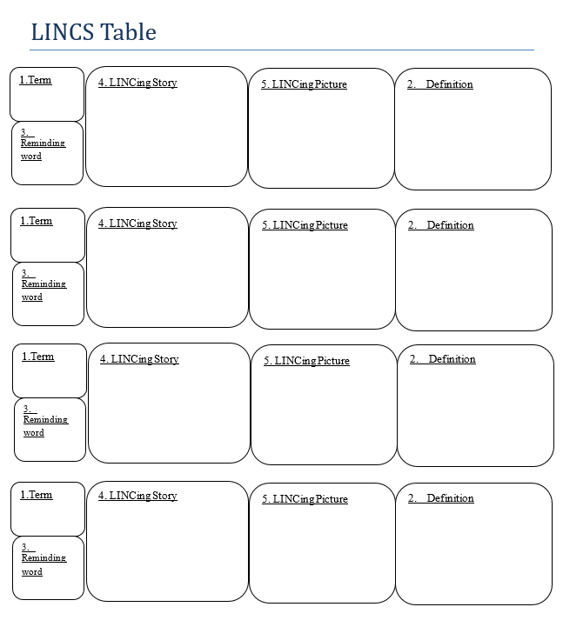

LINCS Table Diagram

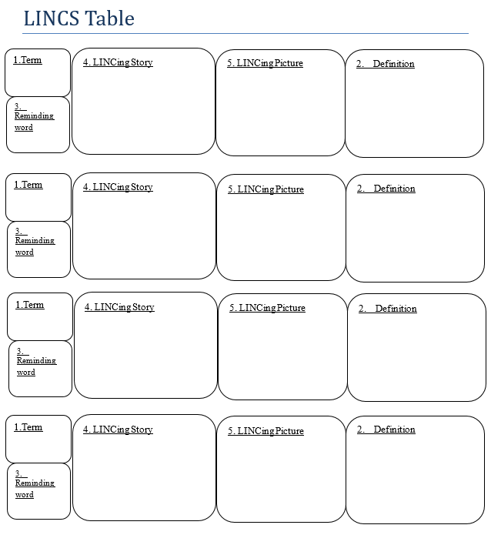
Let’s Shot Put

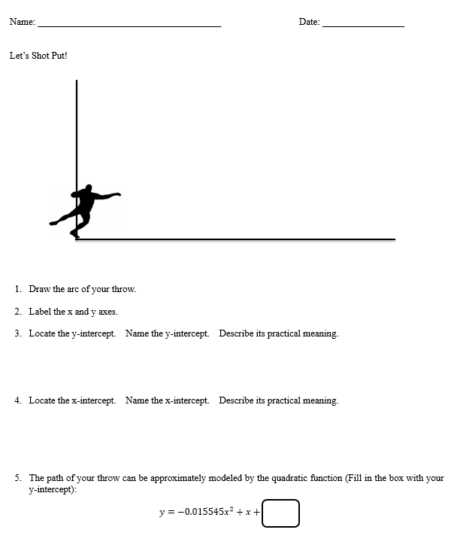

Let’s Shot Put, cont.

