Writing Equations of Lines – A Co-Teaching Lesson Plan

Co-Teaching Approaches
A “(Y)” in front of the following list items indicates the approach is outlined in the lesson. An “(N)” in front of the following list items indicates the approach is not outlined in the lesson.
- (N) Parallel Teaching
- (Y) Team Teaching
- (Y) Station Teaching
- (N) One Teach/One Observe
- (Y) Alternative Teaching
- (Y) One Teach/One Assist

- (N) Parallel Teaching
- (Y) Team Teaching
- (N) Station Teaching
- (N) One Teach/One Observe
- (Y) Alternative Teaching
- (Y) One Teach/One Assist

- (N) Parallel Teaching
- (Y) Team Teaching
- (N) Station Teaching
- (N) One Teach/One Observe
- (Y) Alternative Teaching
- (Y) One Teach/One Assist
- (N) Parallel Teaching
- (Y) Team Teaching
- (N) Station Teaching
- (N) One Teach/One Observe
- (Y) Alternative Teaching
- (Y) One Teach/One Assist

Subject
Algebra 1

Strand
Equations and Inequalities

Topic
Writing Equations of Lines

SOL
A.6 The student will
a) determine the slope of a line when given an equation of the line, the graph of the line, or two points on the line.
b) write the equation of a line when given the graph of the line, two points on the line, or the slope and a point on the line.

Outcomes
Students will write a slope intercept form equation accurately at least 3/4 times on an exit slip after class practice.

Materials
- Graph paper (optional)
- Graphing calculators (optional)
- Station 1 graphs (attached)
- Graph Answer Key (attached)
- Slope Intercept cards (attached, need to be cut apart)
- Silent Bingo Game Card (attached)
- Silent Bingo Game Problems (attached)
- Silent Bingo Game Card Answers (attached)

Vocabulary

horizontal line form, point-slope form, rate of change, slope, slope-intercept form, standard form, vertical line form, X-intercept, Y-intercept

Co-Teacher Actions
Lesson Component | Co-Teaching Approach(es) | General Educator (GE) | Special Educator (SE)
Anticipatory Set | One teach/One assist | GE introduces equations to review writing them (answers in parentheses).  - Write the slope intercept form equation given a slope of -2 and a y-intercept of 4. (y = -2x + 4)  - Write the slope intercept form equation given the point (3, -2) and the slope of 3. (y = 3x-11).  - Write the slope intercept form equation given the two points (-1, 4) and (5, -8). (y = - 6x-2)  GE reviews the correct answers after students have been given the opportunity to attempt each problem on their own. | SE circulates the classroom, checking in with students with disabilities to clarify directions and ensure that students are following along with GE.  SE reminds students of the following, as needed (referencing previous notes and review):  - slope intercept equation y= mx +b  - m representing the slope and b representing the y-intercept  - when writing an equation in slope intercept form given a point and slope, you must solve for b  - when writing an equation in slope intercept form given two points you must solve for m using the slope formula m = y₂-y₁/x₂-x₁ and then solve for b.
Lesson Activities/ Procedures | Stations | GE separate students into three groups with mixed ability levels. Three stations will include:  - GE-writing slope-intercept form equations based on graphs provided  - SE-matching equations, graphs, m, and b using the slope intercept cards.  - Independent practice on computers using Quizizz.com https://quizizz.com/admin/quiz/59b997d5f85f8b11002b560a  (Directions are included in the notes section below)  Each station takes 10-15 minutes. | SE same as GE.  During station 2, if needed, students will be given a limited number of equations to match rather than working with all of the equations at the same time. SE works with students to have them graph the equation using the y= function on the graphing calculator and matching the picture to the graph provided.
Guided/ Independent Practice | Alternative teaching | Students participate in silent bingo (attached). This is completed independently while GE circulates the room, assisting students and checking work to ensure understanding. If students complete the problems in order, they should get bingo after number 18 in the O column, and diagonally up from the bottom of B to the top of O. | Students participate in silent bingo (attached). This is completed independently while SE works with a small group of students who require more direct instruction.  SE can group bingo problems and provide only problems that are alike so that the teachers can review each way to write a slope intercept equation given the various scenarios.  - Group numbers 1-4 together and review writing equations by finding slope using rise/run and finding the y-intercept on the graph.  - Group numbers 5-10 together, reviewing how to insert m and b into the y=mx+b equation without solving for anything.  - Group numbers 11-15, 20, and 21 together, reviewing how to include m, x, and y so that the student solves for b and rewrite the y=mx+b equation.  - Group 16-19 and 22-24 together, using y₂-y₁/x₂-x₁ to solve for m and then including m, x and y (from the same ordered pair) to solve for b and rewrite the y=mx+b equation.
Closure | Team teaching | GE convenes whole class and they complete the following four question exit quiz (can be projected or printed and provided to students) slope intercept form equations given each scenario (answers in parentheses).  - 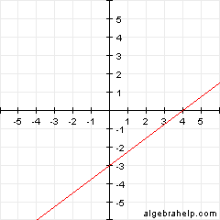(y = 3/4x-3)  - Slope = 2 and point (1, 4) (y = 2x+2)  - Slope = ½ and point (-8, 2) (y = ½x+6)  - Points (0, -3) and (-6, 3) (y = -x - 3). | SE ensures that all students are prepared to take the exit quiz (transpose the material, as needed, if quiz questions are projected for the class).
Formative Assessment Strategies | Team teaching | Teachers observe and work with students as they progress through the lesson review and solve slope-intercept form equations. If students are struggling to show comprehension of the concept, the teacher should review another example problem.  After students have participated in Quizizz, the teacher can export results to review later.  At the end of class, students independently complete the exit quiz, which teachers evaluate and determine if students have demonstrated mastery (at least 3/4 answers correct). If mastery is not accomplished, teachers should reteach and review in future lessons. | SE same as GE.
Homework | Team Teaching | Students complete silent bingo card for homework if they did not complete the entire card in class. | SE same as GE.

Specially Designed Instruction
- Tasks can be scaffolded and presented to students on a limited basis during stations. At station 1, students can work only with writing equations when the y-intercept is present on the graph if they are not yet ready to solve for the intercept after counting the slope. At station 2, there are equation cards that match with a m=, b=, and graph. The teacher can limit the cards that have to be matched each time, presenting only 1 or 2 cards as options to match with a specific equation.
- SE uses alternative teaching to pull aside a specific group of students who may be lacking prior knowledge or have shown difficulty during the various stations. SE can group the bingo questions so that students are solving all of one type of problem at a time, or SE can focus on a specific topic if it was noticed that students had particular difficulties in that area during stations.

Accommodations
- For the station with GE, students are shown how to write the equation of the graph and then type the equation into the y= function on the graphing calculator to check that the pictures correctly match.
- For the station with SE, students are given a limited number of equations to match rather than working with all of the equations at the same time. Work with students to have them graph the equation using the y= function on the graphing calculator and matching the picture to the graph provided.
- During independent practice time, have students divide the bingo questions into groups with similar questions, only answering four to six questions at a time. Review with the teacher how to write each equation based on the information provided.

Modifications
- For those students requiring a modified curriculum, content could be modified to include only y-mx equations or y=x+b equations. Another option is for students to find just the slopes or y-intercepts.
- For the station with GE, students can be given only graphs that have the slope and y intercept shown on the graph. Students do not have to write equations for graphs that require the student to use the slope and a point to solve for the y-intercept.
- For the station with SE, students are given a limited number of equations to match rather than working with all of the equations at the same time. Students only have to match the m= and b= cards to the equation, skipping matching the graph to the equation. Have y=mx+b pre-written for students to reference.

Notes
- “Special educator” as noted in this lesson plan might be an EL teacher, speech pathologist, or other specialist co-teaching with a general educator.
- Go to quizizz.com and create a free account by selecting the "Sign Up" button in the top, right corner of the web page. After creating an account, copy and paste the following link into the internet search barhttps://quizizz.com/admin/quiz/59b997d5f85f8b11002b560a. Select the "Play Live" button to customize the quizizz settings. It is recommended to turn off the question timer so students may work at their own pace. Select "Proceed" when it is time for students to begin working. Students need to go to "join.quizizz.com" and enter the six-digit code that appears on the screen. Students enter their full name and select "Join Game!" The teacher needs to select "Start Game" on the screen in order for students to proceed. Start the game after the first student joins so they may begin working; other students are permitted to join and start working later. When students complete the quizizz, select "End Game" on the screen.
You can export the results as an excel document to download on your computer by selecting "Export Results.” It is recommended that you create your account and review the website before using it in your classroom.

Note: The following pages are intended for classroom use for students as a visual aid to learning.

Virginia Department of Education©2019

Station 1
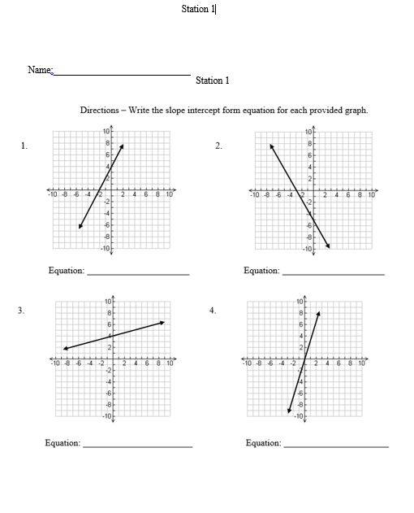

Station 1, cont.
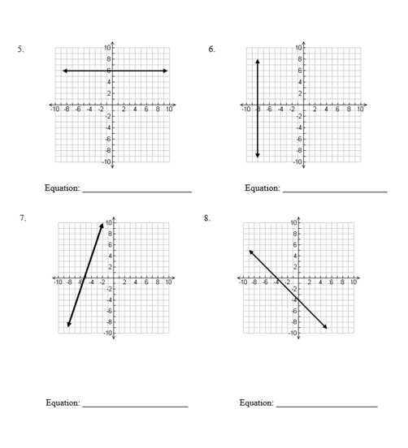

Station 1, cont.
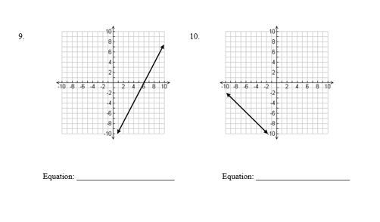

Graph Answer Key
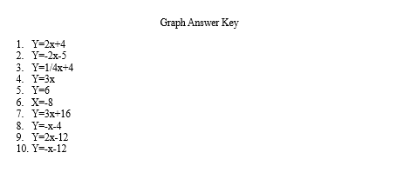

Slope Intercept Cards
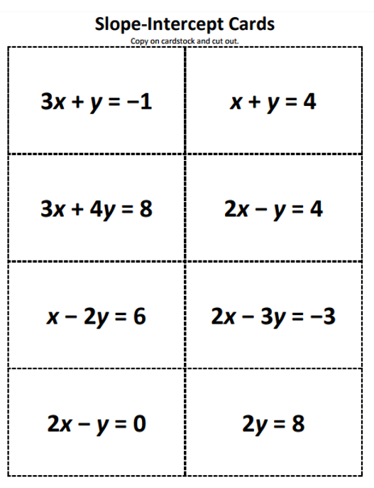

Slope Intercept Cards, cont.
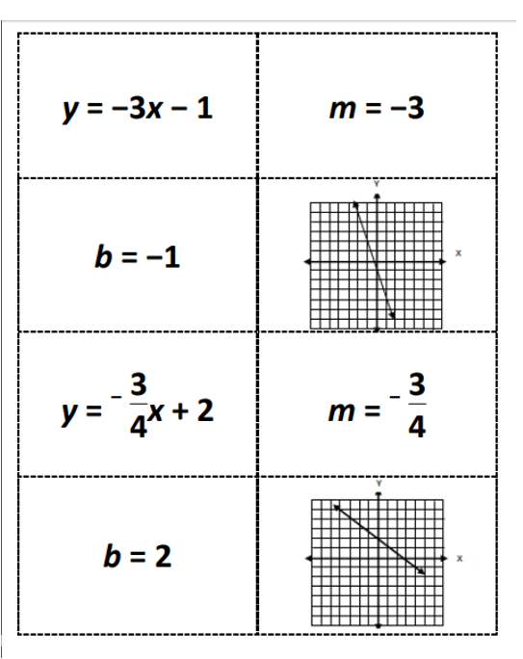
Slope Intercept Cards, cont.
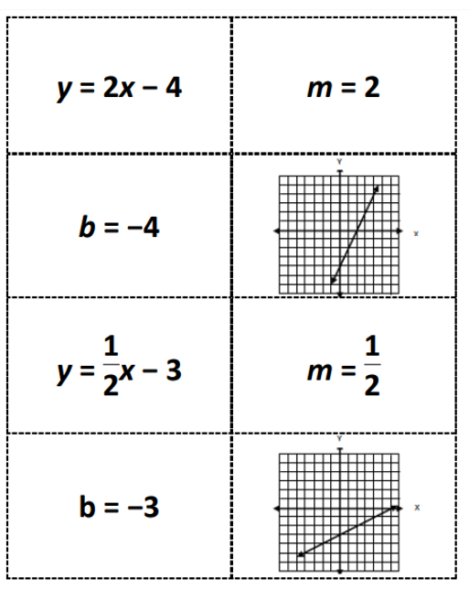

Slope Intercept Cards, cont.
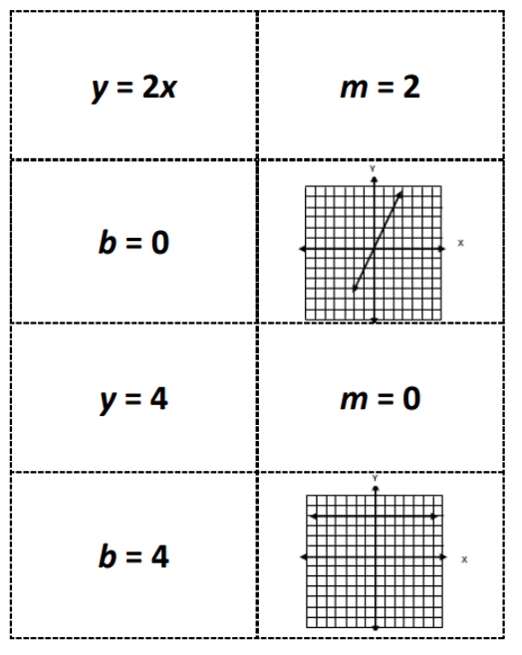
Slope Intercept Cards, cont.
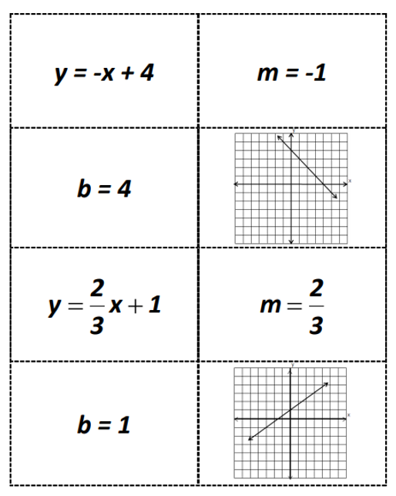
Silent Bingo Game Card
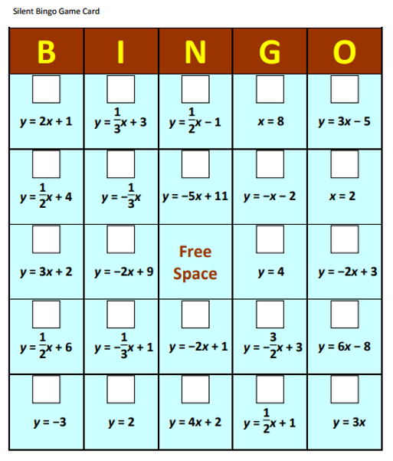
Silent Bingo Game Problems
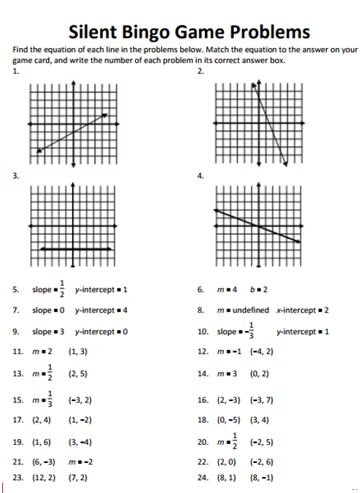
Silent Bingo Game Card Answers
