Graphing Systems of Linear Inequalities – A Co-Teaching Lesson Plan

Co-Teaching Approaches
A “(Y)” in front of the following list items indicates the approach is outlined in the lesson. An “(N)” in front of the following list items indicates the approach is not outlined in the lesson.
- (Y) Parallel Teaching
- (Y) Team Teaching
- (Y) Station Teaching
- (N) One Teach/One Observe
- (Y) Alternative Teaching
- (N) One Teach/One Assist

- (N) Parallel Teaching
- (Y) Team Teaching
- (N) Station Teaching
- (N) One Teach/One Observe
- (Y) Alternative Teaching
- (Y) One Teach/One Assist

- (N) Parallel Teaching
- (Y) Team Teaching
- (N) Station Teaching
- (N) One Teach/One Observe
- (Y) Alternative Teaching
- (Y) One Teach/One Assist
- (N) Parallel Teaching
- (Y) Team Teaching
- (N) Station Teaching
- (N) One Teach/One Observe
- (Y) Alternative Teaching
- (Y) One Teach/One Assist

Subject
Graphing Systems of Linear Inequalities

Strand
Equations and Inequalities

Topic
Graphing Systems of Linear Inequalities

SOL
Primary:
A.5 The student will
d) represent the solution to a system of inequalities graphically.

Related:
A.5 The student will
a) solve multistep linear inequalities in one variable algebraically and represent the solution graphically.

A.6 The student will
a) determine the slope of a line when given an equation of the line, the graph of the line, or two points on the line;
b) write the equation of a line when given the graph of the line, two points on the line, or the slope and a point on the line; and
c) graph linear equations in two variables.

Outcomes
Students will be able to accurately graph systems of inequalities and determine the solution region.

Materials
- Graphing calculators
- Colored pencils or markers
- Graph paper (or individual white boards with the coordinate plane)
- Graphing Inequalities review sheet (attached)
- Graphing Inequalities, Teacher Notes review sheet (attached)
- Graphing Systems of Inequalities activity sheet (attached)
- Teacher Notes for Graphing Systems of Inequalities activity sheet (attached)
- What Can I Buy? activity sheet (attached)

Vocabulary

inequality, solution, solution regions, system of inequalities

Co-Teacher Actions
Lesson Component | Co-Teaching Approach(es) | General Educator (GE) | Special Educator (SE)
Anticipatory Set | Parallel Teaching | Students will review graphing inequalities to prepare for the new lesson.  GE facilitates Graphing Inequalities review sheet with half of the class.  Ge discusses proper methods for graphing inequalities, as necessary. | Students will review graphing inequalities to prepare for the new lesson.  SE facilitates Graphing Inequalities review sheet with half of the class.  SE discusses proper methods for graphing inequalities, as necessary.
Lesson Activities/ Procedures | Team Teaching/  Station Teaching | GE distributes copies of the Graphing Systems of Inequalities activity sheet, graph paper (or individual white boards with the coordinate plane), and colored pencils or markers. As students work example 1, GE models the graphing for all to see.  Students complete the remaining examples as a station activity.  GE runs Example 2 station. Students show their understanding independently for example 4. | SE distributes copies of the Graphing Systems of Inequalities activity sheet, graph paper (or individual white boards with the coordinate plane), and colored pencils or markers. As students work example 1. GE models the graphing for all to see.  Students complete the remaining examples as a station activity.  SE runs Example 3 station. Students show their understanding independently for example 4.
Guided/ Independent Practice | Alternative Teaching | GE distributes the What Can I Buy? activity sheet and facilitates student progress, checking for accuracy as they complete the activity. | SE takes a small group of students to complete the What Can I Buy? activity sheet. These students may need additional support and guidance to be successful on this activity.
Closure | Team Teaching | Class discussion question  How would you write a system of linear inequalities where (2, 4) is a solution and (-3, 2) is not a solution? Justify your answer with a graph. | Class discussion question  How would you write a system of linear inequalities where (2, 4) is a solution and (-3, 2) is not a solution? Justify your answer with a graph.
Formative Assessment Strategies | Team Teaching | Exit slip  How would you graph this system of linear inequalities?  x0, y0, and 2x+3y<12  - Is (3, 2) a solution to the system?  - Is (0, 0) a solution to the system?  - How can you justify the difference in your answers to these questions? | Exit slip  How would you graph this system of linear inequalities?  x0, y0, and 2x+3y<12  - Is (3, 2) a solution to the system?  - Is (0, 0) a solution to the system?  - How can you justify the difference in your answers to these questions?
Homework | Team Teaching | Journal writing  Explain the situation when a system of two inequalities would have no solution. Give an example to support your reasoning. | SE same as GE.

Specially Designed Instruction
- Teacher can scaffold the lesson by breaksing down the lengthy process of graphing and shading by providing step-by-step directions (i.e., write in slope intercept form, plot the y intercept, count the slope (rise over run), solid or dotted line, shade above or below)

Accommodations
- Teacher provides a straight edge to create accurate graphs.
- Teacher provides graphs with labeled axes.
- Teacher provide checklists of steps for the students to refer to as they solve.
- Students can use the Desmos graphing calculator to check their work.

Modifications
- For those students who require a modified curriculum, they could graph linear inequalities on a number line, or graph linear equations.

Notes
- “Special educator” as noted in this lesson plan might be an EL teacher, speech pathologist, or other specialist co-teaching with a general educator.

Note: The following pages are intended for classroom use for students as a visual aid to learning.

Virginia Department of Education©2019

Graphing Inequalities

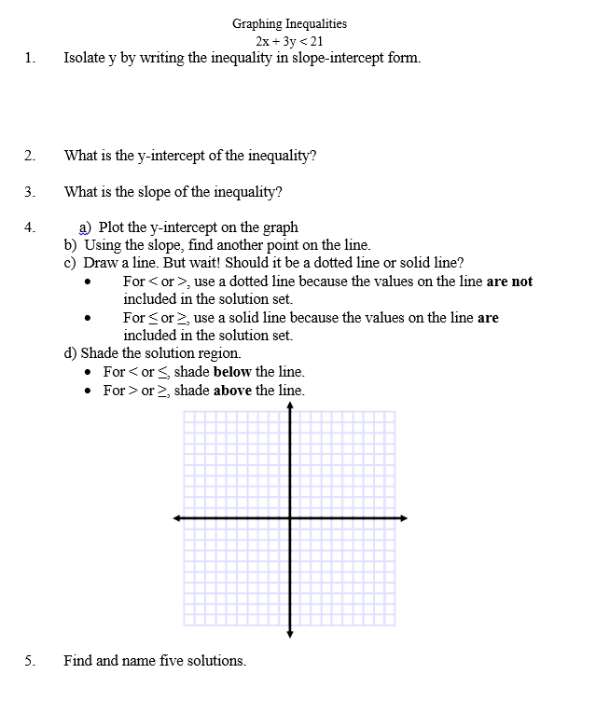

Graphing Inequalities, Teacher Notes

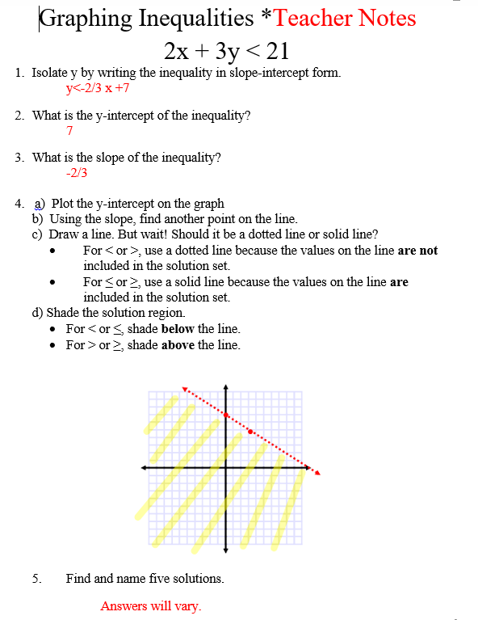

Graphing Systems of Inequalities

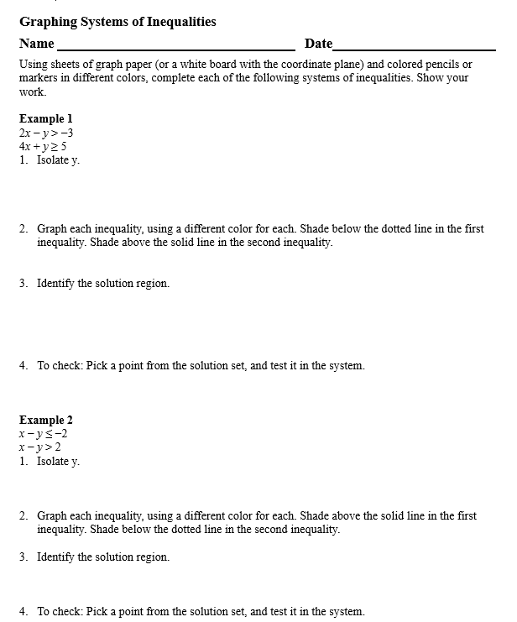
Graphing Systems of Inequalities, cont.

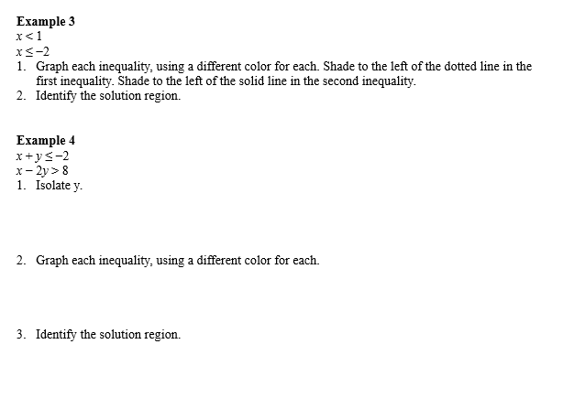

Teacher Notes for Graphing Systems of Inequalities
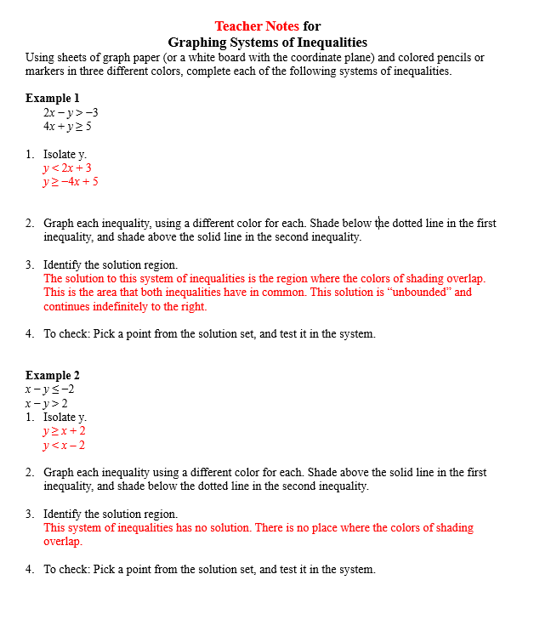

Teacher Notes for Graphing Systems of Inequalities, cont.

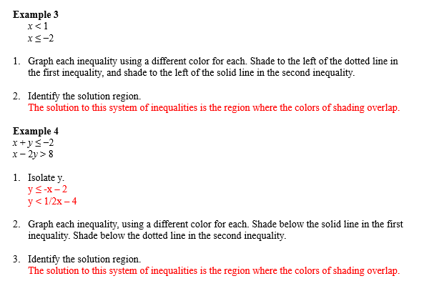

What Can I Buy?

