Relating the graphing of a line to solving an inequality - A Co-Teaching Lesson Plan

Co-Teaching Approaches
A “(Y)” in front of the following list items indicates the approach is outlined in the lesson. An “(N)” in front of the following list items indicates the approach is not outlined in the lesson.

- (Y) Parallel Teaching
- (Y) Team Teaching
- (N) Station Teaching
- (N) One Teach/One Observe
- (Y) Alternative Teaching
- (Y) One Teach/One Assist

Subject
Algebra 1

Strand/Reporting Category
Equations and Inequalities

Topic
Relating the graphing of a line to solving an inequality in one variable

SOL
A.5 The student will
b) represent the solution of linear inequalities in two variables graphically.

Outcomes
Students will accurately solve and graph two variable inequalities on at least 5 attempts during classwork.

Materials
- Scissors
- Graphing calculator (optional)
- Blank paper (optional)
- Glue or tape
- Inequalities FRAME (attached)
- Solving Inequalities in One and Two variables activity sheet (attached)
- Solving inequalities puzzle (attached, pre-cut before using)

Vocabulary

boundary, closed point, dashed line, open point, solid line

Co-Teacher Actions
Lesson Component | Co-Teaching Approach(es) | General Educator (GE) | Special Educator (SE)
Anticipatory Set | One teach/One assist | GE places warm-up questions on the board or gives to students for a review of slope intercept equations.  GE introduces the questions for students to complete independently. Once students complete the questions, the GE reviews answers with the class.  Questions  Identify the slope and y-intercept of the following equations:  - y=1/2x+3 (m=½, b=3)  - y=x-2 (m=1, b=-2)  - 3x-9y=18 (m=⅓, b=-2) | SE begins class by checking in with students with disabilities (SWD) to check for organization and ensure that students are prepared and able to start with the warm-up.  As needed, SE transcribes or reads the warm-up to students.  SE reminds students of the equation of y=mx+b and that m is the slope and b is the y-intercept.  SE provides a visual reminder of the equation for students when necessary.
Lesson Activities/ Procedures | Parallel teaching | GE creates groups based on ability level. GE works with students who have previously demonstrated understanding on inequalities in the same classroom as SE.  Teachers review the four inequality symbols and what they represent when solving and graphing both one and two variable inequalities using the frame organizer (or similar graphic organizer if teachers are not trained in the frame routine).  GE works with students to co-construct the frame organizer, providing the students with the topic to go in the key topic box and working with the students to create a sentence that explains what inequalities are. (Refer to the completed example.)  Graphic Organizer  Each of the four columns are titled with an inequality symbol and the words that represent the symbol.  The first row across is a reminder of how to graph each symbol with one variable, while the second row provides an example of each type of inequality graphed.  The third row provides a reminder of how to graph a two variable inequality, while the final row shows an example with shading and solid versus dotted lines.  Review how to graph each symbol both ways before moving on to the next symbol.  The students can create their own examples to graph in the 2nd and 4th rows. As a class, create a statement that summarizes what is important to remember about graphing inequalities in the So what? box at the bottom. | GE creates groups based on ability level. SE works with students who have shown difficulty when solving inequalities, in the same classroom as GE.  Teachers review the four inequality symbols and what they represent when solving and graphing both one and two variable inequalities using the frame organizer (or similar graphic organizer if teachers are not trained in the frame routine).  The SE provides a frame that has part or all of the information already provided for certain students (read accommodations below to see options).  Provide the students with the topic to go in the key topic box and work with the students to create a sentence that explains what inequalities are. (Refer to the completed example.)  Graphic Organizer  Each of the four columns are titled with an inequality symbol and the words that represent the symbol.  The first row across is a reminder of how to graph each symbol with one variable while the second row provides an example of each type of inequality graphed.  The third row provides a reminder of how to graph a two variable inequality, while the final row will show an example with shading and solid versus dotted lines.  Review how to graph each symbol both ways before moving on to the next symbol.  Provide examples for each of the graph boxes. Work with the students to determine what they found to be important to remember and create a statement that summarizes what is important to remember about graphing inequalities in the So what? box at the bottom.
Guided/  Independent Practice | Parallel teaching | Students complete solving inequalities in one and two variables activity sheet.  GE circulates to provide assistance and check for understanding while students work through each set independently. Once students have finished, they can work with a partner to solve and match the pieces of the solving inequalities puzzle. | Students work to complete solving inequalities in one and two variables activity sheet.  SE works with students to complete the activity. SE and students complete the first two sets together and then students complete the last two sets independently.  Students can work in partners to complete the inequalities puzzle. For students who need more organizational assistance, SE provides the inequalities on separate paper rather than as the pieces of the heart.
Closure | Team teaching | GE posts the following exit slip question on the board or provides it to the students. If needed, provide the included multiple choice options to select the answer that fits best (answer is underlined):  Questions  Why is it necessary to shade part of the number line or coordinate plane when graphing an inequality?  - It shows the range of values that are not solutions.  - It shows the range of values that are solutions.  - It makes the inequality with one variable look different from the inequality with two variable. | SE same as GE.
Formative Assessment Strategies | Team teaching | Teachers monitor and check for understanding as students work on the individual and partner assignments. If teachers see students who are struggling with demonstrating mastery, teachers should walk through a problem with the student and check for understanding through each of the steps.  Additionally, teachers will collect the Inequalities puzzle to check for mastery of solving inequalities. The exit slip also serves as a method of assessing student understanding of graphing inequalities and the meaning behind each graph. | SE same as GE.
Homework | Team teaching | Students finish solving the inequalities puzzle if it is not done in class. | SE same as GE.

Specially Designed Instruction
- The framing routine is used to review previously known content of solving and graphing one-variable equations on a number line and comparing this to solving and graphing two-variable inequalities on a coordinate plane. The frame prompts students to make connections between open circles and dotted lines as well as between closed circles and solid lines.
- Review graphic organizers such as the frame provide a space for students to organize a wide variety of information and present it in such a way that students can begin to make connections between previous information and current topics.
- Parallel teaching allows students to be taught in smaller groups based on ability levels. Students in a group with the general education teacher complete more work on an individual basis with less teacher guidance. Students in a group with the special education teacher have more explicit instruction and guided practice time.

Accommodations
- Use the frame routine to review and compare graphing one- and two-variable inequalities. This frame can be partially or completely finished prior to giving it to students. A recommendation for a partially completed frame includes the title and the “is about” statement at the top of the frame, as well as any graphs that need to be drawn. For graphs that are pre-drawn, students can add additional shading in the correct region of the graph.
- Have segments pre-cut for students who have OT or visual services/accommodations.
- Provide a copy of the equations from the board or the cut-out segments on lined paper for students with executive functioning deficits.
- Use colored pencils to mark the shaded areas on graphs in preparation for graphing systems of inequalities.

Modifications
- For those students who require a modified curriculum, content can be modified to solving and graphing inequalities that only contain one variable. Content can also be modified by decreasing the number steps required for solving.

Notes
- “Special educator” as noted in this lesson plan might be an EL teacher, speech pathologist, or other specialist co-teaching with a general educator.
- The co-teachers who developed this lesson plan received required professional development in the use of specialized instructional techniques which combine an explicit instructional routine with the co-construction of a visual device (graphic organizer). The Framing Routine in conjunction with “The Frame” helps to develop understanding of information and procedures by associating their main ideas and details. These Content Enhancement Routines were developed at the Center for Research on Learning at the University of Kansas.
- Other graphic organizers should be used by teachers who have not received professional development in the Framing Routine. If Virginia teachers would like to learn the Content Enhancement Routines, contact your regional TTAC.

Note: The following pages are intended for classroom use for students as a visual aid to learning.

Virginia Department of Education©2018

The Frame Routine Graphic Organizer

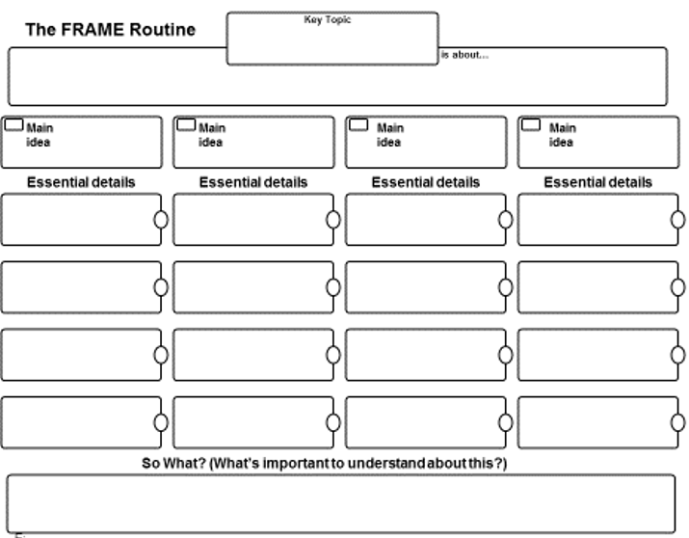

The Frame Routine Graphic Organizer, Sample

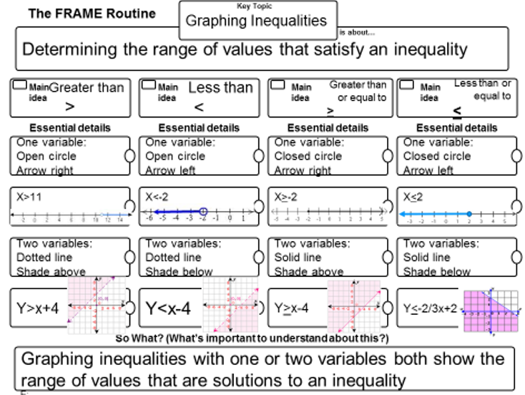

Solving Inequalities in One and Two Variables

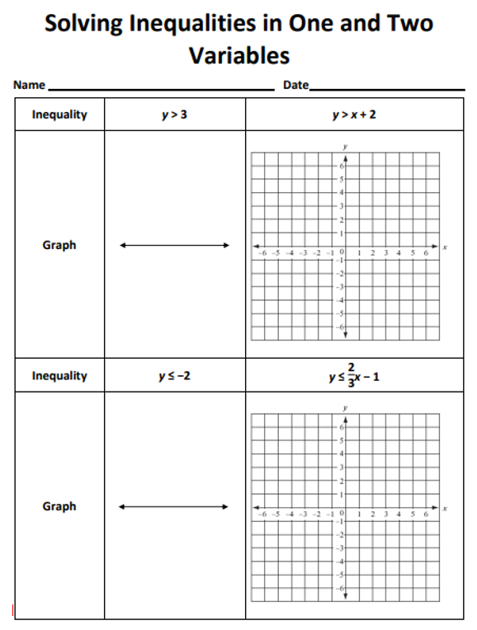

Solving Inequalities in One and Two Variables, cont.

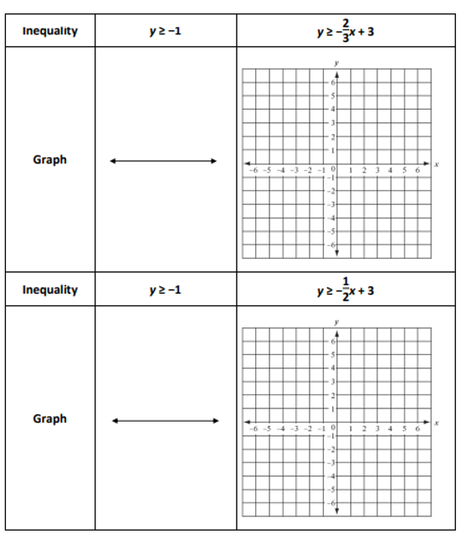

Solving Inequalities Puzzle

