# Simplifying Cubed Roots – Three’s Company - A Co-Teaching Lesson Plan

## Co-Teaching Approaches

A “(Y)” in front of the following list items indicates the approach is outlined in the lesson. An “(N)” in front of the following list items indicates the approach is not outlined in the lesson.

* (Y) Parallel Teaching
* (Y) Team Teaching
* (N) Station Teaching
* (N) One Teach/One Observe
* (Y) Alternative Teaching
* (Y) One Teach/One Assist
* (Y) Parallel Teaching
* (Y) Team Teaching
* (N) Station Teaching
* (N) One Teach/One Observe
* (Y) Alternative Teaching
* (Y) One Teach/One Assist

## Subject

Simplifying Cubed Roots

## Strand

Expressions and Operations

## Topic

Cubed Roots

## SOL

A.3 The student will

b) simplify cubed roots of integers.

## Outcomes

Students will find the simplest form of cubed root expressions.

## Materials

* Graphing calculator
* Equivalent Radical Cubes, Part I
* Equivalent Radical Cubes, Part II

## Vocabulary

*cubed root, cubing, perfect cube, radicand, simplest radical form*

## Co-Teacher Actions

| **Lesson Component** | **Co-Teaching Approach(es)** | **General Educator (GE)** | **Special Educator (SE)** |
| --- | --- | --- | --- |
| **Anticipatory Set** | One teach/One assist | 2. GE allows time for student responses, then facilitates discussions and makes a list of square root facts the students share. (Note: This should enable teachers to know whether students have enough knowledge to determine the cubed root of a perfect cube.)  4. SE builds on  concept by continuing with and. During this discussion, SE highlights the ideas 2(2) (2) = 8, 23 = 8 and that finding the cubed root and cubing are inverse operations. | 1. SE introduces brainstorming bell work. Students brainstorm and list what they know about cubed roots. (SE may also ask them to think about what similarities and differences exist between squares and cubes.) 2. SE asks students to simplify. SE discusses their reasoning and finds various ways to explain the outcome. |
| **Lesson Activities/ Procedures** | Parallel Teach  Team Teach  One teach/one assist  Parallel Teach  One teach/one assist  Team teaching | 1. GE displays the Equivalent Radicals Cubes worksheet. SE groups students in groups of three. There should be a partner A, partner B, and partner C.   GE instructs each partner to find the decimal equivalent of his/her expression and compare it with his/her partners’ decimals.  Teachers monitor half of the class to facilitate this portion of the lesson. (Note: Teachers may need to review order of operations and explain the steps so that the calculator will perform the desired operations.)   1. **Question**  * Now that you have had time to calculate, what do you notice? (Each row has the same decimal equivalent.) Go back and look at each row. * Knowing that they are equivalent, what other observations can be made? Share your observations.   GE monitors the students and assists with the examples.   1. Teachers distribute the Equivalent Radicals (cubes) Part II sheet.  * Instruct students to cut apart the boxes and match up the equivalent expressions. Students should take notes of patterns. After the students have completed the activity, teachers will discuss and explain (to their group) which form of each one is the *simplest* form.  1. GE monitors the students and assists with the examples.   GE asks students to share their ideas, which will definitely include the decimal representation and, given the work already done in this lesson. Encourages other ideas to emerge as well.  By referencing the previous activities, students can begin to see the process of finding the simplest radical form.   1. GE asks students to find all factors of 16 and 18. Then asks students to work in their groups to find as many ways as possible to represent and. GE asks why they were able to represent  with a whole number outside of the radical but not. GE discusses what it means to be in simplest radical form. (A cube root in simplest form is one in which the radicand has no perfect cube factors other than one.) | 1. SE displays the Equivalent Radicals Cubes worksheet. SE groups students in groups of three. There should be a partner A, partner B, and partner C.   SE instruct each partner to find the decimal equivalent of the expression and compare it with each partners’ decimals.  Teachers monitor half of the class to facilitate this portion of the lesson. (Note: Teachers may need to review order of operations and explain the steps so that the calculator will perform the desired operations.)  SE same as GE.   1. SE tells the students that in mathematics we often represent an expression in different ways but that the different representations do not change the value of the expression. For example, 6+7 is the same as 10+3, or 4/8 is the same as ½. Students just learned that each set of expressions in the table are representative of the same number in different ways and that this number can also be written as a decimal. 2. Teachers distribute the Equivalent Radicals (cubes) Part II sheet.  * Instruct students cut apart the boxes and match up the equivalent expressions. Students should take notes of patterns. After the students have completed the activity, teachers will discuss and explain (to their group) which form of each one is the *simplest* form.  1. SE gives the students the expression and asks them to work with their group to represent this expression as many ways as they can without changing the value.   Monitor the students and assist with the examples.   1. Same as GE. |
| **Guided/Independent Practice** | Alternative Teaching | GE has students work with groups to represent the following square roots in simplest form:. Note: There may be several different strategies for simplifying these radicals. Some students may use prime factorization to get the cube factors, and others may use their knowledge of perfect cubes. It is important to accept these strategies and any other mathematically sound strategies that students offer.) | SE gives the same problems as GE. SE scaffolds steps to make it more accessible for students who are struggling to grasp the concept. SE continues to find the factors and simplify the radicals to reinforce the process. It may also help for students to have a multiplication chart with the perfect cubes highlighted. |
| **Closure** | Team teaching | **Exit slip**  How do you know whether a cube root is fully simplified? | SE same as GE. |
| **Formative Assessment Strategies** | Team teaching | **Journaling**   * Explain how you would simplify a cube root into its simplest form. * Compare and contrast simplifying square roots and cube roots. | SE same as GE. |
| **Homework** | Team teaching | GE provides opportunities for students to practice expressing cube roots in the simplest form. | SE same as GE. |

## Specially Designed Instruction

* Teacher will utilize manipulatives such as linking cubes to represent the cubic numbers, and also to find the cubic roots. This will help to provide the Concrete, Representational, Abstract instruction that is often needed.
* Provide a multiplication chart with perfect cubes highlighted (as noted in Guided/Independent Practice).
* Create a flow chart showing the steps for simplifying a cube root.

## Accommodations

* Provide scaffolding on the Equivalent Radicals Cubes worksheet with a factor table for them to complete. This allows students to complete the process with tools to organize their thought processes.
* Suggest students expand out radicand expressions, using prime factorization, and have them circle groups of three when simplifying cube roots.

## Modifications

* For those students who need a modified curriculum, content could be modified to factoring whole numbers, or to simplifying square roots.

## Notes

* “Special educator” as noted in this lesson plan might be an EL teacher, speech pathologist, or other specialist co-teaching with a general educator.

**Note: The following pages are intended for classroom use for students as a visual aid to learning.**

### Virginia Department of Education©2018

**Equivalent Radicals Cubes, Part I**

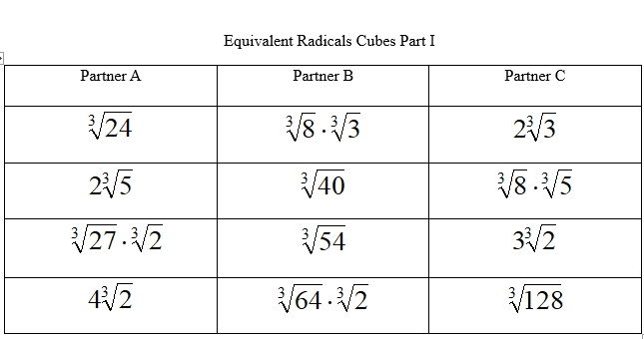

**Equivalent Radicals Cubes, Part II**

