Multiplying Polynomials using Algebra Tiles – A Co-Teaching Lesson Plan

Co-Teaching Approaches
A “(Y)” in front of the following list items indicates the approach is outlined in the lesson. An “(N)” in front of the following list items indicates the approach is not outlined in the lesson.
- (Y) Parallel Teaching
- (Y) Team Teaching
- (Y) Station Teaching
- (N) One Teach/One Observe
- (N) Alternative Teaching
- (N) One Teach/One Assist

- (N) One Teach/One As

Subject
Multiplying Polynomials

Strand
Expressions and Operations

Topic
Multiplying polynomials using algebra tiles

SOL
A.2 Students will perform operations on polynomials, including
b) adding, subtracting, multiplying, and dividing polynomials.

Outcomes
The students will use algebra tiles to model and evaluate products of polynomials.

Materials
- Algebra Tiles
- The Frame Diagram (blank and sample) (attached)
- Multiplying Polynomials Using Algebra Tiles sheet (attached)

Vocabulary

base, binomial, coefficient, degree, exponent, monomial, polynomial, term, trinomial

Co-Teacher Actions
Lesson Component | Co-Teaching Approach(es) | General Educator (GE) | Special Educator (SE)
Anticipatory Set | Parallel Teach | GE posts:  Simplify x(-4x+7)  GE models with algebra tiles and discusses it. | SE posts:  Simplify x(-4x+7)  SE models with algebra tiles and discusses it.
Lesson Activities/ Procedures | Team Teaching | GE demonstrates multiplying polynomials using algebra tiles, as shown below.  (x+1 )(x+6) = x²+7x+6  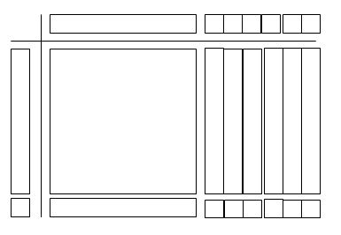  GE gives students (x + 4)(2x -1) to model on their own.  GE presents this next example  (x + 3)(x² + 2x + 1)  Question  - Is this polynomial more difficult to model using algebra tiles?  GE models completing this polynomial example problem algebraically. | SE same as GE.
Guided/  Independent Practice | Station Teaching | GE sets up four stations in the room.  Station 1 - (x + 2)(3x – 3) with algebra tiles.  Station 2 - (2x + 1)(x – 7) with SE.  Station 3 – (x + 1)(x² + 3x –1) with algebra tiles.  Station 4 - (x – 4)(2x² – 4x + 5) with GE.  The stations with algebra tiles reinforce the lesson, while the stations with the teachers build confidence in completing the process without the assistance of the algebra tiles. | SE leads students through station 2 algebraically.
Closure | Team Teaching | GE uses the Frame Diagram as a post lesson construction.  GE guides class through introduction to Key Topic and Main Idea boxes. GE provides students with time to fill in essential details independently.  GE then facilitates a class discussion about these details. Finally, class fills in the So What? box as a class. | SE same as GE.
Formative Assessment Strategies | Team Teaching | GE uses the attached Multiplying Polynomials Using Algebra Tiles sheet as one method of assessment. GE allows students to use algebra tiles where necessary.  GE asks the following questions as exit/entry slips:  - Draw a model of the multiplication of two binomials. Simplify your expression.  - Explain why (2x)(3x) = 6x² and not 6x. | SE same as GE.
Homework | Team Teaching | Journaling  - One of your classmates was absent when we discussed how to multiply polynomials using algebra tiles. Write a paragraph explaining this procedure.  - Describe how to multiply polynomials without using algebra tiles. | SE same as GE.

Specially Designed Instruction
- Teacher could create a fill-in-the-blank algebra tile sheet. By providing the outline of the tiles for each question, students receive extra practice with modeling in order to reinforce the multistep questions. Lessons are tiered to provide the factors on the frame and allow the students to complete the process. Lessons start at their knowledge levels and build from there. This may mean giving them more information in the beginning.
- Teacher will implement the framing routine for all students. This routine has the potential to assist students who are struggling because, as a post-lesson construction, it helps to reiterate the main ideas and the important details. This also gives students a study sheet that may be used in the future.

Accommodations
- Offer students additional entry-level questions before moving on to more complex questions.
- Encourage the use of algebra tiles, drawings, and mathematical notation simultaneously to reinforce the concepts in this lesson.
- Have students use colored pencils for drawing algebra tile models.

Modifications
- For students requiring a modified curriculum, examples could be limited to binomials or curriculum could be modified to creating pictorial models of equations.

Notes
- “Special educator” as noted in this lesson plan might be an EL teacher, speech pathologist, or other specialist co-teaching with a general educator.
- The co-teachers who developed this lesson plan received required professional development in the use of specialized instructional techniques which combine an explicit instructional routine with the co-construction of a visual device (graphic organizer). The Framing Routine in conjunction with “The Frame” helps to develop understanding of information and procedures by associating their main ideas and details. These Content Enhancement Routines were developed at the Center for Research on Learning at the University of Kansas.
- Other graphic organizers should be used by teachers who have not received professional development in the Framing Routine. If Virginia teachers would like to learn the Content Enhancement Routines, contact your regional TTAC.

Note: The following pages are intended for classroom use for students as a visual aid to learning.

Virginia Department of Education©2018

The Frame Diagram

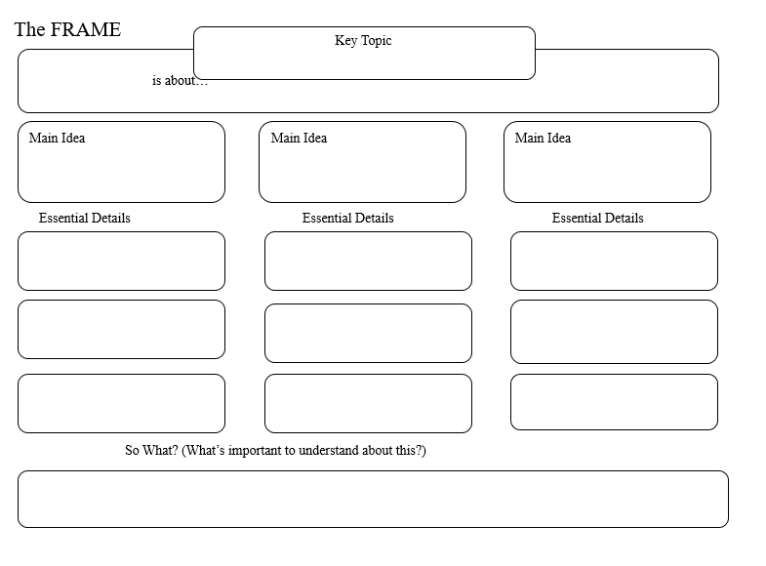

The Frame Diagram (sample)

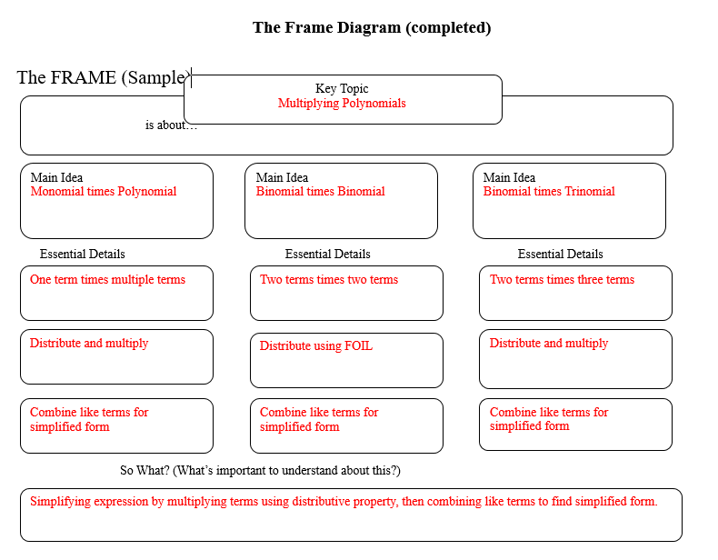

Multiplying Polynomials Using Algebra Tiles

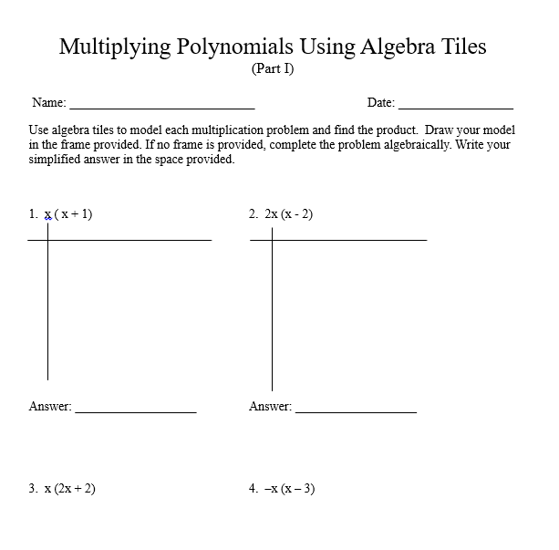

Multiplying Polynomials Using Algebra Tiles cont.

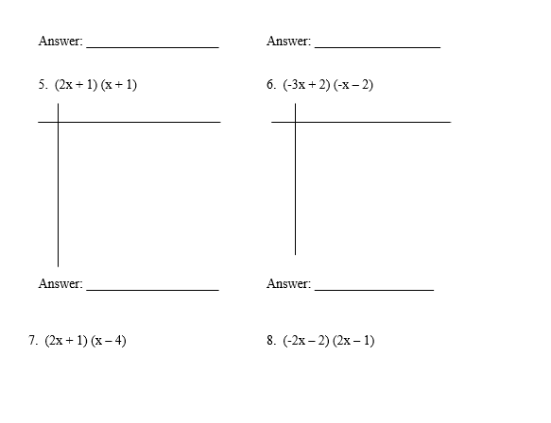
Multiplying Polynomials Using Algebra Tiles cont.

