Using the Laws of Exponents to Interpret Scientific Notation – A Co-Teaching Lesson Plan

Co-Teaching Approaches
A “(Y)” in front of the following list items indicates the approach is outlined in the lesson. An “(N)” in front of the following list items indicates the approach is not outlined in the lesson.

- (Y) Parallel Teaching
- (Y) Team Teaching
- (Y) Station Teaching
- (Y) One Teach/One Observe
- (Y) Alternative Teaching
- (Y) One Teach/One Assist

Subject
Scientific notation

Strand
Expressions and Operations

Topic
Working with scientific notation

SOL
A.2 The student will perform operations on polynomials, including
a) applying the laws of exponents to perform operations on expressions.
(Related: A.1)

Outcomes
Students will apply the laws of exponents to interpret scientific notation.

Materials
- Frame Diagram (attached)
- Frame Diagram (sample, attached)
- Scientifically Speaking activity sheet (attached)

Vocabulary

base, exponent, power, scientific notation

Co-Teacher Actions
Lesson Component | Co-Teaching Approach(es) | General Educator (GE) | Special Educator (SE)
Anticipatory Set | Team Teaching | GE uses the Frame Diagram to review prior knowledge (exponent rules). This review may be set up as a cut and paste activity where the students are provided with a blank frame and each individual component.  Once students have had time to cut and paste, teachers will facilitate a discussion about the exponent rules and the frame. | SE same as GE.
Lesson Activities/ Procedures | One teach/One assist | GE monitors student progress.  Question  The mass of the sun is 1.98x10³⁰ kg. Why do you think this is written in scientific notation?  GE monitors students and asks leading questions during the discussion. | Students will evaluate a number written in scientific notation. (5.43x10⁵)  SE changes the exponent to a negative number and students evaluate the new number. (5.43x10⁻⁵)  SE asks students to explain what changes.  SE monitors student progress and asks leading questions during the discussion.  Question  The distance from the sun to Earth is 1.5x10⁸ km. The distance from Earth to Jupiter is 5.95x10⁸km. How far is Jupiter from the sun?  SE leads discussion on how we can use the exponent rules we already know to solve the problem.
Guided/Independent Practice | Parallel Teaching | GE distributes copies of the Scientifically Speaking activity sheet and has students complete it. | SE distributes copies of the Scientifically Speaking activity sheet and has students complete it.
Closure | Team Teaching | GE summarizes the lesson by having students discuss how they used the laws of exponents to find solutions to the problems. GE asks students what they would have done if they had not known the laws of exponents.  Question  - Did knowing the laws or rules of exponents make it easier? Why?  - Would scientific notation be as beneficial if you didn’t know the laws of exponents? Why, or why not? | SE same as GE.
Formative Assessment Strategies | Team Teaching | GE gives exit slip with the following questions:  - How are the laws of exponents and scientific notation connected?  - How is knowing the laws of exponents helpful when operating with numbers in scientific notation? | SE same as GE.
Homework | Team Teaching | Journaling  Describe a situation in which you would not only use scientific notation, but also perform operations on numbers in scientific notation.  GE instructs students to find real-life examples of numbers that can be written in scientific notation and create their own problems with these numbers. | SE same as GE.

Specially Designed Instruction
- The teacher will use the framing routine to help organize the concepts for the students. This routine has the potential to assist students who are struggling because, as a review of prior knowledge, it allows students to revisit previous ideas and concepts.

Accommodations
- Read through the problems with students. Have them highlight important information and discuss which operations to use.
- Allow students to use calculators to compute answers if they need support.

Modifications
- For students requiring a modified curriculum, content can be focused on Scientific Notation or Writing numbers in exponential notation.

Notes
- “Special educator” as noted in this lesson plan might be an EL teacher, speech pathologist, or other specialist co-teaching with a general educator.
- The co-teachers who developed this lesson plan received required professional development in the use of specialized instructional techniques which combine an explicit instructional routine with the co-construction of a visual device (graphic organizer). The Framing Routine in conjunction with “The Frame” helps to develop understanding of information and procedures by associating their main ideas and details. These Content Enhancement Routines were developed at the Center for Research on Learning at the University of Kansas.
- Other graphic organizers should be used by teachers who have not received professional development in the Framing Routine. If Virginia teachers would like to learn the Content Enhancement Routines, contact your regional TTAC.

Note: The following pages are intended for classroom use for students as a visual aid to learning.

Virginia Department of Education©2018

Frame Diagram

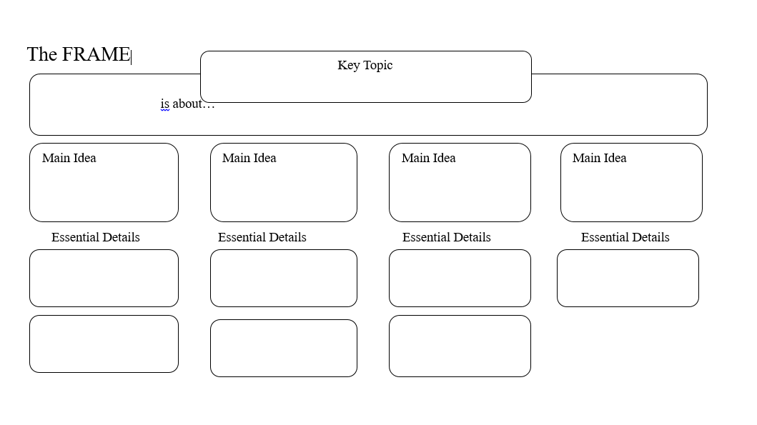

Frame Diagram (sample)

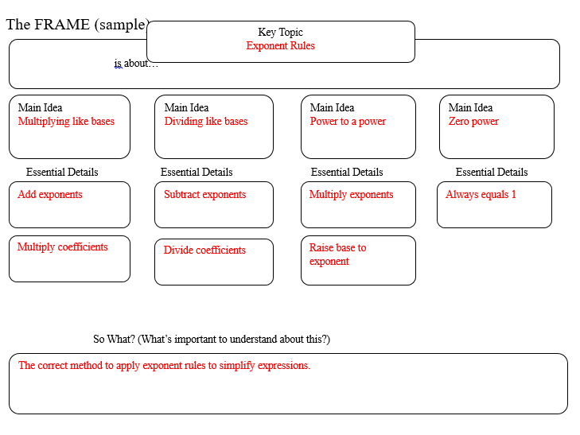

Scientifically Speaking

