3D Figures – A Co-Teaching Lesson Plan

Co-Teaching Approaches
A “(Y)” in front of the following list items indicates the approach is outlined in the lesson. An “(N)” in front of the following list items indicates the approach is not outlined in the lesson.

- (Y) Parallel Teaching
- (Y) Team Teaching
- (N) Station Teaching
- (N) One Teach/One Observe
- (Y) Alternative Teaching
- (N) One Teach/One Assist

Subject
Grade 8 Mathematics

Strand
Measurement and Geometry

Topic

3D Figures

SOL
8.8 The student will construct a three-dimensional model, given the top or bottom, side, and front views.

Outcomes
Given a set of problems, students will be able to construct three-dimensional models, given the top, side, and front view and match a top, side, or front view.

Materials
- Computer
- Colored markers
- Linking cubes
- Short Video on 3D printing (optional)
- WisWeb Applet: Building houses with side views
- 3D Figures with Cubes (attached)
- 3D Figure Patterns (attached)
- Multiple Choice question (attached)
- Guided practice sheet (attached)
- Exit Ticket (attached)
- Matching Cards (attached)
- Matching Cards, page 2 (attached)
- Matching Cards Teacher Key (attached)

Vocabulary

bottom, left side, perspective, right side, top

Co-Teacher Actions
Lesson Component | Co-Teaching Approach(es) | General Educator (GE) | Special Educator (SE)
Anticipatory Set | Team Teaching | GE introduces students to the concept of 3 dimension (3D) in the world. Discuss the differences between 3 dimension and 2 dimension in art. | (Optional)SE prepares video about 3D printing to show to students. SE explains what is happening in the world of printing and begins video.
Lesson Activities/ Procedures | Team Teaching | GE shows students a sample multiple choice question, 3D Figures with Cubes, from involving 3D figures. GE explains the different views and how the question is worded. | SE points to parts of the sample question involving 3D figures, going over the different vocabulary that they may see in questions. SE explains the different views and how the question may be worded.  SE explains the front, top, and side shaded views of a figure. SE uses the same shading for every figure so students can more readily distinguish the three different views.  SE models one of the figures at the front of the classroom. Students then come to the front to examine the figure in each view and explain how many cubes they can see in each.  SE models with linking cubes what the pictures shown on the board would actually look like. Students who are having difficulty seeing the different views come up to the front of room to experience the views.
Guided/  Independent Practice | Alternative Teaching | GE directs students to go to the WisWeb applet to select Building Houses with side views. Students practice building a house using the online representational game. Students who are having difficulty are pulled to work concretely with SE.  GE explains what the views are while working through the problem, as if trying to match it.  Computer lab  GE guides the students through the first figure at the WisWeb Building Houses applet website. Students watch GE work on figure 1 and students discover figures 2-10.  Students assess their own knowledge or skills as they work through each level. | SE pulls students who are frustrated with the online activity and have difficulty seeing the views.  SE uses blocks and the 3D Figure Patterns worksheet to build houses. Students physically create the houses, and after mastery, move to the more abstract representation game on Chromebooks.  A peer buddy may be assigned when students have completed their work on the computer.
Closure | Parallel Teaching | GE has students verbally summarize what they did to complete their last task using think/pair/share.  GE discusses strategies (e.g., building up as opposed to carving out) with students who are having difficulty.  Questions  - Is there more than one way to build this?  - What characteristics do you identify first when constructing a 3D figure?  - If you were given only the top and bottom views, would you be able to build the model accurately? | SE has students verbally summarize what they did to complete their last task using think/pair/share.  SE discusses strategies (e.g., building up as opposed to carving out) with students who are having difficulty.  Questions  - Is there more than one way to build this?  - What characteristics do you identify first when constructing a 3D figure?  - If you were given only the top and bottom views, would you be able to build the model accurately?
Formative Assessment Strategies | Parallel Teaching | GE instructs students to complete an exit ticket on which they must explain their reasoning for their answer. | SE instructs students to complete an exit ticket on which they must explain their reasoning for their answer.
Homework | Team Teaching | GE assigns Matching Cards from VDOE for the students. | SE same as GE.

Specially Designed Instruction
- Use linking cubes for the concrete stage and hands-on learning. This uses the concrete-representation-abstract (CRA).
- Students who have finished the enrichment can become a peer buddy to give guidance on how to complete the assignment to those who are having difficulties.

Accommodations
- Students receive assistance with directions.
- Students who struggle to stay on task or complete lengthy assignments receive clear instruction with small discrete steps. Students can complete assignments in chunks.
- Students requiring a copy of classroom notes should receive a copy of completed notes.
- Teachers should reteach lessons when necessary.
- Students receive small group and one-on-one instruction, as needed.
- Teachers should providing preferential seating, as needed.
- Teacher should reduce the number of questions that need to be completed for struggling students or students who receive reduced math problems as a result of IEP accommodations.
- Students who have slower processing skills should receive increased time to complete the assignment.

Modifications
- For those students requiring a modified curriculum, they could focus on identifying plane and solid figures according to their characteristics (number of angles, vertices, edges, faces).

Notes
- “Special educator” as noted in this lesson plan might be an EL teacher, speech pathologist, or other specialist co-teaching with a general educator.

Note: The following pages are intended for classroom use for students as a visual aid to learning.

Virginia Department of Education©2018
3D Figures with Cubes

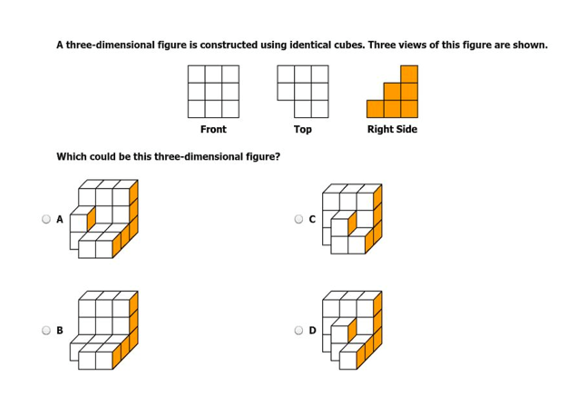

3D Figure Patterns

Guided Practice
3-D Figure Patterns

Make Figures A – D using the linking cubes using the top, side, and front views below.
Check your figure with your partners figure to make sure you both are correct.

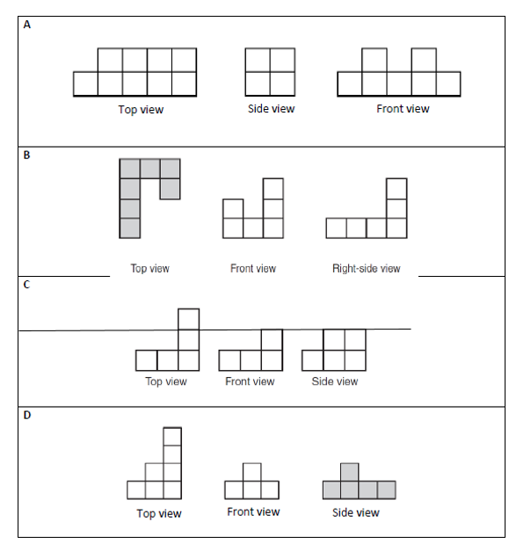

Exit Ticket

EXIT TICKET

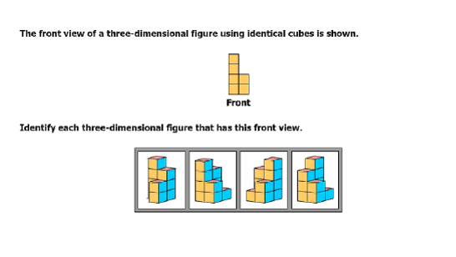
Please explain why you have chosen the pictures that you have below:

Matching Cards

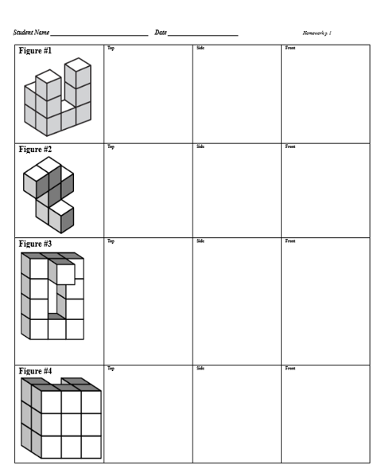

Matching Cards, page 2

Cut out the rectangles below.
Glue each onto page 1, matching each figure with its correct top, side, and front views.
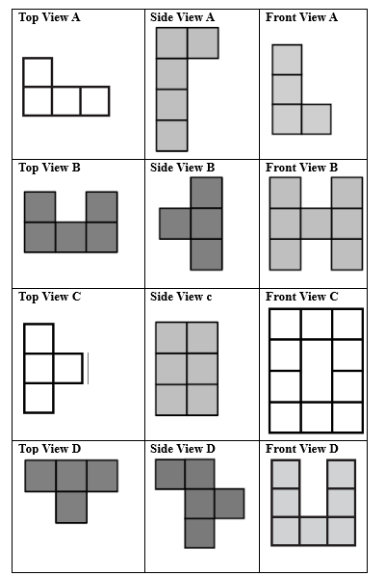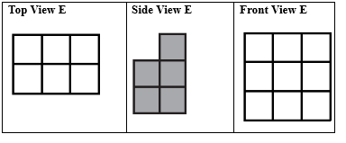

Matching Cards Teacher Key

Homework – teacher key

Copy cards on cardstock and cut out.
