Tax and Discount – A Co-Teaching Lesson Plan

Co-Teaching Approaches
A “(Y)” in front of the following list items indicates the approach is outlined in the lesson. An “(N)” in front of the following list items indicates the approach is not outlined in the lesson.

- (N) Parallel Teaching
- (Y) Team Teaching
- (Y) Station Teaching
- (N) One Teach/One Observe
- (Y) Alternative Teaching
- (N) One Teach/One Assist

Subject
Grade 8 Mathematics

Strand

Computation and Estimation

Topic
Discounts/Sales Tax/Tip

SOL
8.4 The student will solve practical problems involving consumer applications.
Outcomes
Determine discounts, sales tax, tips, and total cost of products in a variety of real-life situations.

Materials
- Tape
- Student computer laptops
- The Frame Routine Diagram (attached)
- Let’s Go Shopping worksheet (attached)
- Coupon Math Chart (attached)
- Shopping Questions worksheet (attached)
- Product Images (attached)
- Coupon Images (attached)
- Price Tag Images (attached)
- Tax, Tip, and Discount Activity worksheet (attached)
- Coupon Tickets (attached)
- Sale Price Recording worksheet (attached)

Vocabulary

bill, discounts, original price, percentage, sales tax, tip, total cost

Co-Teacher Actions
Lesson Component | Co-Teaching Approach(es) | General Educator (GE) | Special Educator (SE)
Anticipatory Set | Team Teaching | GE provides direct instruction to model, setting up the correct proportion. Students then complete the bell ringer, a review on finding percent of change. | SE checks for students who need assistance on the bell ringer, a review on finding percent of change. SE provides individual instruction as needed.
Lesson: | Team teaching/ Station teaching | GE and SE distribute the Frame Routine Diagram and review three main vocabulary words, discount, sales tax, and total cost. Students take notes regarding the main ideas for each word.  GE provides direct instruction on the first two vocabulary words while students take notes. GE monitors students to make sure they stay on task.  Students are given the Let’s Go Shopping worksheet. They receive Coupon Tickets to purchase six to 10 items while trying to save the most money. GE checks for student understanding, making sure students stay on task and assisting with student questions as they might arise.  GE should also check with the students at the independent station to ensure they are on task or to answer questions. | SE and GE distribute the Frame Routine Diagram and review three main vocabulary words, discount, sales tax, and total cost. Students take notes regarding the main ideas for each word.  SE provides direct instruction on the third vocabulary word while students take notes. SE checks for understanding by using a quick informal assessment of thumbs up, thumbs to the side, or thumbs down.  Students search for a local menu online with $100 to spend. They are taking a friend out to dinner, and they must buy drinks, appetizers, entrees, and desserts. They may chose three different coupons to use, and they need to calculate tip, tax, and total cost.  SE monitors students at the menu station. SE checks for student understanding, making sure students stay on task, and assisting with student questions as they might arise. SE also checks with the students at the independent station to ensure they are on task or to answer questions.
Guided/  Independent Practice | Alternative Teaching | GE directs students to the independent station where students choose the website of a restaurant and pick an entrée, drink, and dessert for each student. Students add all selections into one bill. Using the Tax, Tip, and Discount Activity worksheet, students determine total cost, including tax and tip.  GE works with preselected students most likely to have difficulty with the independent task. GE quickly looks over the work of the small group, reteaches the process, and has the group come up with one list of items they would all like to purchase on chart paper. Students staple their individual lists to the chart and submit them for closer review. | GE directs students to the independent station where students choose the website of a restaurant and pick an entrée, drink, and dessert for each student. Students add all selections into one bill. Using the Tax, Tip, and Discount Activity worksheet, students determine total cost, including tax and tip.  SE works with the pre-selected students who are most likely to succeed independently with the task. SE assigns a partner or groups of four to share their lists. Students create one list of items they can all agree on to purchase. SE monitors and answers questions. Groups submit their group list with their individual lists stapled to it for closer review.
Closure | Team Teaching | GE distributes exit slips and give directions to students. | SE instructs students on where to turn in the exit slip while checking student ratings.
Formative Assessment Strategies | Team Teaching | Students take a quiz on PowerSchool the following day. Student data is analyzed to determine which students need additional instruction. GE is responsible for finding the quiz on PowerSchool and creating the test sessions for each class. | Students take a quiz on PowerSchool the following day. Student data is analyzed to determine which students need additional instruction. SE prints out the data to determine which students need additional instruction.
Homework | Team Teaching | Students should complete their work for homework if they did not finish it at either station. GE monitors which students are not completing all of their work and identify which students have homework. | Students should complete their work for homework if they did not finish it at either station. SE informs the students of their homework assignments during the exit pass activity.

Specially Designed Instruction
- Teachers will use the frame routine to provide students with the opportunity to develop a thorough understanding of information associated with key topics and main ideas. It provides a concrete representation of relationships between main ideas and details when evaluating units of study.
- Teachers will provide instruction in and review of calculator use for determining discounts, sales tax, and tips

Accommodations
- Check for understanding frequently, provide prompts, and adjust assignments for students who become overwhelmed easily with difficult tasks or struggle with staying on-task.
- Allow students to complete assignments in chunks if they struggle staying on task or completing lengthy assignments.
- Provide students with a copy of notes, according to their IEP accommodations.
- Provide students with calculators with additional functions (for those who qualify).
- Students identify a reduced number of problems associated with the Toys for Tots and menu activities

Modifications
- For those students who require a modified curriculum, content can be modified so that the student is finding total cost without having to calculate sales, discounts, or tips.

Notes
- “Special educator” as noted in this lesson plan might be an EL teacher, speech pathologist, or other specialist co-teaching with a general educator.
- The co-teachers who developed this lesson plan received required professional development in the use of specialized instructional techniques which combine an explicit instructional routine with the co-construction of a visual device (graphic organizer). The Framing Routine in conjunction with “The Frame” helps to develop understanding of information and procedures by associating their main ideas and details. These Content Enhancement Routines were developed at the Center for Research on Learning at the University of Kansas.
- Other graphic organizers should be used by teachers who have not received professional development in the Framing Routine. If Virginia teachers would like to learn the Content Enhancement Routines, contact your regional TTAC.

Note: The following pages are intended for classroom use for students as a visual aid to learning.

Virginia Department of Education©2018

The Frame Routine Diagram

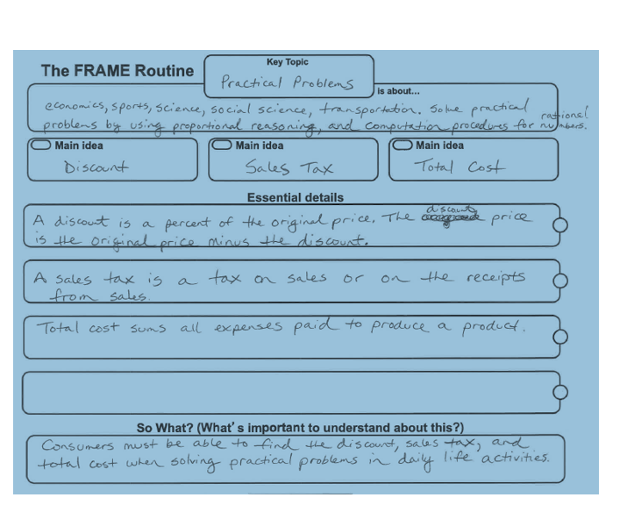
Let’s Go Shopping

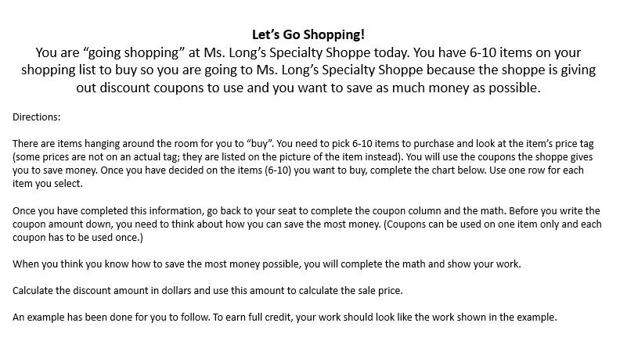

Coupon Math Chart

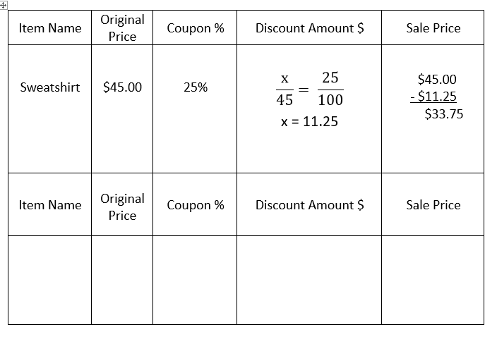

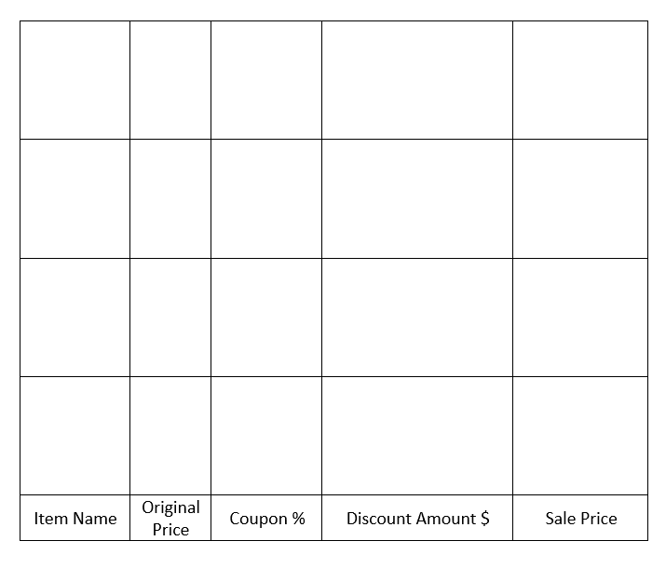

Coupon Images

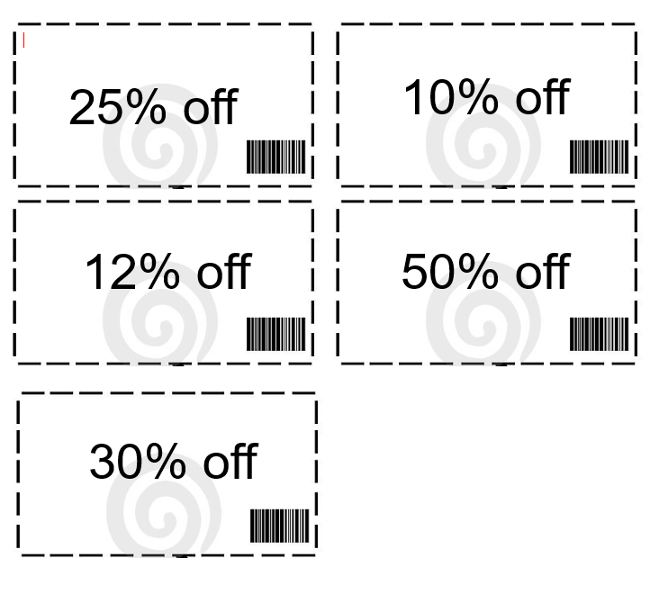

Coupon Tickets

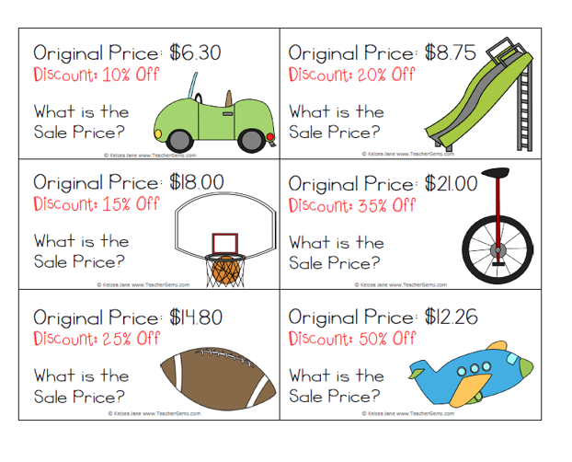

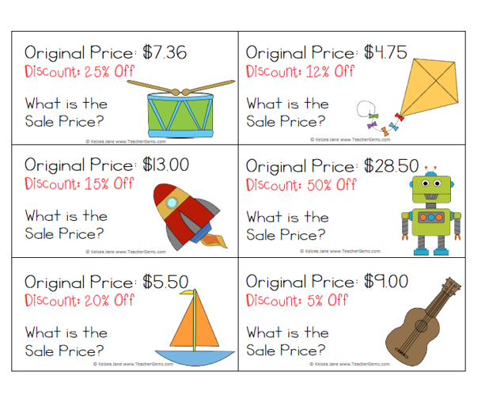
Sale Price Recording Sheet
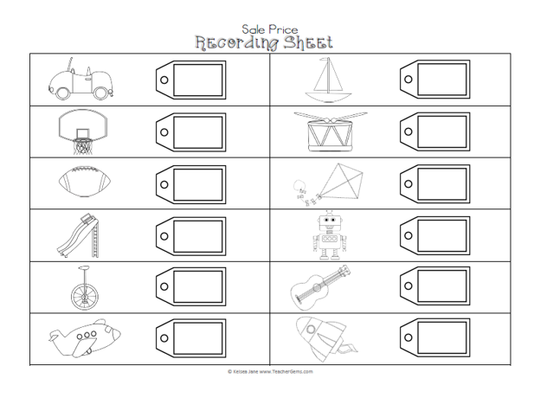
Shopping Questions

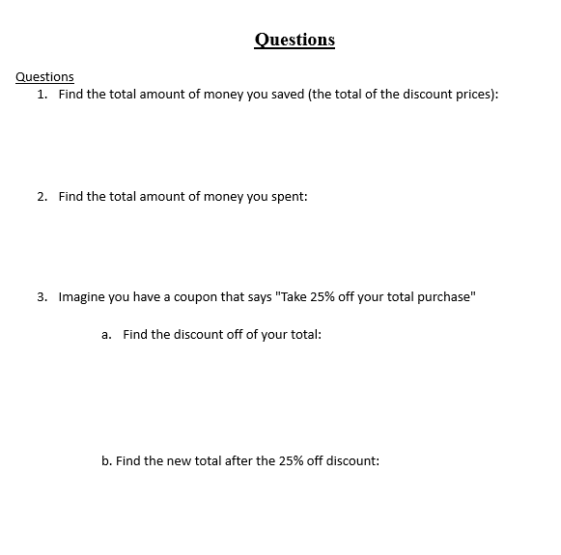

Price Tag Images

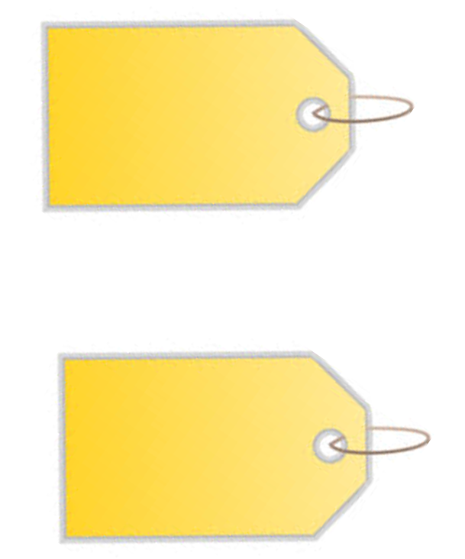

Product Images

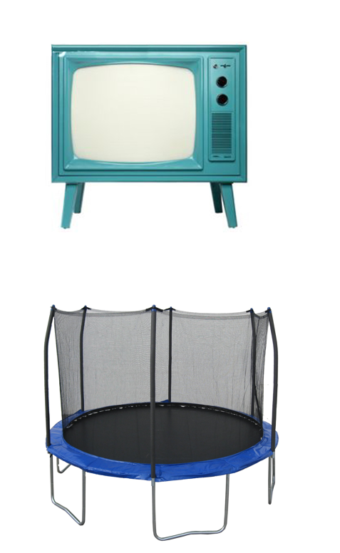

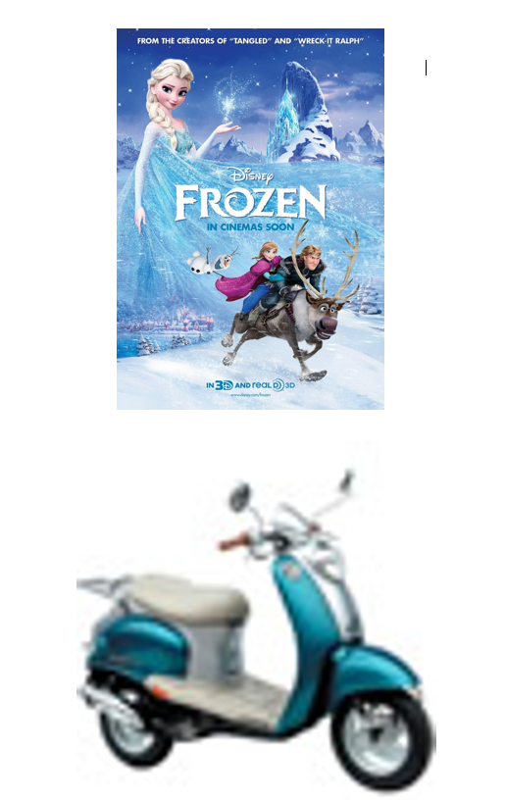
Tax, Tip, and Discount Activity

