Real Number System – A Co-Teaching Lesson Plan

Co-Teaching Approaches
A “(Y)” in front of the following list items indicates the approach is outlined in the lesson. An “(N)” in front of the following list items indicates the approach is not outlined in the lesson.

- (N) Parallel Teaching
- (Y) Team Teaching
- (N) Station Teaching
- (Y) One Teach/One Observe
- (N) Alternative Teaching
- (Y) One Teach/One Assist

Subject
Grade 8 Mathematics

Strand
Number and Number Sense

Topic
Investigating the Real Number System

SOL
8.2 The student will describe the relationships between the subsets of the real number system.

Outcomes
Students will understand the relationship between subsets of numbers. They will be able to identify and describe how the real number system is organized.

Materials
- Scissors
- Student whiteboards and markers
- The Real Number System – Observation Checklist (attached)
- Real Number System Subset Labels (attached)
- Real Number System Venn Diagram (attached)
- Real Numbers Cards (attached)
- Data collection form (attached)

Vocabulary

integers, irrational numbers, natural numbers, rational numbers, real numbers, Subset, whole numbers

Co-Teacher Actions
Lesson Component | Co-Teaching Approach(es) | General Educator (GE) | Special Educator (SE)
Anticipatory Set | Team Teach | GE explains how the number system is organized and gives students a bag of numbers. Students are put in groups and the groups organize these numbers any way – but they must be able to justify why the numbers were put in those groups.  While the SE leads the discussion, the GE writes some of the terms (e.g., fraction, decimal, etc.) the students use on the board.  Teachers should use this activity as a formative assessment of what students know about the subsets of numbers. | SE assists students and ask questions to the groups.  Questions  - Why did you put these two numbers together?  - What do they have in common?  - How are they alike?  - Why are these different?  After a few minutes, SE leads the discussion on how the students grouped the numbers.
Lesson Activities/ Procedures | Team Teach | GE introduces the graphic organizer (GO). GE explains to students how the number system is organized.  The Real Number System Venn Diagram organizer is attached; however, teachers may wish to use a different organizer depending on the needs of the students. | SE completes the GO on the board while GE explains the relationships.  If students have difficulty understanding GO, use a visual aid, such as nested measuring cups, to model.
Guided/  Independent Practice | Team Teach | GE gives each student a number on a sticky note. Be sure to include ones like $\sqrt{64} \frac{6}{2}$ , where students must simplify in order to determine the correct group.  After the SE has modeled several examples, GE instructs students to place their numbers in the smallest possible circle. Then, GE asks them to name all the subsets of numbers to which that number belongs. Continue practicing until students seem to understand how numbers are organized. | SE models a few examples of how to identify the subset of a number. Question  - In which circle would you put 7?  Reinforce the fact that that if a number is in the natural number circle, it is also in the whole, integer, and rational circles.
Closure | Team Teach | GE reminds students that they learned how the real number system is organized. GE asks students to name the subsets to which -5 belongs. | Question  - What is the smallest subset to which 8/2 belongs?  Reinforce the fact that if a number can be simplified, it may affect the subsets to which it belongs.
Formative Assessment Strategies | Team Teach  One Teach one observe | GE gives students the Real Number System Subset Labels and Real Numbers Cards. GE instructs them to sort the numbers into their smallest subsets. | SE uses the check list to make notes of students who are struggling with sorting. This list is used to pull small groups in subsequent lessons.
Homework | Team Teach | GE has students generate a list of three numbers for each subset. | SE same as GE.

Specially Designed Instruction
- Teach students the mnemonic Never Write in Red Ink (natural, whole, integers, rational, irrational) to help them remember the subgroups. This can be incorporated by SE while demonstrating the graphic organizer.
- Teach students to develop their own mnemonic for remembering the subsets.
- Instruct students to use a set of nested measuring cups to understand that natural numbers are a subset of whole numbers, etc. This could be modeled with the whole class during the GO presentation and then retaught in small group instruction, if needed.
- Pre-teach the subsets of whole numbers. Have students use a vocabulary strategy (e.g., LINCing) to develop a concrete understanding of the terms.

Accommodations
- Use different colored paper for the different subsets. This helps students identify the different subsets. Since this cues the students, it may not be appropriate to use for students who need to master the standard. It can be used initially, but removed as students become more familiar with the task.

Modifications
- Use friendly numbers. For example, use 1/2 instead of 13/19. Don’t include numbers that can besimplified.
- Limit the subsets to rational and irrational. As students master that concept, add subsets.

Notes
- “Special educator” as noted in this lesson plan might be an EL teacher, speech pathologist, or other specialist co-teaching with a general educator.
- The co-teachers who developed this lesson plan received required professional development in the use of specialized instructional techniques which combine an explicit instructional routine with the co-construction of a visual device (graphic organizer). The Vocabulary LINCing Routine and its “LINCS Tables” help students learn and remember terms and vocabulary through auditory and visual memory devices. These Content Enhancement Routines were developed at the Center for Research on Learning at the University of Kansas.
- Other graphic organizers should be used by teachers who have not received professional development in these routines. If Virginia teachers would like to learn content enhancement routines, contact your regional TTAC.

The following pages are intended for classroom use for students as a visual aid to learning.

Virginia Department of Education©2018

The Real Number System - Observation Checklist

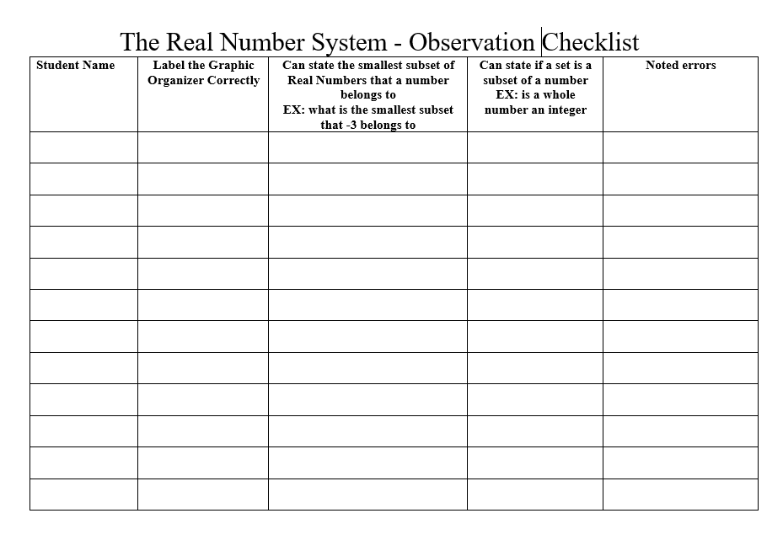

Real Number System Subset Labels

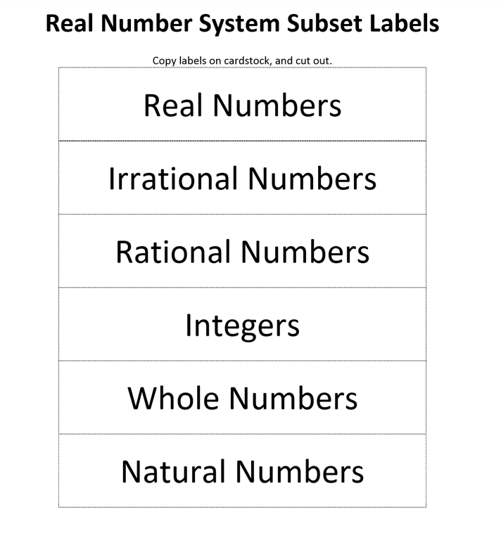

Real Number System Venn Diagram

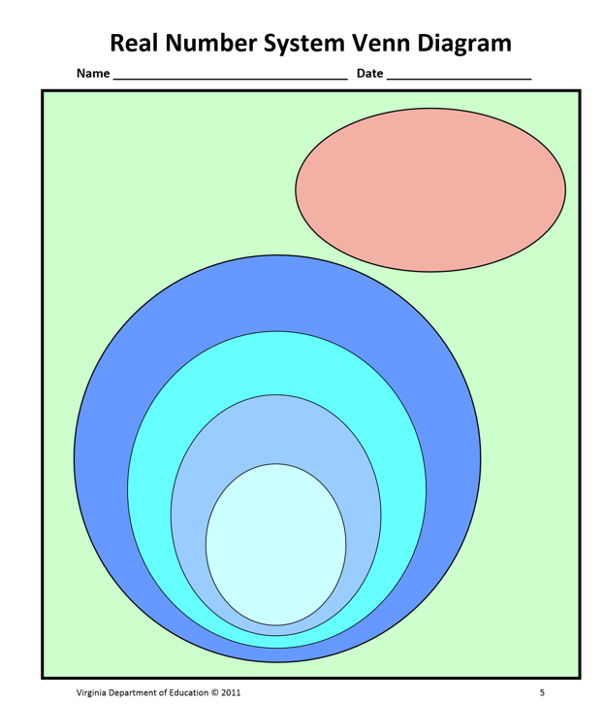
Real Numbers Cards

