Solving Equations – A Co-Teaching Lesson Plan

Co-Teaching Approaches
A “(Y)” in front of the following list items indicates the approach is outlined in the lesson. An “(N)” in front of the following list items indicates the approach is not outlined in the lesson.
- (Y) Parallel Teaching
- (Y) Team Teaching
- (Y) Station Teaching
- (Y) One Teach/One Observe
- (Y) Alternative Teaching
- (Y) One Teach/One Assist

- (Y) One Teach/One Assist

Subject
Grade 8 Mathematics

Strand
Patterns, Functions, and Algebra

Topic
Solving Multistep Equations in One Variable

Standards
8.17 The student will solve multistep linear equations in one variable with the variable on one or both sides of the equation, including practical problems that require the solution of a multistep linear equation in one variable.

Outcomes
Students will be able to solve multistep equations.

Materials
- Balance scale or picture of a balance scale
- Algebra tiles - one set for each student
- Equation-Solving Balance Mat (attached)
- Equation-Solving Ordering Cards (attached)
- Be the Teacher: Solving Equations (attached)
- Co-teaching Station Planning Sheet (attached)
- Solving Equations Partner Sheet (attached)

Vocabulary

coefficient, constant, equation, variable

Co-Teacher Actions
Lesson Component | Co-Teaching Approach(es) | General Educator (GE) | Special Educator (SE)
Anticipatory Set | Team Teaching | GE has a model of a balance scale for the class to see. It should be balanced.  Questions  - What will happen if I add this rock to the left side?  - What will happen if I take away an item from the other side?  - What must I do if I want to keep the scale balanced? | SE models as the GE asks questions. SE makes sure the students see that if they add or take away from one side and not the other, the balance scale will tip (not balance). Students should understand that to keep the scale balanced, both sides must be equal.
Lesson Activities/ Procedures | One teach/One assist  One teach/One observe | GE provides each student with a set of algebra tiles and the Equation-Solving Balance Mat.  GE leads students through the steps for using the tiles to model solutions describing the properties of equality. When students are comfortable with modeling the solutions, transition to writing out the solution steps algebraically while still using the tiles and naming the property to justify.  Eventually, progress to only writing out the steps algebraically without using the tiles. | SE assists with helping students understand how to use materials.  The role of the GE and SE can interchange here.  Both teachers should note how students are progressing through the concrete and representational stages so that struggling students can be pulled for small group.
Guided/ Independent Practice | Alternative Teaching  Team teaching  One teach/One assist | Students continue working on the concrete and representational aspect of equation solving.  This role can interchange with SE.  After teachers see students are ready, give each student one of the Equation-Solving Ordering Cards. Find students who have all of the steps of their equation and then line up the steps in order. GE emphasizes that the process of equation solving involves completing each step. | SE gives each student a whiteboard and marker. SE provides students with an equation to solve. Students hold up their boards to show they are completing each step.  SE models as the GE provides instructions.  SE should monitor students closely and make sure they understand the steps. SE makes note of any remediation that is necessary.
Closure | Team Teaching  Alternative Teaching | GE distributes copies of the Be the Teacher: Solving Equations worksheet. GE has students determine if the solution is correct or not. If it is not correct, they should work the correct solution. | SE determines which students still need assistance. If students seem to understand, the SE and GE should monitor students by asking formative assessment strategy questions.
Formative Assessment Strategies | Team Teaching | Questions  - How can you check the solution to the equation?  - Why is writing each step correctly in solving an equation just as important as finding the answer? | Questions  - Why do you think the student made that error – what was he thinking?  - What would you tell a student to help him understand his mistake?
Homework | Alternative Teaching | GE instructs students to write a paragraph in their journals that explains how to solve an equation. | SE instructs students to write the steps to solving an equation in their journals, writing in complete sentences.

Specially Designed Instruction
- Teacher will help students develop a checklist for the steps in solving an equation.
- Teachers will use the Co-teaching Station Planning Sheet. This strategy allows teachers to group students according to need. The group that shows master meets with the GE once and completes independent activities for the other two stations. The group that can benefit with more teacher instruction meets with each teacher once and has one independent station, and the group who shows difficulty with concept is with a teacher for all three stations. Activities are included but can and should be tailored to meet the needs of the groups.
- Teacher will review prerequisite skill of solving one and two step equations.

Accommodations
- Allow students to utilize the algebra tiles as long as they need them.
- Give students a set of steps to solve equations that they can use as a checklist.
- Allow students to color code steps of equations.
- Pre-teach using the algebra tiles if the method is not familiar to the students.
- Students may have difficulty finding other students in the Equation Solving Ordering Cards. This activity could be modified by giving each student (or groups of students) a set of cards and have students put the steps in order.

Modifications
- For those students who need a modified curriculum, the content can be modified to include only one step or two step equations and/or using only positive whole numbers.

Notes
- “Special Educator” as noted in this lesson plan might be an EL Teacher, Speech Pathologist, or other specialist co-teaching with a General Educator.

Note: The following pages are intended for classroom use for students as a visual aid to learning.

Virginia Department of Education©2018

Equation-Solving Balance Mat
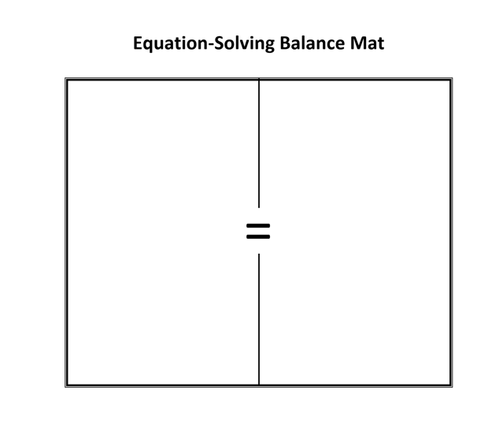
Equation-Solving Ordering Cards

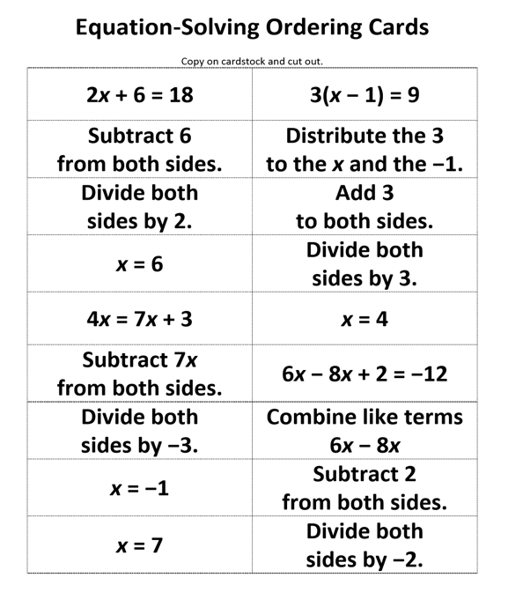

Be the Teacher: Solving Equations

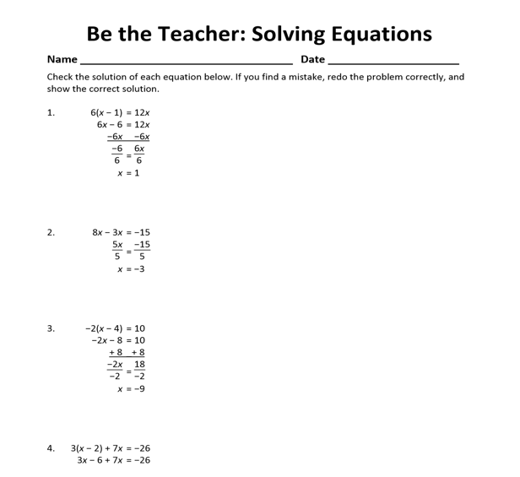

Co-teaching Station Planning Sheet

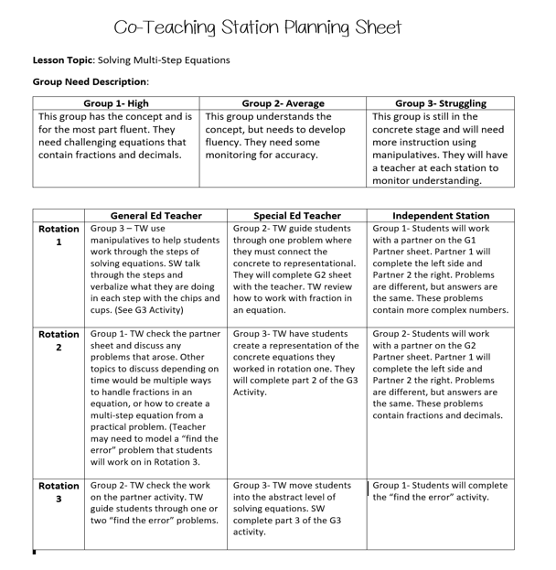

Solving Equations Partner Sheet
