Matching Representations – A Co-Teaching Lesson Plan

Co-Teaching Approaches
A “(Y)” in front of the following list items indicates the approach is outlined in the lesson. An “(N)” in front of the following list items indicates the approach is not outlined in the lesson.

- (Y) Parallel Teaching
- (Y) Team Teaching
- (N) Station Teaching
- (Y) One Teach/One Observe
- (Y) Alternative Teaching
- (Y) One Teach/One Assist

- (Y) Parallel Teaching
- (Y) Team Teaching
- (N) Station Teaching
- (Y) One Teach/One Observe
- (Y) Alternative Teaching
- (Y) One Teach/One Assist
- (Y) Parallel Teaching
- (Y) Team Teaching
- (N) Station Teaching
- (Y) One Teach/One Observe
- (Y) Alternative Teaching
- (Y) One Teach/One Assist
- (Y) Parallel Teaching
- (Y) Team Teaching
- (N) Station Teaching
- (Y) One Teach/One Observe
- (Y) Alternative Teaching
- (Y) One Teach/One Assist

- (Y) Parallel Teaching
- (Y) Team Teaching
- (N) Station Teaching
- (Y) One Teach/One Observe
- (Y) Alternative Teaching
- (Y) One Teach/One Assist

Subject
Grade 8 Mathematics

Strand
Patterns, Functions, and Algebra

Topic
Making connections between representations of a linear function

SOL
8.16 The student will
e) make connections between and among representations of a linear function using tables, graphs, verbal descriptions, and equations.

Outcomes
Given one representation, the student will be able to identify the corresponding representations.

Materials
- Match-up cards
- Envelopes
- Student whiteboard and markers
- Admit One Exit Ticket (attached)
- Wordles (attached)
- Representations of Relationships handout (attached)
- LINCing routine template or similar vocabulary strategy

Vocabulary

equations, functions, graphs, relationship, rules, tables

Co-Teacher Actions
Lesson Component | Co-Teaching Approach(es) | General Educator (GE) | Special Educator (SE)
Anticipatory Set | Alternative Teaching  One teach/One assist | GE shows the Wordles examples and asks the students what each picture represents. GE tells students that wordles are the same thing, just in a different form and sometimes in working with information, it might be useful to have it in different forms. | Preparation  Prior to this lesson the SE should review vocabulary with the students using the LINCing routine or other vocabulary strategy. Some of these words have multiple meanings and may be confusing to some students.  Lesson  While the GE is introducing the lesson, the SE checks homework or attendance, or helps the students translate the Wordle.
Lesson Activities/ Procedures | Team Teaching | GE asks the students to represent the following using a table:  A girl makes $5.00 per hour babysitting. How much will she make if she babysits x hours?  Question  - Now that we have a table of values, how can I write this as an expression?  - What else can I do if I have a table of values? | SE models creating a table.  # of hours (x) pay  1 5  2 5+5 or 2x5 = 10  3 5+5+5 or 3x5 = 15  x  SE helps students see 5x and complete the chart.  SE plots points so students see the graph.  SE reveals we have the same information in four different ways: words, table, rule, and graph.
Guided/Independent Practice | Parallel Teach | GE divides students into three groups. Gives each group a set of Representations of Relationships cards. GE directs each group to match up the four different representations of each relationship.  After all students are comfortable matching the representations, each student in the group chooses one representation (one student will be equation, one will be graph, and one will be table). GE places an equation written in words (i.e., y is two more than a number) and students will write the correct representation on their boards. | SE works with selected students on the same activity, but instead of giving students all cards at once, students just match table and words first. After these are done, the students find the matching graph then the equation.  SE monitors selected students for accuracy and collects data for future instruction.
Closure | One teach/One assist | Question  - Why is it important to know how to represent the same relationship in different forms? | SE monitors the class by prompting students as needed.
Formative Assessment Strategies | Team Teach | GE gives students Admit One Exit Tickets.  After class, meet with SE to disaggregate data obtained from exit tickets and small group to form remediation groups. | SE distributes Admit One Exit Tickets.  After class, meet with GE to disaggregate data obtained from exit ticket and small group to form remediation groups.
Homework | Team teach/ Alternative teach | Journal Response  - Draw a graph to represent the equation “y is equal to four less than a number.”  - Give students a graph and have them come up with the table equation and words to represent the graph. | SE may want to give students the same prompt or a set of the matching cards to practice at home. Cards should be self-checking.

Specially Designed Instruction
- Prior to the lesson, the SE should assess students to determine if they remember how to translate expressions. If needed, provide a mini-review on how to translate words into expressions.
- Prior to the lesson (possibly during the introduction) SE may need to provide direct instruction using a vocabulary strategy such as the LINCing routine. Some of the vocabulary may be confusing for students.

Accommodations
- Copy each representation on different colored paper.
- Start with friendly coefficients (such as 1 or other whole numbers) until students understand the process.
- Precede the lesson with a review of translating equations.

Modifications
- Have students match tables with a graph only.
- Have students work solely on graphing the table of points generated by the other members of the group.

Notes
- “Special educator” as noted in this lesson plan might be an EL teacher, speech pathologist, or other specialist co-teaching with a general educator.
- The co-teachers who developed this lesson plan received required professional development in the use of specialized instruction techniques, which combine an explicit instructional routine with the co-construction and with the frame and helps to develop understanding of information and procedures by associating main ideas and details. These content enhancement routines were developed at the Center for Research on Learning at the University of Kansas.
- Other graphic organizers should be used by teachers who have not received professional development in these routines. If Virginia teachers would like to learn content enhancement routines, contact your regional TTAC.

Note: The following pages are intended for classroom use for students as a visual aid to learning.

Virginia Department of Education©2019

Wordles

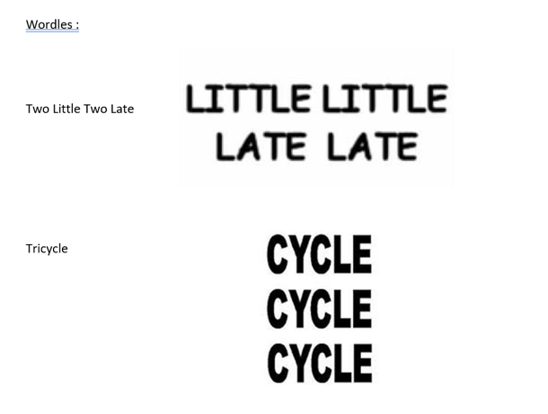

Representations of Relationships

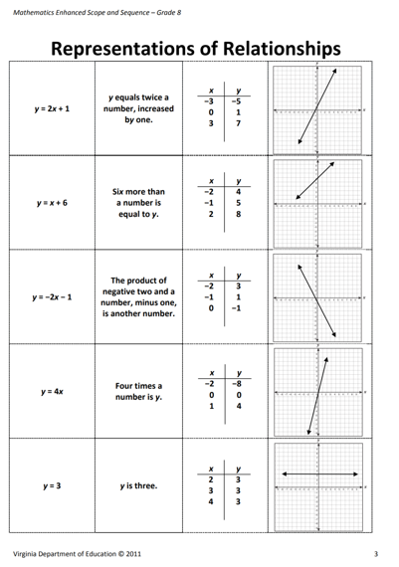
Admit One Exit Ticket

