Solving Practical Problems – A Co-Teaching Lesson Plan

Co-Teaching Approaches
A “(Y)” in front of the following list items indicates the approach is outlined in the lesson. An“(N)” in front of the following list items indicates the approach is not outlined in the lesson.

- (Y) Parallel Teaching
- (Y) Team Teaching
- (N) Station Teaching
- (N) One Teach/One Observe
- (Y) Alternative Teaching
- (N) One Teach/One Assist

Subject
Grade 7 Mathematics
Strand
Computation and Estimation
Topic
Solving practical problems involving operations with rational numbers
SOL
7.2 The student will solve practical problems involving operations with rational numbers.
Outcomes
The student will be able to solve practical problems involving operations with rational numbers.
Materials
- The Frame Routine Graphic Organizer (attached)
- Tasks Cards (attached)
- Independent Practice Questions (attached)
Vocabulary
common factors, common multiples, decimal, decimal point, estimation, factor, fraction, greatest common factor (GCF), hundredths, improper fraction, leading zero, least common denominator, least common multiple (LCM), like denominators, mixed number, percents, place value, simplest form, simplify, sum difference, tenths, thousandths, unlike denominator
Co-Teacher Actions
Lesson Component | Co-Teaching Approach(es) | General Educator (GE) | Special Educator (SE)
Anticipatory Set | Team Teaching | GE discusses the steps for solving practical problems with students and co-constructs a Frame Routine Graphic Organizer.  GE guides students through three practice problems. | SE models the Frame Routine Graphic Organizer on the Board as the students and GE co-construct it.  SE models the practice problems on the board.
Lesson Activities/ Procedures | Team Teaching | GE divides students into five groups.  GE places a task card at each station with one practical problem. Students independently solve the problem, then compare answers. Students work together to determine which answer is correct. After approximately five minutes, teachers rotate the cards and follow the same process for the next card.  G circulates through the groups to encourage participation and collaboration from all students. | SE circulates through the groups to encourage participation and collaboration from all students.
Guided/Independent Practice | Alternative Teaching | Students independently solve problems on the 10 Independent Practice Questions worksheet.  GE circulates through the class providing assistance where needed. | SE reteaches problem-solving to a small group of students, then guides them as they solve the problems.
Closure | Team Teaching | GE brings students back together as a whole group. GE reviews each question to check for understanding. | SE puts each problem on the Board while the GE reviews them. SE answers any questions the students have about solving the problems.
Formative Assessment Strategies | Team Teaching | Students complete an exit ticket. GE creates two problems for students to complete independently. | SE writes the questions on the board and moves through the classroom answering questions, as needed.
Homework
- Students will complete five problems on the Independent Practice Questions worksheet.
Specially Designed Instruction (teacher teaches)
- Teacher give one-on-one instruction as needed.
- Teacher gives simplified directions and provides more practice for repetition of problem solving.
- SE works with students to co-construct the Frame Routine Graphic Organizer.
Accommodations (based on student needs)
- Some students may need to utilize a problem solving template to help them guide their thinking.
- Students receive calculators to solve practical problems, as specified in their IEPs.
- Teachers provide small group and one-on-one instruction, as needed.
Modifications
- Limit problems to one operation per problem for students with significant cognitive delays.
- Students who struggle should have their problems set up according to their IEP accommodations.
- Teachers should modify worksheets to meet the needs of specific students in the class.
Notes
- “Special Educator” as noted in this lesson plan might be an EL Teacher, Speech Pathologist, or other specialist co-teaching with a General Educator.
- The co-teachers who developed this lesson plan received required professional development in the use of specialized instructional techniques which combine an explicit instructional routine with the co-construction of a visual device (graphic organizer). The Framing Routine used in conjunction with the “Frame” helps to develop understanding of information and procedures by associating their main ideas and details. These Content Enhancement Routines were developed at the Center for Research on Learning at the University of Kansas. Link: http://www.kucrl.org/sim/brochures/CEoverview.pdf
- Other graphic organizers should be used by teachers who have not received professional development in the Concept Mastery Routine. If Virginia teachers would like to learn Content Enhancement Routines, contact your regional TTAC.

Note: The following pages are intended for classroom use for students as a visual aid to learning.

Virginia Department of Education©2018
The Frame Routine Graphic Organizer
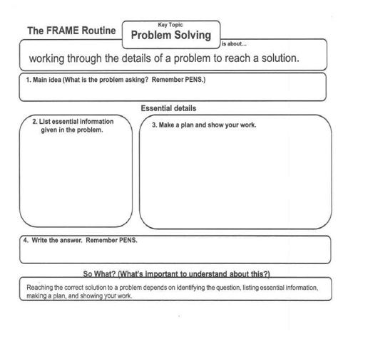

Tasks Cards
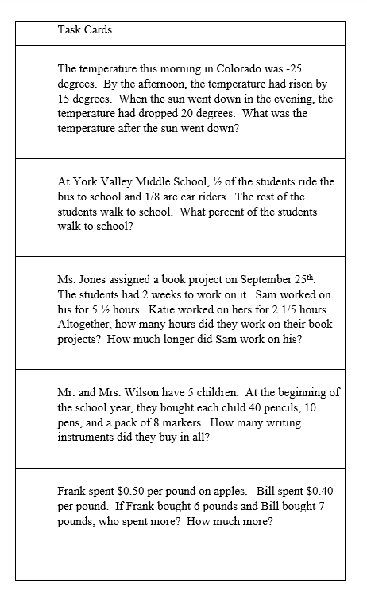

Independent Practice Questions

