Scientific Notation - A Co-Teaching Lesson Plan

Co-Teaching Approaches
A “(Y)”in front of the following list items indicates the approach is outlined in the lesson. A“(N)”in front of the following list items indicates the approach is not outlined in the lesson.

- (Y) Parallel Teaching
- (Y) Team Teaching
- (N) Station Teaching
- (N) One Teach/One Observe
- (N) Alternative Teaching
- (N) One Teach/One Assist

Subject
Math 7

Strand
Number and Number Sense

Topic/Lesson
Ordering Numbers Written in Scientific Notation

Standards
7.1b: Compare and order numbers greater than zero written in scientific notation

Lesson Outcomes
The students will compare and order numbers greater than zero written in scientific notation.

Materials
- Scientific Notation FRAME
- Graphic Organizer
- Scissors
- Glue Sticks
- Construction paper
- Pencils
- Standard Form Cards
- Scientific Notation with the Solar System Activity Sheet
Vocabulary

- Factor
- Product
- Standard Form
- Exponent
- Least
- Greatest
- Scientific Notation
- Coefficient
- Base

Co-Teacher Actions
Lesson Component | Co-Teaching Approach(es) | General Educator (GE) | Special Educator (SE)
Anticipatory Set | Team Teaching | Explain that scientific notation is used to write very large or very small numbers. Display several very large numbers in standard form. Give these numbers some context, such as population, gallons of water in a river, or the amount of money a celebrity paid for a house. Lead a discussion about why it could be difficult to rewrite these numbers correctly. Then write the numbers in scientific notation and use this to introduce scientific notation. Ask students to brainstorm what steps were taken to change the number to scientific notation. | While the general educator is introducing scientific notation the special educator will be at the white board writing the numbers in standard form and scientific notation. The special educator will model the steps to writing numbers in scientific notation.
Lesson Activities/ Procedures | Team Teaching | Introduce scientific notation to class by co-constucting a scientific notation FRAME with the class.  (FRAME is attached)  Describe how to write a number using scientific notation. The graphic organizer can be used to assist the demonstration. Explain that scientific notation is the product of two factors. One factor is a decimal greater than or equal to one, but less than ten. The other factor is a power of ten. Give students some examples and ask them to identify examples and non-examples. Ask students to explain why the non-examples are incorrect. Give students some numbers and ask them to write each number using scientific notation. | Use the White Board to model scientific notation FRAME while GE leads discussion.  Demonstrate on the Active Board how the graphic organizer can be used to assist the students in writing numbers in scientific notation.  Use the white board to write examples and student responses while the general educator leads the discussion, asking questions, clarifying and simplifying as needed.
Guided/Independent Practice | Parallel Teaching  Students will be divided into small groups. Groups will be determined by random selection with careful monitoring of group dynamics. | Give each student a Standard Forms Card Sheet. Have them cut apart the cards and arrange them by the standard form in order from greatest to least. Have students write at the bottom of each card the number in scientific notation.  Once the cards are in order direct students’ attention to the arrangement of exponents focusing on the fact that the numbers with the smallest exponents are the smallest in value. The numbers are then arranged by the decimal factor.  While students solve problems the teachers will:  - Circulate through one small group to check for understanding  - Reteach and assist as needed  Students will remain in small groups approximately 30 minutes. | Give each student a Standard Forms Card Sheet. Have them cut apart the cards and arrange them by the standard form in order from greatest to least. Have students write at the bottom of each card the number in scientific notation.  Once the cards are in order direct students’ attention to the arrangement of exponents focusing on the fact that the numbers with the smallest exponents are the smallest in value. The numbers are then arranged by the decimal factor.  While students solve problems the teachers will:  - Circulate through one small group to check for understanding  - Reteach and assist as needed  Students will remain in small groups approximately 30 minutes.
Closure | Team Teaching | Ask, “Why would you want to write a number in scientific notation?”  Wait for student response. | Ask, “When ordering numbers written in scientific notation, what is the first step?”  Wait for student response.
Formative Assessment Strategies | Team Teaching | Share Exit Ticket with students. Observe students as they complete the exit ticket.  Exit Ticket attached. | Share Exit Ticket with students. Observe students as they complete the exit ticket.  Exit Ticket attached.
Homework | Team Teaching | Assign homework practice sheet.(attached) Let students get started prior to the end of class to check for understanding. | Monitor students to check for understanding and reteach as necessary.

Specially Designed Instruction
- The FRAMEing routine is used to teach/review procedures for writing numbers in scientific notation. (see Notes) The teacher draft of the FRAME that will be co-constructed with the students is attached. In this lesson the FRAME is developed with all students, and additional instruction is given to students who require extra help. This resource helps all students organize information and can be used to aid memory of this concept by students who need additional help.
- Students work in small groups with SE or GE to ensure understanding of concept.
- Use a number line to help students understand that powers of ten with a negative exponent indicate that the number is a decimal between 0 and 1. Students often confuse negative exponents with negative numbers.

Accommodations
- Students with the calculator accommodation will use the calculator including the scientific notation function.
- Students refer to completed FRAMEs to aid in memory of procedures.
- Students use manipulatives to aid in understanding.
- A copy of completed FRAME will be provided to students who need a copy of notes.

Modifications
- For those students who require a modified curriculum, content could be simplified to include only large numbers with positive exponents. Of the content could focus just on powers of ten and recognizing the patterns.

Notes
- “Special Educator” as noted in this lesson plan might be an EL Teacher, Speech Pathologist, or other specialist co-teaching with a General Educator.
- The co-teachers who developed this lesson plan received required professional development in the use of specialized instructional techniques which combine an explicit instructional routine with the co-construction of a visual device (graphic organizer). The Framing Routine used in conjunction with the “Frame” helps to develop understanding of information and procedures by associating their main ideas and details. Content Enhancement Routines were developed at the Center for Research on Learning at the University of Kansas.
- Other graphic organizers should be used by teachers who have not received professional development in the (name of routine[s]). If Virginia teachers would like to learn Content Enhancement Routines, contact your regional TTAC.

Note: The following pages are intended for classroom use for students as a visual aid to learning.

Virginia Department of Education©2018

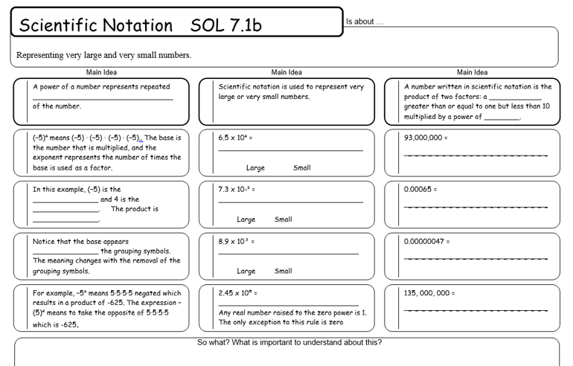
Graphic Organizer
Numbers can be written in standard form and in scientific notation
Standard Form: 5,200,000,000,000
Scientific Notation: 5.2 × 10¹²

Numbers written in scientific notation are made up of three parts: the coefficient, the base, and the exponent.
5.2 × 10¹²
Exponent shows the number of decimal places that the decimal needs to be moved to change the number to standard notation.
(A negative exponent indicates that the decimal is moved to the left when changing to standard notation.)
Base is always 10.
Coefficient must be greater than or equal to 1 and less than 10.

Graphic Organizer

Numbers can be written in standard form and in scientific notation.

Standard Form: 5,200,000,000,000
Scientific Notation: 5.2 × 10¹²

Numbers written in scientific notation are made up of three parts: the coefficient, the base, and the exponent.
5.2 × 10¹²
Exponent

Base

Coefficient

Standard Form Cards
1,200,000,000 | 11,900,000
9,800,000 | 203,000,000,000
80,000,000 | 60,510,000
27,000,000,000 | 1,050,000,000
0.000003 | 0.00000612
0.000054 | 0.00000036
0.0000409 | 0.00006296
0.0000000367 | 0.00000067

Scientific Notation with the Solar System

Complete the chart.

Planet | Approximate distance  from the Sun | Distance written in  scientific notation
Earth | 93,000,000
Jupiter | 484,000,000
Mars | 142,000,000
Mercury | 36,300,000
Neptune | 2,800,000,000
Saturn | 888,000,000
Uranus | 1,780,000,000
Venus | 67,200,000

List the planets in order from greatest to least, using scientific notation.

Planet | Distance from the Sun written in scientific notation

