Solving Inequalities – A Co-Teaching Lesson Plan

Co-Teaching Approaches
A “(Y)” in front of the following list items indicates the approach is outlined in the lesson. An “(N)” in front of the following list items indicates the approach is not outlined in the lesson.
- (Y) Parallel Teaching
- (Y) Team Teaching
- (N) Station Teaching
- (N) One Teach/One Observe
- (N) Alternative Teaching
- (Y) One Teach/One Assist

- (Y) Parallel Teaching
- (Y) Team Teaching
- (Y) Station Teaching
- (N) One Teach/One Observe
- (N) Alternative Teaching
- (Y) One Teach/One Assist

Subject
Grade 7 Mathematics

Strand
Patterns, Functions, and Algebra

Topic
Solving and graphing one and two-step inequalities

SOL
7.13 The student will solve one- and two-step linear inequalities in one variable, including practical problems, involving addition, subtraction, multiplication, and division, and graph the solution on a number line.

Outcomes
The student will use a matching activity to solve and graph one- and two-step inequalities.

Materials
- Calculators
- Vocabulary LINCing Routine Diagram (attached)
- Solving Inequalities Matching Activity worksheet (attached)
- Solving Inequalities Matching Activity Key (attached)
- Inequalities Practice worksheet (attached)

Vocabulary

equal, greater than, greater than or equal to, inequality, inverse operations, less than less than or equal to, one-step inequality,
two-step inequality, variable

Co-Teacher Actions
Lesson Component | Co-Teaching Approach(es) | General Educator (GE) | Special Educator (SE)
Anticipatory Set | Team Teaching | GE presents the equation x + 1 = 5 and the inequality x + 1 < 5 and has students write and/or discuss the difference between the two. During the discussion, be sure to compare the solutions to equations vs. the solutions for inequalities.  GE introduces important vocabulary like variable, inequality, and inequality symbols. GE discusses the differences between an equation and an inequality. | SE participates in team teaching approach by adding information to class discussion and presenting questions/prompting with GE.
Lesson Activities/ Procedures | Team Teaching | - GE works through additional examples of inequalities as a class using discussion points from the anticipatory set.  - GE uses the Vocabulary LINCing Routine Diagram to develop a working definition of an inequality.  - GE provides an additional example of an inequality and uses the solution to discuss how the solution may be represented on a graph. GE discusses how the inequality symbol determines whether the circle is closed or open and in which direction it is colored.  - GE works on more examples with students that include all operations. GE includes examples to discuss what happens when you multiply or divide by a negative. | SE participates in team teaching approach by adding information to class discussion and presenting questions with GE. SE is present at the front of the room or in close proximity to the GE to provide a sense of team during discussion.  SE and GE may break away from team teaching and change to a one teach/one assist LINCing activity as necessary based on student/classroom needs and accommodations.
Guided/Independent Practice | Parallel Teaching | - GE provides students with the Solving Inequalities Matching Activity worksheet * and instructs them to complete it independently. GE monitors students for understanding and progress as they work through the problems  *Inequalities Matching Activity worksheet can be provided to each student as his/her own personal copy to cut and paste or be printed as a class set in which students simply place the solution and graph in each box and wait for the teacher to check for correctness. | 1. SE provides students with the Solving Inequalities Matching Activity worksheet and works the first two problems (finding the solution and graphing) prior to asking students to complete the remaining problems independently. SE provides students with a visual (e.g., Graphing George) to aid in remembering how to graph the inequalities.
Closure | Team Teaching | GE provides students with the Inequalities Practice worksheet and assists students as needed. | SE same as GE.
Formative Assessment Strategies | Team Teaching | GE provides students with an exit ticket.  Question  - What is the difference between an open circle and a closed circle when graphing inequalities? | SE same as GE.
Homework | Team Teaching | GE completes the Inequalities Practice worksheet in a closure activity, if necessary. | SE same as GE.

Specially Designed Instruction
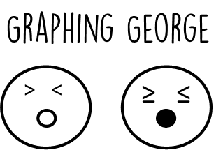
- When grouping students for stations, students with historically lower abilities/performance and/or with IEPs should be grouped together to allow for more assistance and SDI within the station activities.
- When recalling graphing rules, provide a visual (e.g., Graphing George) to aid students.
- Instead of requiring students to draw the graph, provide students with a sorting activity that has a graph to be matched to the solution.

Accommodations
- Provide notes that have the information and steps already typed in to students who require copies of classroom notes as an accommodation. They still have the option of completing the examples for themselves or with the class.
- Use different types of manipulatives and online resources to assist students with solving equations.
- Have students model/draw each step of solving an equation on a separate balance mat.
- For struggling students, reduce the number of problems required on a practice worksheet according to IEP accommodations.

Modifications
- For those students requiring a modified curriculum, content can be modified to include comparing whole numbers or integers using the <,>, + signs.

Notes
- “Special educator” as noted in this lesson plan might be an EL teacher, speech pathologist, or other specialist co-teaching with a general educator.
- The co-teachers who developed this lesson plan received required professional development in the use of specialized instructional techniques which combine an explicit instructional routine with the co-construction of a visual device (graphic organizer). The Vocabulary LINCing Routine and its “LINCS Tables” help students learn and remember terms and vocabulary through auditory and visual memory devices. These Content Enhancement Routines were developed at the Center for Research on Learning at the University of Kansas.
- Other graphic organizers should be used by teachers who have not received professional development in these routines. If Virginia teachers would like to learn content enhancement routines, contact your regional TTAC.

Note: The following pages are intended for classroom use for students as a visual aid to learning.

Virginia Department of Education©2018
Solving Inequalities Matching Activity Worksheet

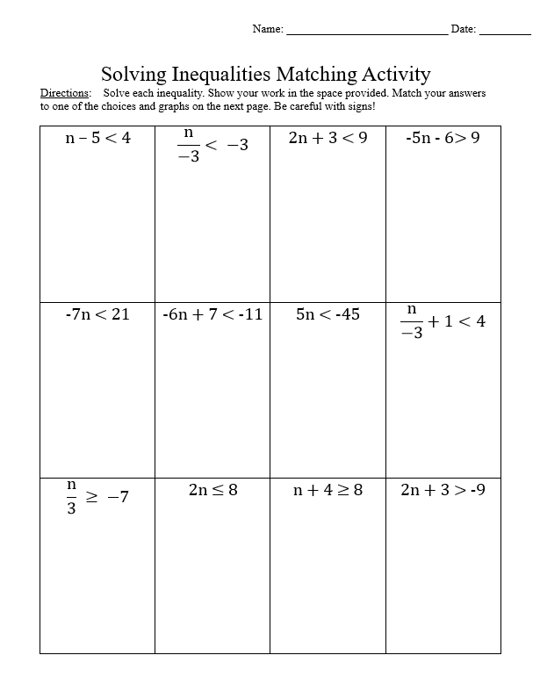

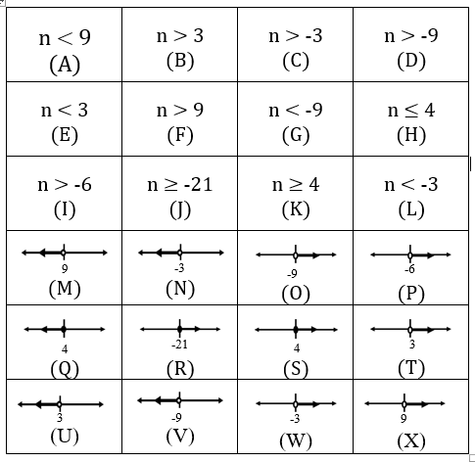

Solving Inequalities Matching Activity Worksheet

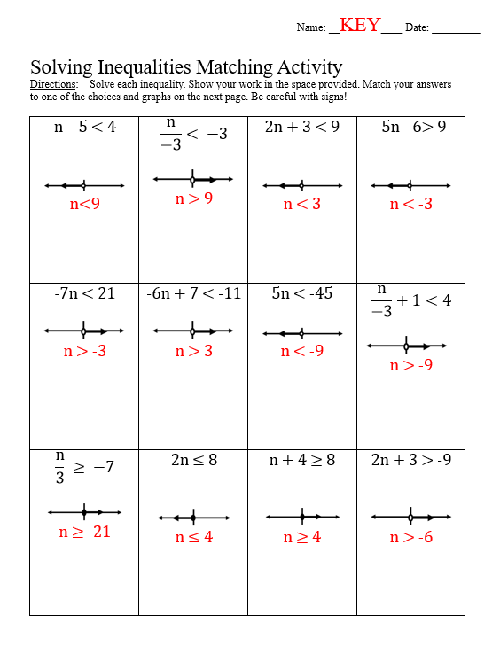

Inequalities Practice Worksheet

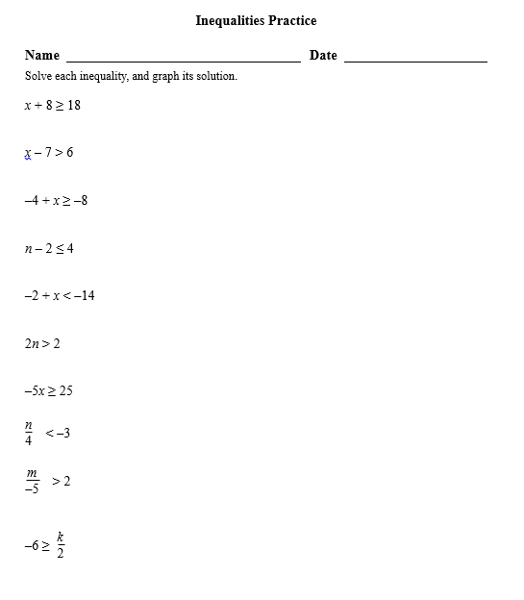

Vocabulary LINCing Routine Diagram (blank)

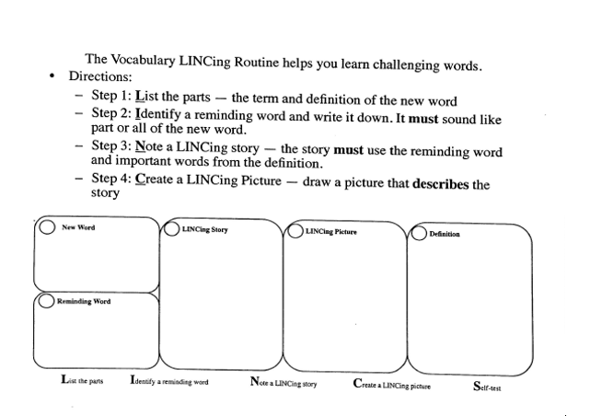

Vocabulary LINCing Routine Diagram (completed)

