Evaluating Expressions – A Co-Teaching Lesson Plan

Co-Teaching Approaches
A “(Y)” in front of the following list items indicates the approach is outlined in the lesson. An “(N)” in front of the following list items indicates the approach is not outlined in the lesson.
- (Y) Parallel Teaching
- (Y) Team Teaching
- (N) Station Teaching
- (N) One Teach/One Observe
- (N) Alternative Teaching
- (Y) One Teach/One Assist

- (Y) Parallel Teaching
- (Y) Team Teaching
- (N) Station Teaching
- (N) One Teach/One Observe
- (N) Alternative Teaching
- (Y) One Teach/One Assist

Subject
Grade 7 Mathematics

Strand
Patterns, Functions, and Algebra

Topic
Evaluating expressions with given replacement values using manipulatives

SOL
7.11 The student will evaluate algebraic expressions for given replacement values of the variables.

Outcomes
Using concrete materials to represent algebraic expressions to build understanding of the concept.

Materials
- Snack-size bags of colored candies (M&M’s or Skittles work best) or number cubes
- Bingo game cards & call sheet
- Calculators
- Evaluating Expressions Notes (attached)
- Evaluating Expressions Notes (completed) (attached)
- Evaluating Expressions with Candy activity (attached)
- Real Life Mathematics handout (attached)
- Real Life Mathematics activity (completed) (attached)
- Evaluating Expressions Practice sheet

Vocabulary

algebraic expression, constant, numerical expression, operation, term, variable

Co-Teacher Actions
Lesson Component | Co-Teaching Approach(es) | General Educator (GE) | Special Educator (SE)
Anticipatory Set | Team Teaching | Question  - What do you know or what can you remember about equations?  GE guides students to understand an equation has at least one number, one variable, an equal sign, and a solution.  GE provides a variety of equations and expressions on the chalk board, whiteboard, or interactive whiteboard. GE asks students to help sort equations into the proper category (equation vs. expression) based on what they know.  GE points out the most obvious difference (visually) between the two (one has an equal sign and the other does not). | SE same as GE.
Lesson Activities/ Procedures | One teach/One assist | - GE provides students with the Evaluating Expressions Notes handout and discusses the definition for and provides examples of the terms provided.  - GE presents students with the expression 2b - c and asks students if they can simplify it. Students should realize that there is nothing they can do with this expression. GE tells students that b = 5 and c = 3. GE asks if they can now simplify the expression.  - GE uses four to five additional sample problems on the board to demonstrate how to evaluate an expression given replacement value(s). GE completes the first two expressions together as a class. GE instructs students to complete the remaining expressions independently, reviewing each one as a class before moving on.  - GE distributes the Evaluating Expressions with Candy worksheet and snack-size bags of colored candies. The colors represent the variables.  GE has students sort their candy according to color and record the values on the worksheet. Students can substitute a number cube for candy. Roll a number cube six times to establish values for each of the variables.  - Students evaluate each expression, using the values of the candy (or rolls of a number cube). GE instructs students to show all steps in evaluating expressions. | - SE assists students with following along, maintaining attention, and completing notes during note-taking activity.  - SE assists students with following along with the teacher/sustaining attention during the sample problem demonstration. SE assists students with evaluating expressions independently, as needed.
Guided/ Independent Practice | Parallel Teaching | GE divides students into two different groups, based on their need for additional support.  - GE distributes the Real Life Mathematics worksheet. GE reviews a sample problem to demonstrate how the same formula/expression is used to complete each section or activity (i.e., bowling, skating, etc.).  - GE instructs students to complete the activity independently. | SE divides students into two different groups based on their need for additional support.  - SE distributes the Real Life Mathematics worksheet. SE reviews a sample problem to demonstrate how the same formula/expression is used to complete each section or activity (i.e., bowling, skating, etc.).  - SE works with group to set up the problems for each section.  - SE instructs students to complete the activity independently.
Closure | One Teach/One Assist | GE distributes bingo chips and game cards. GE displays an expression with replacement values and asks students to evaluate it. Students should mark their board if they have the solution. Continue until a student wins. | SE same as GE.
Formative Assessment Strategies | Team Teaching | GE instructs students to complete an exit ticket. | SE same as GE.
Homework | Team Teaching | GE instructs students to complete Evaluating Real Life Mathematics worksheet, if necessary. | SE same as GE.

Specially Designed Instruction (teacher teaches)
- The teacher can model and verbally repeat each step of the process when substituting the values for the variables and using the order of operations.
- When assigning the Real Life Mathematics activity, provide an example for each section of to ensure that all students understand how each expression is used.

Accommodations (based on student needs)
- Students requiring a copy of classroom notes should receive a copy of completed notes.
- Reduced number of problems assigned for those who need shortened assignments.

Modifications
- Students who need a modified curriculum could be provided the activity sheets in which the values have been filled in on each line and their only requirement is solving (eliminates substituting step) problems.

Notes
- “Special educator” as noted in this lesson plan might be an EL teacher, speech pathologist, or other specialist co-teaching with a general educator.
- Free bingo cards can be found on the Internet.

Note: The following pages are intended for classroom use for students as a visual aid to learning.

Virginia Department of Education©2018

Evaluating Expressions Notes 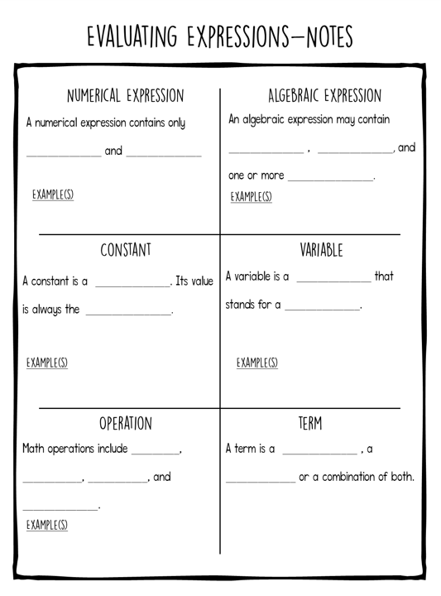

Evaluating Expressions Notes (key)
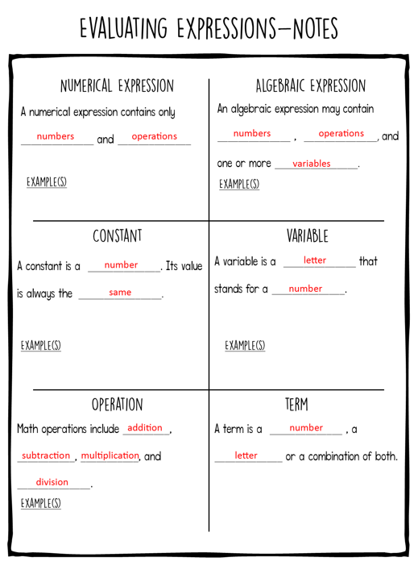

Evaluating Expressions with Candy
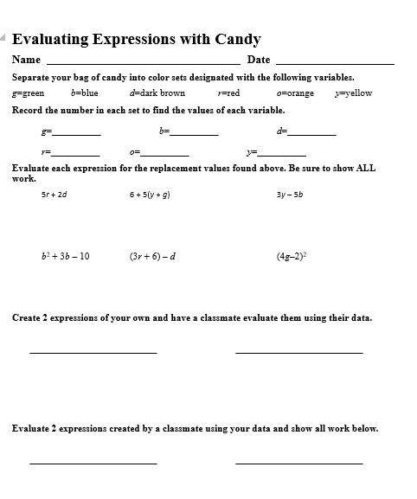
Real Life Mathematics
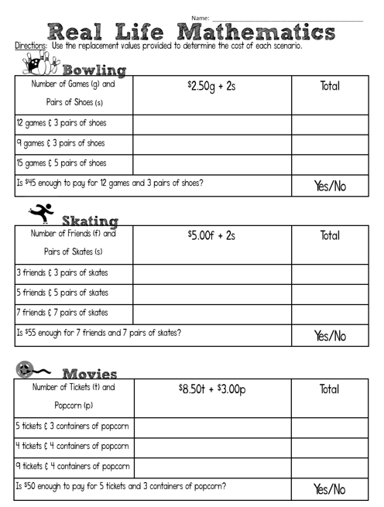
Real Life Mathematics (key)

