Coordinate-Plane – A Co-Teaching Lesson Plan

Co-Teaching Approaches
A “(Y)” in front of the following list items indicates the approach is outlined in the lesson. An “(N)” in front of the following list items indicates the approach is not outlined in the lesson.

- (Y) Parallel Teaching
- (Y) Team Teaching
- (Y) Station Teaching
- (N) One Teach/One Observe
- (Y) Alternative Teaching
- (Y) One Teach/One Assist

Subject
Grade 6 Mathematics

Strand
Measurement and Geometry

Topic
Identifying coordinates of a point and graphing ordered pairs

SOL
6.8 The student will
a) identify the components of the coordinate plane; and
b) identify the coordinates of a point and graph ordered pairs in a coordinate plane.

Outcomes
The student will be able to identify and graph ordered pairs on the coordinate grid. The student will also be able to identify the quadrant of each point by the signs of the x and y coordinate.

Materials
- Chart paper
- Markers
- Centimeter graph paper
- Rulers
- Geoboard
- Pre-drawn coordinate plane(s) for labeling (attached)

Vocabulary

axis, clockwise, coordinate plane, counter-clockwise, Geoboards (earlier grades), ordered pairs, plot, quadrants, Roman numerals, sequential

Co-Teacher Actions
Lesson Component | Co-Teaching Approach(es) | General Educator (GE) | Special Educator (SE)
Anticipatory Set | Team Teaching | Preparation  - GE creates a large coordinate plane for display on graph paper or display on a whiteboard or dry erase board.  Class  GE begins class by leading the students in a group discussion on the coordinate plane while referencing the display. GE asks students what the coordinate plane is called. Asks leading questions, including where they may have seen a coordinate plane before today (they may mention the game Battleship or similar games).  GE tells students that coordinate planes are used throughout mathematics to help us understand geometry and algebra. GE shows students the four quadrants and discuss the differences among them.  4. GE models how to graph each of these ordered pairs on the displayed coordinate plane, making sure to label them clearly. GE asks students whether the points are located where they thought they would be, and why or why not.  GE talks about coordinates and how they determine where a point is located on a coordinate plane. GE tells students they will be working with their own coordinate plane in three activities. | - SE divides the students into groups of two or three in order to share brief observations about the coordinate plane. Most students may pair up with their seat partner or a student closest to them. SE should create predetermined pairings for students who struggle to communicate or share ideas. (Keep in mind students who do not work well together because of behavioral concerns.) SE asks students to whisper to their partner(s) what they notice about the coordinate plane at this point.  - SE displays the following ordered pairs (0, 0), (3, 7), (-3, 7), (-3, -7), (3, -7). SE has students talk with their partners concerning the things they notice about the five sets of ordered pairs, discussing where each pair might be located on the coordinate plane.
Lesson Activities/ Procedures | Parallel Teaching  Station Teaching | GE and SE divide the class into two groups.  Group #1  Activity A:  - GE gives each student several sheets of centimeter graph paper. Each student draws a coordinate plane and labels the x- and y-axes, labels the lines, and identifies the quadrants.  - GE has students work with partners to graph several ordered pairs in their coordinate planes, recording each ordered pair and the quadrant in which the point is placed.  - GE has students find, without plotting and based solely on the coordinates, the pattern of determining the quadrant in which a point should be placed. Students record their thoughts about this pattern in their math journals.  - GE brings all students together to discuss the patterns they discover.  GE and/or SE reassembles the class in the center of the room.  Half the class completes activity B with GE, while half completes activity C with the SE. Then, the groups will switch and complete the other activity.  Activity B  - GE has each student draw a coordinate plane and label the x- and y-axes, label the lines, and identify the quadrants.  - GE distributes rulers and instructs each student to draw a simple outline-type picture on the coordinate plane, using only straight lines.  GE has students place a dot at each point where two lines come together. (Note: GE may require that students use all four quadrants and/or have a certain number of points on their picture.) GE instructs students to label the dots as ordered pairs.  GE directs students to list the ordered pairs on a separate sheet of paper, placing them in sequential order that makes it possible for another student to graph them and connect the dots to recreate the picture. GE emphasizes that for this to work, the ordered pairs must be listed in sequential order around the outline of the picture, either clockwise or counterclockwise.  - GE instructs students to exchange their lists of ordered pairs with their partners. GE tells each student to use this list to recreate the drawing on a blank coordinate plane, connecting the ordered pairs as they plot the points in sequential order.  - GE instructs students check their drawings against the original ones created by their partners and discuss any discrepancies. | GE and SE divide the class into two groups.  Group #2  Activity A:  - SE gives each student a pre-drawn coordinate plane with blanks where the x- and y-axes and quadrants are labelled. SE displays a coordinate plane on the board. As a group, label the x- and y-axes and quadrants. SE discusses how to write Roman numerals. SE assists students in labelling, as needed.  - As a group, practice graphing points on the coordinate plane. Allow students to come up to the board to graph points in front of the class. Next, discuss the quadrant in which the point is placed.  - SE discusses the way in which to plot points, and how, without plotting and based solely on the coordinates, to determine the quadrant in which a point is placed. SE shows the students several examples and has them guess the quadrant in which the point is placed. SE discusses this pattern with the group.  GE and/or SE reassembles the class in the center of the room.  Activity C  - SE distributes Geoboards and has students create the x- and y- axes on them. Students mark a given number of points on their Geoboards with small, round stickers.  - SE has students play a Guess the Point game in pairs. Players take turns trying to locate their opponent’s points by asking yes/no questions and guessing ordered pairs, based on their answers. Players should keep a written record of their questions, the answers, and their guesses. Play proceeds as follows:  - Player A asks a yes/no question of player B (e.g., Is there a point at 7 on the y-axis?) If the answer is yes, player A may ask another question (e.g., Is there a point at -3 on the x-axis?)  - When the answer to a question is no, player A must guess an ordered pair. If the guess is correct, player A marks the point on his/her Geoboard and continues asking questions. If the guess is incorrect, player B takes a turn.  - The first player who locates all of his/her partner’s points is the winner.
Guided/Independent Practice | One teach/One assist | GE provides students with a blank coordinate plane, with axes already drawn, and a list of coordinates. GE assists them as they plot the coordinates on the coordinate plane. GE circulates the room and fixes errors as needed. | SE provides students with a blank coordinate plane, with axes already drawn, and a list of coordinates. SE assists them as they plot the coordinates on the coordinate plane. SE circulates the room and fixes errors as needed. SE begins to identify students who need targeted assistance during the closure time.
Closure | Alternative Teaching | Questions (group discussion)  - How can you determine the quadrant in which an ordered pair should be placed without plotting the point?  - What is the same about the four quadrants? How are the four quadrants different from each other?  - How do you graph a particular point on a coordinate plane?  - How do you identify the ordered pair of a particular point in a coordinate plane? How do you know you are correct?  - What can you say about the ordered pairs found in a specific quadrant?  - Can any given point be represented by more than one ordered pair?  - In naming a point in the coordinate plane, does the order of the two coordinates matter?  or  Journal/Writing Prompts  Describe the steps to follow to graph an ordered pair. Explain whether these steps are the same for every quadrant and why or why not. | SE continues assisting the students who are struggling to plot points in a smaller group while the rest of class moves on to discussion/writing.
Formative Assessment Strategies | Team Teaching | GE uses the coordinate planes and students’ writings about the patterns they notice in activity A as an assessment.  GE uses students’ drawings, lists of ordered pairs, and completed pictures from activity B as an assessment.  GE uses students’ practice plotting points as an assessment. | SE is same as GE.
Homework | Team Teaching | Students will discuss the coordinate plane in everyday life or careers which use a coordinate plane with a family member or research the uses of it. Students should record their findings and bring them in to share with the class tomorrow. | SE is same as GE.

Specially Designed Instruction
- Teacher may need to pre-teach/review pre-requisite vocabulary terms before the lesson.
- Students may need instruction/repetition of key vocabulary terms listed in order to fully grasp their meaning.
- Students are broken into two groups during activity A. The groups are predetermined by the teachers ahead of time. Group #1 completes the activity as prescribed, while group #2 completes the activity with modifications or accommodations provided, along with more explicit instruction on how to plot points.
- Students who have slower processing receive additional time for student response during class/small group discussion.
- Students are provided with a pre-drawn coordinate plane during the independent practice time. This saves time and allows the focus to be on plotting the points.
- Students who struggle with written expression may not excel at the journal writing activity and need to be provided an alternate activity.

Accommodations
- During activity A, some students (group #2) will be provided with a pre-drawn coordinate grid with blanks/spaces in which to label the parts. This saves time and allows for a neat and accurate reference for these students later. Double-check student papers to ensure that they are labelling the parts correctly.
- When stated in students’ IEPs, a completed copy of notes should be provided.
- During some activities, especially when playing the Battleship game in activity 3, some students may need a visual checklist/ instructions on how to plot points.

Modifications
- For those students who need modifications, content can be modified so that students are identifying the vocabulary associated with the coordinate plane (axes, origin, ordered pairs, quadrants) and not plotting points. Content could also be modified so that students are identifying integers on horizontal and vertical axes.

Notes
- “Special educator” as noted in this lesson plan might be an EL teacher, speech pathologist, or other specialist co-teaching with a general educator.
- This lesson was created for a class which takes place on 90-minute block scheduling. Classes with shorter time constraints may need to modify these activities or stretch them out over two class days.

Note: The following pages are intended for classroom use for students as a visual aid to learning.

Virginia Department of Education©2018

Coordinate Plane

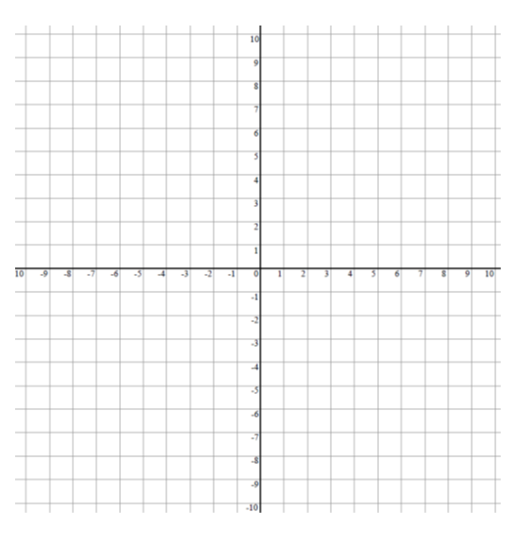

Coordinate Planes

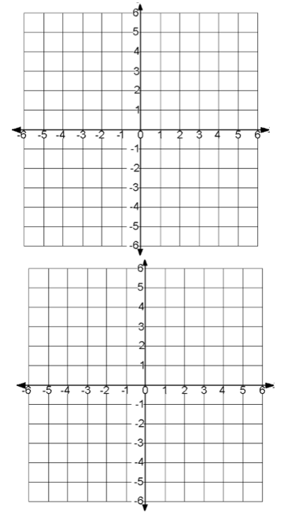
Coordinate Planes
