Deriving $π –$ A Co-Teaching Lesson Plan

Co-Teaching Approaches
A “(Y)” in front of the following list items indicates the approach is outlined in the lesson. An “(N)” in front of the following list items indicates the approach is not outlined in the lesson.

- (Y) Parallel Teaching
- (Y) Team Teaching
- (N) Station Teaching
- (N) One Teach/One Observe
- (Y) Alternative Teaching
- (Y) One Teach/One Assist

Subject
Grade 6 Mathematics

Strand
Measurement and Geometry

Topic
Deriving formulas to measure attributes of circles

SOL
6.7 The student will
a) derive π (pi)
b) solve problems, including practical problems, involving circumference and area of a circle.

Outcomes
Students will explore the relationship between circumference, diameter, radius, and pi and be able to solve problems with an understanding of area and circumference of circles.

Materials
- Scissors
- Yarn (wax strings like bendaroos or wiki stix, particularly work well with this activity)
- Inch rulers
- Calculators
- Unit squares
- VDOE formula sheets

Different Sized Circles Worksheet (attached)
- Circling Measures Graphic Organizer (attached)
- Area and Circumference Review Worksheet (attached)
- LINCS Tables Template (Blank and Completed) (attached)

Vocabulary

area of a rectangular figure, circumference of a circle, diameter, perimeter of a rectangular figure, pi, surface area (6.7), radius (earlier grades), volume of a rectangular figure

Co-Teacher Actions
Lesson Component | Co-Teaching Approach(es) | General Educator (GE) | Special Educator (SE)
Anticipatory Set | Parallel Teaching | GE splits students into two even groups and introduces vocabulary. These groups may be divided into an advanced and a basic group for the purposes of this activity.  Group #1 works in pairs in order to create working definitions for each of the three vocabulary words used in this lesson.  Students write the words circumference, diameter, and radius. They will think-pair-share in order to write definitions that can easily be used by classmates when referring to these words. Each group is assigned a section of the white board on which to write.  When each group has agreed upon a definition for each word, they write their definitions in their section. GE leads the students in a class discussion of the definitions in order to create a class definition for each word. GE shares with students the textbook definitions of these words and decides which definition students prefer. | Group #2 completes a LINCing routine on the definitions of circumference, diameter, and radius. (If students have not had prior experience with a LINCing routine, SE explains the process for using this tool and its benefits.) SE instructs students to access prior knowledge and think about what each of these three terms mean as it relates to a circle.  SE defines each term as a class and writes the definitions on the board. Students begin by writing the vocabulary word in the first box. In the last box, they write its definition. Underneath the first box, they write a word that helps remind them of its definition. They also create a LINCing story and picture to help them connect the reminding word to the definition.  SE and students complete the first word together, then students create their own examples for the next two vocabulary words. SE monitors student progress and shares responses with the class.
Lesson Activities/ Procedures | Team Teaching | GE joins reassembles class.  GE opens the discussion by asking students for the definitions of circumference, diameter, and radius of a circle. (Previously talked about in the anticipatory set). GE tells students they will investigate how the circumference of a circle compares to the circle’s diameter.  Students fold each circle in half, crease it, unfold it, and draw a line along the crease. GE directs students to use their rulers to measure the length of this line across the center of each circle and records each measurement in the chart under the Length of Line column. GE emphasizes that this is the diameter of each circle.  GE asks students what they observed about the circumference divided by the diameter of each circle. They should notice that each ratio is the whole number 3 followed by different numbers in the decimal places. GE points out that they have discovered that the circumference of a circle is a little more than 3 times larger than the diameter of the same circle.  GE displays the formula for circumference, C=2$πr$, and explains each aspect of it as follows:  - C= circumference (length of yarn)  - $π$ or pi = the ratio of the circumference of a circle to its diameter (ratio of length of yarn to length of line or length of yarn divided by length of line)  - $2r$= radius multiplied by 2, which is the diameter (length of line)  Students complete their estimates of the area of each circle. GE introduces the formula for the area of a circle, $A=πr^{2}$. In the seventh (blank) column on the Circling Measures graphic organizer, students write $A=πr^{2}$ in the heading box. Students use calculators to find the exact area of each circle by substituting the known values into the formula and performing the indicated operations.  Students share how their estimated areas, derived by filling the circles with unit squares, compare with the exact areas calculated by the formula. | SE distributes scissors and copies of the Different Sized Circles handout. Students cut out the circles. (Students who have difficulty with fine motor skills, such as cutting, or difficulty with attention, may need precut circles.  SE gives each student a ruler, a 3-foot length of yarn, and a copy of the Circling Measures graphic organizer. SE directs students to use the yarn to measure the distance around each circle, cutting the exact length of yarn needed for each circle. (The same students listed in step 2 may need the yarn pre-cut to the size needed for the activity.)  Students use the ruler to measure the length of each piece of yarn. SE instructs them to record each measurement in the chart under the Length of Yarn column. SE emphasizes that this is the circumference of each circle.  Students divide the diameter of each circle in half and record each value under the Length of Line column Divided by 2. SE emphasizes that this is the radius of each circle.  Students divide the length of yarn by the length of line for each circle and record each value under Length of Yarn column and the Length of Line column.  SE tells students they have now determined a relationship between the length of yarn (circumference) and the length of the line (diameter) - that is, the ratio of the circumference of a circle to its diameter.  SE distributes calculators. In the sixth (blank) column on the Circling Measures graphic organizer, students write C=2$π$r in the heading box. Then, students use calculators to find the exact circumference of each circle by substituting the known values into the formula and performing the indicated operations.  Students use unit squares to fill in each circle without going beyond the edges. This enables them to estimate the area of each circle. Considering that a square does not accommodate rounded edges, point out to students that they have to estimate the amount of some of the squares being used.
Guided/Independent Practice | One teach/One assist  One teach/One observe | GE provides students with a copy of the VDOE formula sheet. GE explains to them where to find the formulas for area and circumference of a circle. Students complete the worksheet on finding the circumference and area of circles given the radius or diameter using the formula sheet for guidance.  GE monitors students and answers questions as needed. | SE assists struggling students with the problems on the worksheet.
Closure | Alternative Teaching | Questions  - What is the term for the distance around a circle? What is the term for the distance around a rectangular figure?  - What is the relationship between the diameter and the radius of a circle?  - What is the relationship between the circumference of a circle and its diameter or radius?  or  Journal/Writing Prompts:  - Explain how yarn was used to measure the circumference of circles.  - Given the proportional relationship between circumference and diameter, explain why C/d=π is true.  or  Extension:  Have students do this activity with other circles. | SE continues assisting the students who are struggling to solve for area and circumference in a smaller group while the rest of class moves on to discussion/writing.
Formative Assessment Strategies | Team teaching | GE uses students’ answers during discussion time as a formative check of understanding.  GE collects students’ worksheets in order to check for progress.  GE has students complete an exit slip stating the relationship between radius, diameter, and circumference. | SE same as GE.
Homework | Team Teaching | GE instructs students to find any circle in their home and measure the circumference, radius, and diameter. After recording these measurements, students should check to make sure these values work in the chart provided during the activity and if the relationships between the values are consistent with the circles measured in class. | SE same as GE.

Specially Designed Instruction
- Students may need continued instruction/repetition of key vocabulary terms listed in order to fully grasp their meaning.
- During the Anticipatory Set introducing vocabulary, the students will be broken into two groups, which should be predetermined by the teachers. Group #1 completes a higher level vocabulary activity, while group #2 completes the activity with the assistance of the LINCing routine in order to better grasp vocabulary.
- During class/small group discussion, allow additional time for student response in order to accommodate students who have slower processing.
- Students who struggle with written expression may not excel at the journal writing activity and will need to be provided with additional assistance.
- Students who struggle with finding area and circumference are given additional instruction during the closure time to prevent misunderstandings regarding the concept, or the concepts are taught separately so the student has more practice finding circumference before area is introduced.

Accommodations
- Prompt students to recognize the relationships between the various values in the chart.
- Students, especially those who struggle with fine motor skills or attention, will be provided with pre-cut yarn and pre-cut circles for portions of the activity. This will save time, prevent frustration, and allow focus on the content of the lesson.
- Students may have difficulty making the connection between the first part of the activity, where they are measuring circumference with yarn, and the latter part of the activity, where they are using pencil and paper to find circumference. Make sure to reinforce connections continually as students complete both activities.

Modifications
- For students requiring a modified curriculum, content can be modified to include just identifying the parts of the circle, measuring diameter and radius, and determining the relationship between diameter and radius.

Notes
- “Special educator” as noted in this lesson plan might be an EL teacher, speech pathologist, or other specialist co-teaching with a general educator.
- The co-teachers who developed this lesson plan received required professional development in the use of specialized instructional techniques which combine an explicit instructional routine with the co-construction of a visual device (graphic organizer). The Vocabulary LINCing Routine and its “LINCS Tables” help students learn and remember terms and vocabulary through auditory and visual memory devices. These Content Enhancement Routines were developed at the Center for Research on Learning at the University of Kansas
- Other graphic organizers should be used by teachers who have not received professional development in these routines. If Virginia teachers would like to learn content enhancement routines, contact your regional TTAC.
- This lesson was created for class which takes place on 90-minute block scheduling. Classes with shorter time constraints may need to modify these activities or stretch them out over two class days.

Note: The following pages are intended for classroom use for students as a visual aid to learning.

Virginia Department of Education©2018

LINCS Tables Template

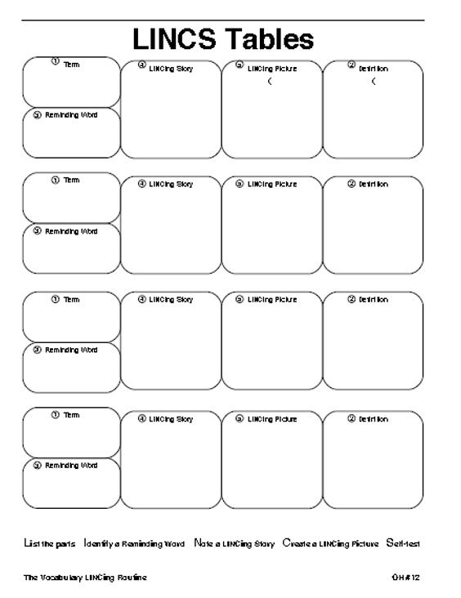

LINCS Tables Template (Completed)

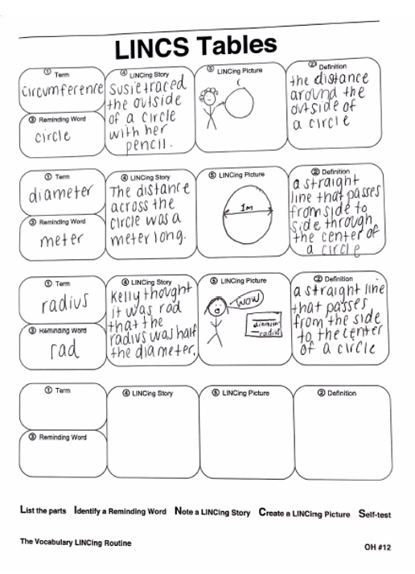

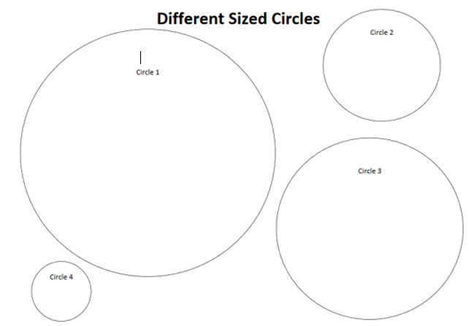Different Sized Circles Worksheet

Circling Measures

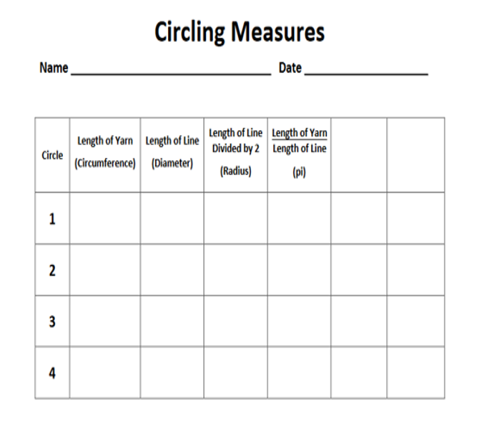
Area and Circumference Review Worksheet

