Compare and Order Integers – A Co-Teaching Lesson Plan

Co-Teaching Approaches
A “(Y)” in front of the following list items indicates the approach is outlined in the lesson. An “(N)” in front of the following list items indicates the approach is not outlined in the lesson.

- (Y) Parallel Teaching
- (Y) Team Teaching
- (N) Station Teaching
- (Y) One Teach/One Observe
- (N) Alternative Teaching
- (Y) One Teach/One Assist

Subject
Grade 6 Mathematics

Strand
Number and Number Sense

Topic
Determine which integers are greater and put in sequential order

SOL
6.3 The student will
b) compare and order integers.

Outcomes
The student will use the number line to order integers.

Materials
- Comparing Integers Warm-up (attached)
- Comparing Integers Warm-up Answer Key (attached)
- Frame Routine for Comparing Integers (completed) (attached)
- Comparing Integers Practice sheet (attached)
- Comparing Integers Assessment Questions worksheet (attached)
- Comparing Integers Assessment Questions Answer Key (attached)

Vocabulary

integer - the set of whole numbers, their opposites, including zero {…-3, -2, -1, 0, 1, 2, 3…}, negative integer - an integer less than zero. A negative integer is always less than a positive integer, positive integer - an integer greater than zero, zero - an integer that is neither positive nor negative

Co-Teacher Actions
Lesson Component | Co-Teaching Approach(es) | General Educator (GE) | Special Educator (SE)
Anticipatory Set | Team Teach | GE distributes the Comparing Integers Warm-up worksheet and has students complete it. GE assists any students having difficulty. | SE assists any students having difficulty. SE discusses the answers with the whole class.
Lesson Activities/ Procedures | Parallel Teaching  Team Teach | GE splits the class into two groups, making the second group smaller and mainly for students who will benefit from small group instruction.  - GE draws 10 number lines on the board similar to the one shown below.  - Questions  • John has $3 in his wallet. Joan owes $5 to her mother. Who has more money? (John)  • Monday’s high temperature was 7°. Tuesday’s was −3°. Which day had the higher temperature? (Monday)  • Jamal is 10-years-old. Maggie is 12-years-old. Who is older? (Maggie)  • In Alaska, Friday’s temperature was −10°. On Saturday, it was −15°. Which day had the higher temperature? (Friday)  GE writes the corresponding integers on one of the number lines as students answer the questions. GE uses a different number line for each question. Each time the students decide which number is greater, GE circles that number on its number line.  3. GE points out to the students that the larger number on each number line is circled. GE asks them to compare the number lines and indicate what these larger numbers have in common. (The larger number in each pair of numbers is always the number on the right.)  4. GE erases the number lines and puts up the following number line:  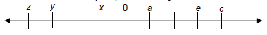  Questions  • Does a or e represent the larger number? (e)  • Does c or x represent the larger number? (c)  • Does z or y represent the larger number? (y)  • Which is larger, the number represented by a or 0? (a)  • Does x or y represents the larger number? (x)  GE asks the students to defend their answers.  5. GE asks the students to work in pairs to make a rule about comparing integers. Students should decide that for numbers on the number line, the farther to the right they are, the larger they are, and the farther to the left they are, the smaller they are.  6. GE returns to whole group instruction to complete the notes on the integers framing routine. GE reviews the Frame Routine for Comparing Integers to extend understanding and give shape to integer knowledge. | SE creates a second group for students, who will benefit from small group instruction, thus allowing for a shorter wait time and different versions of number lines (i.e., number lines with numbers already written, temperature gauge, etc.).  - SE draws 10 number lines on the board, similar to the one shown below.  - Questions  • John has $3 in his wallet. Joan owes $5 to her mother. Who has more money? (John)  • Monday’s high temperature was 7°. Tuesday’s was −3°. Which day had the higher temperature? (Monday)  • Jamal is 10-years-old. Maggie is 12-years-old. Who is older? (Maggie)  • In Alaska, Friday’s temperature was −10°. On Saturday, it was −15°. Which day had the higher temperature? (Friday)  SE writes the corresponding integers on one of the number lines as students answer the questions. SE uses a different number line for each question. Each time the students decide which number is greater, GE circles that number on its number line.  3. SE points out to the students that the larger number on each number line is circled. SE asks them to compare the number lines and indicate what these larger numbers have in common. (The larger number in each pair of numbers is always the number on the right.)  4. SE erases the number lines and puts up the following number line:  Questions  • Does a or e represent the larger number? (e)  • Does c or x represent the larger number? (c)  • Does z or y represent the larger number? (y)  • Which is larger, the number represented by a or 0? (a)  • Does x or y represent the larger number? (x)  SE asks the students to defend their answers.  5. SE asks the students to work in pairs to make a rule about comparing integers. Students should decide that for numbers on the number line, the farther to the right they are, the larger they are, and the farther to the left they are, the smaller they are.  6. SE participates in a discussion of the framing routine. SE modifies notes as necessary (see accommodations and modifications below for suggestions).
Guided/ Independent Practice | Team teach/One teach/One observe (SE may need to make observations for data collection during this time) | GE distributes the Comparing Integers Practice sheet and allows students to work in pairs. GE provides assistance as needed. | SE distributes the Comparing Integers Practice sheet and allows students to work in pairs. SE provides assistance as needed.
Closure | Team Teach | GE asks students to create their own number line with six letters representing numbers.  GE instructs students to write “Which is greater?” five times on a piece of paper about this number line, exchange the paper with a partner, and answer the questions. | SE provides a set of number lines already filled in with six letters representing numbers and questions for designated students to answer.
Formative Assessment Strategies | Team Teach | GE distributes the Comparing Integers Assessment Questions worksheet and has the students complete it. | SE modifies and/or reduces the Comparing Integers Assessment Questions worksheet as necessary for designated students requiring shortened assignments.

Specially Designed Instruction
- Teacher may utilize the Frame Routine, or other graphic device, to provide specially designed instruction.
- Provide most to least prompts by allowing the students to use a laminated number line and markers to initially order integers.

Accommodations
- On the Frame Routine for Comparing Integers worksheet, some students may need to have a copy of completed notes but with some blanks (cloze procedures) or a completed copy that they can highlight, as noted in students’ IEPs. This routine is supposed to be fluid and change according to students’ comments and suggestions.
- When students are required to work in pairs, prompting and additional questioning may be needed from a teacher for students who struggle to communicate with peers or think abstractly.
- During the Formative Assessment, strategies may be shortened for struggling students or students who receive reduced math problems as a result of IEP accommodations.
- In the Anticipatory Set, a worksheet with smaller numbers in the equations may be substituted for the Comparing Integers Warm-up worksheet.
- Instead of creating new questions/number lines, provide some students with pre-drawn number lines and pre-written questions. This tests their ability to master the content and not their creative thinking skills.

Modifications
- For those students who require a modified curriculum, the content could be modified so that students are comparing and ordering positive numbers.

Notes
- “Special educator” as noted in this lesson plan might be an EL teacher, speech pathologist, or other specialist co-teaching with a general educator.
- The co-teachers who developed this lesson plan received required professional development in the use of specialized instruction techniques, which combine an explicit instructional routine with the co-construction and with the frame and helps to develop understanding of information and procedures by associating main ideas and details. These content enhancement routines were developed at the Center for Research on Learning at the University of Kansas.
- Other graphic organizers should be used by teachers who have not received professional development in these routines. If Virginia teachers would like to learn content enhancement routines, contact your regional TTAC.

Note: The following pages are intended for classroom use for students as a visual aid to learning.

Virginia Department of Education©2019

Comparing Integers Warm-up

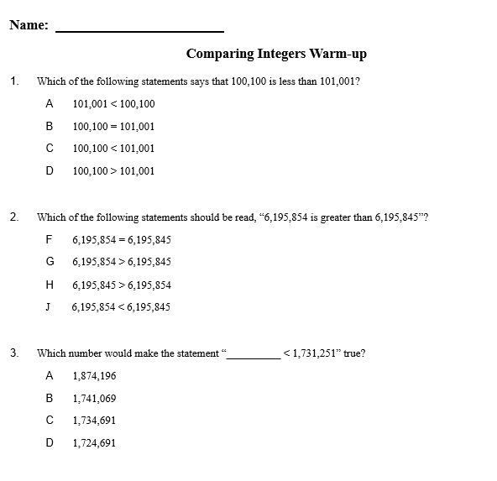

Comparing Integers Warm-up Answer Key

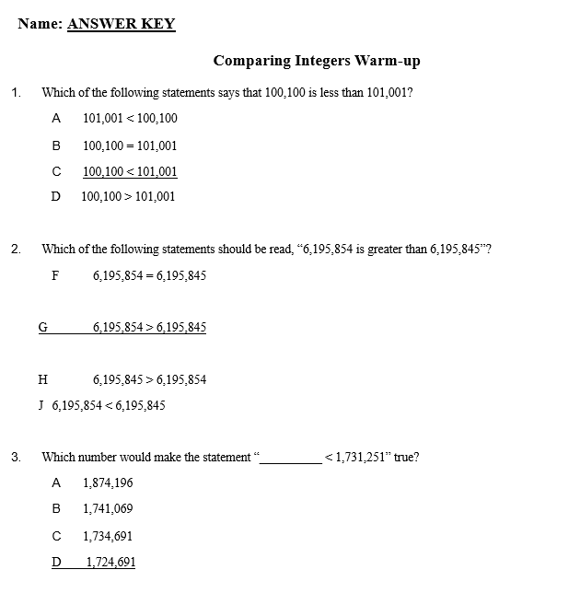

The Frame Routine for Comparing Integers

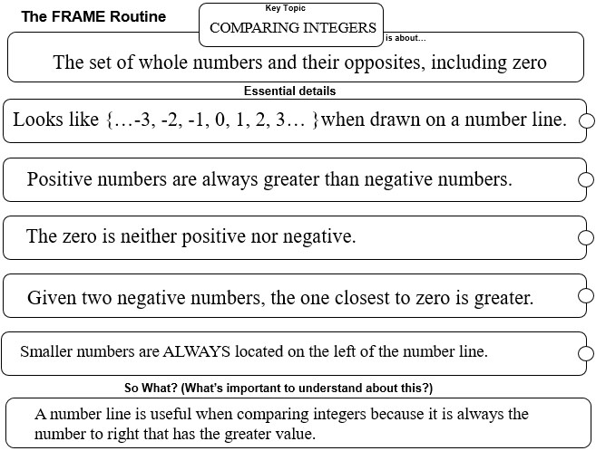

Comparing Integers Practice

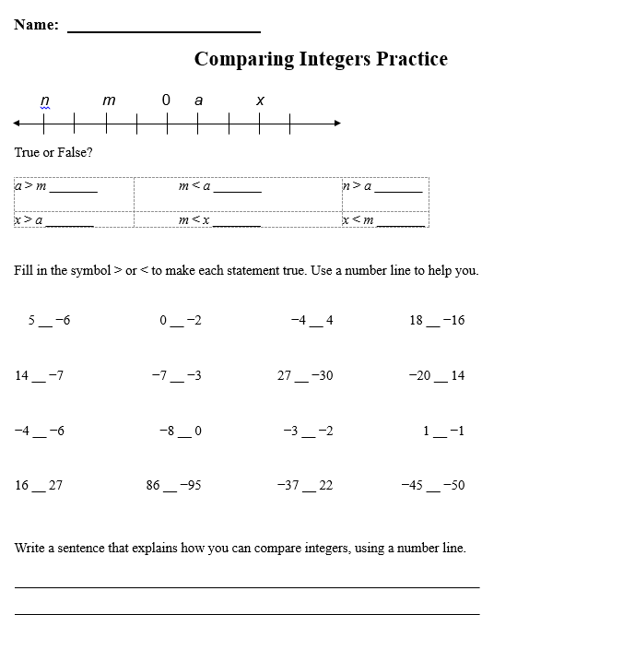

Comparing Integers Assessment Questions

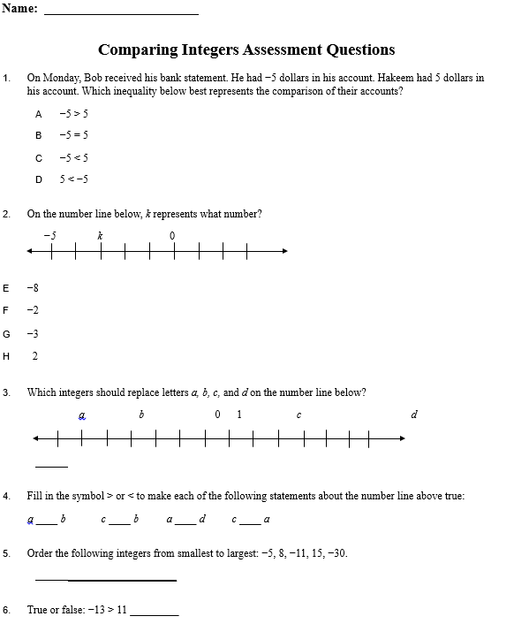

Comparing Integers Assessment Questions Answer Key

