Comparing Rational Numbers – A Co-Teaching Lesson Plan

Co-Teaching Approaches
A “(Y)” in front of the following list items indicates the approach is outlined in the lesson. An “(N)” in front of the following list items indicates the approach is not outlined in the lesson.
- (N) Parallel Teaching
- (Y) Team Teaching
- (N) Station Teaching
- (Y) One Teach/One Observe
- (Y) Alternative Teaching
- (Y) One Teach/One As

Subject
Grade 6 Mathematics

Strand
Number and Number Sense

Topic
Investigating rational numbers in percent, decimal, and fractional forms

SOL
6.2 The student will
- represent and determine equivalencies among fractions, mixed numbers, decimals, and percents; and
- compare and order positive rational numbers.

Outcomes
The student will be able to determine equivalencies, and compare and order fractions, mixed numbers, decimals, and percents.

Materials
- Large number line
- Timer
- Bell
- Baggies
- Concept Mastery Diagram worksheet (attached)
- Rational Numbers Cards chart (attached)
- Rational Numbers Cards chart key (attached)
- Representing Rational Numbers Chart (attached)
- Modified Rational Numbers Cards chart (attached)
- Modified Rational Numbers Cards Key (attached)
- Converting Rational Numbers chart (attached)

Vocabulary
decimals (4.3,5.2), fractions (4.3,5.2), percent (6.2), percentage (6.2), ratio (6.1)

Co-Teacher Actions
Lesson Component | Co-Teaching Approach(es) | General Educator (GE) | Special Educator (SE)
Anticipatory Set | Team teaching/  One teach/One assist | GE reviews the concept mastery device on percents to extend understanding and tap into prior knowledge. See the Concept Mastery Diagram worksheet as an example. | SE participates in a discussion of the concept mastery routine.  SE monitors and assists students, as needed.  SE modifies notes as appropriate (see accommodations and modifications below for suggestions).
Lesson Activities/ Procedures | Team teaching/One teach/One assist | GE prints the attached Rational Number Cards on cardstock and cuts them out prior to this activity. All cards need to be the same size and color.  GE draws a number line on the board or posts a large number line on a wall. Above and to the left of the number line, post three signs labeled  - Fraction  - Decimal  - Percent  (as shown below).  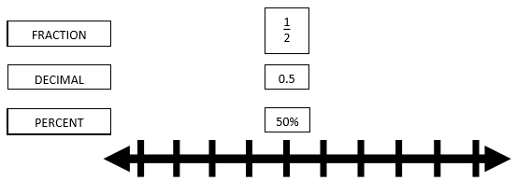  GE organizes the classroom furniture by lining up the desks in a straight line along the length of the room and placing chairs on both sides of the line of desks. This allows students to be seated in two rows, facing each other across the line of desks.  (In order for this activity to work, the total number of student participants must be an even number, divisible by 3 [e.g., 12, 18, 24, 30, or 36]. If the number of students in the class does not match one of these numbers, GE creates groups with the largest number of student participants possible and has the remaining students serve as volunteer timekeepers, number line organizers, and/or recorders for filling in the attached Representing Rational Numbers Chart.)  GE keeps time and directs all students to tape their numbers in order along the number line and complete their individual charts as numbers appear along the number line.  Preparation  1. GE reviews how to convert between different forms of rational numbers (i.e., between fractions, decimals, and percents).  2. GE gives each student one rational number card, making sure that for each number distributed, all three forms of that number are handed out. Also, distribute copies of the Representing Rational Numbers Chart.  3. GE divides the class into two groups by having students count off by twos. Seat one group (group A) in random order on one side of the desks/tables and the other group (group B) on the other side.  4. GE assists in giving game directions. Asks students for clarification of directions.  GE and SE assist, model, and observe. Write down the names of students who struggle with converting ratios. Keep this list for the guided/independent practice or closure portion of the lesson. | SE assists with the organization of the classroom and seating of students during the activity. Some students may require special seating since it is not their normal setting.  Preparation  SE participates in a discussion of converting rational numbers. SE shows examples on the board.  SE helps with distributing rational number cards and the Representing Rational Numbers Chart.  Directions  4. SE explains the object of the game is to match up all three forms of each rational number.  Students in group B remain seated throughout the game. When the bell rings, students have 30 seconds to determine whether their numbers match the numbers of the people opposite them.  If the numbers match, the student in group A stands behind the student with the match in group B.  The bell rings every 30 seconds, signaling all students in group A to move one chair to their right. The student seated in the last chair at the end of the row cycles to the first chair in the row.  The first group of three students to match all three forms of a number tape their numbers in the correct position on the number line. They also record their numbers on their Representing Rational Numbers Chart.  The remaining students continue to play until all numbers are matched, placed, and recorded. If necessary, numbers previously placed on the number line may be moved slightly to make room for additional numbers.  GE and SE assist, model, and observe. Write down the names of students who struggle with converting ratios. Keep this list for the guided/independent practice or closure portion of the lesson.
Guided/ Independent Practice | Team Teaching | GE prints a set of the Modified Rational Numbers Cards and Modified Rational Numbers Key for each student. The students cut out the Modified Rational Numbers Cards and place them into baggies with their names on them. Students practice putting them all into groups and then check with the key or teacher. | SE assists students with cutting needs and those who were observed as struggling during the lesson. If some students are still struggling with matching the cards, make a small group during the closure time for alternative teaching and/or remediation.
Closure | Alternative Teaching | Questions  - Look at the fractions on the number line. What are some relationships between the numerators and denominators that help you in placing fractions in numerical order prior to converting them to decimals?  - Why is it necessary to have multiple forms of rational numbers?  or  Journal/Writing Prompts  Students choice one from below.  - Explain how this activity helped you understand the relationship between fractions, decimals, and percents.  - Write your procedures for converting rational numbers from one form to another. | While GE is working with the rest of the students, SE reviews how to convert one form to another. Continue practicing.  SE works with a struggling group, helping them answer the journal prompt orally. SE writes down what students say on a (group) sheet of paper.
Formative Assessment Strategies | Team teaching and Alternative teaching | GE uses questioning, journal/writing prompts, observing during the game, and independent practice with their own cards.  GE distributes copies of the Converting Rational Numbers worksheet and has students complete it in class and/or finish it for homework. | SE checks a list of students’ names when they are successful at matching their Modified Rational Numbers Cards, even though some students have different sets of cards from the rest of the group.  SE modifies the Converting Rational Numbers worksheet for some students.
Homework | Alternative teaching | GE instructs students to finish the Converting Rational Numbers worksheet. | SE modifies the remaining worksheet for students in need.

Specially Designed Instruction (teacher teaches)
- Teacher can make individual bags to practice matching common percents, decimals, and fractions for students with memory difficulties. Many students need repetition and these baggies can be used in a variety of ways (warm-up activity, team games [e.g., who can match them all the fastest], extra practice when classwork is complete, etc.).
.

Accommodations (based on student needs)
- During the Anticipatory set, some students may need to have a copy of the Concept Mastery Diagram with blanks (cloze procedures) or a completed copy, which they can highlight. Keep in mind that this routine is supposed to be fluid and change according to students’ comments and suggestions.
- During Guided/Independent Practice, have some Modified Rational Numbers Cards already cut out and in baggies for some students. This will allow more time to match the cards with mastery.
- For Homework, reduce the number of problems for certain students as needed on the Converting Rational Numbers worksheet.

Modifications
- Instead of expecting the student to be able to convert between all forms, modify objective to include converting between fractions and decimals.

Notes
- “Special educator” as noted in this lesson plan might be an EL teacher, speech pathologist, or other specialist co-teaching with a general educator.
- The co-teachers who developed this lesson plan received required professional development in the use of specialized instructional techniques which combine an explicit instructional routine with the co-construction of a visual device (graphic organizer). The Concept Mastery Routine uses the “Concept Diagram” to enable teachers to develop student understanding of complex concepts. These Content Enhancement Routines were developed at the Center for Research on Learning at the University of Kansas. Link: http://www.kucrl.org/sim/brochures/CEoverview.pdf
- Other graphic organizers should be used by teachers who have not received professional development in the Concept Mastery Routine. If Virginia teachers would like to learn Content Enhancement Routines, contact your regional TTAC.
- This lesson was created for a class which takes place on a 90-minute block scheduling. Classes with shorter time constraints may need to modify these activities or stretch them out over two class days.

Note: The following pages are intended for classroom use for students as a visual aid to learning.

Virginia Department of Education©2018

Concept Mastery Diagram

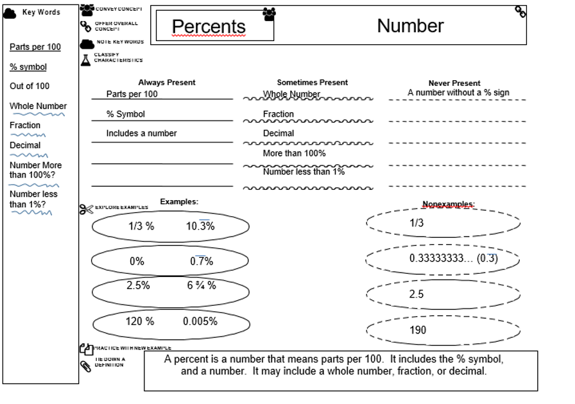

Rational Numbers Cards

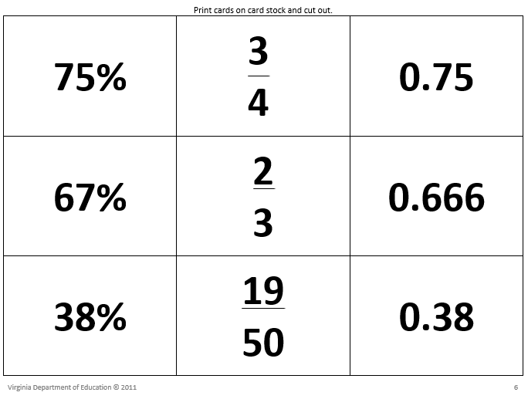

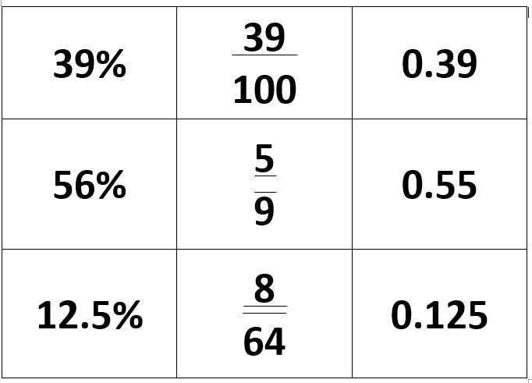

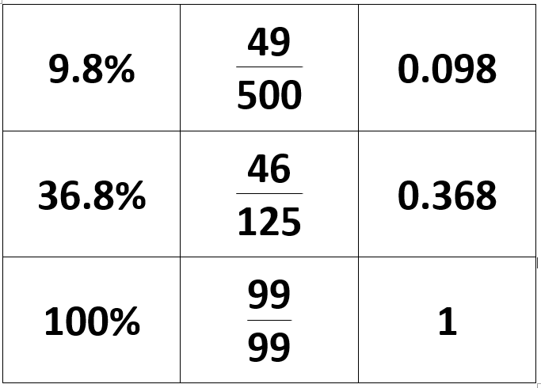

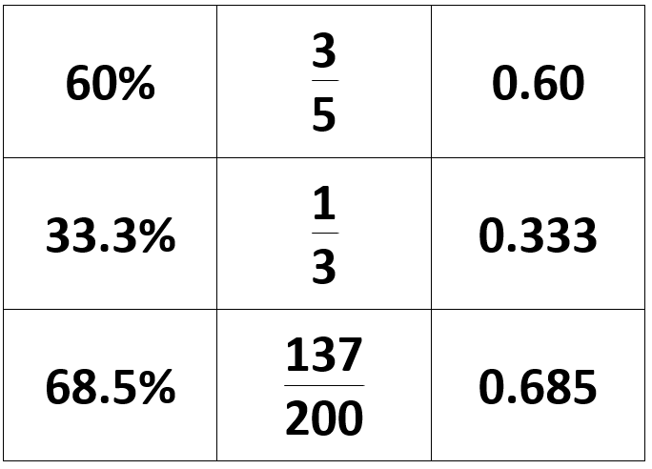

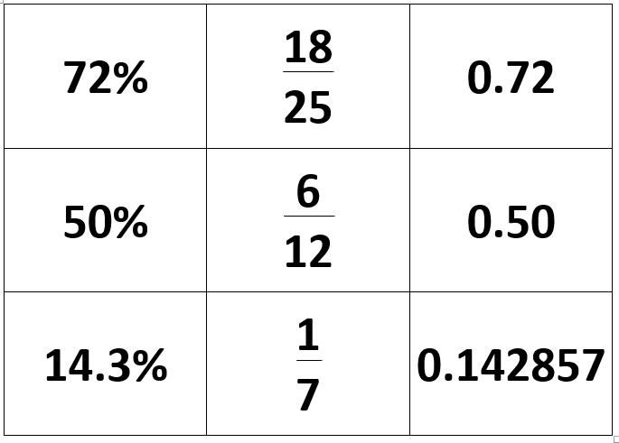

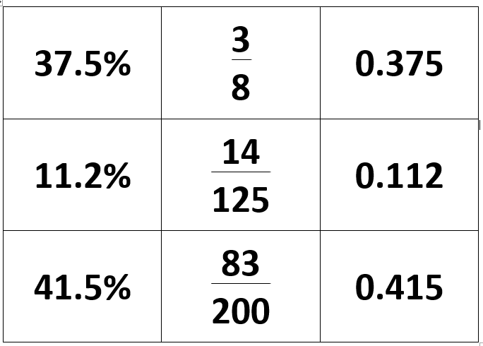

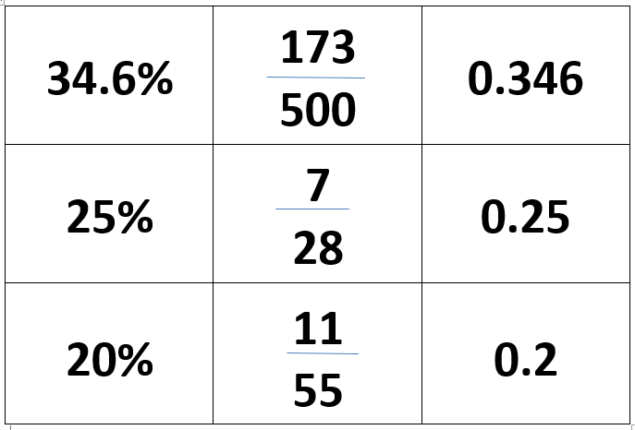

Rational Numbers Cards Key

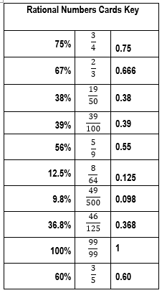
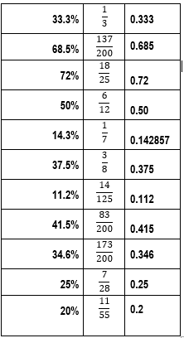

Representing Rational Numbers Chart

Modified Rational Number Cards —
Used for student baggies

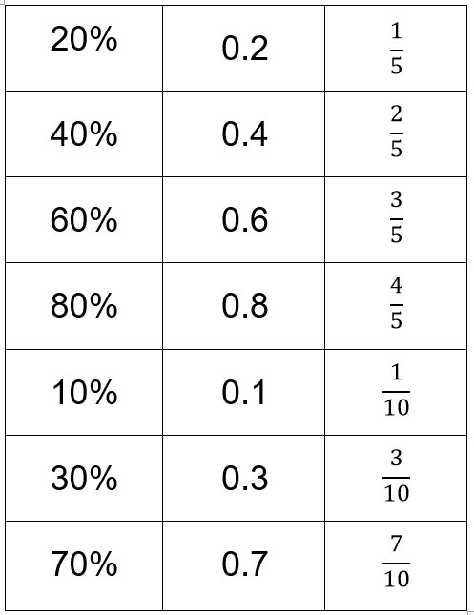

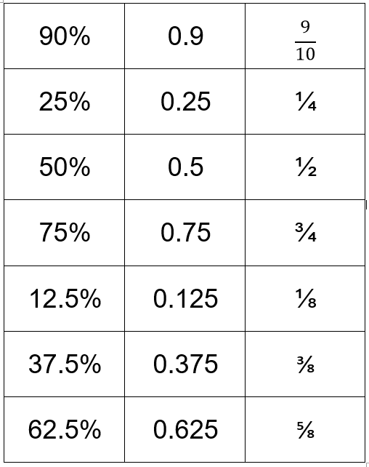

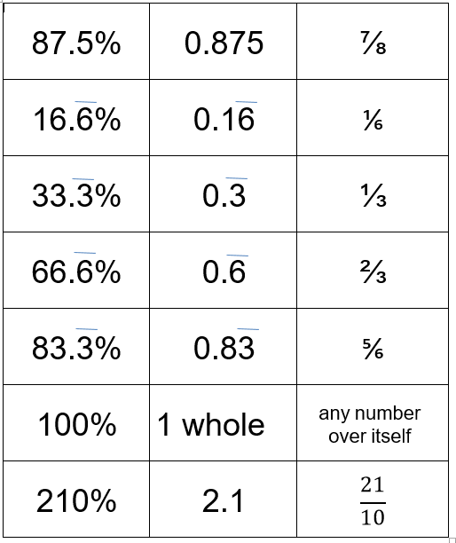

Modified Rational Numbers Key—
Put in student baggies as a quick reference tool

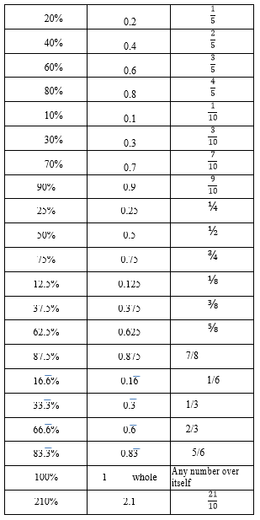

Converting Rational Numbers

