Ratios – A Co-Teaching Lesson Plan

Co-Teaching Approaches
A “(Y)” in front of the following list items indicates the approach is outlined in the lesson. An “(N)” in front of the following list items indicates the approach is not outlined in the lesson.

- (Y) Parallel Teaching
- (Y) Team Teaching
- (N) Station Teaching
- (Y) One Teach/One Observe
- (N) Alternative Teaching
- (Y) One Teach/One Assist

Subject
Grade 6 Mathematics

Strand
Number and Number Sense

Topic
Represent relationships between quantities using ratios

SOL
6.1 The student will represent relationships between quantities using ratios, and will use appropriate notations, such as $\frac{a}{b}$, a to b, and a:b.

Outcomes
The students will use color tiles (or construction paper squares) to describe and compare two sets of data, using ratios and appropriate notations.

Materials
- Sets of 20 red and 30 yellow color tiles or construction paper squares
- Red and yellow colored pencils
- Survey Questions (attached)
- The Frame Diagram and key (attached)
- Understanding Ratios worksheet (attached)
- Grid (attached)
- Understanding Ratios - Extension worksheet (attached)
- Exit Ticket Examples (attached)
- Ratios worksheet (attached)

Vocabulary

ratio - comparison of any two quantities.

Co-Teacher Actions
Lesson Component | Co-Teaching Approach(es) | General Educator (GE) | Special Educator (SE)
Anticipatory Set | Team Teach | GE assists students in answering Survey Questions.  GE distributes the Frame Diagram and introduces ratios. GE completes diagram with the whole class, filling it in as the discussion dictates.  GE discusses the different types of ratios and introduces the three ways to write ratios and the different ways to compare quantities. GE engages class in discussion as to why fractions are only appropriate for part to whole ratios.  GE explains that order matters when properly representing relationships within and between sets. For example, if asked for the ratio of the number of cats to dogs in a park, the ratio must be expressed as the number of cats to the number of dogs, in that order.  GE asks students to compare the number of boys in the class to the number of girls. GE asks students to compare the number of girls to the number of boys. Has them write each comparison in the three ratio notations. For example, for 6 boys and 3 girls, the ratio of boys to girls is 6 to 3, 6:3, which simplifies to 2:1, while the ratio of girls to boys is 3 to 6, 3:6, which simplifies to 1:2. Because this example is part to part, the fraction form would not be appropriate. The ratio of girl to total class would be 3 to 9, 3:9, or 3/9, which simplifies to 1/3. Because this example is part to whole, the fraction would be appropriate. GE discusses that like fractions, ratios should be simplified.  Students can work in groups so that group members can confer.  GE instructs students to write the ratio of boys to all students in the class (6 to 9, 6:9, or 6/9, which simplifies to 2/3 for the above example.  GE asks students to describe the relationship between the way the question is asked and the way the ratio is written. (The set named first goes first in the ratio.) GE leads discussion on this concept. | SE assists students as they enter the classroom. SE helps them quickly answer Survey Questions posted around the room.  SE tells students we will be using this information throughout the unit.  SE participates in discussion of the framing routine. SE modifies notes as appropriate (see accommodations and modifications below for suggestions).
Lesson Activities/ Procedures | Parallel Teach | GE distributes the sets of red and yellow color tiles or squares, colored pencils, sheets of grid paper, and the Understanding Ratios worksheet to half of the class. GE gives students a few minutes to experiment with putting together various sets of red and yellow tiles or squares.  GE has students complete the first activity on the worksheet and has students color the set on the grid paper and number the picture, as well as write the ratios requested. It is very important that students use the squares or tiles, color the grid, and write the ratio. GE reviews the answers with the students.  GE has students complete the worksheet. During the activity, GE should monitor their work to make sure they are focusing on the relationships between the identified sets. Some students may begin to notice similarities in the sets. GE may need to reduce the number of problems the students are expected to complete.  When students are finished, GE discusses and answers and what relationships students have discovered from activity. | SE distributes the sets of red and yellow color tiles or squares, colored pencils, sheets of grid paper, and the Understanding Ratios worksheet to the other half of the class. SE gives students a few minutes to experiment with putting together various sets of red and yellow tiles or squares.  SE completes the same grid activity with the other group. SE may need to complete one set of grid sheets for the entire group instead of each person, or reduce the number of problems the students are expected to complete.  When students are finished, SE discusses and answers and what relationships students have discovered from activity.
Guided/ Independent Practice | Alternative Teaching | GE distributes the Understanding Ratios Extension worksheet to students who have grasped concepts from previous activity. GE reminds students that their answers are to be complete statements.  If students noticed the relationships when completing the problems on the previous worksheet, GE asks them to explain how they figured it out. Several explanations are valid, including, separating set four into two groups, each of which looks like set one, or the numbers were doubled.  GE allows students to exchange their worksheets and check the work of a fellow student. | SE continues working with any students who need more practice or clarification/discussion with the grid activity.
Closure | Team Teach | GE has students write a definition and/or give verbal description of ratio and give several examples of a ratio. | SE has students write a definition and/or give verbal description of ratio and give several examples of a ratio.
Formative Assessment Strategies | One Teach  One Assist | GE instructs students to complete the exit ticket and assists as needed. | GE instructs students to complete the exit ticket and assists as needed.
Homework | Team Teach | GE may assign the attached Ratios worksheet to students for homework. GE reminds students to write each ratio all three ways. | SE may modify and/or reduce worksheet homework assignment, as necessary, for designated students requiring shortened assignments.

Specially Designed Instruction
- The teacher will explicitly teach how to use the Frame Diagram worksheet (or other graphic organizer) to visually represent all the different components of ratios and how they are written. Teacher will use think aloud strategy as he/she uses the graphic organizer.
- The teacher can break down the three different ways to write ratios into more manageable chunks. For example, have students identify ratios using the word “to” first, and then move on to the other ways after they have shown mastery.
- Another prerequisite skill the teacher may need to explicitly review first is the idea that fractions are part to whole representations, and how to simplify fractions.

Accommodations
- On the Frame Diagram worksheet, some students may need a completed copy of these notes, but with some blanks (cloze procedures) or a completed copy that they can highlight, as noted in the students’ IEPs. Keep in mind that this routine is supposed to be fluid and change according to students’ comments and suggestions.
- During the lesson, students could work in pairs or groups of three to manipulate one set of grid sheets and red and yellow tiles instead of each student completing the lesson individually.
- For students who struggle to communicate with peers or think abstractly, prompting and additional questioning may be needed from a teacher when students are required to work in pairs.
- For struggling students or students who receive reduced math problems as a result of IEP accommodations, the Understanding Ratios worksheet may be shortened.
- For designated students requiring shortened assignments, reduce homework as necessary.

Modifications
- For students who require a modified curriculum, the objective could instead be that the student will represent relationships between quantities with ratios using the notation a to b.

Notes
- “Special educator” as noted in this lesson plan might be an EL teacher, speech pathologist, or other specialist co-teaching with a general educator.
- The co-teachers who developed this lesson plan received required professional development in the use of specialized instructional techniques which combine an explicit instructional routine with the co-construction of a visual device (graphic organizer). The Framing Routine in conjunction with “The Frame” helps to develop understanding of information and procedures by associating their main ideas and details. These Content Enhancement Routines were developed at the Center for Research on Learning at the University of Kansas. Link: http://www.kucrl.org/sim/brochures/CEoverview.pdf
- Other graphic organizers should be used by teachers who have not received professional development in the Framing Routine. If Virginia teachers would like to learn the Content Enhancement Routines, contact your regional TTAC.

Note: The following pages are intended for classroom use for students as a visual aid to learning.

Virginia Department of Education©2018

Survey Questions

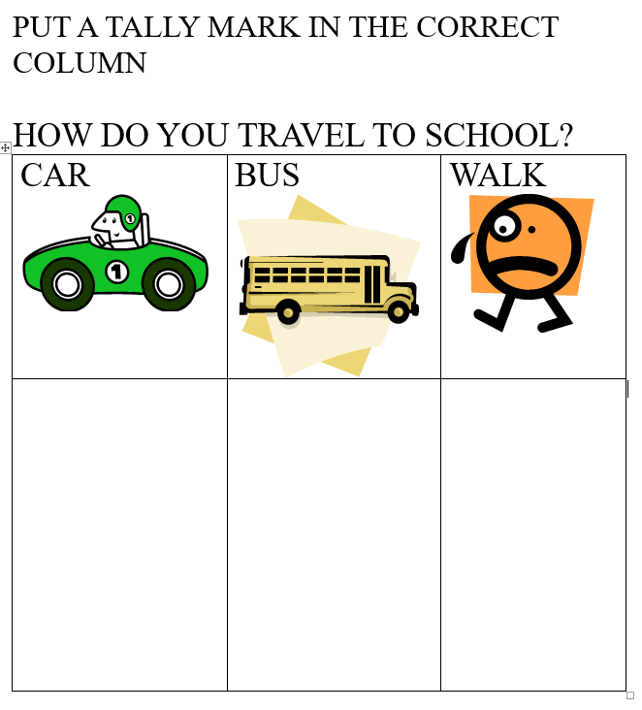

Survey Questions

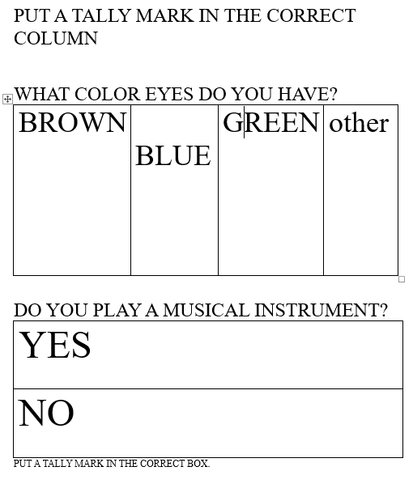

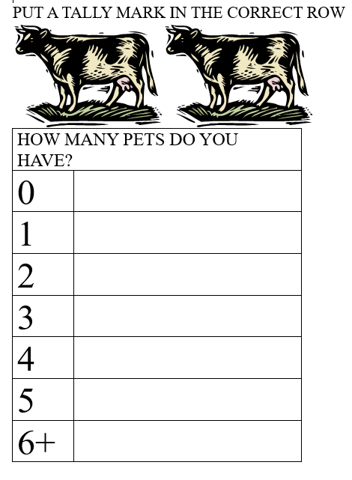

Sign-up Form

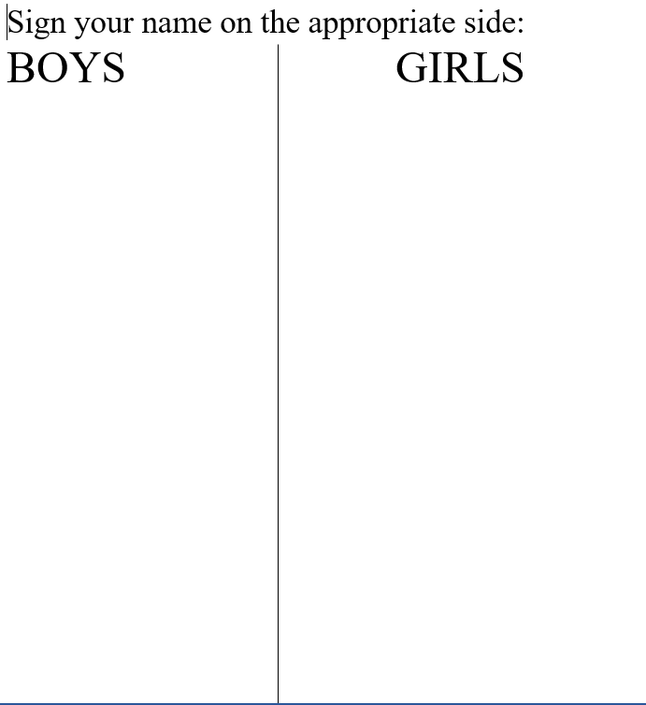

The Frame Diagram

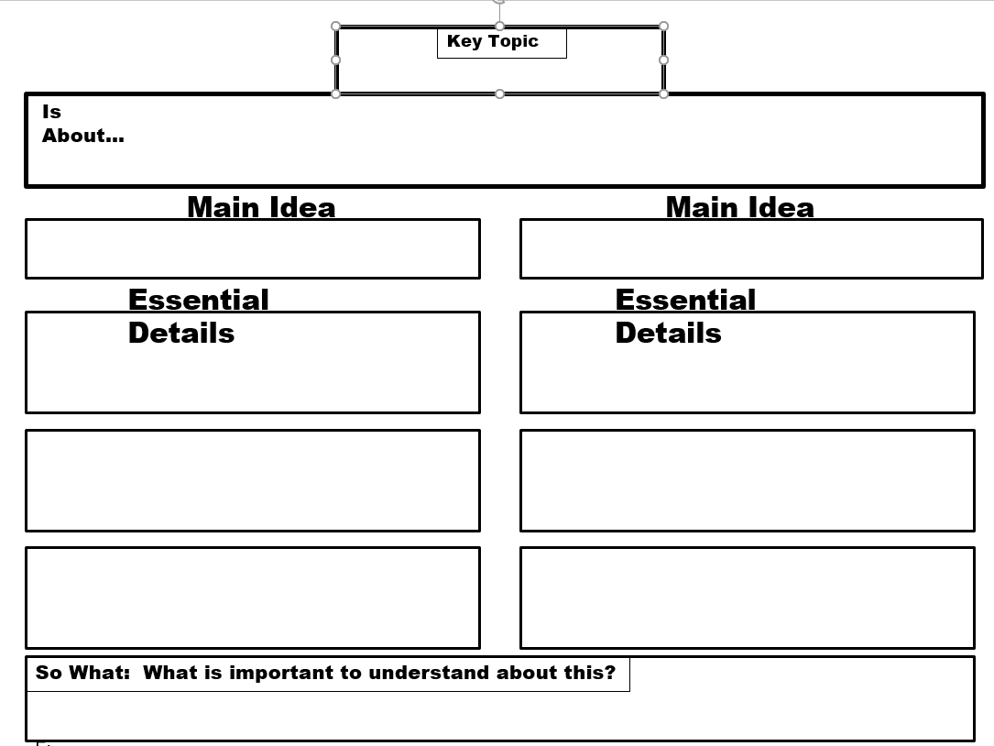

The Frame Diagram (Key)

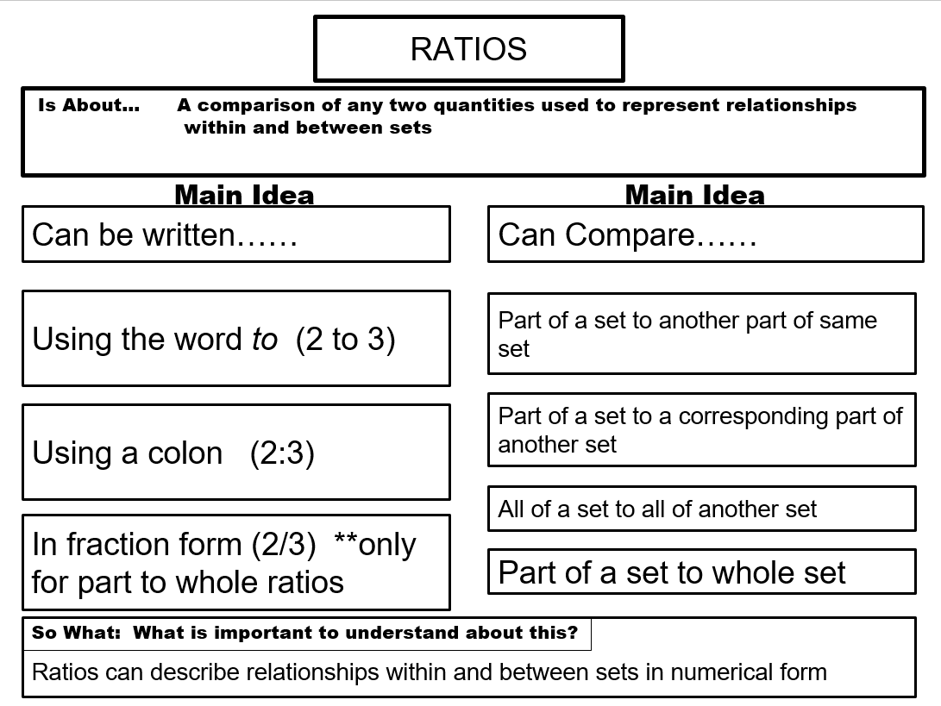

Understanding Ratios

Use a set of color tiles or construction paper squares to model each of the following ratios. After you have modeled a set, use colored pencils to draw a picture of the set by coloring it on grid paper. Write each ratio at least two different ways, and remember to simplify.

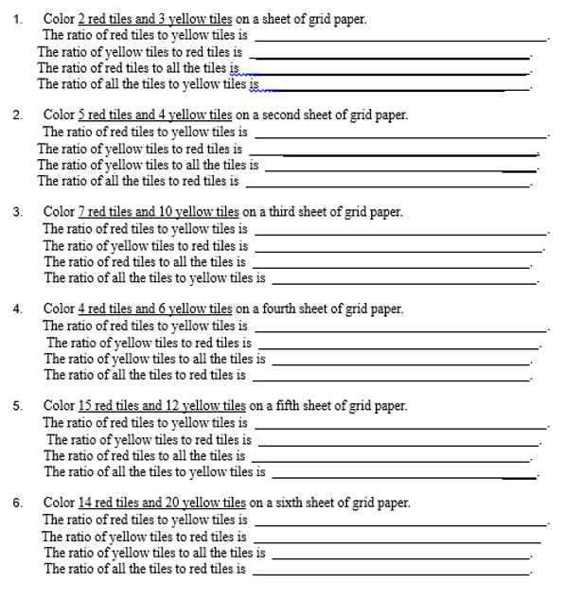

Grid

Exit Ticket Examples

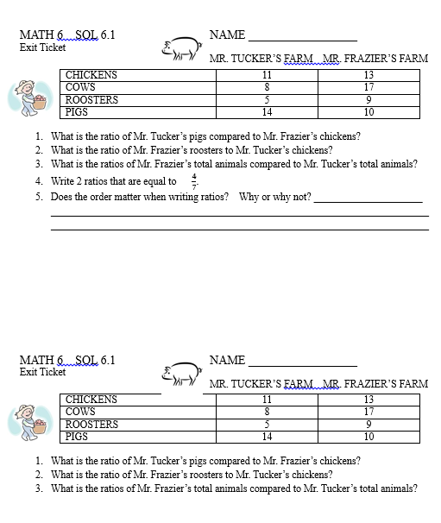

Understanding Ratios - Extension

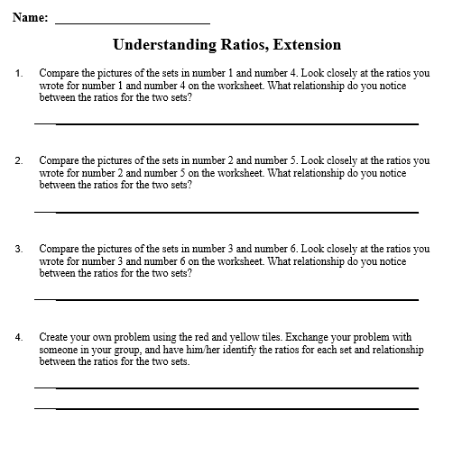

Ratios
Write each ratio, and remember to simplify if possible.

