Solving Inequalities – A Co-Teaching Lesson Plan

Co-Teaching Approaches
A “(Y)” in front of the following list items indicates the approach is outlined in the lesson. An “(N)” in front of the following list items indicates the approach is not outlined in the lesson.

- (N) Parallel Teaching
- (Y) Team Teaching
- (Y) Station Teaching
- (Y) One Teach/One Observe
- (N) Alternative Teaching
- (N) One Teach/One Assist

Subject
Grade 6 Mathematics

Strand
Patterns, Functions, and Algebra

Topic
Graphing and Solving Inequalities

Standards
6.14 The student will
b) solve one-step linear inequalities in one variable, involving addition or subtraction, and graph the solution number line.

Outcome
The student will solve addition and subtraction inequality problems and graph solution on a number line.

Materials
- Whiteboard
- Document Camera
- Computer
- Individual candy bags (Life Savers, peppermint discs, Twizzlers)
- Inequalities Practice sheet
- Solving Inequalities Matching Activity sheet
- Candy Graphs PowerPoint
- One Step Inequalities Practice Quiz
- Hand Signals handout
- Frame Graphic Organizer

Vocabulary

closed circle, equation, expression, greater than, greater than equal to, inequality, less than, less than equal to, open circle, solution set, variable

Co-Teacher Actions
Lesson Component | Co-Teaching Approach(es) | General Educator (GE) | Special Educator (SE)
Anticipatory Set | Team teaching/  One teach/One observe | GE introduces the inequality x < 5 and has students write what they think it means on whiteboards.  GE discusses this with the class, including important vocabulary words inequality, inequality symbols, and variable.  GE presents inequality examples including all inequality symbols.  GE discusses the differences between expressions, equations, and inequalities.  GE instructs students to graph the following inequalities:  X ≥ - 6  X ≤ 4  X > 3  X < -4 | SE shares simple strategy with the hand gesture for remembering when to use open and closed circles.  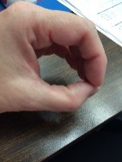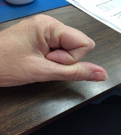  Closed Circle Open Circle  (See larger photos below.)  SE circulates, checking for understanding (formative assessment) with each student using a checklist/clipboard.
Lesson Activities/ Procedures | Team Teaching | GE discusses how the inequality symbol determines whether the circle is closed or open and in which direction it is colored. GE models this on the SMARTboard.  GE works on co-construction of the Frame Graphic Organizer, with the key topic of Inequality. | SE presents the inequality x + 5 > 8 and asks students to work with a partner to solve it.  SE asks students to describe how they solved for the variable and to compare the process to solving equations. During this discussion, compare the solutions to equations vs. the solutions for inequalities. SE demonstrates how to check the solution for an inequality.  SE completes the equation on the SMARTboard with students answering questions and completing their own Frames Graphic Organizer.  SE distributes partially completed Frames as needed.
Guided/ Independent Practice | Station | GE separates students into three groups for stations. Each student completes the activity sheet associated with the assigned station. Students turn this in at the end of day two for a grade. They can use the Frame Graphic Organizer as a reference in each station.  Station 1 GE leads students completing problems on the Inequalities Practice sheet.  Station 3 Students complete Solving Inequalities Matching Activity sheet using the whiteboards. This station will be student led. | Station 2 SE models the first two problems of the Candy Graphs PowerPoint activity. Students complete the activity, modeling the graphing of the inequalities using their candy.
Closure | Team Teaching | GE develops the So What? statement from their Frames Graphic Diagram. | SE asks what open and closed signs mean, when to flip signs, and what is inverse operation of addition and subtraction.
Formative Assessment Strategies | Team Teaching | GE evaluates students’ work from each station and uses it to form groups for the next day. | Students complete One Step Inequalities Practice Quiz on day two in a small group setting, with a read aloud as needed.
Homework | Team Teaching | Students create their own one-step inequality and explain how they solved it. | SE gives students 15 minutes to complete, if additional time is needed. Students must complete for homework.

Specially Designed Instruction
- Use “think alouds” to demonstrate how to solve inequalities and model the process step by step.
- Use multi-sensory strategies and manipulatives to demonstrate using the inverse operation to solve the inequality.
- Teacher may utilize the Frame Routine, or other graphic device, to provide specially designed instruction

Accommodations
- Provide an alternative setting if stations become overwhelming to students.
- Reduce the number of problems for certain students, according to students’ IEPs.
- Students can use their Frame Graphic Organizer to help recall essential vocabulary. Partially completed Frame Graphic Organizers will be distributed to certain students.
- Students who have difficulty with recalling multistep procedures will be given a checklist to self-monitor the steps necessary to solve the inequalities.

Modifications
- For those students requiring a modified curriculum, the content could be modified to comparing numbers using inequality signs.

Notes
- This lesson is designed to take approximately two class periods over two days.
- “Special educator” as noted in this lesson plan might be an EL teacher, speech pathologist, or other specialist co-teaching with a general educator.
- The co-teachers who developed this lesson plan received required professional development in the use of specialized instruction techniques, which combine an explicit instructional routine with the co-construction and with the frame and helps to develop understanding of information and procedures by associating main ideas and details. These content enhancement routines were developed at the Center for Research on Learning at the University of Kansas.
- Other graphic organizers should be used by teachers who have not received professional development in these routines. If Virginia teachers would like to learn content enhancement routines, contact your regional TTAC.

Note: The following pages are intended for classroom use for students as a visual aid to learning.

Virginia Department of Education©2019

Hand Signals
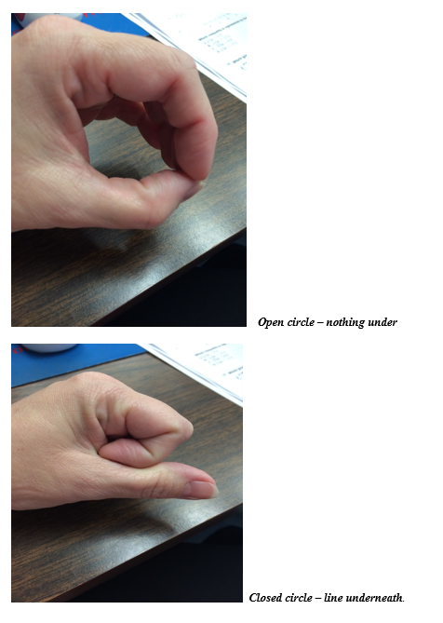
Frame Graphic Organizer

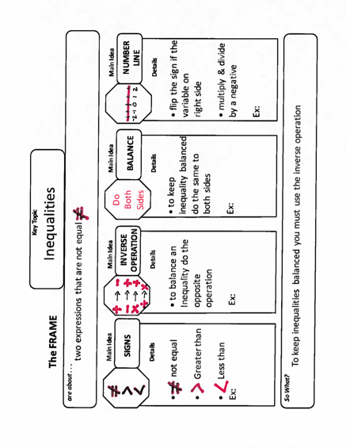
Candy Graphs PowerPoint

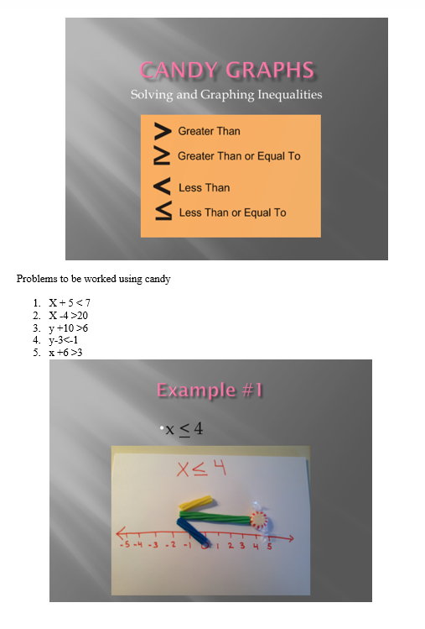
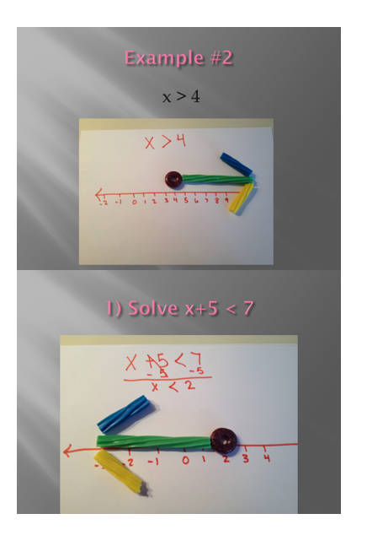
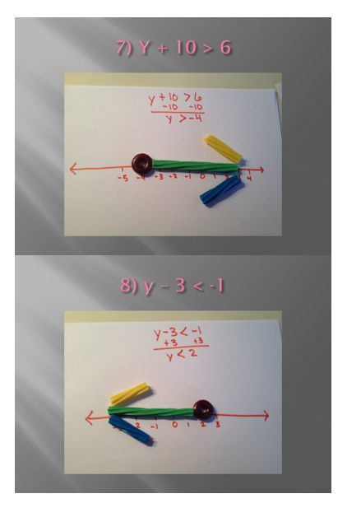

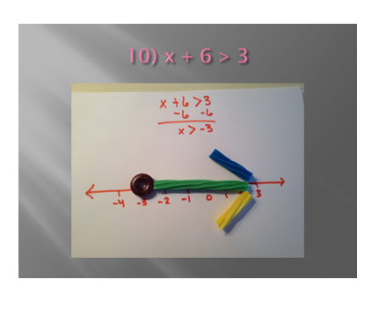

Solving Inequalities Matching Activity

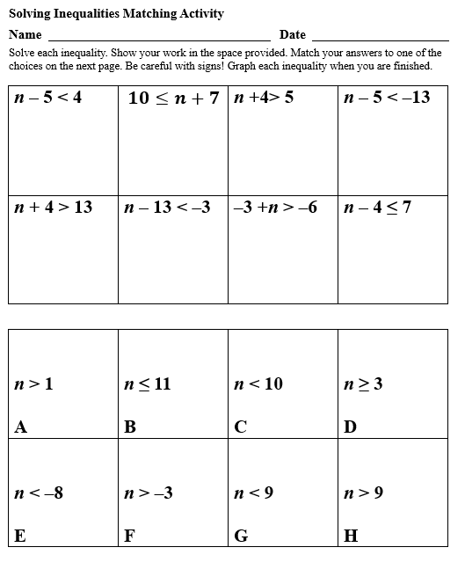

Inequalities Practice

One Step Inequalities Practice Quiz

