Math Mat Problem Solving – A Co-Teaching Lesson Plan

Co-Teaching Approaches
A “(Y)” in front of the following list items indicates the approach is outlined in the lesson. An “(N)” in front of the following list items indicates the approach is not outlined in the lesson.

- (Y) Parallel Teaching
- (Y) Team Teaching
- (N) Station Teaching
- (N) One Teach/One Observe
- (N) Alternative Teaching
- (N) One Teach/One Assist

Subject
Grade 4 Mathematics

Strand
Computation and Estimation

Topic
Problem solving with fractions and mixed numbers.

SOL
4.5 The student will
- solve single-step practical problems involving addition and subtraction with fractions and mixed numbers.

Outcomes
The student will be able to solve practical problems involving addition and subtraction with fractions and mixed numbers.

Materials
- Fraction Strips
- Problem-solving mat
- Chart paper

Vocabulary

common factors, common multiples, difference, estimation, factor, fraction, greatest common factor (GCF), improper fraction, least common denominator, least common multiple (LCM), like and unlike denominators, mixed number, simplify, simplest form,

Co-Teacher Actions
Lesson Component | Co-Teaching Approach(es) | General Educator (GE) | Special Educator (SE)
Anticipatory Set | Team teaching | Begin by asking students to consider how they typically solve a problem in their everyday lives.  Do they just do something without thinking, do they get suggestions and opinions from others, or do they look at their options?  Discuss the importance of connecting the mathematics they are studying to real-life situations. Ask students what kind of questions they need to ask themselves when confronted with a mathematics problem. Ask what they think about when solving such problems. Lead them to realize that they should ask themselves: “What do I know? What do I want to know? What information given is important? What should I do to find the answer? Does the answer make sense?” | Introduce/reintroduce the problem-solving mat.  Assist and guide the discussion by copying the attached problem-solving mat on a large chart paper.
Lesson Activities/ Procedures | Team teaching | Present the following problem to students: A school wants to make a new playground by cleaning up an abandoned lot that is shaped like a rectangle. They give the job of planning the playground to a group of students. The students decide to use one-fourth of the playground for a basketball court and three-eighths of the playground for a soccer field. How much of the playground has been used? How much is left to be used?  Have student pairs complete the problem-solving mat using the information given and solve the problem.  Have several selected students share their solution strategies and thinking. | Monitor and assist students as needed. Ask the “Why?” and “How do you know?” questions, listening for understanding and misconceptions. Select several students to share their thinking with the class (looking for different solution strategies).  Monitor students who incorrectly and correctly solve the problem to group them for guided/independent practice.  Fill-in the problem-solving mat with students’ responses.
Guided/Independent Practice | Parallel Teaching | Independent Practice Group  Marty made two types of cookies. He used two-thirds cup of sugar for one recipe and one-fourth cup of sugar for the other. How much sugar did he use in all?  Direct students to complete problem-solving mat. Discuss the information written on the mat with a partner. Have student pairs solve the problem.  Monitor students, asking the “Why?” and “How do you know?” questions, listening for understanding and different strategies for solving the problem. Select students to share their thinking and solution strategies. Be sure to make connections between the solution strategies.  Repeat the process with the following problems:  - Steven drank one-third of a gallon of milk in the morning, and one-sixth at dinner. How much milk did Steven drink in all? How much of the gallon is left?  - James walks one-half mile to the library, and Jane walks three-eighths of a mile to the same library. How much further does James walk?  - John took a hike. He completed one-half mile before lunch and three-fourths of a mile after lunch. How far did John hike altogether? If John’s goal is two miles, how much further does he have to go? | Guided Practice Group  Marty made two types of cookies. He used two-thirds cup of sugar for one recipe and one-quarter cup of sugar for the other. How much sugar did he use in all?  Guide students as a group to complete the problem-solving mat. Discuss information in the problem and brainstorm ways that this problem might be solved. Have student pairs work together to solve the problem.  Monitor the students’ work and discussions, listening for understandings and misunderstandings, asking the “Why?” and “How do you know?” questions. Select several students to share their thoughts and solution strategies with the group. Ask leading questions to make sure each individual understands the strategies and the solution.  Repeat the process with the following problems:  - One-tenth of the M&Ms in a bag are red and one-fifth are blue. What fraction of all the M&Ms are red and blue?  - James walks one-half mile to the library, and Jane walks three-eighths of a mile to the same library. How much further does James walk?
Closure | Parallel Teaching | Select students to share their thinking. Ask questions to highlight different strategies. | Same as GE.
Formative Assessment Strategies | Team Teaching | Exit Ticket  Observe students as they work.  After class, use data to form groups. | Same as GE.
Homework |  | Optional: Students can create and solve an additional problem in their mathematics journals.

Specially Designed Instruction
- The vocabulary LINCing routine should be used with students as a specialized instruction/review device. While not used directly in this lesson, it could be used the next day to help struggling students develop a better understanding of content. A blank template is attached below.
- Accompany instruction with manipulatives, illustrations, and thinking aloud to help students understand difficult concepts and procedures.
- Provide scaffolded practice to students who need that extra support.

Accommodations
- Students use manipulatives.
- Students use number line and/or multiplication chart.
- Allow multiple ways for students to demonstrate understanding such as drawing, writing, or using manipulatives on the problem-solving mat.

Modifications
- For those students who require a modified curriculum, content could be modified to adding/subtracting whole numbers or fractions with the same denominators.

Notes
- This is an introductory lesson to problem solving with fractions. Mixed numbers should be introduced later in the unit using the same format.
- “Special educator” as noted in this lesson plan might be an EL teacher, speech pathologist, or other specialist co-teaching with a general educator.
- The co-teachers who developed this lesson plan received required professional development in the use specialized instruction techniques which combine an explicit instructional routine with the co-construction with the frame helps to develop understanding of information and procedures by associating main ideas and details. These content enhancement routines were developed at the Center for Research on Learning at the University of Kansas.
- Other graphic organizers should be used by teachers who have not received professional development in these routines. If Virginia teachers would like to learn content enhancement routines, contact your regional TTAC.

Note: The following pages are intended for classroom use for students as a visual aid to learning.

Virginia Department of Education © 2019

Exit Ticket
Print and cut out.
Exit Ticket  Jackie has $\frac{1}{3}$ of a Hershey bar. Steven has $\frac{4}{12}$ of a Hershey bar. How much do they have together? | Exit Ticket  Jackie has $\frac{1}{3}$ of a Hershey bar. Steven has $\frac{4}{12}$ of a Hershey bar. How much do they have together?
Exit Ticket  Jackie has $\frac{1}{3}$ of a Hershey bar. Steven has $\frac{4}{12}$ of a Hershey bar. How much do they have together? | Exit Ticket  Jackie has $\frac{1}{3}$ of a Hershey bar. Steven has $\frac{4}{12}$ of a Hershey bar. How much do they have together?
Exit Ticket  Jackie has $\frac{1}{3}$ of a Hershey bar. Steven has $\frac{4}{12}$ of a Hershey bar. How much do they have together? | Exit Ticket  Jackie has $\frac{1}{3}$ of a Hershey bar. Steven has $\frac{4}{12}$ of a Hershey bar. How much do they have together?
Exit Ticket  Jackie has $\frac{1}{3}$ of a Hershey bar. Steven has $\frac{4}{12}$ of a Hershey bar. How much do they have together? | Exit Ticket  Jackie has $\frac{1}{3}$ of a Hershey bar. Steven has $\frac{4}{12}$ of a Hershey bar. How much do they have together?
Exit Ticket  Jackie has $\frac{1}{3}$ of a Hershey bar. Steven has $\frac{4}{12}$ of a Hershey bar. How much do they have together? | Exit Ticket  Jackie has $\frac{1}{3}$ of a Hershey bar. Steven has $\frac{4}{12}$ of a Hershey bar. How much do they have together?

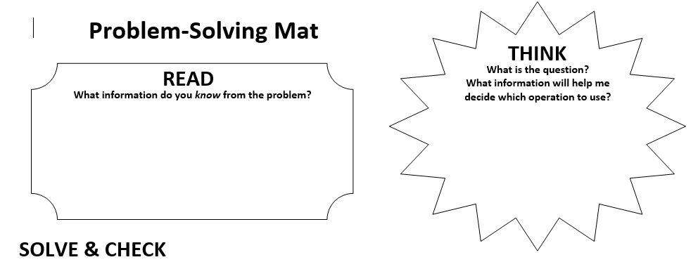
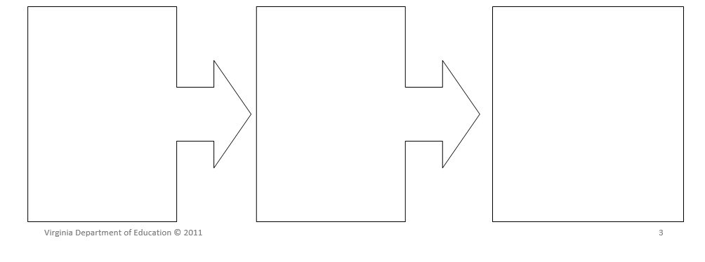
LINCS Vocabulary Strategy
Name: Date:
LINCS Vocabulary Strategy
Term | LINCing Story | LINCing Picture | Definition
Reminding Word
Term | LINCing Story | LINCing Picture | Definition
Reminding Word
Term | LINCing Story | LINCing Picture | Definition
Reminding Word
Worksheet created by Nicole Allison at allisonspeechpeeps@blogspot.com

