Comparing Fractions – A Co-Teaching Lesson Plan

Co-Teaching Approaches
A “(Y)”in front of the following list items indicates the approach is outlined in the lesson. A“(N)”in front of the following list items indicates the approach is not outlined in the lesson.

- (N) Parallel Teaching
- (Y) Team Teaching
- (N) Station Teaching
- (N) One Teach/One Observe
- (N) Alternative Teaching
- (Y) One Teach/One Assist

Subject
Grade 3 Mathematics

Strand
Number and Number Sense

Topic
Comparing fractions

SOL
3.2 The student will
- compare fractions having like and unlike denominators, using words and symbols (>, <, or ≠) with models.

Outcomes
The student will be able to compare the size of unit fractions with like and unlike denominators, using a length/measurement model.

Materials
- Two Hershey chocolate bars of the same size
- Knife (adult use only)
- YouTube videos on paper folding fraction strips : this one shows how to fold into fifths. Fold again to make tenths.
- Precut sets of seven 3” x 12” strips of construction paper in five different colors (e.g., red, blue, green, yellow, purple, pink, white). You need one set of seven strips for each student.
- Scissors
- Pencils or markers
- Resealable plastic storage bags
- Mine’s Bigger! Fraction Comparison Game directions (attached)
- Mine’s Bigger! Fraction Comparison Game Record Sheet (attached)
- Fraction Cards (attached and should be precut for students to use)
- Paper bags

Vocabulary

compare, congruent, denominator, equal to, fraction, greater than, less than, numerator

Co-Teacher Actions
Lesson Component | Co-Teaching Approach(es) | General Educator (GE) | Special Educator (SE)
Anticipatory Set | Team Teaching | (1) The GE directs students’ attention to a Hershey’s chocolate bar and compares it to the bar the SE is holding. Ask, “Are the two bars the same size?” (yes). Now, split the bar in half and lead class to identify each portion as “half.” Write both the word and the number symbol for one-half. Demonstrate the next step by splitting the one-half section of candy into one-fourths. Lead the class to identify one-fourth and write the word and number symbol (¼). Ask, “Which would you rather eat, the one-fourth or one-half segment? Why?” | (2) The SE takes the same size Hershey’s chocolate bar and divides it into thirds. Ask, “Are the three parts of the bar the same size?” (yes) Lead the class to identify each portion as one-third and write the word and symbol for one-third.  Compare to the GE sections of the candy bar by laying all three pieces side-by-side. Lead students to make comparative statements about the three pieces of the same-size candy bar. Ask questions such as: “Can you cover up the one-third with the one-fourth piece?” (No, so one-third is greater than one-fourth.) “Can you cover one-third with one-half?” (Yes, so one-half is larger or greater than one-third.)
Lesson Activities/ Procedures | One teach/one assist | The GE explains that the students will be creating fraction strips to use during different mathematics lessons with number sense. Students need to experience fractions by creating fraction strips in one-half, one-fourth, one-third, one-fifth, one-sixth, one-eighth, and one-tenth with different colors of construction paper.  Everyone gets seven strips of different colors of construction paper and will need a pencil and scissors.  First instruct students to label the red strip that represents the whole (whole = 1).  Next have the students fold the blue strips in half and then cut down the center.  Indicate that the two equal halves are congruent. Remind students what congruent means or introduce this vocabulary term.  Indicate how students need to label both the halves of the blue sheets. Have students lay the blue strips directly under the red (whole) strip. Ask them to compare the size of the strips. (GE should monitor the cutting of the strips. It is imperative that the pieces be cut as precisely as possible, because like fractions are equivalent.)  Repeat this process using the green strips for fourths, yellow strips for eighths, and purple for thirds. With each step, be sure to ask critical questions so students will develop their understanding of comparing fractions related to the same whole.  Ask student to think about how they might be able to create sixths from the pink strip. (Lead them to see that thirds can be cut in half to make sixths. Repeat the folding for thirds on the pink, fold one more time to have sixths.)  You might want to demonstrate how to divide fifths into tenths, or you will give students premeasured strips to cut and label. | While the GE teacher explains the supplies that will be used for the lesson, the SE teacher gives all students seven strips of different-colored construction paper, scissors and a marker.  SE helps specific students mark and cut their fraction strips as the GE explains step by step. SE assists any student that has difficulty keeping up with the different steps.  SE demonstrates similar items that are congruent, such as two books in the class that are same size.  SE will ask how many half sheets it takes to cover the red whole. Have all students show this concept.  SE continues to assist students that need extra assistance in following the sequential steps.  SE continues to assist students that need extra help in grasping the concept of covering the appropriate fraction strips with the appropriate amount.
Guided/  Independent Practice | Team Teaching | - Divide the class into teams of two to explore and compare their fraction strips. Player 1 selects a fraction piece from his/her baggie and asks his/her partner to find a fraction that is greater than, equal to, or less than his/her piece. Player 2 then chooses a fraction strip for his/her partner to find strips to compare in the same manner. Continue this for 10-15 minutes. GE walks around and monitors conversations to make sure students are making correct comparisons.  - Explain the comparison fraction game of “Mine’s Bigger!”. Divide students into two-person teams. There are pre-cut fraction cards in a small paper bag for students to draw for the game. Player 1 draws a fraction from the bag, and both players record the fraction in column 1. Player 2 draws a fraction card from the bag, and both players write the fraction in column 3. Both players must use the symbols <, >, or = to compare the fractions and decide which one is larger by documenting the answer in the fourth column. The player with the larger fraction answer will receive the point. If the fractions end up being equal, no point is given. The player to reach 10 points first is the winner of the game. | - SE monitors students who may have difficulty following the directions for comparing fractions with their partner, or the SE may pull a small group of students to play the game with the SE.  - SE teacher points to and guides using the comparison fraction game of “Mine’s Bigger!” and compares using a record sheet given to every two-person team with students.  - SE teacher stays with the groups that do not grasp smaller or larger fractions and reinforces the correct answers.
Closure |  | Show how the fractions have different denominators. Ask students to make observations about the numerators and denominators of the strips they made today. If no one states it, lead students to see that the denominator tells how many equal parts are in the whole, and the smaller the denominator, the smaller the parts will be. This is different than whole-number comparisons. (Students often have the misconception that one-eighth is larger than one-fourth because the number 8 is larger than 4.)  Explain how to compare fractions with the same denominator, then ask how students compared fractions with different denominators. | SE draws the comparisons of fractions on the interactive board and organizes them in the order that the fraction strips were done, from a whole at the top, using a fraction tree as shown below.  1  $$\frac{1}{2}+ \frac{1}{2}$$  $$\frac{1}{4}+\frac{1}{4}+\frac{1}{4}+\frac{1}{4}$$  $$\frac{1}{8}+\frac{1}{8}+\frac{1}{8}+\frac{1}{8}+\frac{1}{8}+\frac{1}{8}+\frac{1}{8}+\frac{1}{8}$$
Formative Assessment Strategies | One Teach/ One Assist | Students complete an exit ticket with this question: What part of the fraction do you focus on when comparing two fractions? Compare ½ and 5/8 using <, >, =, or ≠. Draw a picture to show your reasoning.  GE collects these slips to determine who needs more instruction in comparing fractions. | Help students record answers in their graphic organizers with pictures of the fraction tree.
Homework | Team Teaching | Follow a cooking recipe at home with a parent/guardian or grandparent. Name three fractions you recognize and report your answers in your graphic organizers. | Same as GE.

Specially Designed Instruction
- Model how to correctly use fraction strips; assist students with identifying the difference between each fraction piece.
- Provide systematic instruction to sequence learning from easier to more difficult. Start first with two fraction pieces, and then systematically move to more fraction pieces.
- Ask students to verbalize as they compare the fractions

Accommodations
- Clarify or repeat directions.
- Provide assistance when making, labeling, and cutting fraction strips.
- Provide pre-made fraction strips to those who need them
- Read aloud any material, as needed.
- Provide visual cues to help students who may have difficulty visualizing dimensions and sizes. Show each piece of the fraction with an image that is labeled with the specific amount starting from a whole all the way to one-tenth. Each piece can be made into one large anchor chart for students to have as a visual with all the fraction parts on it.

Modifications
- For those students needing a modified curriculum, the content can be changed to comparing just fractions with like denominators, or using just words to compare and not the symbols.

Notes
- “Special educator” as noted in this lesson plan might be an EL teacher, speech pathologist, or other specialist co-teaching with a general educator.
- It is imperative for students to establish the understanding that, when working with fractions, the whole must be identified. In this activity, the whole is the red strip and all the subsequent fractional parts are labeled according to their relationship to the whole.

Note: The following pages are intended for classroom use for students as a visual aid to learning.

Virginia Department of Education © 2018

Mine’s Bigger! Fraction Comparison Game
Directions
- Decide who will be Player 1 and who will be Player 2.
- Player 1 draws a fraction card from a paper bag, and both players write the fraction in the first column of the chart.
- Player 2 draws a fraction card from the bag, and both players write the fraction in the third column of the chart.
- Students compare their fractions using fraction strips.
- Players must then use the symbols <, >, or = to compare the two fractions, deciding which one is bigger and writing in the fourth column.
- The player with the bigger fraction earns 1 point. If the fractions are equal, no points are awarded.
- The first player to get 10 points wins the game.

Mine’s Bigger! Fraction Comparison Game
Recording Sheet

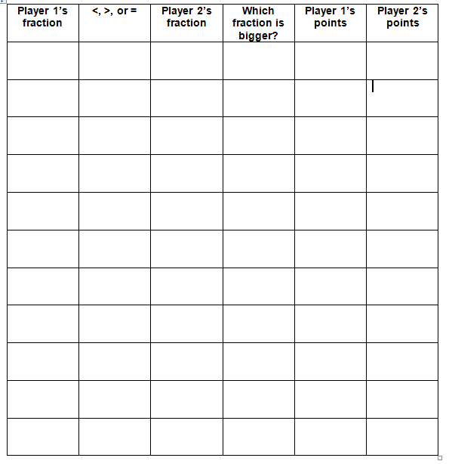
Fraction Cards
Copy on card stock, and cut out on the dotted lines.
$\frac{1}{2}$ | $\frac{3}{4}$ | $\frac{1}{3}$
$\frac{2}{3}$ | $\frac{2}{6}$ | $\frac{3}{8}$
$\frac{4}{8}$ | $\frac{5}{6}$ | $\frac{1}{6}$
$\frac{2}{4}$ | $\frac{1}{8}$ | $\frac{3}{5}$

$\frac{1}{10}$ | $\frac{4}{6}$ | $\frac{3}{6}$
$\frac{3}{10}$ | $\frac{5}{10}$ | $\frac{6}{10}$
$\frac{2}{8}$ | $\frac{7}{8}$ | $\frac{6}{8}$
$\frac{5}{8}$ | $\frac{1}{4}$ | $\frac{2}{10}$

