Place Value – A Co-Teaching Lesson Plan

Co-Teaching Approaches
A “(Y)” in front of the following list items indicates the approach is outlined in the lesson. An “(N)” in front of the following list items indicates the approach is not outlined in the lesson.

- (Y) Parallel Teaching
- (Y) Team Teaching
- (Y) Station Teaching
- (N) One Teach/One Observe
- (N) Alternative Teaching
- (N) One Teach/One Assist

Subject
Grade 3 Mathematics

Strand
Number and Number Sense

Topic
Reading, writing, and identifying the place values of digits in six-digit numbers

SOL
3.1 The student will
- read, write, and identify the place and value of each digit in a six-digit whole number, with and without models

Outcomes
Students will be able to read and write up to six-digit numerals, and identify the place value of each digit.

Materials
- Dry-erase materials (boards, markers, and erasers) or paper/pencil for students
- Chart paper (if you choose to create an anchor chart during the lesson)
- Markers (if you choose to create an anchor chart during the lesson)
- Classroom set of base-10 blocks
- Place-value Mats (attached)
- Dice
- Index cards
- Prepared sets of 24 Numeral Squares (attached) in plastic baggies
- Construction paper in six different colors, cut and stapled into headbands designated for the six place-value positions (enough for each student in the small group to have a headband)
- Exit Ticket (attached)

Vocabulary

digit, hundred thousands, hundreds, ones, place value, tens, ten thousands, thousands

Co-Teacher Actions
Lesson Component | Co-Teaching Approach(es) | General Educator (GE) | Special Educator (SE)
Anticipatory Set | Team Teaching | - Review ones, tens, and hundreds vocabulary by:  - writing and having students read several three-digit numerals on the board.  - To check for understanding, direct students to write the number you state orally on whiteboards/paper and show what they know when you give a signal. Repeat for two to three more numbers.  - Next, ask students to identify the place value of one of the numbers (e.g. 674; what is the value of the 7 in this number? 70) Repeat for other numbers, checking value of ones, tens, and hundreds.  - Now write a four-digit number on the board and ask students to identify this number. (This is will let you know who is already thinking about thousands.) | - Explain that today, students will practice reading and writing larger numbers and naming the place value of each digit.  *Before the lesson, split the class into two heterogenous groups of equal size.  - Direct students to their learning groups.
Lesson Activities/ Procedures | Parallel Teaching | Introduce the thousands place and demonstrate how to write a four-digit number. Use base-10 blocks to show students that just as 10 ones equal one ten, and 10 tens equals one hundred and 10 hundreds equals one thousand. Because we know we can only have one digit in each place, we need another place to show one thousand.  Continue to demonstrate the need for two more place values when we have 10 or more thousands and 10 or more ten thousands. Tell students we call these places: ten-thousands, and hundred-thousands. (Take time here to build understanding of the thousands growing into ten-thousands, and ten-thousands growing into hundred-thousands.)  Model how to read and write a four-digit, a five-digit number, and a six-digit number.  - Read the digits before the comma.  - Say “thousand” at the comma.  - Read the digits after the comma.  Example: 835,297 is read eight hundred thirty-five thousand, two hundred ninety-seven.  - Eight hundred thirty-five  - Thousand  - Two hundred ninety-seven  *Either create an anchor chart with names of place values and standard- and word-form examples of larger numbers, or leave information on the whiteboard or other focal point in the classroom for reference during station work. | Same as GE with other half of class
Guided/  Independent Practice | Station Teaching | Create three groups of students based on needs and social skills. Every student will visit each station. Stations should take 10-15 minutes, not including transition time. Adjust according to student needs.  Gather students in a whole group to explain the directions for the independent station for practice. (Teachers will explain other stations as students travel to them.)  Independent Station  Students will use attached place-value mats and a die. They will roll the die six times, recording the digit rolled each time in a place value of their choice. The goal is to create the largest number possible. After making four numbers, students should write their biggest number on the blank side of an index card. On the lined side, they should write the number in word form.  *Cards can be collected and checked by teachers, and the largest number can be announced (as well as the smallest). Cards can then be used as a station or independent activity to review standard and word forms.  *Cards could be used in later lessons (as an extension, because the standard only goes up to four digits) about ordering numbers from greatest to least, and from least to greatest (Mathematics SOL 3.1[c])  GE-led station:  Explain, guide, and monitor the following small-group activity, using the numeral cards and place value headbands.  - Using base-10 blocks as place-value models, demonstrate how to represent place value through the thousands place. Then, explain to students that they will be exploring place value through the hundred-thousands place, using place-value mats.  - Assemble students into groups of six, and have each group member put on a place-value headband. Give each group a set of 24 numeral squares and a place-value mat, and have each group create four six-digit numerals by randomly selecting numerals and putting them in the correct places on the mat: the ones-place student draws a numeral and places it in the ones place; the tens-place student draws a numeral and places it in the tens place, and so forth. After each six-digit number has been created, have each group member write it down, and practice saying the number to the group. | Vocabulary Focus Station with small groups according to student needs:  Note: Before the lesson, complete Step 1 for each student that will be in this small group.  - Using attached place-value mats, cut places apart to make six separate cards.  - SE makes sure each student can pronounce the place value name on each card.  - Students mix their cards and try to put them back in the correct order.  - When the order is understood, students will partner up within their small group and combine their cards. Mix them all up and turn them over to create a game of “Memory.” Each student takes turns turning over two cards, reading them out loud, and trying to make a match. When all matches are made, they work together to put their pairs in correct place value order.
Closure | Team-Teach | Ask students to reflect upon their learning today. Possible reflections could address what was learned, what was difficult, what was the most enjoyable/helpful, or anything students feel compelled to share about their work today. Volunteers will be asked to share to the whole group. | Take turns with GE calling on and responding to student reflections.
Formative Assessment Strategies | Team Teaching | - Observation and notes within small group work station.  - Write out a four-digit number in written form (e.g. two-thousand eight-hundred sixteen) and have students write the corresponding standard form on a large index card or piece of paper. Call on one student to write the number on the board/chart and have all check the response. Repeat with a five-digit and a six-digit number. Collect the papers.  - Exit Ticket for all students | Observation and notes at teacher table station.  SE may want to provide a place-value chart for students needing assistance in writing the numbers.  Exit Ticket for all students

Specially Designed Instruction
- Oral repetition of vocabulary and modeling for correct usage and pronunciation
- Base-10 blocks to connect quantity with new vocabulary
- Explicit and repeated modeling of base 10 blocks representation with the number written in Standard form and word form

Accommodations
- Vocabulary words posted in room (anchor chart, written on board, on a bulletin board)
- Vocabulary cards (created at SE teacher station)
- Reduced number of station visits student if expected to participate in

Modifications
- For those students requiring a modified curriculum, the content can be modified so that the students are identifying only up to the hundreds place or tens place

Notes
- “Special educator” as noted in this lesson plan might be an EL teacher working with a general educator or other specialist co-teaching with a general educator.

Note: The following pages are intended for classroom use for students as a visual aid to learning.

Virginia Department of Education © 2018

Place-value Mats
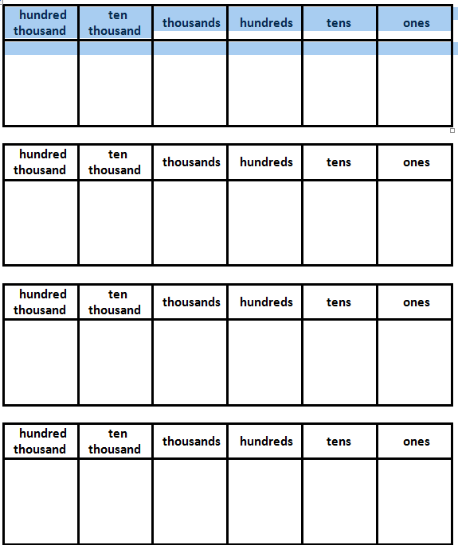

Numeral Squares
Copy on cardstock, and cut apart.
1 | 2 | 3 | 4 | 5 | 6 | 7 | 8 | 9 | 0
1 | 2 | 3 | 4 | 5 | 6 | 7 | 8 | 9 | 0
1 | 2 | 3 | 4 | 5 | 6 | 7 | 8 | 9 | 0
1 | 2 | 3 | 4 | 5 | 6 | 7 | 8 | 9 | 0
1 | 2 | 3 | 4 | 5 | 6 | 7 | 8 | 9 | 0
1 | 2 | 3 | 4 | 5 | 6 | 7 | 8 | 9 | 0
1 | 2 | 3 | 4 | 5 | 6 | 7 | 8 | 9 | 0
1 | 2 | 3 | 4 | 5 | 6 | 7 | 8 | 9 | 0

Exit Ticket
Name: _____________________________
- Write the following digits in the correct places on the place value chart.
1 in the hundreds place
3 in the thousands place
6 in the ten-thousands place
0 in the ones place
7 in the hundred-thousands place
8 in the tens place

,

- How do you say the number you made above in words?
________________________________________________________________________
________________________________________________________________________
________________________________________________________________________

