Fair Shares – A Co-Teaching Lesson Plan

Co-Teaching Approaches
A “(Y)” in front of the following list items indicates the approach is outlined in the lesson. An “(N)” in front of the following list items indicates the approach is not outlined in the lesson.

- (N) Parallel Teaching
- (Y) Team Teaching
- (Y) Station Teaching
- (N) One Teach/One Observe
- (Y) Alternative Teaching
- (Y) One Teach/One Assist

Subject
Grade 2 Mathematics

Strand
Number and Number Sense

Topic
Name and write fractions represented by a set.
SOL
2.4 The student will
- name and write fractions represented by a set, region, or length model for halves, fourths, eighths, thirds, and sixths.

Outcomes
The student will solve practical problems involving a set to include halves, fourths, eighths, thirds, and sixths.

Materials
- Frame Routine for Fractions (attached)
- Paper plates
- Plastic counters (round, if possible)
- Fraction Story Problems (attached)
- Fully Scrambled SIM Sort (attached)
- Partially Scrambled SIM Sort (attached)
- Unscrambled SIM Sort (attached)
- Chart paper
- Markers
- Dry-erase materials (boards, markers, and erasers)
- Chocolate bar (attached)

Vocabulary

denominator, numerator, subsets, unit fractional parts, whole

Co-Teacher Actions
Lesson Component | Co-Teaching Approach(es) | General Educator (GE) | Special Educator (SE)
Anticipatory Set | Team Teaching | Explain that you brought one chocolate bar to school to share with the co-teacher. Lead a discussion into how to do that with both parties getting an equal part. (If students don’t say it, point out that this chocolate bar can be divided into 12 individual rectangles which can be shared). Discuss what would change if, before the bar was broken up, another teacher came to the class. Would they still be able to share the bar? Discuss how the bar would have to be broken. Continue to discuss the options considering fourths, sixths, and eighths.  Co-construct a frame routine for fractions (attached). | Model with the original chocolate bar. Randomly select students (e.g., use Popsicle sticks with each student’s name written on a stick) to choose students to answer questions.  Assist students in constructing their frame routine for Fractions.
Lesson Activities/ Procedures | Team Teaching | - Place students into five small groups and give each group 12 circular-shaped counters and  six small paper plates.  - After the problem has been presented and predictions made, discuss what happened to the set. Draw a pictorial representation or display a representation for the first division. | - Explain that you will be reading a story problem (attached). As you read, students will use the counters and the plates to predict how the characters will solve the problem. Read aloud the first story problem. Allow students to make predictions and then use their manipulatives to see whether their predictions were correct.
Guided/Independent Practice | Station Teaching  Team Teaching | Give each group one of the remaining story problems to solve. Direct students in each group to discuss the problem, use the manipulatives to solve it, and then represent their solution on a piece of chart paper.  When groups have finished, conduct a carousel walk (each group rotates to read the problem-and-solution posters of the other groups). Then have each group read their story problem aloud to the class and share their solution.  Display each group’s chart.  Ask the students, “What do you notice happening to the fair shares as the denominator of the fraction gets larger?” Show students that when the set of 12 items was divided into halves, each share was one half of the 12 items, or a total of six items. When the set of 12 items was divided into sixths, each share was one sixth of the 12 items, or a total of two items. Have students look for the pattern, using the think-pair-share strategy. Students think about the patterns they see, talk about it with a partner, and then share with the whole class what they have discovered: the larger the denominator, the smaller the fair share. | After all groups have shared their story problems and solutions, discuss and compare what happened to the set of items being divided in each problem. Discuss the fair shares (equal-size portions) described in each problem. Explain that fractions are fair shares of a whole or a set.
Closure | Alternative Teaching | SIM Fraction Cut and Paste  Distribute the fully scrambled version of the SIM Fraction Frame. Direct students to cut apart the different boxes and rearrange them in the appropriate way. Direct students to paste the fraction names across the top row of their new chart and then to find the matching components and glue them in the proper places.  Students should complete this activity independently. | SIM Fraction Cut and Paste  Those students who need more assistance will work collaboratively to identify those parts of the different fractions and paste the items in order. The teacher will use concrete modeling to help these students complete the SIM worksheet correctly. Teacher may use either the full or partially scrambled SIM fraction sets.
Formative Assessment Strategies | Team Teaching. | - Using the SIM Cut and Paste, ask the students to compare the fractions shown on their worksheet. Ask: What do they have in common? How are they different?  - Exit Ticket  - How many pencils should Mary and Pat each have if they share a 10-pack of pencils? (5) What fraction would represent how many pencils Pat received? (½)  - I have 15 new books to share with two friends. What fraction of the books would we each receive? (⅓) How many books will each of us receive? (5) | Same as GE.
Homework | Team Teaching | Have the students complete a “fraction hunt” at home that suggest or represent fractions. Students can bring in pictures or drawings of the finds. | Same as GE.

Specially Designed Instruction
- The Framing Routine is used to teach/review procedures for the identification of fractions (halves, thirds, fourths, sixths and eighths). The teacher will provide students with an empty frame, a pre-typed cut-and-paste sort option. This will then be co-constructed as a class, with students completing the task with teacher support and concrete materials, or with teacher modeling. In this lesson, the frame is developed with all students, and additional instruction is given to select students to ensure they understand how to use it as a resource to aid their memory. This will include working with fraction circles, fraction bars, and two-colored counters. The SE will provide direct instruction during this activity to ensure understanding by all students. Small-group instruction with the pre-typed pieces will allow for more time to be used focusing on the concepts rather than the writing. It may also be an option to have a semi-completed, with all but the visuals already put into place. By sharing it with all students, peers will be able to use it to help partners.
- Accompany instruction with manipulatives, illustrations, and thinking aloud to help students understand difficult concepts and procedures.

Accommodations
- Use of concrete visuals: circle fractions, fraction bars, and fractional sets.
- Have the students act out the story problem they have been assigned.
- Provide a read-aloud option to those students who are not reading on grade level.
- Create a set of cards showing the solutions to the fraction story problems and allow students to match solutions to the problems.
- Chunking of cut-and-paste items: SE will use semi-completed SIM form with only the visual representations not in place. The teacher will then only put out the shape fractions and then collaboratively work with the students to put them in order. The process will then be repeated for the sets and the fraction lines.
- Modify the fraction story problems to include picture cues for struggling readers.

Modifications
- For students who need a modified curriculum, teacher may simplify instructions.
- Teachers may modify the curriculum to understanding only halves and fourths.
- Teacher may modify the way students demonstrate understanding, such as by using manipulatives rather than completing the worksheet.

Notes
- “Special educator” as noted in this lesson plan might be an EL teacher, speech pathologist, or other specialist co-teaching with a general educator.
- The co-teachers who developed this lesson plan received required professional development in the use of specialized instructional techniques which combine an explicit instructional routine with the co-construction of a visual device (graphic organizer). The Framing Routine used in conjunction with the “Frame” helps to develop understanding of information and procedures by associating their main ideas and details. These Content Enhancement Routines were developed at the Center for Research on Learning at the University of Kansas. Link: http://www.kucrl.org/sim/brochures/CEoverview.pdf
- Other graphic organizers and sorts should be used by teachers who have not received professional development in the Framing Routine. If Virginia teachers would like to learn Content Enhancement Routines, contact your regional TTAC.

Note: The following pages are intended for classroom use for students as a visual aid to learning.

Virginia Department of Education © 2018

Chocolate Bar
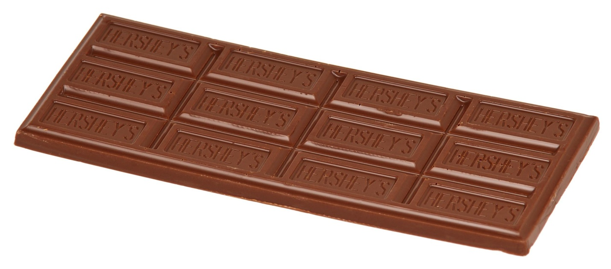
Print on card stock and cut out.

Fraction Story Problems
Story Problem 1  Chase has 12 cookies. If he and his best friend Jake share the cookies equally, what fraction of the cookies does each boy get? How many cookies will be in each fractional share? | Story Problem 2  Tonya has 12 cookies. She eats some at breakfast, some at lunch and the rest at dinner. If she eats an equal number of cookies each time, what fraction of the cookies does she eat at each meal? How many cookies are in each fractional share?
Story Problem 3  Jose has 12 cookies. If his family (Jose, his mom, his dad, and his sister) share them equally, what fraction of the cookies does each person get? How many cookies are in each fractional share? | Story Problem 4  Sadie bought a box of 12 cookies for her party. If 5 of her friends attend the party and want to share the cookies equally with Sadie, what fraction of the cookies does each child get? How many cookies are in each fractional share?
Story Problem 5  Danny has 12 cookies on his plate. As he is walking to the table he drops the plate and his dog eats all 12 cookies! What fraction of the cookies did his dog eat? How many cookies are in each fractional share? | Story Problem 6  Claire has 12 cookies in her bag. She and her friend are going to share the cookies equally with Claire’s mom. What fraction of the cookies will each person get? How many cookies are in each fractional share?
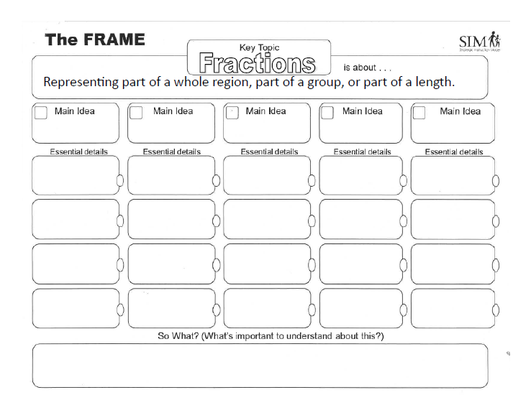
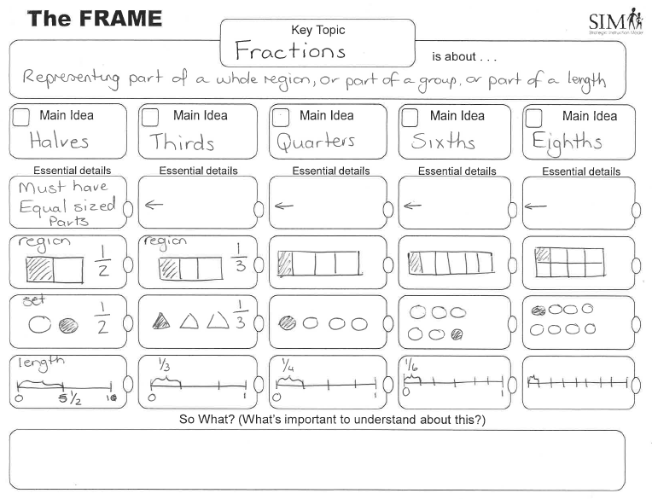
Fully Scrambled SIM Sort
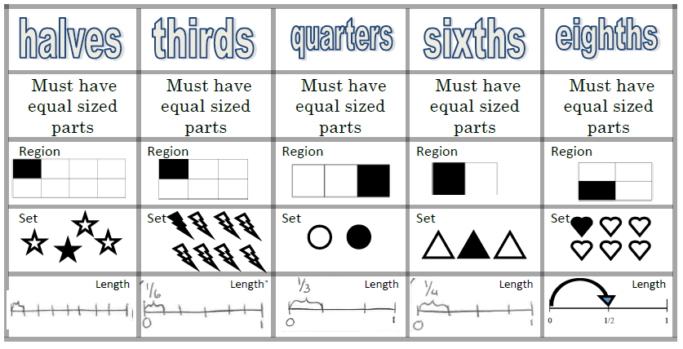
Partially Scrambled SIM Sort
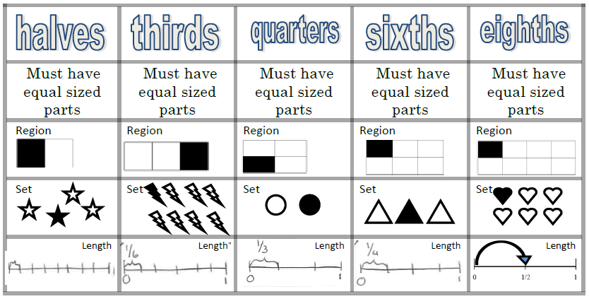

Unscrambled SIM sort
