Even or Odd – A Co-Teaching Lesson Plan

Co-Teaching Approaches
A “(Y)” in front of the following list items indicates the approach is outlined in the lesson. An “(N)” in front of the following list items indicates the approach is not outlined in the lesson.

- (Y) Parallel Teaching
- (Y) Team Teaching
- (N) Station Teaching
- (Y) One Teach/One Observe
- (N) Alternative Teaching
- (N) One Teach/One Assist

Subject
Grade 2 Mathematics

Strand

Number and Number Sense

Topic

Determining even and odd numbers using objects

SOL
2.2 The student will
- use objects to determine whether a number is even or odd.

Outcomes
The student will explore even and odd numbers by pairing sets of objects into groups of two.

Materials
- Hand pointer
- Odd and Even Poem (attached)
- Odd and Even Poster (attached)
- “Learning Odd and Even Numbers for Kids – 1st and 2nd Grade” (video): Youtube odd and even video
- Counters
- Large container (e.g., box, bag)
- Hundreds chart (displayed using a demonstration tool or on a large chart)
- Hundreds Chart (individual for each student; laminated or in plastic sleeves) (attached)
- Dry-erase materials (boards, markers [blue and red], and erasers)
- Colored pencils or crayons (blue and red)
- Classroom Observation Form (attached)
- Even/Odd Homework activity sheet (attached)

Vocabulary
column, even, equal, odd, pair, pattern, rows, skip count

Co-Teacher Actions
Lesson Component | Co-Teaching Approach(es) | General Educator (GE) | Special Educator (SE)
Anticipatory Set  *Peer Discussion | Team Teaching | - Before students arrive have the following “I Can” statement written on the board: “I Can… recognize even and odd numbers.  - Have students read the “I Can” statement aloud together.  - Have students turn to their math buddy (shoulder partner) for a peer discussion on what they think they will be doing for the math lesson today based on the “I Can” statement (remind students to utilize their “math words” during discussion). Walk around to monitor student discussions.  - Show “Even and Odd” Video on the interactive board for students to watch.  - Have students share with the class their discussions about the video. | - Use the hand pointer to track words on the board while students are reading the “I Can” statement.  - Walk around to monitor student discussions  - After one minute of discussion, the teacher will call on students to share what they discussed with their math buddy. The teacher leads quick discussion on expectations of today’s lesson.  - Post “Odd and Even Poem” on the interactive board for students to recite together with teacher. The teacher uses hand pointer to track words of poem while reciting.  - After students watch the video, have students turn to their math buddy (shoulder partner) for a peer discussion on what they watched on the video.
Lesson Activities/ Procedures | One Teach/One Observe  One Teach/One Assist | - The GE will observe, collect data, and assist students as the other teacher leads the whole group.  - The GE will be taking observational notes to gather data about:  - student participation  - student interactions  - data for IEP meetings  - data for teacher planning meetings  - data for creating math groups.  - As students are working, the GE will observe the strategies and rationale they use.  - The GE may ask questions to determine students’ comprehension of the concepts presented and assist as necessary. | - Distribute to each student a Hundreds Chart, a blue dry-erase marker and a red dry-erase marker.  - The SE will have the students grab a handful of counters from a large container and create as many pairs as they can with them.  - After students have finished creating their pairs, have them count the total number of counters they paired by skip counting by twos.  - Direct any student who has a leftover counter to stand up.  - Display the Hundreds Chart using a demonstration tool (e.g., document camera, digital display) or on chart paper.  - Have the students with leftover counters to announce their total numbers of counters.  - Have those students record their number on their hundreds charts with the blue marker by shading it in.  - The SE will be recording these numbers on the interactive Hundreds Chart using the blue marker.  - The SE will explain to the students that because each of these numbers had one counter left over when making pairs, each one is an “odd number.”  - Have all the students mark the odd numbers that are marked on the interactive Hundreds Chart on their Hundreds Chart with the blue marker.  - Read together the numbers that have been marked on the Hundreds Chart. Discuss any observations students make about the numbers marked in blue.  - Next, direct each student who had no counters left to stand up.  - Have these students announce their total number of counters, record these numbers on their Hundreds Chart, and the teacher will record these numbers on the interactive Hundreds Chart using the red marker.  - Teacher will explain to the students that because each of these numbers had no counters left over when making pairs, each of these numbers is an “even number.”  - Read together the numbers that have been marked on the Hundreds Chart. Discuss any observations students make about the numbers marked in red.
 | Parallel Teaching | - The GE will be working with a group of students on recognizing even and odd numbers.  - With the group, make sure each student has a partner.  - Give each partner set enough counters so that each student has 20 counters, a paper copy of the hundreds chart, a blue crayon and a red crayon.  - Tell the partners that they will be using their counters to determine what numbers up to 20 are odd or even.  - Direct them to take one counter and decide whether it has a partner (no). Does this make the number 1 an odd or an even number (odd)? Continue adding one counter at a time, repeating the pairing and questioning. It is important that students build their understanding of the concept of odd/even before relying on the numerical representation of the chart.  - Instruct the partners to color the odd numbers on their hundreds charts blue and the even numbers on their hundreds charts red as they pair up the different sets of counters.  - Discuss with the students any patterns they see on their charts (students should be able to see that every other number is either blue (odd) or red (even).  - Help students to predict other numbers as being odd or even (numbers greater than 40). Have students check out the predictions with more counters.  - The GE should monitor partners as they work, and check to see that they are using their counters correctly. Aid, as needed.  - Teacher may note who is having difficulty, and give help as needed. | Same as GE.  The SE should monitor partners as they work and check to see that they are using their counters correctly. Assist, as needed.
Closure | Team Teaching | - Revisit the “I Can …” statement and ask, “How would you explain to someone new about how to know whether a number is odd or even?”  - Students will turn to their mathematics buddy (shoulder partner) and share one thing they learned in the class today during this lesson.  - Teacher will have students answer the following questions: “What was the most important thing you learned? | - Help the GE facilitate the closing discussion.  - The SE can take notes on student questions.
Formative Assessment Strategies | Team Teaching | Exit Ticket  - “What characteristic do all even numbers have in common? What characteristic do all odd numbers have in common? How can skip counting be used to help determine whether a number is even or odd?  - Have students fold a blank sheet of paper into fourths. Have them pick two even numbers and two odd numbers, greater than 10, to illustrate showing the numbers to be odd or even.  - Quiz to assess students’ mastery of being able to recognize even and odd numbers. | Re-word the question to make it appropriate for student to access the task.  * When appropriate, the teachers will pull aside a small group of students for read-aloud accommodations.
Homework | Team Teaching | - The students will be given a worksheet where the students need to recognize even and odd numbers. | Same as GE.

Specially Designed Instruction (Teacher will)
- Provide explicit instruction for each step of the task.
- Provide most-to-least prompts.
- Provide small-group instruction.
- Provide written prompts/cues.
- Allow opportunities for repetitive practice.

Accommodations
- FM headset transmitters (the students hear the speaker’s words directly in their ears, without any distracting background noise, allowing them to enjoy and participate fully in class).
- Peer buddy (Students are discreetly grouped by ability, and this provides a chance for students with and without disabilities to work together.).
- Preferential seating (Students’ seats are placed in a location that is most beneficial for his/her learning in the classroom.).
- Peer buddy/peer tutoring.
- Reduce the number of problems for those students with slow processing speed or short attention to task.
- Simplifying directions (when directions are given for students to have clarification).
- Extended time to complete assessments (for students who require extra time to complete assignments).
- Breaking assignments into smaller steps (for students who become overwhelmed when presented with too many items at once).

Modifications
- For those students requiring a modified curriculum, content can be modified to include only numbers to the tens places, or can be modified so that the objective is for the student to be able to identify pairs.

Notes
- “Special educator” as noted in this lesson plan might be an EL teacher, speech pathologist, or other specialist co-teaching with a general educator.

Note: The following pages are intended for classroom use for students as a visual aid to learning.

Virginia Department of Education © 2018
Classroom Observation Form
TIME/DATE: ____________________________ OBSERVER:_____________________________

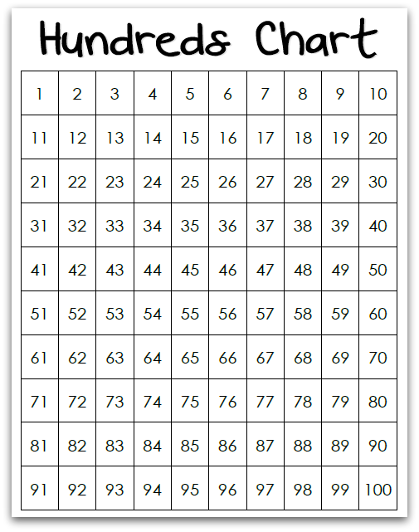

Odd and Even Poem

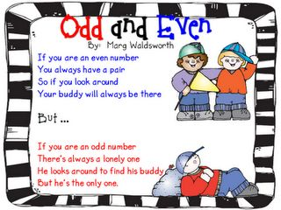
Odd and Even Poster
