Symmetrical Snow Fun – A Co-Teaching Lesson Plan

Co-Teaching Approaches
A “(Y)” in front of the following list items indicates the approach is outlined in the lesson. An “(N)” in front of the following list items indicates the approach is not outlined in the lesson.

- (N) Parallel Teaching
- (Y) Team Teaching
- (N) Station Teaching
- (Y) One Teach/One Observe
- (Y) Alternative Teaching
- (N) One Teach/One Assist

Subject
Grade 2 Mathematics

Strand
Measurement and Geometry

Topic
Drawing a line of symmetry

SOL
2.12 The student will
- Draw a line of symmetry in a figure; and
- Identify and create figures with at least one line of symmetry.

Outcomes
The students will be able to use every day practical items to identify the line of symmetry and draw the line of symmetry on an image provided.

Materials
- Story about snow: Under the Snow, by Melissa Stewart (ISBN 978-1-56145-493-8) (accessible for free at Under the Snow)
- Demonstration tool (e.g., document camera, digital display)
- Circular Sled (attached)
- Yard stick or other straight stick
- Snowy Symmetry activity sheet (attached)
- Snow-themed cut-out shapes for differentiation (attached)
- Markers
- Plastic straws
- Scissors
- Snowy Symmetrical Sort activity sheet (attached)
Vocabulary

equal, fourths, half, line of symmetry, symmetrical, whole

Co-Teacher Actions

Lesson Component | Co-Teaching Approach(es) | General Educator (GE) | Special Educator (SE)
Anticipatory Set | Team Teaching | The GE will introduce the lesson by explaining that one of his/her favorite seasons is winter, because of snow. | The SE teacher will then talk about his/her favorite thing to do in the snow and lead a think-pair-share on what activities the students enjoy doing in the snow.
Lesson Activities/ Procedures | One Teach/  One Assist  Team Teaching | The GE will read the interactive board version of the book Under the Snow.  The GE teacher will display the previously co-created LINC vocabulary tables to ensure that students understand what the words “symmetry” and “equal” mean (see notes on Specially Designed Instruction, below).  The GE will display an image of a circular sled at (circular sled) and pose the following scenario: “You want to go down the hill on this sled with your friend. Each of you must have exactly the same space on the sled. How could you share the space on this sled equally? You need to show the two spaces, using one straight line.”  Discuss which lines are correct and why not all correct lines are drawn the same way.  Explain that the lines they just drew are called lines of symmetry and that a figure is symmetrical when one-half of it is the mirror image of the other half. | The SE teacher will monitor students for focus and attention.  The SE teacher will ask students to come to the board and demonstrate their straight lines. As students share their thinking, use guiding questions like those below to engage them in mathematical conversation.  - Is this line straight?  - Do you see anything on this side of the sled that is not on the other side of the sled?  - Does this line give you and your friend the same amount of space on the sled?  - Is there another way to share this sled?  - Can we turn the line like this (diagonal, vertical, or horizontal)?  - Can there be more than one way to share this sled equally?
Guided/Independent Practice | Alternative Teaching | Distribute the Snowy Symmetry activity sheet and straws. Direct each student to manipulate the straw to find a line of symmetry on each image and to draw the line of symmetry, if the image has one.  After students have found the lines of symmetry in the images, have them cut apart and sort the images into two groups: symmetrical and nonsymmetrical. Have them use copies of the Snowy Symmetrical Sort activity sheet to sort the images.  Review and summarize with the class what students did and learned in the activity. Ask the class to summarize their ideas by answering the question, “How do you know when a shape is symmetrical?” | The SE will provide differentiation by using precut shapes rather than images. Some of the shapes will have a premade line of symmetry drawn in and some will have a nonsymmetrical line drawn in. The students will fold the shapes using the line and see what it looks like if the shape is symmetrical or nonsymmetrical. The students will use that knowledge to fold those other shapes that do not have the predrawn lines added.  The teacher will work with students to identify which shapes are symmetrical. The strategy will be to fold the item in half and see if they can match the two halves. If the fold provides two equal matches, then there is a line of symmetry and they can trace the fold with a marker. Once all shapes have been identified as symmetrical or nonsymmetrical, they will be pasted to the sort chart.
Closure | One Teach/One Observe | Ask the class the following questions:  - Can a line of symmetry be curvy?  - Can something have more than one line of symmetry?  - If a cake has one line of symmetry, how many people can share it equally? What if it has two lines of symmetry?  Exit Ticket  Each student will be provided an index card and asked to identify all lines of symmetry of the card. | The SE will observe for understanding, and provide help, if needed.
Formative Assessment Strategies | Alternative Teaching | Snow Symmetrical Sort activity sheet and exit ticket. | Differentiated snow cut-out.  Sort and exit ticket.
Homework | Team Teaching | Identify five symmetrical shapes. Illustrate and draw a line of symmetry for each shape. | Same as GE.

Specially Designed Instruction
- The Vocabulary LINCing Routine could help students process and develop understanding of vocabulary words (see Notes). A teacher draft of LINCS Tables is attached, which could be co-constructed with students as a specialized instruction.
- Accompany instruction with manipulatives, illustrations, and thinking aloud to help students understand difficult concepts and procedures. (see above)
- SE will provide die-cut shapes (some symmetrical and some nonsymmetrical) and teach the strategy of folding the items as close to equal as possible and seeing whether the folded pieces are the same, thereby helping the students identify whether the shape has a line of symmetry (equal pieces show there is a line of symmetry; non-equal pieces show there is not a line of symmetry).

Accommodations
- Use of concrete visuals.
- Emphasize the “s” sound in symmetry and same to help students connect with the vocabulary.
- Reduce the number of pictures a student is asked to sort.
- Do the Snowy Sort with a small group while other groups experiment with mirrors to show lines of symmetry. (Use with advanced students who finish the planned activity first.)

Modifications
- For those students requiring a modified curriculum, content could be changed so that students are working with the terms equal and the same. Students could sort pictures according to those characteristics rather than symmetry.

Notes
- “Special educator” as noted in this lesson plan might be an EL teacher, speech pathologist, or other specialist co-teaching with a general educator.
- The co-teachers who developed this lesson plan received required professional development in the use of specialized instructional techniques which combine an explicit instructional routine with the co-construction of a visual device (graphic organizer). The Vocabulary LINCing Routine and its “LINCS Tables” help students learn and remember terms and vocabulary through auditory and visual memory devices. These Content Enhancement Routines were developed at Center for Research on Learning at the University of Kansas.
- Other graphic organizers should be used by teachers who have not received professional development in these routines. If Virginia teachers would like to learn content enhancement routines, contact your regional TTAC.

Note: The following pages are intended for classroom use for students as a visual aid to learning.

Virginia Department of Education © 2018
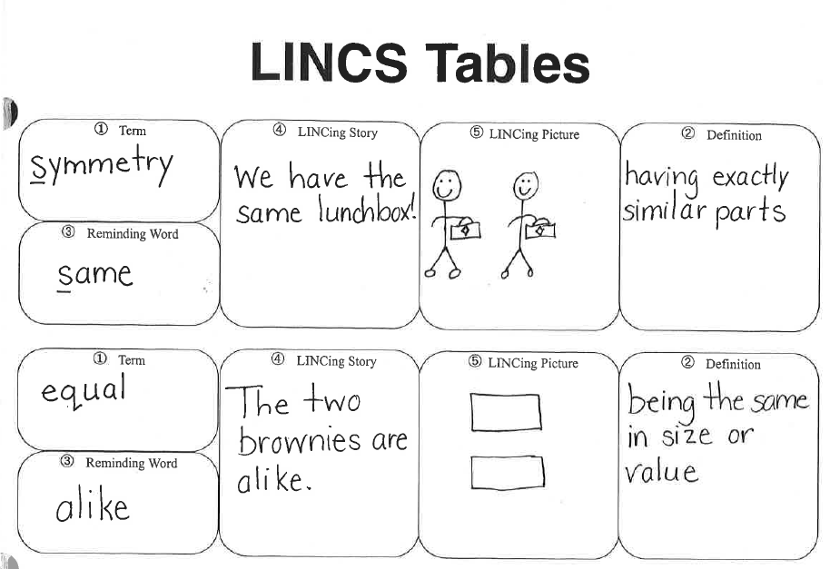

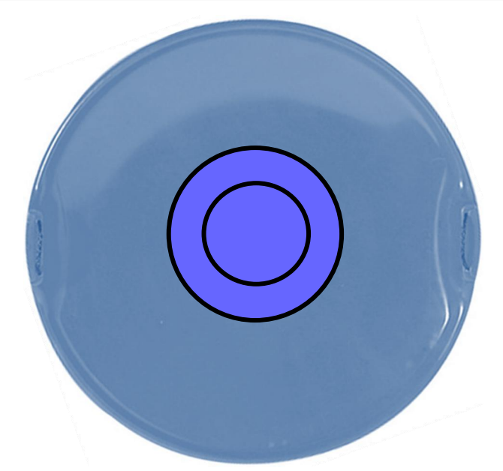
Circular Sled
Snowy Symmetrical Sort
Name:________________________

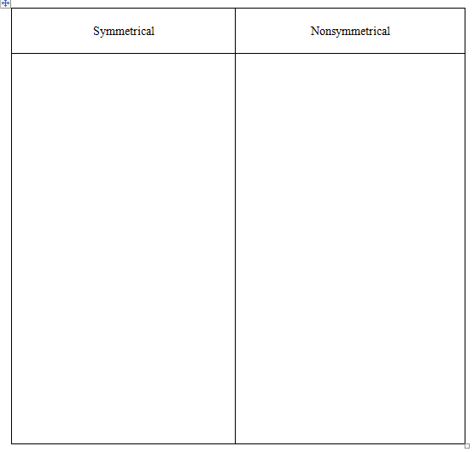
How do you know whether a shape is symmetrical or not?
______________________________________________________________________________
______________________________________________________________________________
______________________________________________________________________________
Snowy Symmetry
Name:___________________________
Does each picture have a line of symmetry? If it does, draw it.

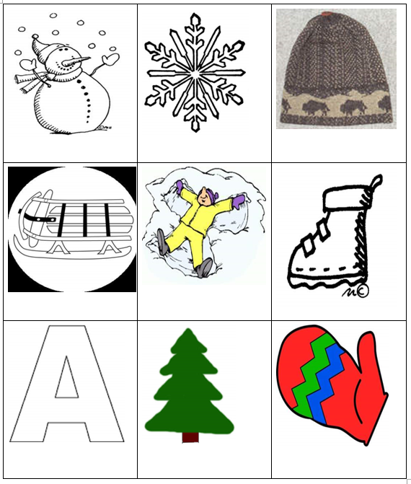
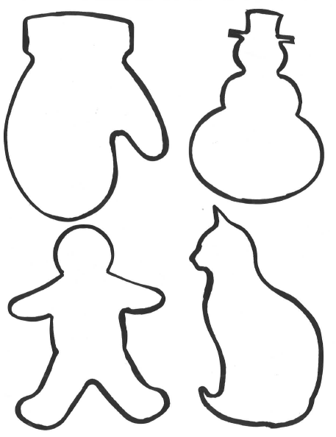
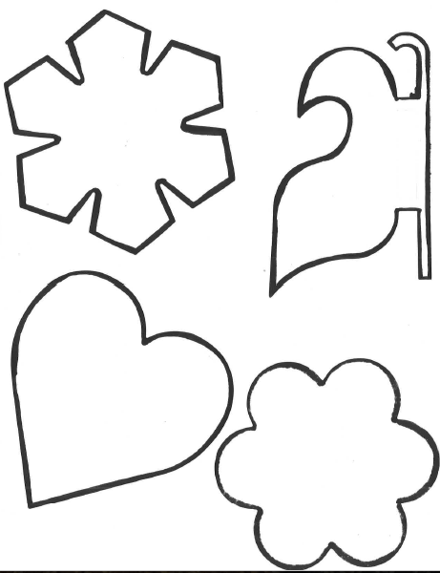

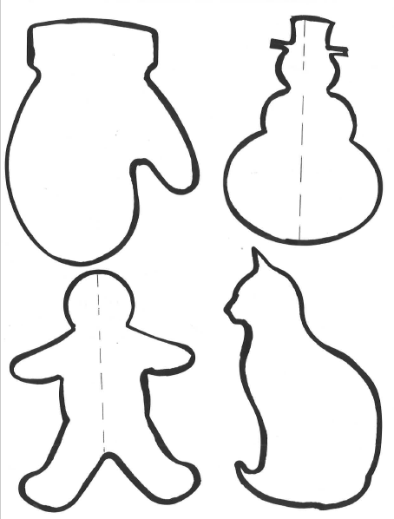p
