Sorting and Classifying by Attributes- A Co-Teaching Lesson Plan

Co-Teaching Approaches
A “(Y)” in front of the following list items indicates the approach is outlined in the lesson. An “(N)” in front of the following list items indicates the approach is not outlined in the lesson.

- (N) Parallel Teaching
- (Y) Team Teaching
- (N) Station Teaching
- (N) One Teach/One Observe
- (Y) Alternative Teaching
- (Y) One Teach/One Assist

Subject
Grade 1 Mathematics

Strand
Patterns, Functions and Algebra

Topic
Classifying

SOL
1.13 The student will sort and classify concrete objects according to one or two attributes (size, shape, color, or thickness), label attributes of a set, and name multiple ways to sort a given set.

Outcomes
The student will use practical and real objects to sort and classify concrete objects according to one or two attributes, including color, size, shape, and thickness.

Materials
- Attribute blocks
- Train Body (attached)
- Anchor charts (attached)

Vocabulary
attributes, classify, color, different, label, same, shape, size, sort, thickness

Co-Teacher Actions
Lesson Component | Co-Teaching Approach(es) | General Educator (GE) | Special Educator (SE)
Anticipatory Set | Team Teaching | Demonstrate for students how, in our everyday world, we can connect with others by our similarities. Ask the students what the two teachers have in common (i.e., hair color, clothing, shoes, etc.) | Model attribute comparison with the GE.
Lesson Activities/ Procedures | Team Teaching | Tell the students that the class is going to be playing a mystery game, called “Guess my Sort!” where students will be asked to identify what they have in common.  This game will be played several times to show student inclusion and diversity. | Remind students to use the anchor charts.  The teachers will alternate choosing students who have similar attributes and then ask the class to “sort” the students and identify what the common attribute is.
Guided/  Independent Practice | Parallel  Teaching | - Distribute randomly one attribute block to each student. Inform students that they will play a game to make a train out of the blocks. The train will be displayed along the tray below the board so everyone can see.  - Start the game by choosing and displaying one attribute block to be the train’s engine. Have students describe the block’s four attributes of size, color, thickness, and shape (e.g. “large, red, thick triangle”). If a student thinks he or she has a block that shares two attributes with the first block, he or she may come up and place it as the first car on the train. He or she must also identify its two shared attributes as well as its other two attributes. If necessary, provide a sentence frame, such as, “My block has the same _________ and _________ as the previous block. Its other two attributes are _________ and _________.”  - The next student who has a block that shares two attributes with the second block may then come forward, add the block to the train, and identify its two shared attributes as well as its other two attributes.  - Play continues until as many blocks as possible have been added to the train. | Same as GE, however, the SE may choose to differentiate this activity by giving one of the attributes needed and asking the students to find a shape that has another common attribute For example: That shape is a red, large, thick, circle. Look at your red shapes, does anyone have a shape that shares one of the other attributes? Or another option is to only sort by one shared attribute at a time.
Closure | One Teach, One Assist | Exit Ticket  Provide each student with a random attribute block and tell them to think about what attributes they could use to classify their block. Students will draw or trace their block and then choose the attributes that they can use to classify the block. | As the students submit their exit tickets, and the SE will check to make sure that the information given matches the shape they have traced.
Formative Assessment Strategies | Alternative Teaching | Exit Ticket  Questions to ask during instruction:  “Look at the third (or any number) block in the train. Is there another block that could be the next block besides the one that is already there? If so, why?”  “Look at the fourth (or any number) block in the train. What block or blocks could not be the next block? Why?” | Exit Ticket  Questions to ask during instruction:  Pick up one of the pieces of the train. Ask the students to identify the four attributes. Ask them what made that shape the right choice to fit the shape it is connected to (identify similar attributes). Repeat these questions with other pieces.
Homework | Team Teaching | Students will be given an attribute scavenger hunt to complete at home. Each student will find and record things they find at home that have their 2 given attributes. Examples: blue and round, thin and square, thick and red, etc. Each student will be given 2 different attribute combinations. They will share their lists with the class the following day.

Specially Designed Instruction
- Accompany instruction with manipulatives, illustrations, and thinking aloud to help students understand difficult concepts and procedures (see above notes).
- Anchor charts: These will be reviewed before the lesson activity because they describe what attributes we sort by.
- SE will be completing the train activity with more-intensive modelling and a greater level of assistance when choosing the shape that meets the two attribute criteria.

Accommodations
- Concrete manipulatives
- Adjusted formative assessment questions
- If students have difficulty focusing on four attributes, begin by working with only two (e.g., size and color).
- Put thin and thick attribute blocks in a long sock. Have students select blocks that fit the targeted attribute (e.g., thin blocks), using their sense of touch.
- Provide students with a visual reference for the attributes thick and thin.

Modifications
- For those students who need a modified curriculum, the teacher could modify this activity by either giving one of the attributes needed and asking the students to find a shape that has another common attribute. For example: That shape is a red, large, thick, circle. Look at your red shapes, does anyone have a shape that shares one of the other attributes? Another option for modification is to only sort by one shared attribute at a time.

Notes
- “Special educator” as noted in this lesson plan might be an EL teacher, speech pathologist, or other specialist co-teaching with a general educator.

Note: The following pages are intended for classroom use for students as a visual aid to learning.

Virginia Department of Education © 2019
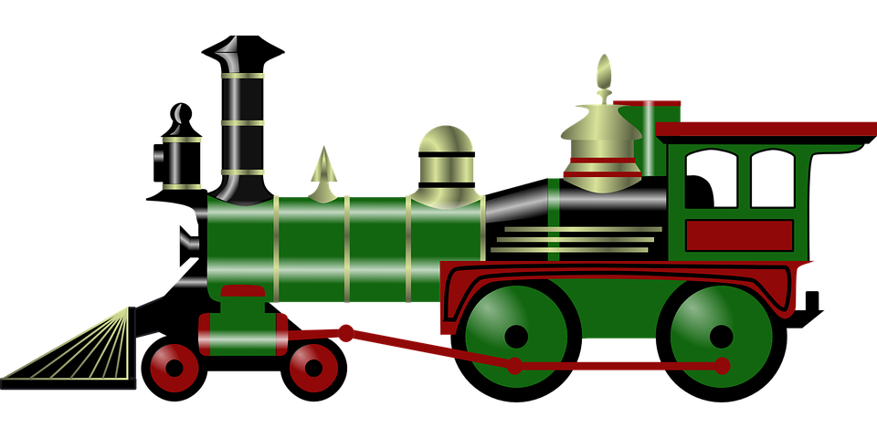
Train Body
My Shape:
COLOR _______________ SHAPE: __________________________

SIZE _________________ THICK/THIN: _____________________

My Shape:
COLOR _______________ SHAPE: __________________________

SIZE _________________ THICK/THIN: _____________________

My Shape:
COLOR _______________ SHAPE: __________________________

SIZE _________________ THICK/THIN: _____________________

My Shape:
COLOR _______________ SHAPE: __________________________

SIZE _________________ THICK/THIN: _____________________

COLOR _______________ SHAPE: __________________________

SIZE _________________ THICK/THIN: _____________________

