Mathematics Instructional Plan – Grade 8

Sort and Verify Multistep Equations
Strand: Patterns, Functions, and Algebra
Topic: Solve multistep linear equations in one variable.
Primary SOL: 8.17 The student will solve multistep linear equations in one variable with the variable on one and both sides of the equation, including practical problems that require the solution of a multistep linear equation in one variable.
Related SOL: 8.14b

Materials
- Multistep Equations Sort activity sheet (attached)
- Multistep Equations Sort and Verify activity sheet (attached)
- Multistep Equations Sort and Verify Assessment Questions activity sheet (attached)
- Practical Problems activity sheet (attached)
- Scissors
- Glue

Vocabulary
coefficient, distributive property, equation, like terms, variable, verify, substitution property

Student/Teacher Actions: What should students be doing? What should teachers be doing?
- Discuss and review with the class the steps for solving multistep equations. Write the steps on the board as students respond.
- Work through the steps as a class with $-2\left(-3x-8\right)=8x+2$ and $-4x+4-4x=2x-10$.
- Discuss what it means to verify your solutions.
- Model verifying both solutions found based on the equations above.
- Have students to work in pairs to complete the Multistep Equations Sort and Verify activity sheet.
- Distribute the Multistep Equations Sort, scissors, and glue.
- Have students complete the Multistep Equations Sort and Verify Assessment Questions activity sheet.

Assessment

Questions
  - What properties of the real-numbers system are you applying while solving and verifying multistep equations?
  - What does it mean to verify your solution?

Journal/writing prompts (include a minimum of two)
- Create a four-step equation for your partner to solve and verify. Then explain why the equation you have created requires four steps to solve for your variable. Be sure to include properties in your explanation.
- Create your own real-world, practical problem that would involve solving an equation with one variable that requires multiple steps.

Other Assessments
  - After the activity has concluded, bring the class back together. Post an equation from the Multistep Equations Sort and Verify activity on the board. Have students work them out on dry-erase boards or on an electronic device. Have students raise their boards and share their solutions. Then have students verify their solutions. Have students then raise their boards and share their verifications. Repeat this with a few of the other equations found in the activity.
  - Provide students with several equations (one at a time) and have them show the number of steps that would be required to solve each equation on the hands.

Extensions and Connections (for all students)
- Challenge students to solve and verify a set of equations involving more than four steps.
- Provide students with some equations that have been solved incorrectly. Have students prove that the solution does not work for the equations and identify the mistakes made. Then have students solve the equation correctly and verify their solutions.

Strategies for Differentiation
- Create a new set of equations that vary in their level of difficulty. Use the new set to create leveled groups and pairs where students will be required to complete the same activity but with equations that vary in difficulty.
- Provide students with an index card that displays the steps for solving multistep equations to use while working through this activity.

Note: The following pages are intended for classroom use for students as a visual aid to learning.

Virginia Department of Education © 2018

Multistep Equations Sort
Directions:
- Cut and paste the equations below into each box labeled Equation on the Multistep Equations Sort and Verify activity sheet. The first equation has been modeled for you.
$$-4\left(2x-8\right)=48$$ | $$4\left(2x-8\right)=48$$
$$6\left(2x-3\right)=20+2x$$ | $$3x+8-2x=10+4x$$
$$-3x+8-2x=10-4x$$ | $$-6\left(2x-3\right)=20-2x$$

- Cut out the steps for solving the equations found below. Glue these steps for solving in the correct order needed to solve each equation on the activity sheet. The first equation has been completed for you. The corresponding steps for solving have a strikethrough indicating that it has been used and should be discarded.
$$8=10+3x$$ | $-2x$ $-2x$
$8$ $8$ | $$-8 - 8$$
$$x= -2$$ | $$8x-32=48$$
$$-8x= 16$$ | $$x=10$$
$$-5x+8=10-4x$$ | $$x+8=10+4x$$
$$-x -x$$ | $$+5x +5x$$
$$x=3\frac{4}{5}$$ | $$10 10$$
$$-10 -10$$ | $$-10 -10$$
$$-20 -20$$ | $$-32 - 32$$
$$3 3$$ | $$-\frac{1}{5}=x$$
$$-\frac{2}{3}=x$$ | $$-2=x$$
$$-12x+18=20-2x$$ | $$+32 +32$$
$$12x-18=20+2x$$ | $$8=10+x$$
$$8x=80$$ | $$+12x +12x$$
$$10x-18=20$$ | $$18=20+10x$$
$$10 10$$ | $$-2=3x$$
$$10x=38$$ | $$-2=10x$$
$$-8x+32=48$$ | $$+18 +18$$
- After you have sorted all of the steps for solving, verify your solutions.

Multistep Equations Sort and Verify
Name Date
Example
Equation:  $$-4\left(2x-8\right)=48$$ |  | Verification:  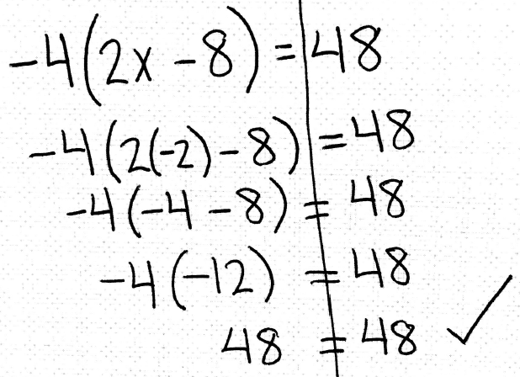
$$-8x+32=48$$

$$-32 -32$$

$$-8x= 16$$

$$-8 -8$$

$$x=-2$$

Equation: |  | Verification:

Equation: |  | Verification:

Equation: |  | Verification:

Equation: |  | Verification:

Equation: |  | Verification:

Multistep Equations Sort and Verify Assessment Questions
Name: Date: Period:
Directions: Solve the equations below and verify your answers.
Equation | Verification
$$-4\left(-2x-8\right)=-48$$

Equation | Verification
$$-4\left(-2x-8\right)=48$$
Equation | Verification
$$3\left(x+1\right)=5+x$$

Equation | Verification
$$2\left(-1x-3\right)=3+x$$

Equation | Verification
$$5x-2+8x=4x-2$$

Equation | Verification
$$3\left(x-4\right)=2x+1$$

Practical Problems
- It is your birthday and you are going to get a new cellphone. The day you buy the phone, you will have to pay the $49 interest fee and a $200 down payment. The remaining balance of the phone will be paid off in 24 equal payments. The total bill is $980, including the interest fee and down payment. Write an equation to solve for p, the required monthly payments.
What will be the cost of your monthly payments for the new cellphone?
- A cellphone company charges a monthly rate of $55 for unlimited text and data and $0.50 per minute for phone calls. The bill for last month was $66.
Write and solve an equation to find out how many minutes for phone calls were charged on this bill.
- You have $80 and your sister has $110. You are saving $8 per week and your sister is saving $5 per week.
Write and solve an equation to find out how many weeks it will take for you and your sister to have the same amount of money saved.

- Sammy was selling tickets for the football game. He sold five more adult tickets than senior tickets and twice as many children’s tickets than senior tickets. Let s represent the number of senior tickets sold.
Write an expression to represent the number of adult tickets sold.
Write an expression to represent the number of children tickets sold.
Adult tickets cost $6, children tickets cost $2 and senior tickets cost $4. Sammy made $142 selling football tickets.
Write an equation to represent the total ticket sales.
How many senior tickets did Sammy sell?

