Mathematics Instructional Plan – Grade 8

Slope and y-intercept
Strand: Patterns, Functions, and Algebra
Topic: Recognize and describe the graph of a linear function.
Primary SOL: 8.16 The student will
- recognize and describe the graph of a linear function with a slope that is positive, negative, or zero;
- identify the slope and y-intercept of a linear function given a table of values, a graph, or an equation in
y = mx + b form;
Related SOL: 6.12, 7.10, 8.15

Materials
- Teacher-made slope foldable
- Scissors
- Slope-Intercept Cards (attached)
- Silent Bingo Game Card (attached)
- Graph paper (optional)

Vocabulary
coordinate plane (earlier grades)
dependent variable, equation of a line, linear function, negative slope, positive slope, rate of change, slope, y-intercept (8.16a, 8.16b)

Student/Teacher Actions: What should students be doing? What should teachers be doing?
- Create a tab foldable with the class. The tabs should display definition, positive slope, negative slope, zero slope, and no slope. Go through the foldable and explain each concept: positive slope, negative slope, zero slope, and no slope.
- Give each student a pair of scissors and the Slope-Intercept Cards. Have students cut the cards apart and match the cards to make sets of five cards each—equation in standard form, equation in slope-intercept form, m (slope), b (y-intercept), and graph.
- Distribute copies of the Bingo Game Card. Have students play the Bingo game individually. As the teacher calls out a number for slope or a number for y-intercept, students will put a mark beside that equation. Tell them they can only check one equation at a time. Whenever a student gets “Bingo,” check his/her game card.

Assessment

Questions
    - Write whether a slope is positive, negative, zero, or undefined.
    - Write the slope and y-intercept of a graph.
    - Write the slope and y-intercept of a table of values.
    - Write the slope and y-intercept of an equation.

Journal/Writing Prompts
    - Write the formula for a linear function, and identify and describe what m and b stand for. Create an example in your explanation.
    - Write about lines with undefined slope (vertical lines) and compare undefined slope to lines with a defined slope.
    - Explain why the graph of a horizontal line does not have an x-intercept, assuming the equation is not x = 0. Describe how you know this.
    - Explain why the graph of a vertical line does not have a y-intercept, assuming the equation is not y = 0. Describe how you know this.

Other
    - Have students create a design on graph paper using 10 straight lines. Have them give the design to a partner, who will determine the slope and y-intercept of each line.
    - Graph a linear function, given an equation using different methods.

Strategies for Differentiation
- Encourage the use of graph paper and dry-erase boards with grids for students to see the slope and intercepts.
- Laminate the Slope-Intercept Cards so students can write on the cards with dry-erase markers.
- Have students work in pairs for both activities, as needed.

Note: The following pages are intended for classroom use for students as a visual aid to learning.

Virginia Department of Education © 2018

Slope-Intercept Cards
Copy on card stock and cut out.
y = −3x − 1 | m = −3
b = −1
y = ⁻ $\frac{3}{4}$x + 2 | m = ⁻ $\frac{3}{4}$
b = 2

y = 2x − 4 | m = 2
b = −4
y = $\frac{1}{2}$x − 3 | m = $\frac{1}{2}$
b = −3

y = 2x | m = 2
b = 0
y = 4 | m = 0
b = 4
y = –x + 4 | m = –1
b = 4 | 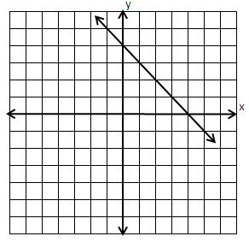
b = 1 | 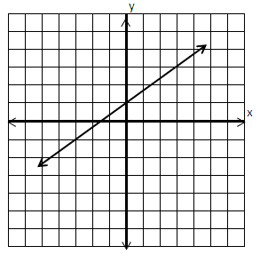

Silent Bingo Game Card
B | I | N | G | O
y = 2x + 1 | y = $\frac{1}{3}$x + 3 | y = $\frac{1}{2}$x − 1 | x = 8 | y = 3x − 5
y = $\frac{1}{2}$x + 4 | y = −$\frac{1}{3}$x | y = −5x + 11 | y = −x − 2 | x = 2
y = 3x + 2 | y = −2x + 9 | Free  Space | y = 4 | y = −2x + 3
y = $\frac{1}{2}$x + 6 | y = −$\frac{1}{3}$x + 1 | y = −2x + 1 | y = −$\frac{3}{2}$x + 3 | y = 6x − 8
y = −3 | y = 2 | y = 4x + 2 | y = $\frac{1}{2}$x + 1 | y = 3x

